  信息与电子工程学院 | 模拟与数模混合集成电路 | 赵梦恋
2018-2019学年夏学期 | 模拟与数模混合集成电路 | 2019年5月

- If the aspect ratio of an enhancement n-channel MOSFET is 4 μm/1 μm, (the relative model parameters can be seen in Table 1.1) the voltages of drain, gate, source and bulk are 3V, 2V, 0V and 0V respectively, calculate the drain current in this device. Then given the result of another p-channel MOSFET, whose voltages of drain, gate, source, and bulk are -3V, -2V, 0V and 0V respectively.
Table 1.1
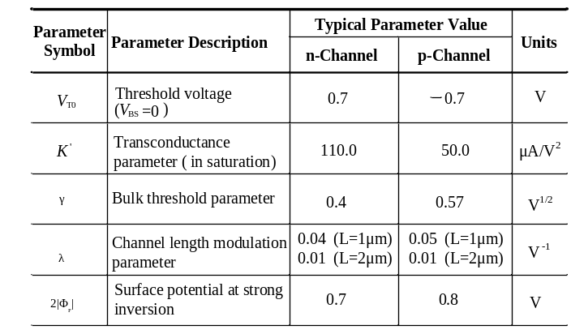
Solution:
NMOS：As V_{D}=3V，V_{G}=2V，V_{S}=0V，V_{B}=0V
So V_{DS}=3V，V_{GS}=2V，V_{SB}=0V
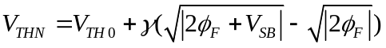=0.7V
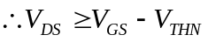，the NMOS works in saturation region and have
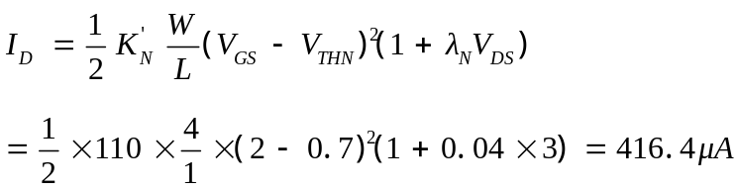

PMOS：As V_{D}=-3V，V_{G}=-2V，V_{S}=0V，V_{B}=0V
So V_{SD}=3V，V_{SG}=2V，V_{SB}=0V
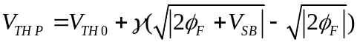=-0.7V
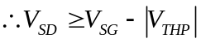，the PMOS works in saturation region and have
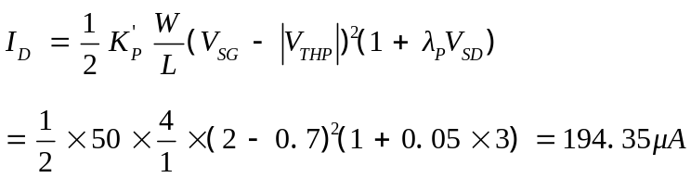

- Find the small-signal model (g_{m}, g_{mb}, g_{ds}) for an n-channel transistor with the drain at 4 V, gate at 4 V, source at 2 V, and the bulk at 0 V. Assume the model parameters from Table 1.1, and W/L = 10 μm/1 μm.
Solution:
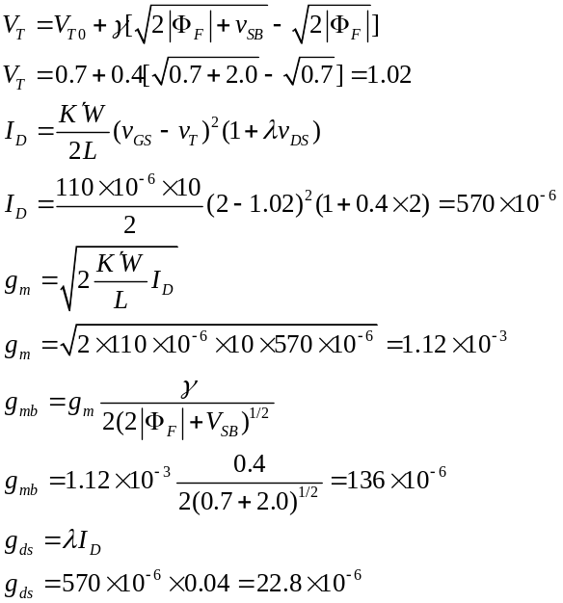
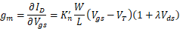

- Current I_{ds} in a transistor is 62.5μA when its gate-source voltage is 1V. The current is 1mA when V=2.5V.
- Which operating region (linear or saturated) of the transistor is these values of V correspond to?
- Calculate β and V_{T} for given transistor.
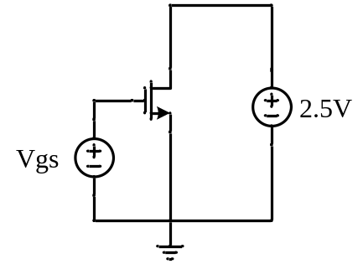

Figure 1.3

Solution:
- Both V₁ and V₂ are larger than V_{T,} and
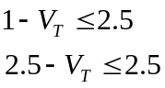
Therefore, the transistor works in saturated region in both circumstances.
- Since
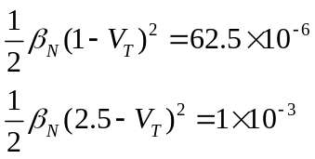
It can be derived from above equations that
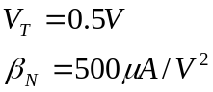

- Show that two MOS transistors connected in parallel with channel widths of W₁ and W₂ and identical channel lengths of L can be modeled as one equivalent MOS transistor whose width is W₁+W₂ and whose length is L, as shown in Fig.1.4. Assume the transistors are identical except for their channel widths.
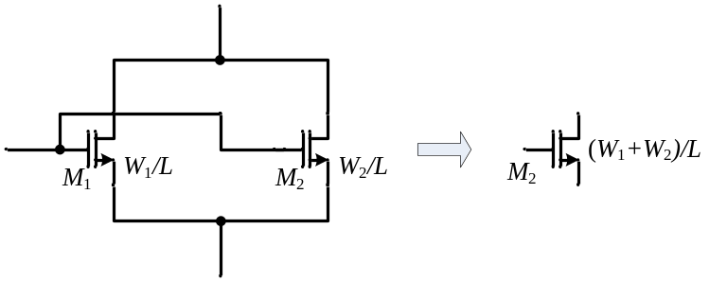

Figure 1.4
Demonstration:
For 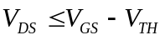
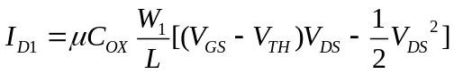
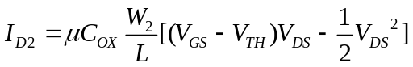
……
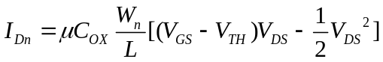
For 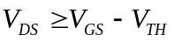
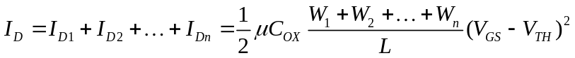
Thus the equivalent length = L and the equivalent width = W1+ W2+ … + Wn.

1-5. Show that two MOS transistors connected in series with channel lengths of L₁ and L₂ and identical channel widths of W can be modeled as one equivalent MOS transistor whose width is W and whose length is L₁+L₂, as shown in Fig. 1.5. Assume the transistors are identical except for their channel lengths. Ignore the body effect and channel-length modulation.
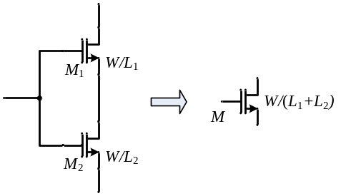

Figure 1.5
Answer：
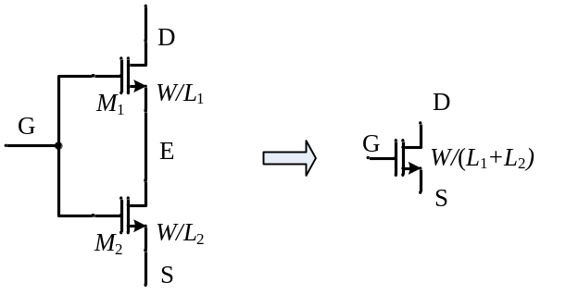
(1) When V_{GS}<V_{TH} and V_{GE}<V_{GS}<V_{TH}, the MOSFETs are in cut off.
(2) While M1 operates in triode (V_{DE} < V_{GE} –V_{THN}), that is equivalent to V_{DE} +V_{ES} < V_{GE} + V_{ES}–V_{THN}, i.e. V_{DS} < V_{GS} –V_{THN}.
Thus M2 operates in triode, too.
Thus
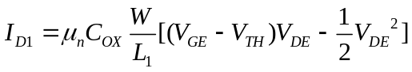 (1)
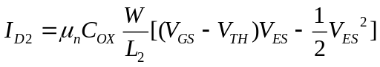 (2)
Since
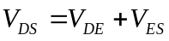 (3)
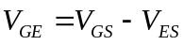 (4)
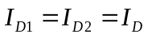 (5)
It can be derived from equations (1), (2), (3), (4) and (5) that
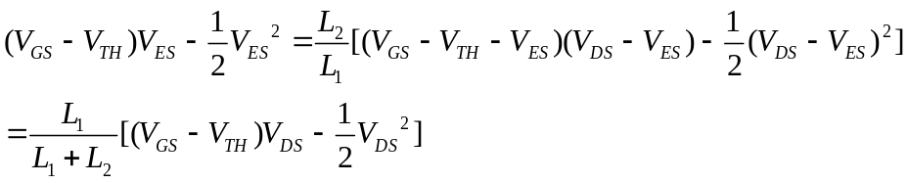
So we can get 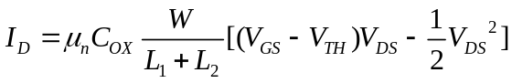
(3) While M1 operates in saturation (V_{DE} > V_{GE} –V_{THN}). It means V_{DE} + V_{ES} > V_{GE}+ V_{ES}–V_{THN}, i.e. V_{DS} > V_{GS} –V_{THN}.
V_{E} = V_{G} –V_{GE} < V_{G} –V_{THN}, it means V_{ES} < V_{GS} –V_{THN。}M2 operates in triode.
So
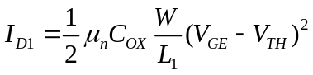 (1)
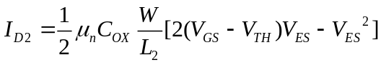 (2)
(3)
(4)
(5)
It can be derived from equations (1), (2), (3), (4) and (5) that
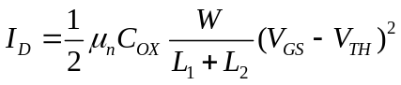
That just like a MOSFET operating in saturation, which has a length of L₁+L₂ and a width of W.
It can be deducted similarly that n MOSFETs in series acts as a MOSFET with an aspect ratio of W/(L₁+L₂+…L_{n}).

1-6.A) Fig. 1.6 shows the real and ideal I-V characteristics of two enhancement N-MOSFETs by real line and broken line respectively. Compare the difference of the two MOSFETs and explain why different.
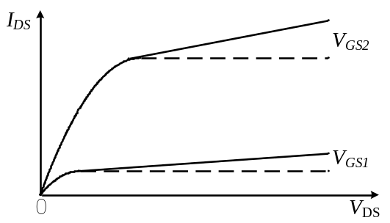
Figure 1.6
B) In Table 1.1, why is γ_{P} greater than γ_{N} for a n-well, CMOS technology?
Solution:
- Consider channel length modulation effect:
V_{GS1}——long channel device
V_{GS2}——Short channel device

- The expression for γ is:
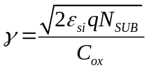
Because γ is a function of substrate doping, a higher doping results in a larger value for γ. In general, for an nwell process, the well has a greater doping concentration than the substrate and therefore devices in the well will have a larger γ. That’s why γ_{P} is greater than γ_{N.}

