1倍速CD = 150KB/S
1倍速DVD=1358KB/s= 9倍CD速
Tertiary storage 廉价，可移动存储介质，软盘，CD，移动硬盘
Sytem Call 3种传参方法，1. Register 2. Pass address to register 3. Patermeter pushed to stack, poped by system

进程
Why process rather than program?
1.different data with same program
2.different program with same data
A process include:
1.program counter; 2. stack (temporary data: parameters, return address, local variables); 3. data section (global variables) ; 4. maybe heap. ( here text is the code
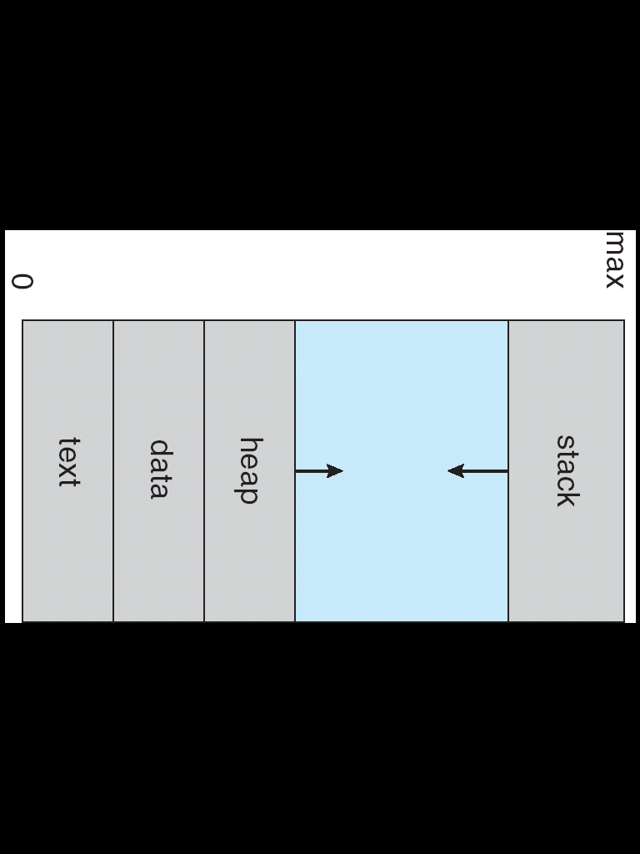

进程状态：A process has states while a program does not have states
1.new: being created
2.running: instructions are being executed
3.waiting: waiting for some event to occur (I/O completion, reception of a signal)
4.ready: waiting to be assigned to a processor
5. terminated: has finished execution
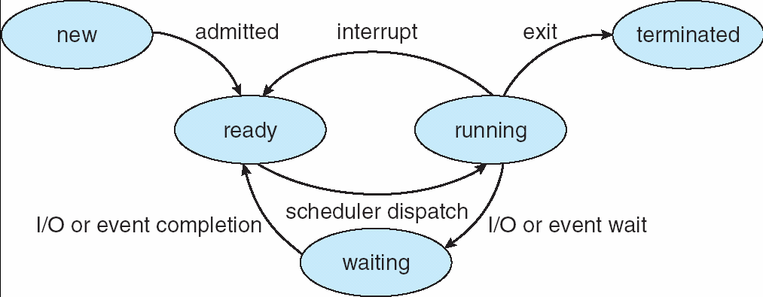
PCB的内容：
1.Process state
2.Program counter
3.CPU registers
4.CPU scheduling information
5.Memory-management information
6.Accounting information
7.I/O status information
8.page table or relocation register and limit register
9.file open table
调度队列的种类
Processes migrate among the various queues
1. job queue – set of all processes in the system
2. ready queue – set of all processes residing in main memory, ready and waiting to execute. Generally stored as a linked list
3. device queues – set of processes waiting for a particular I/O device, eg. a tape driver, a disk
调度器scheduler分类
long-term scheduler (or job scheduler) –selects which processes should be brought into the ready queue
short-term scheduler (or CPU scheduler) – selects which process should be executed next and allocates CPU
Attention: The long-term scheduler controls the degree of multiprogramming
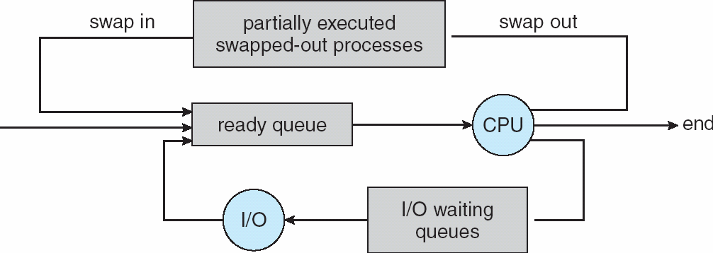
Context-switch
Context-switch time is overhead; the system does no useful work while switching.
Process Termination
Process executes last statement and asks the operating system to delete it (exit)
1.Output data from child to parent (via wait)
2.Process’ resources are de-allocated by operating system
Parent may terminate execution of children processes (abort)
1.Child has exceeded allocated resources
2.Task assigned to child is no longer required
3.If parent is exiting
Some operating system do not allow child to continue if its parent terminates--All children terminated - cascading termination
Advantages of process cooperation
Information sharing, Computation speed-up, Modularity and Convenience.
Interprocess Communication
1.shared memory and 2.message passing

进程同步种类：blocking (synchronous) vs. nonblocking (asynchronous)
1.blocking send: the sending process is blocked until the message is received by the receiving process or by the mailbox
2.nonblocking send: the sending process sends the message, and resumes operation
3.blocking receive: the receiver blocks until a message is available
4.nonblocking receive: the receiver retrieves either a valid message or a null, and resumes operation
生产者-消费者问题（指利用了n-1个单元）
item buffer[BUFFER_SIZE];
int in = 0;
int out = 0;
// producer
item nextProduced; // local variable
while (1) {
/* produce an item in nextProduced */
while (((in + 1) % BUFFER_SIZE) == out)
; // do nothing
buffer[in] = nextProduced;
in = (in + 1) % BUFFER_SIZE;
}
// consumer
item nextConsumed; // local variable
while (1) {
while (in == out) ; // buffer is empty
nextConsumed = buffer[out];
out = (out + 1) % BUFFER_SIZE;
/* consume the item in nextConsumed */
}

线程
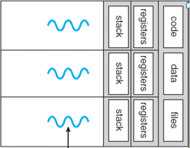
Benefits
1.Responsiveness (e.g. thread as GUI engine)
2.Resource Sharing (e.g. shared variable)
3.Economy (e.g. save memory)
4.Utilization of multiprocessor architectures
Thread can be a basic scheduling unit, but not one of resource allocation.
用户线程和内核线程
User threads：
1. supported above the kernel
2.implemented by a thread library at the user level
3.the library support thread creation, scheduling, management with no support from the kernel
4.(on a single thread kernel) any user-level thread performs a blocking system call blocks the whole process
Kernel threads：
1.supported directly by the operating system: the kernel performs thread creation, scheduling, and management in kernel space
2.slower to create and manage than user threads
3. independent block among threads
4. good support for multiprocessors
同步信号和异步信号
synchronous signals - 1. an illegal memory access, a division by zero 2. delivered to the same process that cause the signal
asynchronous signals
1. a user keystroke (Ctrl-C), a timer expiration
2. typically sent to another process
Multithreading models
Many to one：
1.many user-level threads mapped to single kernel thread
2.thread management is done in user space，used on systems that do not support kernel threads
3.drawbacks：whole process block if one thread blocks. unable to run parallel on multiprocessors
One to one：
1.each user-level thread maps to a kernel thread：more concurrency than many-to-one，support multiprocessors
2.drawback：overhead of creating kernel threads
3.examples：Windows 95/98/NT/2000，OS/2
Many to many：
1.multiplexes many user level threads to a smaller or equal number of kernel threads
2. allows the programmer to create a sufficient number of user threads
3. avoid bad blocking, support multiprocessors
Examples：Solaris 2，Windows NT/2000 with the ThreadFiber package
*Two-level Model -- M:M + 1:1
Similar to M:M, except that it allows a user thread to be bound to kernel thread.
Examples: IRIX, HP-UX, Tru64 UNIX, Solaris 8 and earlier.
线程的终止：thread cancellation
1.target thread: the thread to be cancelled
2.asynchronous cancellation: one thread immediately terminates the target thread，may be cancelled in the middle of updating data shared with other threads，may not free a system-wide resource
3.deferred cancellation: the target thread can periodically check if it should terminate (at so called cancellation points in Pthread)
线程池
Why the thread pools?
1. avoid creation and termination overhead, so that it is faster to service a request
2. put bound on number of threads, thus limit CPU and memory usage
Considerations :
1.number of CPUs
2.amount of physical memory
3.expected number of concurrent requests
fork may cp all/current, exec replace whole.
CPU调度
Maximum CPU utilization obtained with multiprogramming
CPU scheduling
Decisions may take place when a process, but not limited to:
1.Switches from running to waiting state
2.Switches from running to ready state
3.Switches from waiting to ready
4.Terminates
Scheduling under 1 and 4 is nonpreemptive.
All other scheduling is preemptive.
Dispatcher
Dispatcher module gives control of the CPU to the process selected by the short-term scheduler; this involves:
1.switching context
2.switching to user mode
3.jumping to the proper location in the user program to restart that program
Dispatch latency – time it takes for the dispatcher to stop one process and start another running.
CPU调度的评判标准 Scheduling Criteria
1.CPU utilization – keep CPU as busy as possible
2.Throughput – number of processes that complete their execution per time unit
3.Turnaround time 周转时间– the interval from the time of submission of a process to the time of completion
4.Waiting time – amount of time a process has been waiting in the ready queue
5.Response time – amount of time it takes from when a request was submitted until the first response
CPU调度算法
FCFS：等待时间不稳定，响应时间不稳定。
特点：easy to understand, easy to implement (an FIFO queue), large variance of waiting/response time, convoy effect, nonpreemptive, bad for time-sharing system
SJF：分为preemptive(SRTF) & nonpreemptive.平均等待时间最短。
Nonpreemptive会把当前正在执行的推掉。最优但不实际，是其他算法的判定标准。会造成starvation(饥饿)
Approximation: predict the next burst length.
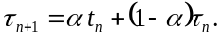
Each successive term has less weight than its predecessor.
Highest response Ratio Next，最高响应比优先
HRN = (W + T) / T ；W: Waiting Time T: Burst Cycle Time
Priority: preemptive & nonpreemptive. 存在饥饿的问题，可以通过aging的方法来弥补。
Round Robin： q large ⇒ FIFO. q small ⇒ q must be large with respect to context switch, otherwise overhead is too high. No process waits more than (n-1)q time units. higher average turnaround than SJF, but better response. Typical time quanta: 10 to 100 ms. 80% of the CPU bursts should be shorter than the quantum.
other
Multilevel Queue: scheduling between the queues, commonly implemented as fixed-priority preemptive.
Each queue has its own scheduling algorithm.
foreground – RR background – FCFS
Multilevel Feedback-Queue: a process that waits too long is moved to a higher-priority queue. Prevents starvation.

进程同步
Concurrent access to shared data may result in data inconsistency. Maintaining data consistency requires mechanisms to ensure the orderly execution of cooperating processes.

Atomic operation means an operation that completes in its entirety without interruption.

Race condition竞争: The situation where several processes access and manipulate shared data concurrently. The final value of the shared data depends upon which process finishes last.
To prevent race conditions, concurrent processes must be synchronized.
临界区问题的解决
1.Mutual Exclusion. If process Pi is executing in its critical section, then no other processes can be executing in their critical sections.
2.Progress. If no process is executing in its critical section and there exist some processes that wish to enter their critical section, then the selection of the process that will enter the critical section next cannot be postponed indefinitely.
3.Bounded Waiting. A bound must exist on the number of times that other processes are allowed(被允许而不一定要进入) to enter their critical sections after a process, as made a request to enter its critical section and before that request is granted.
算法1：进程共享变量int turn = 0
do {
while (turn != i) ;
Critical Section
turn = 1- i;
Reminder Section
} while (1);
分析：满足了互斥，但不满足progress。这个算法要求P0和P1交替进入，是不可行的。假设P0没有运行到与临界区相关的处理语句就停下来了。这个时候，turn=0，那么就算P1已经准备好进入自己的临界区，它也无法进入。
算法2：进程共享变量boolean flag[2] = false
flag [i] = true意味着Pi已经准备好进入
do {
flag[i] := true;
while (flag[1-i]) ;
critical section
flag [i] = false;
Remainder Section
} while (1);
分析：满足了互斥，但不满足progress。作为反例，假设一次调度使得P0、P1都执行了第一句，那么flag[0]和flag[1]都等于true这样，两个进程会一直相互等下去。

Dekker算法（7.4题）
同时使用算法1和算法2的共享变量，对于第i个进程（i = 0 或 1）：
do {
flag[i]=true;
while (flag[1-i]) {
if (turn==1-i) {
flag[i]=false;
while (turn==1-i) ;
flag[i]=true;
}
}
}
//Critical Section i
turn=1-i;
flag[i]=false;
//Remainder Section
}while(1);
算法3：Peterson’s Solution
do {
flag [i]:= true;
turn = 1-i;
while (flag [1-i] and turn == 1-i) ;
Critical Section
flag [i] = false;
Remainder Section
} while (1);
分析：满足了互斥、有空让进和有限等待。这个算法能够解决临界区问题。这里，turn的含义是“当前的‘进入权’给了谁”。而Flag[i]==ture的含义为，Pi已经准备好进入自己的临界区了。
Bakery Algorithm -- n processes
do {
choosing[i] = true;
number[i] = max(number[0], number[1], …, number [n – 1])+1;
choosing[i] = false;
for (j = 0; j < n; j++) {
while (choosing[j]) ;
while ((number[j] != 0)&&((number[j], j) < (number[i], i))) ;
}
//critical section
number[i] = 0;
//remainder section
} while (1);
Special atomic hardware instructions
基于TestAndSet
boolean TestAndSet(boolean *target) {
boolean rv = *target;
*target = true;
return rv;
}
boolean lock = false 对于第i个进程:
do {
while (TestAndSet(&lock)) ;
Critical Section
lock = false;
Remainder Section
}while(1);
分析：满足了互斥，但不满足有限等待条件。这里某个号数的进程可以一直霸占进入临界区的机会，使得其他号数的进程无限等待。
基于Swap的算法：
boolean lock = false对于第i个进程
do {
key = true;
while (key == true) Swap(lock,key);
Critical Section
lock = false;
Remainder Section
} while(1);
分析：满足了互斥，但不满足有限等待条件。这里某个号数的进程可以一直霸占进入临界区的机会，使得其他号数的进程无限等待。
Bounded-waiting mutual exclusion with TestAndSet()
boolean waiting[n] = false ;
boolean lock = false ;
do {
waiting[i]=true;
key= true;
while (waiting[i] && key)
key=TestAndSet(lock);
waiting[i]=false;
//critical section;
j= (i+1) % n ;
while ((j != i) && !waiting[ j ])
j= (j+1) % n ;
if (j == i) lock = false ;
else waiting[ j ] = false ;
//remainder section ;
}while(1)
Semaphores基于信号量的算法：
把一个进程P屏蔽，从就绪队列转移到L上去：wait(S){
S.value--;
if (S.value < 0){
//add this process to S.List;
block;
}
}
把一个进程P唤醒，从L转移到就绪队列中：
signal(S){
S.value++;
if (S.value <= 0){
//remove a process P from S.List;
wakeup(P);
}
}
S.value>0表示有S个资源可用；
S.value=0表示无资源可用或表示不允许进程再进入临界区；
S.value<0 则|S.value|表示在等待队列中进程的个数或表示等待进入临界区的进程个数。
wait(S)表示申请一个资源；signal(S)表示释放一个资源。
如果两个wait操作相邻，那么它们的顺序至关重要，而两个相邻的signal操作的顺序无关紧要。一个同步wait操作与一个互斥wait操作在一起时，同步wait操作在互斥wait操作前。
Bounded-Buffer Problem
full = 0, empty = n, mutex = 1。
// producer
while (true) {
// produce an item
wait (empty);
wait (mutex);
// add the item to the buffer
signal (mutex);
signal (full);
}
// consumer
while (true) {
wait (full);
wait (mutex);
//remove an item from buffer
signal (mutex);
signal (empty);
// consume the removed item
}
Readers-Writers Problem
mutex = 1, wrt = 1
//readers
readcount = 0
wait(mutex);
readcount++;
if (readcount == 1)
wait(rt);
signal(mutex);
//reading is performed
wait(mutex);
readcount--;
if (readcount == 0)
signal(wrt);
signal(mutex)；
//writers
wait(wrt);
//writing is performed
signal(wrt);
Dining-Philosophers Problem
semaphore chopstick[5] = 1。
对于第i哲学家：
do {
wait(chopstick[i]);
wait(chopstick[(i+1) % 5]);
eat;
signal(chopstick[i]);
signal(chopstick[(i+1) % 5]);
think;
} while (1);
其他解决方法：
1.allow at most four philosophers to be sitting simultaneously at the table--a spare resource.
2.allow a philosopher to pick up chopsticks only if both are available, and pick up them simultaneously.
3.use a asymmetric solution: an odd philosopher picks up first the left chopstick and then the right chopstick, whereas an even one picks up first the right and then the left.
Deadlock and Starvation
Deadlock – two or more processes are waiting indefinitely for an event that can be caused by only one of the waiting processes
Starvation – indefinite blocking. A process may never be removed from the semaphore queue in which it is suspended
有限缓冲区问题：进程共享一块有界的缓冲区。如何实现安全同步？
采用信号量full， empty， mutex，
初始值full = 0, empty = n, mutex = 1。
wait(full);
wait(mutex);
……
signal(mutex);
signal(empty);
……
while (1);
死锁问题
A set of blocked processes each holding a resource and waiting to acquire a resource held by another process in the set.
1.Mutual exclusion: only one process at a time can use a resource.
2.Hold and wait: a process holding at least one resource is waiting to acquire additional resources held by other processes.
3. No preemption: a resource can be released only voluntarily by the process holding it, after that process has completed its task.
4. Circular wait: there exists a set {P1, P2, …, Pn} of waiting processes such that P1 is waiting for a resource that is held by P2, P2 is waiting for a resource that is held by P3, …, Pn–1 is waiting for a resource that is held by Pn, and Pn is waiting for a resource that is held by P1.
Handling Deadlocks
1.Prevention 低设备使用率和系统吞吐率
条件2：必须同时申请所有资源(之后不wait)；或只有没有资源才可申请(之前不hold)。资源利用率低 饥饿
条件3：申请其它资源不能立即得到，那么现有资源可被抢占
适用cpu 内存 不适用打印机 磁带驱动器
条件4：资源排序，递增申请
2. Avoidance
3. Detection
4.Recovery
5.Ignore the problem and pretend that deadlocks never occur in the system (Unix)

Resource-Allocation Graph该算法只适用单个实例资源
If no cycle exists, then the allocation of the resource will leave the system in a safe state.

Safe State
System is in safe state if there exists a sequence <P₁, P₂, …, P_{n}> of all the processes is the systems such that for each P_{i}, the resources that P_{i} can still request can be satisfied by currently available resources + resources held by all the P_{j}, with j < i.
safe state ⇒ no deadlocks
unsafe state ⇒ possibility of deadlock

Banker’s Algorithm(Deadlock Avoidance)
Resource-Request Algorithm
1. If Requesti ≤ Needi go to step 2. Otherwise, raise error condition, since process has exceeded its maximum claim.
2.If Requesti ≤ Available, go to step 3. Otherwise Pi must wait, since resources are not available.
3. Pretend to allocate requested resources to Pi by modifying the state as follows:
Available = Available - Requesti
Allocationi = Allocationi + Requesti
Needi = Needi – Requesti
If safe ⇒ the resources are allocated to Pi
If unsafe ⇒ Pi must wait, and the old resource-allocation state is restored
Safety Algorithm
1.Let Work and Finish be vectors of length m and n, respectively. Initialize:
(a) Work = Available
(b) Finish [i] = false for i = 0, 1, …, n- 1.
2.Find an index i such that both:
(a)Finish[i] == false
(b)Requesti ≤ Work
If no such i exists, go to step 4.
3.Work = Work + Allocationi
Finish[i] = true
go to step 2.
4.If Finish [i] == true for all i, then the system is in a safe state.
Detection Algorithm(死锁检测算法)
Almost the same with safety algorithm
1.(b)For i = 1,2, …, n, if Allocationi ≠ 0, then
Finish[i] = false; otherwise, Finish[i] = true.
4.If Finish[i] == false, for some i, 1 ≤ i ≤ n, then the system is in deadlock state.
Moreover, if Finish[i] == false, then Pi is deadlocked.
The algorithm requires an order of O(m x n2 ) operations to detect whether the system is in deadlocked state
Wait for图算法：简化了资源分配图，只适用单个实例资源

内存管理
Binding地址绑定
Addresses in the program are generally symbolic.
A compiler binds these symbolic addresses to relocatable addresses.
A linkage editor (loader) binds these relocatable addresses to absolute addresses.
1. Compile time: If memory location known a priori, absolute code can be generated; must recompile code if starting location changes.
2. Load time: Must generate relocatable code if memory location is not known at compile time.
3. Execution time: Binding delayed until run time if the process can be moved during its execution from one memory segment to another. Need hardware support for address maps (e.g., base and limit registers).

Logical vs. Physical Address Space
Central to proper memory management
1.logical address – generated by the CPU; also referred to as virtual address
2.physical address – address seen by the memory unit
Differ in execution-time address-binding scheme and same in compile-time and load-time.
Memory-Management Unit(内存管理单元)
MMU is a hardware device that maps virtual to physical address.
In MMU scheme, the value in the relocation register is added to every address generated by a user process at the time it is sent to memory.
The user program deals with logical addresses; it never sees the real physical addresses.
Dynamic Linking
linking postponed until execution time. Particularly useful for (shared) libraries; better memory usage; easier library updates; operating system need to check if routine is in processes’ memory address.
Swapping
Major part of swap time is transfer time
Backing store – fast disk large enough
Overlay
An overlay is when a process replaces itself with the code of another program.
法1：不能换出有待处理IO的进程
法2：IO只能操作系统缓冲区
1.Contiguous Allocation
Base register contains value of smallest physical address.
Limit register contains range of logical addresses.
Logical address must be less than limit register
MMU maps logical address dynamically
Dynamic Storage-Allocation Problem
First-fit: Allocate the first hole that is big enough
Best-fit: Allocate the smallest hole that is big enough; must search entire list, unless ordered by size; Produces the smallest leftover hole
Worst-fit: Allocate the largest hole; must also search entire list. Produces the largest leftover hole.
first fit and best fit are better than worst fit. first fir a little better than best fit.
Fragmentation
External Fragmentation – total memory space exists to satisfy a request, but it is not contiguous
Internal Fragmentation – allocated memory may be slightly larger than requested memory; this size difference is memory internal to a partition, but not being used.
Compaction is possible only if relocation is dynamic, and is done at execution time.
2.Paging
Divide physical memory into fixed-sized blocks called frames (size is power of 2, 512B~ 8,192B).
Divide logical memory into blocks of same size called pages.
Page table- translate logical to physical addresses
Page number (p) – used as an index into a page table which contains base address of each page in physical memory
Page offset (d) – combined with base address to define the physical memory address that is sent to the memory unit
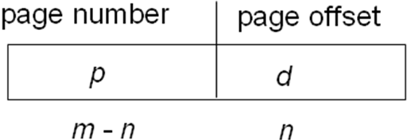
Implementation of Page Table
Page table is kept in main memory.
Base register (PTBR) points to the page table
Length register (PTLR) indicates size of the table.
Every data/instruction access requires two memory accesses. One for the page table and one for the data/instruction.
Can be solved by the use of a special fast-lookup hardware cache called associative memory or translation look-aside buffers (TLBs).
Memory Protection - Valid-invalid bit
Shared Pages
Shared code must appear in same location in the logical address space of all processes.
Structure of the Page Table
1.Hierarchical Paging (Two-Level Paging)
Page-number(2-level) + Page-offset
2.Hashed Page Tables
The virtual page number is hashed into a page table. This page table contains a chain of elements hashing to the same location.
3.Inverted Page Tables
3.Segmentation
Segment table – maps 2d physical addresses. 动态链接
Logical address consists <segment-number, offset>. Each table entry has:
base – contains the starting physical address where the segments reside in memory
limit – specifies the length of the segment
STBR and STLR
Allocation: segments vary in length→dynamic storage-allocation problem ; first fit/best fit ; external fragmentation
Sharing : same segment number
segmentation and paging
Segmented paging is helpful when the page table becomes very large. A large contiguous section of the page table that is unused can be collapsed into a single segment table entry with a page-table. Paged segmentation handles the case of having very long segments that require a lot of time for allocation. By paging the segments, we reduce wasted memory due to external fragmentation and simplify the allocation.

虚拟存储
Basic Concepts
Virtual memory – separation of user logical memory from physical memory. 当物理内存较小时提供一个较大的外部虚拟存储
1.only part of the program needs to be in memory for execution. 2.logical address space can therefore be much larger than physical address space. 3.allows address spaces to be shared by several processes. 4.allows for more efficient process creation. 5.virtual memory allows other benefits during process creation: copy-on-write ; memory-mapped file.
Demand Paging
Bring a page into memory only when it is needed
1.Less I/O needed 2.Less memory needed
3.Faster response 4.More users
Page Fault
1.Operating system looks at another table to decide:(1)Invalid reference ⇒ abort (2)Just not in memory 2.Get empty frame 3.Swap page into frame 4.Reset tables 5.Set validation bit = v 6. Restart the instruction that caused the page fault
Page Fault Rate 0 ≤ p ≤ 1.0. EAT = (1 – p) x memory access + p (page fault overhead + swap page out + swap page in + restart overhead )
Copy-on-Write (COW) allows both parent and child processes to initially share the same pages in memory until either process modifies. More efficient process creation.
Page Replacement Algorithm页置换的算法
Goal - lowest page-fault rate.
Reference string: page numbers only, with adjacent duplications eliminated.
1.First-In-First-Out Algorithm - use a FIFO queue to hold all pages in memory. When a page is brought into memory, insert it at the tail. When a free frame is needed, we replace the page at the queue. Belady’s Anomaly
2.Optimal Page Replacement OPT/MIN- replace the page that won’t be used for the longest period of time
3.Least Recently Used - associates with each page the time of that page’s last use. When a page must be replaced, choose the page that has not been used for the longest period of time.
a. Counter implementation - A time-of-use field. Copy the clock into it when referenced. Look for smallest time-of-use field. Difficulties: requires a search of the page table; a write to memory for each memory access; page-table maintain in context switch; overflow of the clock.
b. Stack implementation - Keep a stack of page numbers in a double linked list. Move a page to the top when referenced. Requires 6 pointers to be changed. Always replace the page at the bottom. No search for replacement.
PS: both need special hardware support(TLB).

4.LRU-Approximation Page Replacement
Reference Bit - with each page associate a bit, initially = 0, when page is referenced, bit set to 1.
a. Additional Reference Bits
Use right-shift history byte for each page, current reference bit shift into the left-most bit. choose the page with lowest number.
b. Second-Chance Algorithm
FIFO + reference bit. Circular Queue. Inspect the current frame, if the reference bit is set, reset it, and skip to next frame; otherwise, replace it.
c. Enhanced Second-Chance Algorithm
Modify bit (dirty, bit). Replace the first page encountered in the lowest nonempty class. Drawback: may have to scan several times. (Mac)
5.Counting-based Algorithms - keep a counter of number of references to each page.
a. Least-frequently-used (LFU) - page with the smallest count is replaced. counter shift right at regular interval , exponentially decaying average.
b. Most-frequently-used (MFU) - based on the argument that page with the smallest count was probably just brought in and has yet to be used.
Frame Allocation
1.Fixed Allocation – Equal or Proportional(比例).
2.Priority Allocation
Global vs Local Replacement.
Global(more common used) - process selects from the set of all frames. High priority process can take a frame from a lower priority process. Results in greater system throughput. Problem: a process cannot control its own page-fault rate.
Local – process selects from only its own set of allocated frames. the number of frames allocated to a process does not change.
Thrashing & Working-Set Model
If a process doesn’t have “enough” pages, the page-fault rate is very high ⇒ 1.low CPU utilization 2.os thinks it needs to increase the degree of multiprogramming 3.another process added to the system 4.worse the condition.
Thrashing :≡ A process is busy swapping pages in and out. Σ size of locality > total memory size, thrashing occur. Δ ≡ working-set window ≡ a fixed number of page references. Working-Set Size WSS = total number of pages referenced in the most recent Δ (varies in time). Δ too small will not encompass entire locality. Δ too large will encompass several localities. Δ = ∞ will encompass entire program.
D = Σ WSSi ≡ total demand frames. if D > m ⇒ thrashing. Policy: if D > m, then suspend one of the processes (and swap it out completely).
Working-set strategy prevents thrashing while keeping the degree of multiprogramming as high as possible, it optimizes CPU utilization.
Implementation: approximate with interval timer + a reference bit.
Example: Δ = 10,000, timer interrupts every 5000 references, keep in memory 2 bits for each page. Whenever a timer interrupts, copy and sets the values of all reference bits to 0. If one of the bits in memory = 1 ⇒ page in working set
Memory-Mapped Files
Memory-mapped file I/O allows file I/O to be treated as routine memory access by mapping a disk block to a page in memory.
1.Simplifies file access by treating file I/O through memory rather than read() write() system calls. 2.Allows several processes to map the same file - pages in memory to be shared.
Allocating Kernel Memory
1.Buddy System - Allocates memory from fixed-size segment consisting of physically contiguous pages. (用高位地址判断是否Buddy)
2.Slab Allocator - Slab is one or more physically contiguous pages. Cache consists of one or more slabs. Single cache for each unique kernel data structure. When cache created, filled with objects marked as free. When structures stored, objects marked as used. If slab is full of used objects, next object allocated from empty slab. If no empty slabs, new slab allocated. Benefits include no fragmentation, fast memory request satisfaction.

文件系统接口
File – A sequence of logical records.
File Attributes
1.Name 2.Identifier – unique tag identifies file within file system 3.Type 4.Location 5.Size 6.Protection 7.Time, date, and user identification
8.Information about files kept in the directory structure, which is maintained on the disk.
File Operations - 1.Create 2.Write 3.Read 4.Reposition within file 5.Delete 6.Truncate截短
Open-file table
A file can be opened simultaneously by more than one processes in name of several users
A per-process table tracks all files that a process has open. May have a pointer to an entry in the system-wide table.
A system-wide table contains process -independent information. Have an open count tracks the number of processes.
Info associated with an open file: 1.File pointer 2.File-open count 3.Disk location of the file 4.Access rights
File Types – Name, Extension
Access Methods - Sequential & Direct Access
File Directory
A directory is a collection of nodes containing information about all files. Both the directory structure and the files reside on disk.
Information in dir: name, type, address , current length, maximum length, date last accessed (for archival), date last updated (for dump), owner ID (who pays), protection information.
Operations: 1.Search 2.Create 3.Delete 4.List a directory 5.Rename 6.Traverse the file system
Directory Structure
Goal: 1.Efficiency 2.Naming 3.Grouping
1.Single-Level (2)(3)X limited name length
2.Two-Level (3)X
3.Tree-Structured Absolute or relative path name
4.Acyclic-Graph have shared subdirectories and files. A file may have multiple absolute path names. Distinct file names may refer to the same
Delete file ⇒ dangling pointer. To solve, using (1)Backpointers using a daisy chain (2) Every-entry-count. 保证无圈方法:a.只允许指向文件的链接; b.每次增加link时检查有无圈.
5.General Graph – Need garbage collection
File System Mounting
A file system must be mounted before it can be accessed. An unmounted file system is mounted at a mount point.A directory structure can be built out of multiple partitions.
File Sharing
Desirable on multi-user systems. May be done through a protection scheme.
(1)User IDs and Group IDs
(2)Remote File Systems: NFS, CIFS
File Protection
Mode of access: read, write, execute
three classes of users
a) owner access 7 ⇒ 1 1 1
b) group access 6 ⇒ 1 1 0
c) public access 1 ⇒ 0 0 1

文件系统实现
File-System Structure
File structure goal:
1.Logical storage unit - data blocks
2.Collection of related information - FCB
File system organized into layers
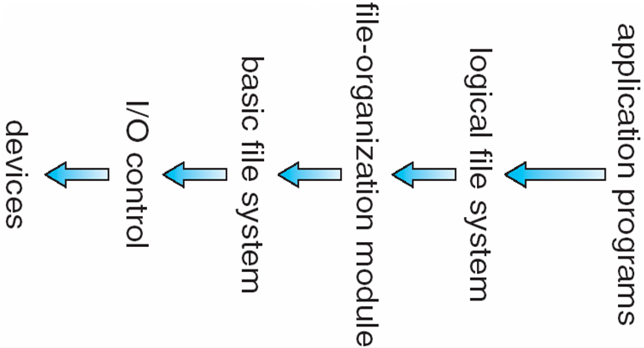
File system resides on secondary storage
Device driver controls the physical device
File-System Implementation
On disk:
1.Boot control block contains info needed by system to boot OS from that volume.
boot block(UFS) & partition boot sector(NTFS)
2.Volume control block contains volume details
(# of blocks, free block count and pointers, free FCB count and pointers)
superblock(UFS) & master file table(NTFS)
3.Directory structure organizes the files.
inode numbers(UFS) & master file table(NTFS)
4.Per-file File Control Block (FCB) contains many details about the file.
In memory
1.in-memory mount table
2. in-memory directory structure
3. system-wide open-file table - contains a copy of the FCB of each open files, open count, etc.
4.per-process open-file table - contains a pointer to the entry in the system-wide open-file table, read/write position, etc.
File Control Block
1.file permissions 2.file dates(create, access, write) 3.file owner, group, ACL 4. file size 5. file data blocks or pointers to file data blocks.

File Open
1.the directory structure is searched for the given file name 2.if found, the FCB is copied into a system-wide open-file table in memory 3.an entry is made in the per-process open-file table 4.returns a pointer to the entry in the per-process open-file table -- file descriptor in UNIX, file handle in Windows
File Close
1.the per-process table entry is removed. 2.the system-wide table entry’s open count is decremented. if the count hits zero, all updated info is copied back to the disk, and the system-wide table entry is removed.
Virtual File Systems
Provides an object-oriented way of implementing file systems. Allows the same system call interface(API) to be used for different types of file systems. The API is to the VFS interface, rather than any specific type of file system.
Three Layers: 1. file-system interface – based on open, close, read, write and on file descriptors.
2. virtual file system.
Directory Implementation
1.Linear list of file names with pointer to the data blocks 2.Hash Table – linear list with hash data structure
Allocation Methods磁盘分配方法
Contiguous allocation
Benefits: simple, only starting location and length (number of blocks) are required; good support of random access.
Problem: dynamic storage-allocation - first fit, best fit; external fragmentation – compaction.
Difficulty: files grow, difficult to determine how large a file.
Extent-Based Systems - a modified contiguous allocation scheme. It allocate disk blocks in extents; an extent is a contiguous block on the disk; extents are allocated for file allocation; a file consists of one or more extents.
LA/512 Block X + start address Displacement Y
Linked allocation
Benefits: simple, need only starting address in directory entry; no external fragmentation.
Drawbacks: no random access, can be used effectively only for sequential-access files; space required for the pointers in every block - use clusters(簇) 按簇(几个块一起)分配,减少指针消耗,但会增加内碎片
Reliability: pointers scatter all over the disk, and may lost or damage - double FAT!
LA/511 Block X Displacement Y+1
Indexed allocation
brings all pointers into the index block; directory entry contains the address of the index block.
Benefits: support random access; no external fragmentation
Drawbacks: waste space(whole block may contains one or two pointers)
Index table of variant size files
1.Linked scheme 2.Multilevel index 3.combined scheme(12+ 256+256^2+256^3)
LA/512 X =displacement in index table
Y=displacement in block
File Allocate Table(FAT)
Disk-space allocation used by MS-DOS and OS/2
A section at the beginning of each partition is set aside to contain the table. A FAT is used as a linked list. 0 means free block; a special value (-1) means end-of-file; double FAT to increase the reliability. FAT cause a lot of disk head seeks.
FAT is usually cached in memory; random access time is improved, we can find the location of any block by reading the FAT (provided it is cached in memory). 类似于游标的一种实现.
Free-Space Management空闲空间管理
1.bit map, or bit vector (n blocks)
Each block is represented by 1 bit(1 free 0 occupied). Bit map requires extra space.
First free block number calculation=(number of bits per word) *(number of 0-value words) +offset of first 1 bit
Ex: block size = 512B disk size = 1GB n = 1GB / 512B = 2M = 256KB clustering blocks in group (say, of four blocks) reduces the number to 64KB.
Easy to get contiguous files
2.Linked Free-space List
Cannot get contiguous space easily; no waste of space; an FAT implementation may help to improve performance; FIFO or stack?

磁盘系统
Transfer rate is rate at which data flow between drive and computer.
Positioning time (random-access time) is time to move disk arm to desired cylinder (seek time) and time for desired sector to rotate under the disk head (rotational latency)
Drive attached to computer via I/O bus
1.Busses vary, including EIDE, ATA, SATA, USB, Fibre Channel, SCSI.
2.Host controller in computer uses bus to talk to disk controller built into drive or storage array.
Moving-head Disk Mechanism
A read-write head “flies” just above each surface of every platter. The heads are attached to a disk arm that moves all the heads as a unit. The surface of a platter is logically divided into circular tracks, which are subdivided into sectors. The set of tracks that are at one arm position makes up a cylinder.
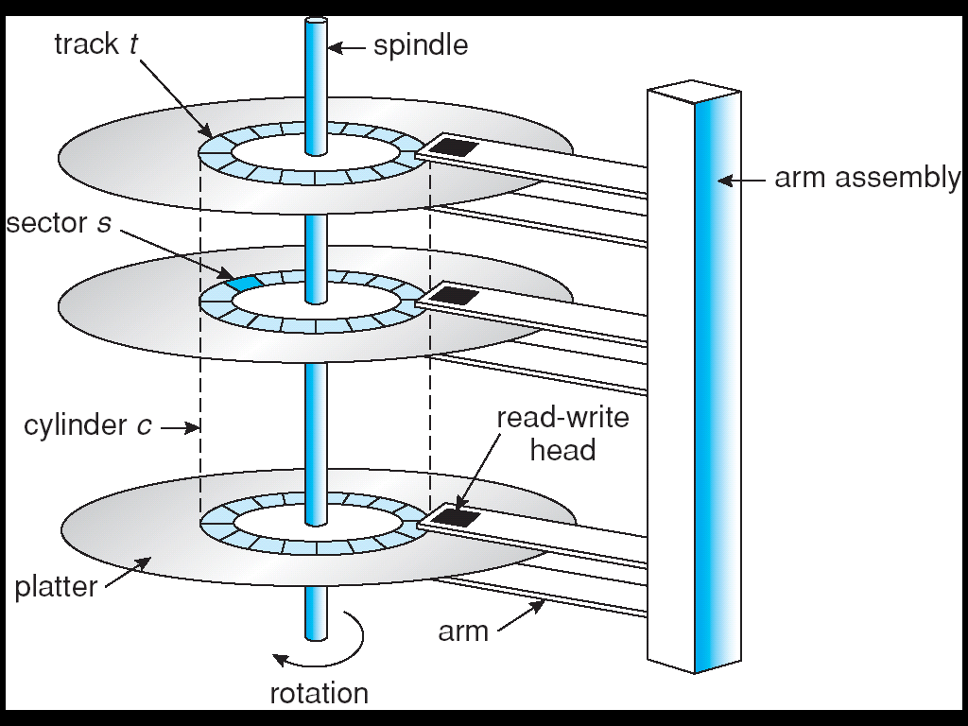
Disk Structure
Disk drives are addressed as large 1-dimensional arrays of logical blocks, where the logical block is the smallest unit of transfer - typical called a sector, 512B or 1KB
The 1-dimensional array of logical blocks is mapped into the sectors of the disk sequentially.
1.sector 0 is the first sector of the first track on the outermost cylinder.
2.mapping proceeds in order through that track, then the rest of the tracks in that cylinder, and then through the rest of the cylinders from outermost to innermost.
Disk Scheduling
The operating system is responsible for using hardware efficiently — for the disk drives, this means having a fast access time and disk bandwidth.
Access time has two major components
1.Seek time is the time for the disk are to move the heads to the cylinder containing the desired sector. 2.Rotational latency is the additional time waiting for the disk to rotate the desired sector to the disk head
Minimize seek time
Seek time ≈ seek distance
Disk bandwidth is the total number of bytes transferred, divided by the total time between the first request for service and the completion of the last transfer
Disk Scheduling Algorithm 磁盘调度算法
1.FCFS – First Come First Service
2.SSTF – 选寻道时间最短的. May cause starvation
3.SCAN(elevator algorithm) The disk arm starts at one end of the disk, and moves toward the other end, servicing requests until it gets to the other end of the disk, where the head movement is reversed and servicing continues. 扫到头
4.C-SCAN – 基于SCAN，磁盘是圆形的，从一头倒另一头很快并且不执行JOB. 扫到头，快速扫回
5.LOOK 扫到有JOB的c最远的位置，不用到头
6.C-LOOK 快速扫回，注意不是环形，只是快速扫回，中途不干活，比如设备只能单向存取.
Disk Management
1.Low-level formatting, or physical formatting — Dividing a disk into sectors that the disk controller can read and write.
2.To use a disk to hold files, the operating system still needs to record its own data structures on the disk. a. Partition the disk into one or more groups of cylinders. b. Logical formatting or “making a file system” c. To increase efficiency most file systems group blocks into clusters. (1)Disk I/O done in blocks. (2)File I/O done in clusters
Master Boot Record
RAID Structure
RAID – multiple disk drives provides reliability via redundancy. Increases the mean time to failure
Frequently combined with NVRAM(Non-volatile RAM) to improve write performance. RAID is arranged into six different levels.
RAID 0: non-redundant striping.
RAID 1: mirrored disks.
RAID 2: memory-style error correcting codes.
RAID 3: bit-interleaved parity.
RAID 4:block-interleaved parity.
RAID 5: block-interleaved distributed parity.
RAID 6: P + Q redundancy.

I/O 系统
An I/O channel is a special processor.
Virtual devices are implemented with spooling!
Basic I/O Concepts
device drivers– present a uniform device access interface to the I/O subsystem
I/O subsystem – separates the rest of the kernel from the complexity of managing I/O devices
Port – a device communicates with the machine via a connection point, e.g. a serial port
Bus – a set of wires and a protocol
Controller– a collection of electronics that operate a port, a bus, or a device: the processor communicates with the controller by reading and writing bit patterns in data and control registers; Special I/O instruction or Memory-mapped I/O.
Polling轮询
Determines state of device. Command-ready; busy; error. Inefficient when speed differ much.
Interrupt中断
1.CPU interrupt request line triggered by I/O device. 2.Interrupt handler receives interrupts.
3. Maskable to ignore or delay some interrupts
Two lines: Nonmaskable and maskable interrupt.
4.Interrupt vector to dispatch interrupt to correct handler: based on priority; Some nonmaskable.
5.Interrupt mechanism also used for exceptions.
DMA(Direct Memory Access)
1.Used to avoid programmed I/O for large data movement 2.requires DMA controller- a special-purpose processor. 3.Bypasses CPU to transfer data directly between I/O device and memory. Handshake between the main processor and the DMA controller: two wires - DMA-request wire and DMA-acknowledge wire
Application I/O Interface I/O应用接口
1.I/O system calls encapsulate device behaviors in generic classes. 2.Device-driver layer hides differences among I/O controllers from kernel.
Block and Character Devices Network Devices
Clocks and Timers Blocking and Nonblocking I/O
Kernel I/O Subsystem
1.I/O scheduling Device-status Table
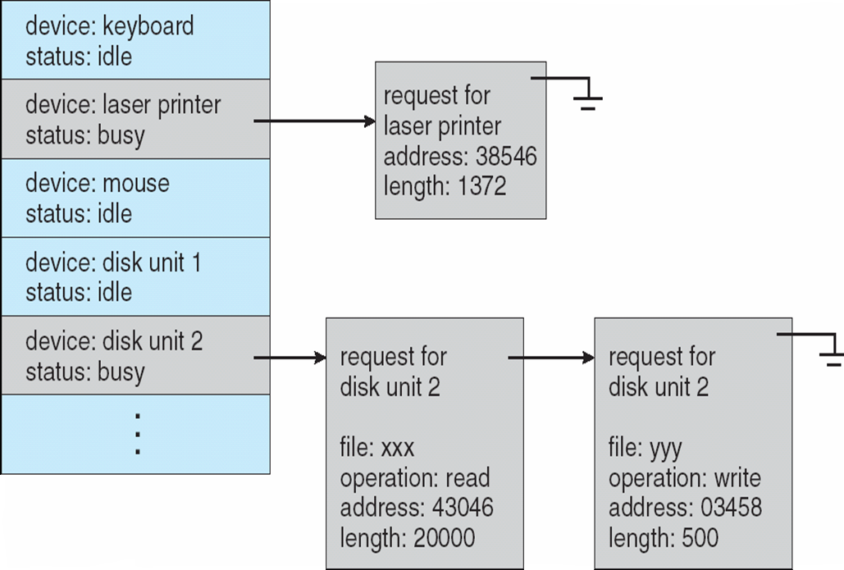
2.Buffering
1.To cope with a speed mismatch between the producer and consumer of a data stream.
2.To adapt between devices that have different data-transfer sizes.
3.To support copy semantics for application I/O.
3. Caching
Fast memory holding copy of data. Always just a copy. More efficient than access to the original.
Difference between caching and buffering: a buffer may hold the only copy of data whereas a cache always holds a copy on faster storage.
4.Spooling and Device Reservation
A buffer that holds output for a device, such as a printer, that cannot accept interleaved(交叉) data streams. Spooling is one way OS can coordinate concurrent output.
Device Reservation provides exclusive access to a device. System calls for allocation and deallocation. Watch out for deadlock.
5.error handling
6.I/O Protection
User process may accidentally or purposefully attempt to disrupt normal operation via illegal I/O instructions. a. All I/O instructions defined to be privileged(特权). b. I/O must be performed via system calls - Memory-mapped and I/O port memory locations must be protected too.
I/O port registers
1.status register 2.control register
3.data-in register(s) 4.data-out register(s)
Kernel I/O subsystem summary
- management of name of files and devices
- access control to files and devices
- file system space allocation
- device allocation (including reservation)
- buffering, caching, spooling
- I/O scheduling
- device status monitoring, error handling
- device driver configuration
A program that acts as an intermediary between a user of a computer and the computer hardware.
Operating system goals:
Execute user programs and make solving user problems easier.
Make the computer system convenient to use.
Use the computer hardware in an efficient manner.

Computer system can be divided into four components
1.Hardware – provides basic computing resources
CPU, memory, I/O devices
2.Operating system
Controls and coordinates use of hardware among various applications and users
3.Application programs – define the ways in which the system resources are used to solve the computing problems of the users
Word processors, compilers, web browsers, database systems, video games
4.Users
People, machines, other computers

OS is a resource allocator
1.Manages all resources
2.Decides between conflicting requests for efficient and fair resource use
OS is a control program - Controls execution of programs to prevent errors and improper use of the computer

bootstrap program is loaded at power-up or reboot
1.Typically stored in ROM or EEPROM, generally known as firmware
2.Initializates all aspects of system
3.Loads operating system kernel and starts execution

Computer-system operation
One or more CPUs, device controllers connect through common bus providing access to shared memory
Concurrent execution of CPUs and devices competing for memory cycles

Computer-System I/O Operation
I/O devices and the CPU can execute concurrently.
Each device controller is in charge of a particular device type.
Each device controller has a local buffer.
CPU moves data from/to main memory to/from local buffers
I/O is from the device to local buffer of controller.
Device controller informs CPU that it has finished its operation by causing an interrupt.

Common Functions of Interrupts
Interrupt transfers control to the interrupt service routine generally, through the interrupt vector, which contains the addresses of all the service routines.
Interrupt architecture must save the address of the interrupted instruction.
Incoming interrupts are disabled while another interrupt is being processed to prevent a lost interrupt.
A trap is a software-generated interrupt caused either by an error or a user request.
An operating system is interrupt driven.

I/O Structure
After I/O starts, control returns to user program only upon I/O completion.
1.Wait instruction idles the CPU until the next interrupt
2.Wait loop (contention for memory access).
3.At most one I/O request is outstanding at a time, no simultaneous I/O processing.
After I/O starts, control returns to user program without waiting for I/O completion.
1.System call – request to the operating system to allow user to wait for I/O completion.
2.Device-status table contains entry for each I/O device indicating its type, address, and state.
3.Operating system indexes into I/O device table to determine device status and to modify table entry to include interrupt.

Direct Memory Access Structure
1.Used for high-speed I/O devices able to transmit information at close to memory speeds.
2.Device controller transfers blocks of data from buffer storage directly to main memory without CPU intervention.
3.Only on interrupt is generated per block, rather than the one interrupt per byte.

Storage Structure
Main memory – only large storage media that the CPU can access directly.
Secondary storage – extension of main memory that provides large nonvolatile storage capacity.
Magnetic disks – rigid metal or glass platters covered with magnetic recording material
1.Disk surface is logically divided into tracks, which are subdivided into sectors.
2.The disk controller determines the logical interaction between the device and the computer.

Caching
Important principle, performed at many levels in a computer (in hardware, operating system, software)
Information in use copied from slower to faster storage temporarily
Faster storage (cache) checked first to determine if information is there
1.If it is, information used directly from the cache (fast)
2.If not, data copied to cache and used there
Cache smaller than storage being cached
1.Cache management important design problem
2.Cache size and replacement policy

Operating System Structure
Multiprogramming needed for efficiency
1.Single user cannot keep CPU and I/O devices busy at all times
2.Multiprogramming organizes jobs (code and data) so CPU always has one to execute
3.A subset of total jobs in system is kept in memory
4.One job selected and run via job scheduling
5.When it has to wait (for I/O for example), OS switches to another job
Timesharing (multitasking) is logical extension in which CPU switches jobs so frequently that users can interact with each job while it is running, creating interactive computing
1.Response time should be < 1 second
2.Each user has at least one program executing in memory [process
3.If several jobs ready to run at the same time [ CPU scheduling
4.If processes don’t fit in memory, swapping moves them in and out to run
5.Virtual memory allows execution of processes not completely in memory

Process Management
A process is a program in execution. It is a unit of work within the system. Program is a passive entity, process is an active entity.
Process needs resources to accomplish its task
1.CPU, memory, I/O, files 2.Initialization data
Process termination requires reclaim of any reusable resources
Single-threaded process has one program counter specifying location of next instruction to execute - Process executes instructions sequentially, one at a time, until completion
Multi-threaded process has one program counter per thread
Typically system has many processes, some user, some operating system running concurrently on one or more CPUs - Concurrency by multiplexing the CPUs among the processes / threads

Memory Management
All data in memory before and after processing
All instructions in memory in order to execute
Memory management determines what is in memory when - Optimizing CPU utilization and computer response to users
Memory management activities
1.Keeping track of which parts of memory are currently being used and by whom
2.Deciding which processes (or parts thereof) and data to move into and out of memory
Allocating and deallocating memory space as needed

File-System management
1.Files usually organized into directories
2.Access control on most systems to determine who can access what
OS activities include
1.Creating and deleting files and directories
2.Primitives to manipulate files and dirs
3.Mapping files onto secondary storage
4.Backup files onto stable (non-volatile) storage media

I/O Subsystem
One purpose of OS is to hide peculiarities of hardware devices from the user
I/O subsystem responsible for
1.Memory management of I/O including buffering (storing data temporarily while it is being transferred), caching (storing parts of data in faster storage for performance), spooling (the overlapping of output of one job with input of other jobs)
2.General device-driver interface
3.Drivers for specific hardware devices

Operating System Services
User interface - Almost all operating systems have a user interface (UI) - Varies between Command-Line (CLI), Graphics User Interface (GUI), Batch
Program execution - The system must be able to load a program into memory and to run that program, end execution, either normally or abnormally (indicating error)
I/O operations - A running program may require I/O, which may involve a file or an I/O device.
File-system manipulation - The file system is of particular interest. Obviously, programs need to read and write files and directories, create and delete them, search them, list file Information, permission management.
Communications – Processes may exchange information, on the same computer or between computers over a network - Communications may be via shared memory or through message passing (packets moved by the OS)
Error detection – OS needs to be constantly aware of possible errors
a. May occur in the CPU and memory hardware, in I/O devices, in user program
b. For each type of error, OS should take the appropriate action to ensure correct and consistent computing
c. Debugging facilities can greatly enhance the user’s and programmer’s abilities to efficiently use the system

System Calls
Programming interface to the services provided by the OS
Typically written in a high-level language (C or C++)
Mostly accessed by programs via a high-level Application Program Interface (API) rather than direct system call use
Three most common APIs are Win32 API for Windows, POSIX API for POSIX-based systems (including virtually all versions of UNIX, Linux, and Mac OS X), and Java API for the Java virtual machine (JVM)

Operating System Design and Implementation
Design and Implementation of OS not “solvable”, but some approaches have proven successful
Internal structure of different Operating Systems can vary widely
Start by defining goals and specifications
Affected by choice of hardware, type of system
User goals and System goals
1.User goals – operating system should be convenient to use, easy to learn, reliable, safe, and fast
2.System goals – operating system should be easy to design, implement, and maintain, as well as flexible, reliable, error-free, and efficient

Microkernel System Structure
Moves as much from the kernel into “user” space
Communication takes place between user modules using message passing
Benefits: 1.Easier to extend a microkernel 2.Easier to port the operating system to new architectures. 3.More reliable (less code is running in kernel mode) 4.More secure
Detriments: Performance overhead of user space to kernel space communication

Virtual Machines
A virtual machine takes the layered approach to its logical conclusion. It treats hardware and the operating system kernel as though they were all hardware
A virtual machine provides an interface identical to the underlying bare hardware
The operating system creates the illusion of multiple processes, each executing on its own processor with its own (virtual) memory
The resources of the physical computer are shared to create the virtual machines
1.CPU scheduling can create the appearance that users have their own processor
2.Spooling and a file system can provide virtual card readers and virtual line printers
3.A normal user time-sharing terminal serves as the virtual machine operator’s console

System Boot
Operating system must be made available to hardware so hardware can start it
Small piece of code – bootstrap loader, locates the kernel, loads it into memory, and starts it
1.Sometimes two-step process where boot block at fixed location loads bootstrap loader
2.When power initialized on system, execution starts at a fixed memory location - Firmware used to hold initial boot code
