Chapter 2: Relational Model
Keys
Let K ⊆ R, K is a superkey(超码) of R if values for K are sufficient to identify a unique tuple in each possible relation r(R)
K is a candidate key(候选码) if K is minimal(no subset)
Relational-Algebra Operations
Select σp(r) = {t | t ∈ r and p(t)}
Project ∏A1, A2, …, Ak (r)
Union r ∪ s = {t | t ∈ r or t ∈ s}
Set difference r – s = {t | t ∈ r and t ∉ s}
Cartesian product r x s = {t q | t ∈ r and q ∈ s}
Rename ρx[(A1, A2, …, An)] (E)
Set-Intersection r ∩ s ={ t | t ∈ r and t ∈ s }
Natural-Join r s
Theta join r θs= σθ(r x s)
Division
r ÷ s = { t | t ∈ ∏ R-S(r) ∧ ∀ u ∈ s ( tu ∈ r ) }
q = r ÷ s, q is the largest rel. satisfying q x s ⊆ r
Assignment temp1 ← ∏R-S (r)
Chapter 3: SQL
Data Definition
Domain Types in SQL
char(n). varchar(n). int. smallint. numeric(p,d). real, double precision. float(n).
Create Table Construct
create table r (A1 D1, A2 D2, ..., An Dn,
integrity-constraint1,…
integrity-constraintk)
Integrity Constraints
not null
primary key (A1, ..., An)
check (P), where P is a predicate
unique(A1, ..., An)
Drop and Alter Table Constructs
drop table r
alter table r add A D
alter table r drop A
Basic Structure of SQL Queries
Basic Structure
select A1, A2, ..., An
from r1, r2, ..., rm where P
∏A1, A2, ..., An(σP (r1 x r2 x ... x rm))
The select Clause
corresponds to the projection
∏branch-name(loan)
operation of relational algebra
select [ distinct | all ] attrlist | * from r1,r2,…rn
all is default.
Select with operators
select amount ∗100 from loan
would return a relation that amount is multiplied by 100.
The from Clause
select A as B
can rename resultant field A to B.
Tuple Variables
select T.loan-number, S.amount
from borrower as T, loan as S
where T.loan-number = S.loan-number
String Operations
% character matches any substring.
_ character matches any character.
where customer-street like ‘%Main%’
转义符: \ (\\, \%, \_...)
连接: using “||” or concat()
大小写: upper(), lower()
其它: length(), substr()…
Ordering the Display of Tuples
order by customer-name desc , amount asc
default: asc,升序
Duplicates
In relations with duplicates, SQL can define how many copies of tuples appear in the result.
Multiset (多重集) versions of some of the relational algebra operators:
* σθ(r1): If there are c1 copies of tuple t1 in r1, and t1 satisfies selections σθ , then there are c1 copies of t1 in σθ (r1)
* ΠA(r1): For each copy of tuple t1 in r1, there is a copy of tuple ΠA(t1) in ΠA(r1) where ΠA(t1) denotes the projection of the single tuple t1.
* r1 x r2 : If there are c1 copies of tuple t1 in r1 and c2 copies of tuple t2 in r2, there are c1 x c2 copies of the tuple t1. t2 in r1 x r2
Set Operations
union, intersect, except: ∪,∩,−
The relations must be compatible
eliminates duplicates by default, to get duplicates, use the following:
union all, intersect all and except all
Suppose a tuple occurs m times in r and n times in s, then, it occurs:
m + n times in r union all s
min(m,n) times in r intersect all s
max(0, m – n) times in r except all s
Aggregate Functions
Aggregate Functions (均不计算NULL!)
avg min max sum count
input to avg and sum must be numeric. E.g.
select avg (balance)
select count (distinct customer-name)
Grounp By Clause
select branch-name, avg (balance)
from account group by branch-name
Having Clause
select branch-name, avg (balance)
from account group by branch-name
having avg (balance) > 1200
！predicates in the having clause are applied after the formation of groups whereas predicates in the where clause are applied before forming groups！
Null Values
where amount is null | is not null
5 + null returns null
5 < null or null <> null or null = null
returns unknown
(unknown or true) = true, (unknown or false) = unknown, (unknown or unknown) = unknown
(true and unknown) = unknown, (false and unknown) = false, (unknown and unknown) = unknown
(not unknown) = unknown
！Result of where clause predicate is treated as false if it evaluates to unknown！
Nested Subqueries
Examples
where customer-name in | not in (select customer-name from depositor)
where customer-name not in ( ‘Smith’, ‘Jones’ )
Set Comparison
E.g. Find all branches that have greater assets than some branch located in Brooklyn
where assets > some | any
(select assets from branch
where branch-city = ‘Brooklyn’)
any == some,只要和后面集合中的某些项成立就可以！
all, 要和集合中所有的成立！
Test for Empty Relations
exists r ⇔ r ≠ Ø
not exists r ⇔ r = Ø
！We can write “relation A contains relation B” as “not exists (B except A)” (Note that X – Y = Ø ⇔ X ⊆ Y)！
The unique construct tests whether a subquery has any duplicate tuples.
Complex Queries
Derived Relations
select … from (subquery) as T(r1, r2)
With Clause
with T(r1, r2) as (subquery)
Views(隐藏某属性)
create view V as (subquery)
select … from V …
Modification of the Database
Deletion
delete from account where …
Insertion (with NULL)
insert into account values (‘A-777’,‘Perryridge’, null)
insert into account (account-number, branch-name) values (…)
insert into table (subquery)
subquery is evaluated at first.
Updates
update T set … where P
update T set case
when case1 then up1
else up2
end
Chapter 4: Advanced SQL
SQL Data Types and Schemas
Built-in Data Types in SQL
date ‘2001-7-27’
time ’09:00:30’
timestamp ‘2001-7-27 09:00:30.75’
cast <string-valued-expression> as …
interval ‘1’ day
extract (year | date ... from r.starttime)
User-Defined Types
create domain Dollars numeric(12, 2)
also drop domain and alter domain
Constraints in User-Defined Domain
create domain … [constraint test] check(value > = 4.00)
‘constraint test’ is optional
check (branch-name in (subquery))
Integrity Constraints
Integrity constraints 防止因意外损坏造成数据库数据越界、缺失
Domain constraints are the most elementary form of integrity constraint.
Referential Integrity
Ensures that a value that appears in one relation for a given set of attributes also appears in another relation.
The subset α of R2 is a foreign key referencing K1 in relation r1, if for every t2 in r2 there must be a tuple t1 in r1 such that t1[K1] = t2[α].
Referential Integrity on Modification
If t1 is deleted from r1, referenced tuples in t2: σα = t1[K] (r2), return error or cascading deletion.
Insertion and update in r2 must check the referential integrity.
Update of K in r1, similar to deletion: return error or cascading update.
Referential Integrity in SQL
Primary key – primary key
Foreign keys
foreign key (account-number) references account
account-number char (10) references account
foreign key (account-number) references account(account-number)
Cascading Actions in SQL
foreign key (branch-name) references branch
on delete cascade
on update cascade
or: on delete set null
or: on delete set default
！best prevented using null
Referential integrity is only checked at the end of a transaction. If a cascading causes a constraint violation, the system aborts the transaction. ！
Assertions (e.g. ppt4.22)
create assertion <assertion-name> check <predicate>
test it on every update that may violate the assertion, may case a significant amount of overhead
Authorization
Security
DB/OS/Network/Physical/Human
Forms of Authorization
To data: insert/update/delete/read
To schema:
Index: create/delete indicies
Resource: create relations
Alteration: addition/deletion attr in rel.
Drop: deletion of relations
！A user with resource authorization who creates a new relation is given all privileges on that relation automatically
Authorization and Views
可给予用户View权限而不给予relation权限，对部分用户隐藏部分数据的方法
The creator of a view gets only those privileges that provide no additional authorization beyond that he had.
E.g. if creator of view cust-loan had only read auth on borrower and loan, he gets only read auth on cust-loan
Granting of Privileges
权限图(authorization graph)
图根为 the database administrator.
权限级联收回(不存在其他与DBA通路时被收回)
循环授权在环中任意点与DBA无通路时，环自动删除
Roles
Roles: 一类用户，授权时与用户类似，可指定用户的Role
create role teller | manager
grant teller to manager
grant teller to alice, bob
Authorization Specification in SQL
grant [<privilege list>
on <relation | view >] | [roles] to <user list> | public | <role list>
Privileges in SQL
select/insert/update[attr]/delete/ references/usage/all privileges
usage: 允许自定义类型
grant select on branch to U1 with grant option
允许继续grant权限
Revoking Authorization in SQL
revoke <privilege list> on <relation name or view name> from <user list> [restrict|cascade]
With restrict, the revoke command fails if cascading revokes are required
<privilege-list> may be all to revoke all privileges.
If <revokee-list> includes public, all users lose the privilege except those granted it explicitly.
If the same privilege was granted twice to the same user by different grantees, the user may retain the privilege.
revoke grant option for select on branch from U1
只收回select的grant option.
Ch6. DB Design and the E-R Model
Design Phases
Spec. of data requirements
Conceptual design
Spec. of functional requirements
Logical Design
Physical Design
防止信息冗余和不完整
The Entity-Relationship Model
Entity Sets
A database can be modeled as
a collection of entities(objects实体),
Relationship(联系) among entities.
An entity set(实体集) is a set of entities of the same type that share the same properties. (用属性描述)
Attributes
简单属性/复合属性|单值属性/多值属性|派生属性
Relationship Sets
A relationship(联系) is an association among several entities
A relationship set(联系集) is a mathematical relation among n ≥ 2 entities, each taken from entity sets
Mike - lives(relationship) - Addr
！A rel. instance in a given relationship set must be uniquely identifiable from its participating entities！
！There can be more than one relationship set involving the same entity sets！
Degree: Refers to number of entity sets that participate in a relationship set. Mostly binary.
Constraints
Mapping Cardinalities(影射数)
For binary relationships:
One to one / one to many
Many to one / many to many
Keys
Superkeys/candidatekeys/primarykeys
Entity-Relationship Diagram (E-R)
See diagrams later for details.
directed line (→), signifying “one,” undirected line (—), signifying “many,”
Roles are indicated in E-R diagrams by labeling the lines that connect diamonds to rectangles. Role labels are optional, and are used to clarify semantics of the relationship
Participation of an Entity Set
Total participation (double line):
实体集的每个实体都有关系集的一个关系
Partial participation:
可以不包含任何关系
三元关系E-R图
三元关系及以上的，禁止从关系中引出1个以上箭头(多对1)
Design Issues
Common mistakes:
1) to use the primary key of an entity set as an attribute of another entity set, instead of using a relationship
2) to designate the primary key attributes of the related entity sets as attributes of the relationship set
Weak Entity Sets (弱实体集)ppt439
* Entity set do not have a primary key
* The existence of a weak entity set depends on the existence of a identifying or owner entity set(标识/属主实体集)
* It must relate to the identifying entity set via a total, one-to-many relationship set from the identifying to the weak entity set
* The discriminator(分辨符) (or partial key部分码) of a weak entity set is the set of attributes that distinguishes among all the entities of a weak entity set that depend on one particular strong entity.
primarykey=primarykey0+discriminator
graph: double rect/diamond & dashed underlines
Properties
* The identifying relationship set should have no descriptive attributes
* A weak entity set can participate in relationships other than the identifying relationship
* A weak entity set may participate as owner in an identifying relationship with another weak entity set
* May express a weak entity set as a multivalued composite attribute of the owner entity set
* A weak entity set may be more appropriately modeled as an attribute if it participates in only the identifying relationship, and if it has few attributes
Extended E-R Features
Specialization(特殊化)/Top-down
IS A – C++中单继承。
Generalization/Bottom-up
同特殊化互逆,表示法一致可互换
Constraints on Specialization/Generalization
Constraint on whether or not entities may belong to more than one lower-level entity set within a single generalization.
Disjoint (by writing disjoint beside ISA)
Overlapped, default(more than one).
Completeness constraint(完备性约束) -- specifies whether or not an entity in the higher-level entity set must belong to at least one of the lower-level entity sets within a generalization.
Total(double line)/partial(default)
Aggregation(聚集)
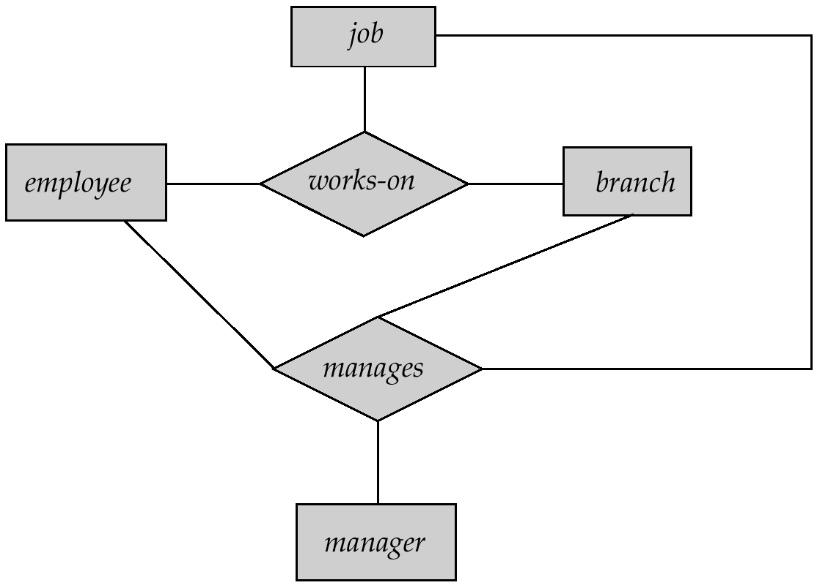
去除冗余
Treat relationship as an abstract entity Allows relationships between relationships
Abstraction of relationship into new entity
Design of an E-R Database Schema
E-R Design Decisions
* The use of an attribute or entity set to represent an object.
* Whether a real-world concept is best expressed by an entity set or a relationship set.
* The use of a ternary relationship versus a pair of binary relationships.
* The use of a strong or weak entity set
* The use of specialization/ generalization – contributes to modularity in the design.
* The use of aggregation – groups a part of an E-R diagram into a single entity set, can treat the aggregate entity set as a single unit without concern for the details of its internal structure.
(See last of card for graphs)
Reduction of an E-R Schema to Tables
* A strong entity set reduces to a table with the same attributes
* Composite attributes are flattened(变平) out by creating a separate attribute for each component attribute
* A multivalued attribute M of an entity E is represented by a separate table EM
* A weak entity set becomes a table that includes columns for the primary key of the identifying strong entity set
* A relationship set is represented as a table with columns for the primary keys of the two participating entity sets, and any descriptive attributes of the relationship set.
Redundancy of Tables
* Many-to-one and one-to-many relationship sets that are total on the many-side can be represented by adding an extra attribute to the many side, containing the primary key of the one side to eliminate redundancy.
* For one-to-one relationship sets, either side can be chosen to act as the “many” side
* If participation is partial on the many side, we can also combine tables by using null values
* The table corresponding to a relationship set linking a weak entity set to its identifying strong entity set is redundant.
Representing Specialization as Tables
M1: Form a table for the higher level entity and a table for each lower level entity set, include primary key of higher level entity set and local attributes.
More tables
M2: Form a table for each entity set with all local and inherited attributes
More redundant data
If spec. is total, table for generalized entity (person) isn’t required
If the generalization is disjoint and total, the method is appropriate
Relations Corresponding to Aggregation
To represent aggregation, create a table containing
* primary key of the aggregated relationship,
* the primary key of the associated entity set
* Any descriptive attributes
Ch7. Relational Database Design
Design Pitfalls ppt7.3
Atomic Domains and First Normal Form
Domain is atomic if its elements are considered to be indivisible units
A relational schema R is in first normal form(第一范式) if the domains of all attributes of R are atomic
Atomicity is treated diff. in diff. cases.
Decomposition Using Functional Dependencies
Functional Dependencies
有属性(集) X, Y,以及tuples t1, t2:
t1[X] = t2 [X] ⇒ t1[Y ] = t2 [Y ]
则称Y函数依赖X记X->Y
* A functional dependency is a generalization of the notion of a superkey.
* Functional dependencies allow us to express constraints that cannot be expressed using superkeys.
* A specific instance of a relation schema may satisfy a functional dependency even if the functional dependency does not hold on all legal instances.
* A functional dependency is trivial if it is satisfied by all instances of a relation
In general, α → β is trivial if β ⊆ α
General Faults in decomposing 7.21
Lossless-join Decomposition
(无损连接分解)
A decomposition {R1, R2, ..., Rn} of R is a LJD if, for all relations r on schema R that are legal,
r= ∏R1 (r) ∏R2 (r) …
R = R1∪R2∪…∪Rn
简言之，分解再自然连接后不变
A decomp of R into R1 and R2 is lossless join if and only if at least one of the following dependencies is in F+:
R1 ∩ R2 → R1
R1 ∩ R2 → R2
Boyce-Codd Normal Form(BC范式)
A relation schema R is in BCNF with respect to a set F of functional dependencies if for all functional dependencies in F+ of the form α → β, where α ⊆ R and β ⊆ R, at least one of the following holds:
α → β is trivial (i.e., β ⊆ α)
α is a superkey for R
BCNF要求所有可能α β都满足
BCNF Decomposition (e.g. ppt7.27)
Suppose we have a schema R and a non-trivial dependency α →β causes a violation of BCNF. We decompose R into:
  - (α U β )
  - ( R - ( β - α ) )
Dependency Preservation
If it is sufficient to test only those dependencies on each individual relation of a decomposition in order to ensure that all functional dependencies hold, then that decomposition is dependency preserving.
It is not always possible to get a BCNF decomposition that is dependency preserving
BCNF一定无损，不一定DP
Third Normal Form: Motivation
There are some situations where
BCNF is not dependency preserving,
efficient checking for FD violation on updates is important
Solution: define a weaker normal form, called Third Normal Form.
* Allows some redundancy (with resultant problems; we will see examples later)
* But FDs can be checked on individual relations without computing a join.
* There is always a lossless-join, dependency-preserving decomposition into 3NF.
Def. of Third Normal Form
A relation schema R is in third normal form (3NF) if for all α → β in F+, at least one of the following holds:
* α → β is trivial (i.e., β ∈ α)
* α is a superkey for R
* Each attribute A in β – α is contained in a candidate key for R.
(NOTE: each attribute may be in a different candidate key)
* If a relation is in BCNF it is in 3NF.
* Third condition is a minimal relaxation of BCNF to ensure dependency preservation
Testing for 3NF
* Use attribute closure to check for each dependency α → β, if α is a superkey.
* If α is not a superkey, we have to verify if each attribute in β is contained in a candidate key of R
Comparison of BCNF and 3NF
A schema that is in 3NF but not in BCNF has the problems
* repetition of information (e.g., the relationship banker-branch)
* need to use null (e.g., to represent the relationship banker-branch where there is no corresponding value for customer).
Design Goals
Goals: BCNF. Lossless join. Dependency preservation.
If cannot achieve this, accept one of
* Lack of dependency preservation
* Redundancy due to use of 3NF
SQL does not provide a direct way of specifying functional dependencies other than superkeys.
Can specify FDs using assertions, but they are expensive to test
Testing for FDs Across Relations (ppt7.37)
Relationship of NFs
5NF ⊆4NF ⊆BC ⊆3NF ⊆2NF ⊆1NF
Functional Dependency Theory
Closure of Functional Dependencies
The set of all functional dependencies logically implied by F is the closure(闭包) of F. We denote the closure of F by F+.
We can find all of F+ by applying Armstrong’s Axioms(公理)
if β ⊆ α, then α → β
(reflexivity自反律)
if α → β, then γ α → γ β
(augmentation增广律)
if α → β, and β → γ, then α → γ
(transitivity传递律)
公理产生的F+正确且完备
We can further simplify manual computation of F+ by using the following additional rules.
* If α → β holds and α → γ holds, then α → β γ holds
(union rule 合并规则)
* If α → β γ holds, then α → β holds and α → γ holds (decomposition分解规则)
* If α → β holds and γ β → δ holds, then α γ → δ holds (pseudo transitivity伪传递规则)
Closure of Attribute Sets
Given a set of attributes a, define the closure of a under F (denoted by a+) as the set of attributes that are functionally determined by a under F.
a → β is in F+ ⬄ β ⊆ a+
Uses of Attribute Closure
Testing for superkey:
To test if α is a superkey, we compute α+, and check if α+ contains all attributes of R.
Testing functional dependencies
To check if a functional dependency α → β holds (or, in other words, is in F+), just check if β ⊆ α+.
Is a simple and cheap test, and very useful
Computing closure of F
For each γ ⊆ R, we find the closure γ+, and for each S ⊆ γ+, we output a functional dependency γ → S.
Canonical Cover (正则覆盖)
A canonical cover for F is a set of dependencies Fc such that
* F logically implies all dependencies in Fc, and
* Fc logically implies all dependencies in F, and
* No functional dependency in Fc contains an extraneous attribute, and
* Each left side of functional dependency in Fc is unique.
Intuitively, a canonical cover of F is a “minimal” set of functional dependencies equivalent to F
* it does not contain extraneous attributes, having no redundant dependencies or redundant parts of dependencies
* it combines functional dependencies with the same left side. It is cheaper to test Fc than it is to test F itself
Extraneous Attributes
* Attribute A is extraneous in α if A ∈ α and F logically implies (F – {α → β}) ∪ {(α – A) → β}.
* Attribute A is extraneous in β if A ∈ β and the set of functional dependencies (F – {α → β}) ∪ {α →(β – A)} logically implies F.
Note: implication in the opposite direction is trivial in each of the cases, since a “stronger” FD always implies a weaker one
Testing if an Attribute is Extraneous
if attribute A ∈ α is extraneous in α
1 compute ({α} – A)+ using the dependencies in F
2 check that ({α} – A)+ contains A; if it does, A is extraneous
if attribute A ∈ β is extraneous in β
1 compute α+ using only the dependencies in F’ = (F – {α → β}) ∪ {α →(β – A)},
2 check that α+ contains A; if it does, A is extraneous
Computing Canonical Cover
R = (A, B, C), F = {A → BC, B → C, A → B, AB → C}
1 Combine A → BC and A → B into A → BC
Set is now {A → BC, B → C, AB → C}
2 A is extraneous in AB → C
* Check if the result of deleting A from AB → C is implied by the other dependencies
Yes: in fact, B → C is already present!
* Set is now {A → BC, B → C}
3 C is extraneous in A → BC
* Check if A → C is logically implied by A → B and the other dependencies
Yes: using transitivity on A → B and B → C.
4 The canonical cover is: { A → B, B → C }
Decomposition Using Functional Dependency
Decide whether a particular relation R is in “good” form.
In the case that a relation R is not in “good” form, decompose it into a set of relations {R1, R2, ..., Rn} such that
* each relation is in good form: each Ri should be in either Boyce-Codd Normal Form or Third Normal Form
* Lossless-join decomposition: Otherwise would result in information loss
* Dependency preservation(保持依赖): Let Fi be the set of dependencies F+ that include only attributes in Ri.
* Preferably the decomposition should be dependency preserving, that is, (F1 ∪ F2 ∪ … ∪ Fn)+ = F+
* Otherwise, checking for violation of functional dependencies may require join, which is expensive.
Decomposition Using Multivalued Dependencies
Multivalued Dependencies
Let R be a relation schema and let α ⊆ R and β ⊆ R. The multivalued dependency α →→ β holds on R if in any legal relation r(R), for all pairs for tuples t1 and t2 in r such that t1[α] = t2 [α], there exist tuples t3 and t4 in r such that:
t1[α] = t2 [α] = t3 [α] = t4 [α]
t3[β] = t1 [β]
t3[R – β] = t2[R – β]
t4 [β] = t2[β]
t4[R – β] = t1[R – β]

Chapter 8: Application Design and Development
Triggers
A trigger(触发器) is a statement that is executed automatically by the system as a side effect of a modification to the database.
Example
create trigger overdraft-trigger after update on account
referencing new row as nrow for each row
when nrow.balance < 0
begin atomic
(update actions)
end
Triggering Events and Actions in SQL
* Triggering event can be insert, delete or update
* Triggers on update can be restricted to specific attributes
create trigger overdraft-trigger after update of balance on account
* Values of attributes before and after an update can be referenced. (transition variables)
referencing old row as
for deletes and updates
referencing new row as
for inserts and updates
Triggers Before an Event
create trigger setnull-trigger before update on r
referencing new row as nrow
for each row
when nrow.phone-number = ‘ ‘
set nrow.phone-number = null
Statement Level Triggers
Use for each statement instead of for each row
Use referencing old table or referencing new table to refer to temporary tables (called transition tables) containing the affected rows
Can be more efficient when dealing with SQL statements that update a large number of rows
External World Actions
* Triggers can be used to record actions-to-be-taken in a separate table
* Have an external process that repeatedly scans the table, carries out external-world actions and deletes action from table
When Not To Use Triggers
* Triggers should be written with great care, since a trigger error detected at run time causes the failure of the insert/delete/update statement that set off the trigger
* Can even lead to an infinite chain of triggering
Chapter 10 XML
Introduction
XML: Extensible Markup Language
Comparison with Relational Data
Inefficient: tags, which in effect represent schema information, are repeated
Better than relational tuples as a data-exchange format
* not like relational tuples, XML data is self-documenting due to presence of tags
* Non-rigid format: tags can be added
* Allows nested structures
* Wide acceptance, not only in database systems, but also in browsers, tools, and applications
Structure of XML Data
Basic Structure
* Mixture of text with sub-elements is legal in XML. Useful for document markup, but discouraged for data representation
Attributes
<account acct-type = “checking” monthly-fee=“5”>
Attributes Vs. Subelements
* In the context of documents, attributes are part of markup, while subelement contents are part of the basic document contents
* In the context of data representation, the difference is unclear and may be confusing
* Suggestion: use attributes for identifiers of elements, and use subelements for contents
More on XML Syntax
* Elements without subelements
<account number=“A-101” balance=“200” />
* To store string data that may contain tags, without the tags being interpreted as subelements, use CDATA as below.
<![CDATA[<account> … </account>]]>
Namespaces
unique-name:element-name
Avoid using long unique names all over document by using XML Namespaces
<bank Xmlns:FB=“http://www.FB.com”>
<FB:branch> …
XML Document Schema
DTD: Widely used
XML Schema: Newer, increasing use
Document Type Definition (DTD)
DTD constraints: What elements can occur/ What attributes can/must an element have/ What subelements can/must occur inside each element, and how many times.
DTD does not constrain: data types. All values represented as strings in XML
DTD syntax:
<!DOCTYPE bank [
<!ELEMENT element (subelements-specification) >
<!ATTLIST element (attributes) >
]>
Element Specification in DTD
Subelements can be specified as
* names of elements
* #PCDATA (parsed character data), i.e., character strings
* EMPTY (no subelements) or ANY (anything can be a subelement)
Subelement specification may have regular expressions
<!ELEMENT bank (( account | depositor)+)>
<!ELEMENT message (to+ from, cc*, sub, text)>
<!ELEMENT to (#PCDATA )>
“|” - alternatives, “+” - 1 or more occurrences
“*” - 0 or more occurrences, “?” - 0 or 1 occurrences
Attribute Specification in DTD
For each attribute:
<!ATTLIST name1 type1 default1|#REQUIRED|#IMPLIED… >
Type of attribute
CDATA
ID (identifier) or IDREF (ID reference) or IDREFS (multiple IDREFs)
Whether
mandatory ( #REQUIRED )
has a default value (value),
or neither ( #IMPLIED )
<!ATTLIST account acct-type CDATA “checking”>
<!ATTLIST customer customer-id ID #REQUIRED accounts IDREFS #REQUIRED>
IDs and IDREFs
* An element can have at most one attribute of type ID
* The ID attribute value of each element in an XML document must be distinct
* An attribute of type IDREF must contain the ID value of an element in the same document
* An attribute of type IDREFS contains a set of (0 or more) ID values…
Limitations of DTDs
* All values are strings, no integers, reals, etc.
* Difficult to specify unordered sets of subelements
* IDs and IDREFs are untyped
XML Schema
* XML Schema addresses the faults of DTDs.
* XML Schema is itself specified in XML syntax
* XML Schema is integrated with namespaces
* XML Sche is more complicated than DTDs
<xs:schema xmlns:xs=… >
<xs:element name=“bank” type=“BankType”/>
<xs:element name=“account”>
<xs:complexType> <xs:sequence>
<xs:element name=“” type=“xs:string”/> …
</xs:squence> </xs:complexType> </xs:element>
….. definitions of customer and depositor ….
<xs:complexType name=“BankType”>
</xs:complexType> </xs:schema>
<xs:keyref name = “AK” refer=“aKey”>
<xs:selector xpath = “/bank/account”/>
<xs:field xpath = “account_number”/>
</xs:keyref>
Querying and Transformation
Standard XML querying/translation lang
XPath / XSLT / XQuery
Tree Model of XML Data
* Element nodes have children nodes, which can be attributes or subelements
* Text in an element is modeled as a text node child of the element
* The root node has a single child, which is the root element of the document
XPath
Result of path expression: set of values that along with their containing elements/attributes match the specified path.
* Path( ) returns without the enclosing tags
* Selection predicates may follow any step in a path, in [ ]
/bank-1/customer/account[balance>400] /bank-1/customer/account[balance]
returns account containing a balance subele
Attributes are accessed using “@”
/bank-1/cust/acc [bal>400]/@account-number
Functions in XPath
count(), and, or, not(),
IDREFs can be referenced using function id()
More XPath Features
* Operator “|” used to implement union, cannot be nested inside other operators
“//” in path can be used to skip levels of nodes
“//” alone, specifying “all descendants” (of last step)
“..” alone specifies the parent(of last step)
doc(name) returns the root of a named doc
XQuery
XQuery uses a for…let…where…order by…result syntax
for: SQL from
let: allows temporary variables
where: SQL where
order by: SQL order by
result: SQL select
for $x in /bank-2/account
let $acctno := $x/@account-number
where $x/balance > 400
return <account-number> $acctno </account-number>
Joins & Nested Queries…
Storage of XML Data
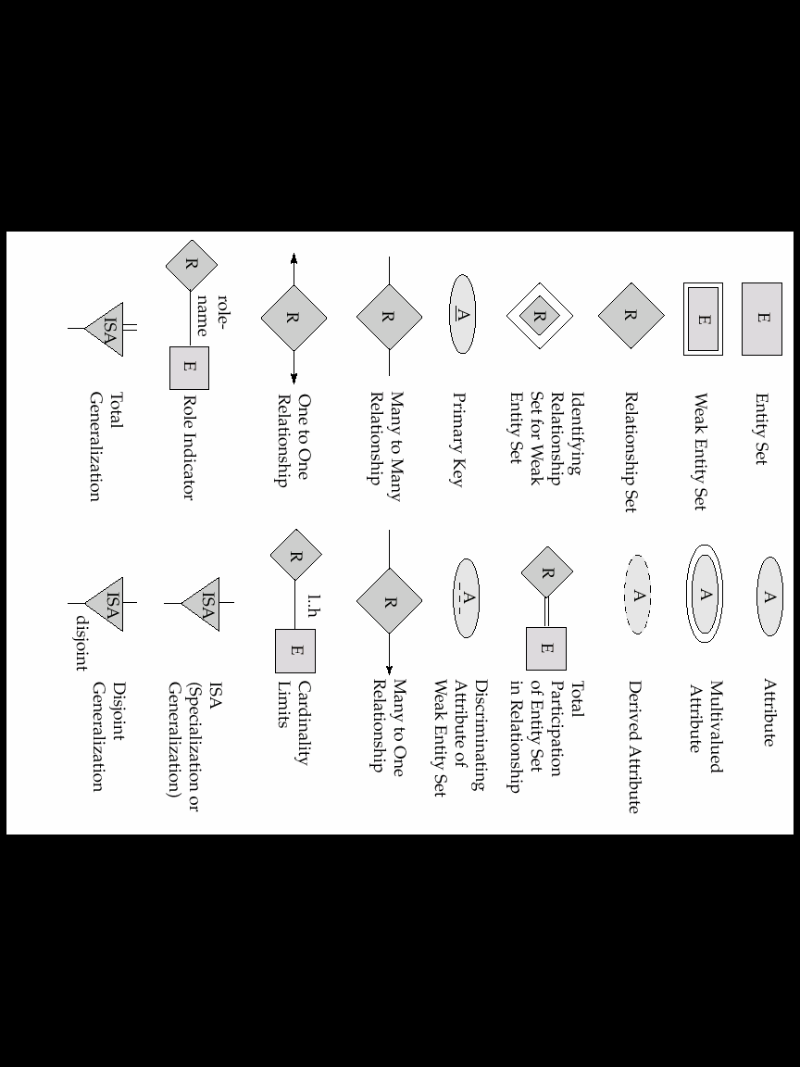
E-R Graphs:

