1.1What are the three main purposes of an operating system?
(1) Interface between the hardware and user;
(2) manage the resource of hardware and software;
(3) abstraction of resource;
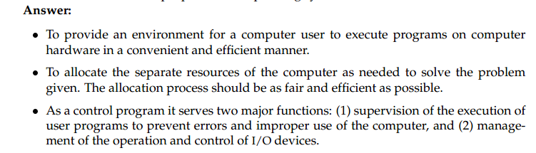
1.2 List the four steps that are necessary to run a program on a completely dedicated machine.
Preprocessing > Processing > Linking > Executing.
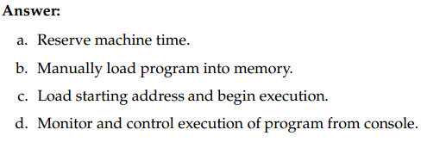

1.6 Define the essential properties of the following types of operating systems:
a. Batch
b. Interactive
c. Time sharing
d. Real time
e. Network
f. Distributed
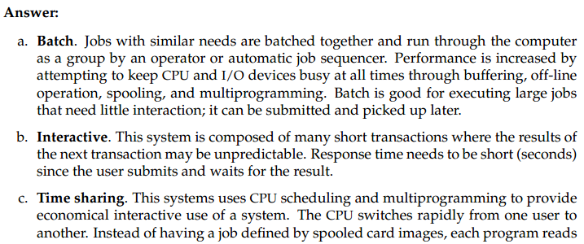
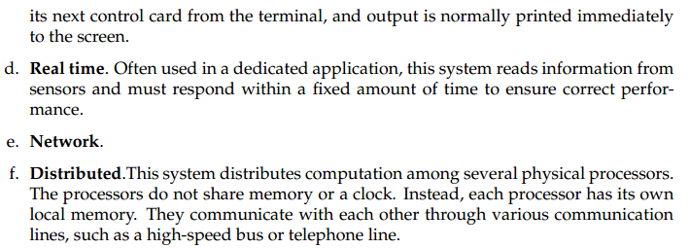

1.7 We have stressed the need for an operating system to make efficient use of the computing
hardware. When is it appropriate for the operating system to forsake this principle and to“waste” resources? Why is such a system not really wasteful?

2.2 How does the distinction between monitor mode and user mode function as a rudimentary
form of protection (security) system?

2.3 What are the differences between a trap and an interrupt? What is the use of each function?
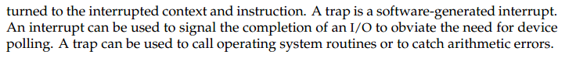

2.5 Which of the following instructions should be privileged?
a. Set value of timer.
b. Read the clock.
c. Clear memory.
d. Turn off interrupts.
e. Switch from user to monitor mode.
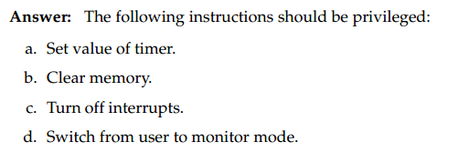

2.8 Protecting the operating system is crucial to ensuring that the computer system operates
correctly. Provision of this protection is the reason behind dual-mode operation, memory
protection, and the timer. To allow maximum flexibility, however, we would also like to
place minimal constraints on the user.
The following is a list of operations that are normally protected. What is the minimal set
of instructions that must be protected?
a. Change to user mode.
b. Change to monitor mode.
c. Read from monitor memory.
d. Write into monitor memory.
e. Fetch an instruction from monitor memory.
f. Turn on timer interrupt.
g. Turn off timer interrupt.
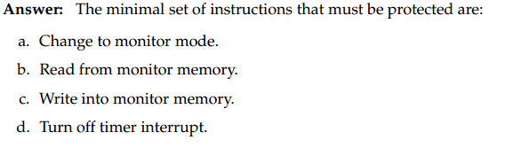

3.6 List five services provided by an operating system. Explain how each provides convenience to the users. Explain also in which cases it would be impossible for user-level programs to provide these services.
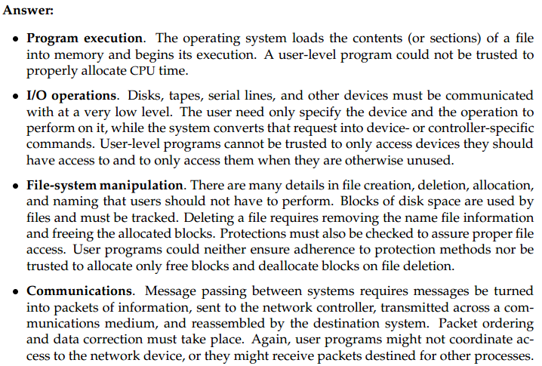
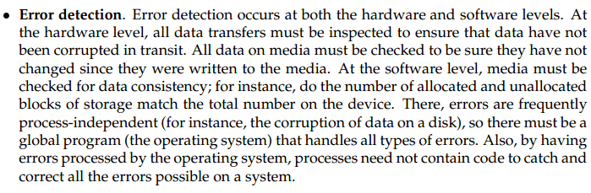

3.7 What is the purpose of system calls?

3.10 What is the purpose of system programs?

4.1 MS-DOS provided no means of concurrent processing. Discuss three major complications
that concurrent processing adds to an operating system.
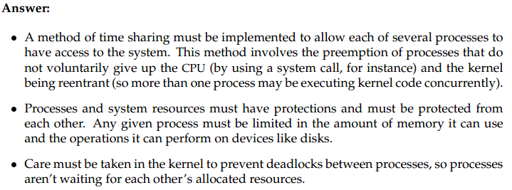

4.6 The correct producer–consumer algorithm in Section 4.4 allows only n-1 buffers to be
full at any one time. Modify the algorithm to allow all buffers to be utilized fully.
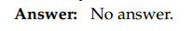

5.1 Provide two programming examples of multithreading giving improve performance over
a single-threaded solution.
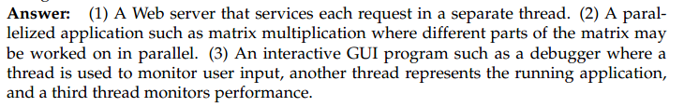

5.3 What are two differences between user-level threads and kernel-level threads? Under what circumstances is one type better than the other?
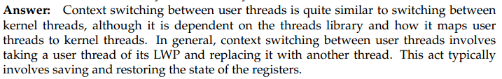

6.3 Consider the following set of processes, with the length of the CPU-burst time given in
milliseconds:
Process Burst Time Priority
P1 10 3
P2 1 1
P3 2 3
P4 1 4
P5 5 2
The processes are assumed to have arrived in the order P1, P2, P3, P4, P5, all at time 0.
a. Draw four Gantt charts illustrating the execution of these processes using FCFS, SJF, a nonpreemptive priority (a smaller priority number implies a higher priority), and RR
(quantum = 1) scheduling.
b. What is the turnaround time of each process for each of the scheduling algorithms in
part a?
c. What is the waiting time of each process for each of the scheduling algorithms in part
a?
d. Which of the schedules in part a results in the minimal average waiting time (over all
processes)?
Answer:
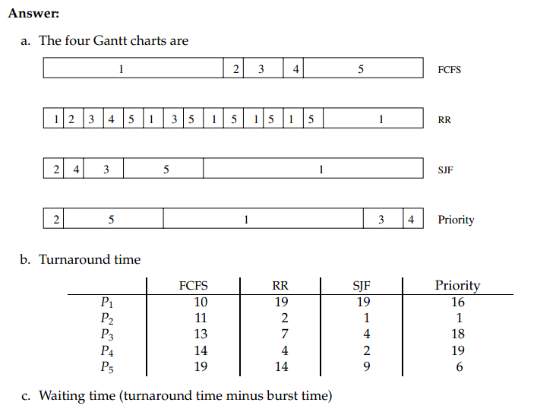
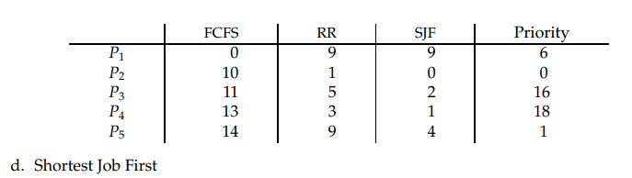

6.4 Suppose that the following processes arrive for execution at the times indicated. Each
process will run the listed amount of time. In answering the questions, use nonpreemptive
scheduling and base all decisions on the information you have at the time the decision
must be made.

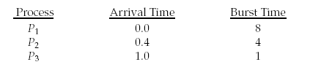
a. What is the average turnaround time for these processes with the FCFS scheduling
algorithm?
b. What is the average turnaround time for these processes with the SJF scheduling algorithm?
c. The SJF algorithm is supposed to improve performance, but notice that we chose to
run process P1 at time 0 because we did not know that two shorter processes would
arrive soon. Compute what the average turnaround time will be if the CPU is left
idle for the first 1 unit and then SJF scheduling is used. Remember that processes P1
and P2 are waiting during this idle time, so their waiting time may increase. This
algorithm could be known as future-knowledge scheduling.
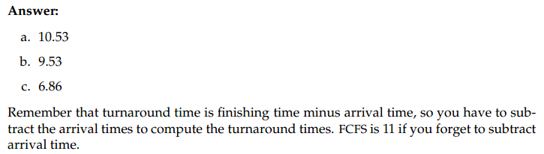

6.10 Explain the differences in the degree to which the following scheduling algorithms discriminate in favor of short processes:
a. FCFS
b. RR
c. Multilevel feedback queues
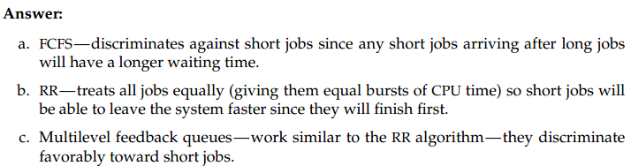

7.7 Show that, if the wait and signal operations are not executed atomically,
then mutual exclusion may be violated.

7.8 The Sleeping-Barber Problem. A barbershop consists of a waiting room with n chairs and the barber room containing the barber chair. If there are no customers to be served,the barber goes to sleep. If a customer enters the barbershop and all chairs are occupied, then the customer leaves the shop.If the barber is busy but chairs are available, then the customer sits in one of the free chairs. If the barber is asleep, the customer wakes up the barber. Write a program to coordinate the barber and the customers.

8.2 Is it possible to have a deadlock involving only one single process? Explain your answer.

8.4 Consider the traffic deadlock depicted in Figure 8.11.
a. Show that the four necessary conditions for deadlock indeed hold in this example.
b. State a simple rule that will avoid deadlocks in this system.

8.13 | Consider the following snapshot of a system:
 |  | Allocation | Max | Available
 |  | A B C D | A B C D | A B C D
 | ^{P}0 | 0 0 1 2 | 0 0 1 2 | 1 5 2 0
 | ^{P}1 | 1 0 0 0 | 1 7 5 0
 | ^{P}2 | 1 3 5 4 | 2 3 5 6
 | ^{P}3 | 0 6 3 2 | 0 6 5 2
 | ^{P}4 | 0 0 1 4 | 0 6 5 6

Answer the following questions using the banker’s algorithm:
a. What is the content of the matrix Need?
b. Is the system in a safe state?
c. If a request from process P1 arrives for (0,4,2,0), can the request be granted immediately?
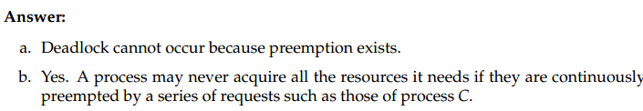

9.5 Given memory partitions of 100K, 500K, 200K, 300K, and 600K (in order), how would each
of the First-fit, Best-fit, and Worst-fit algorithms place processes of 212K, 417K, 112K, and 426K (in order)? Which algorithm makes the most efficient use of memory?
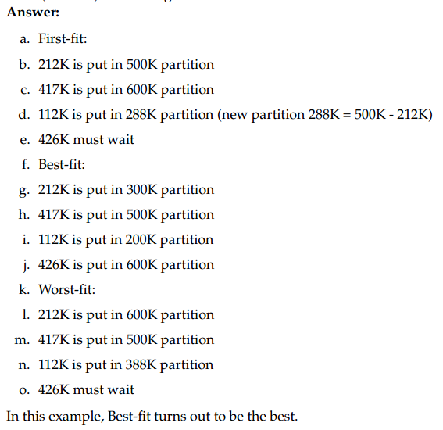

9.8 Consider a logical address space of eight pages of 1024 words each, mapped onto a physical
memory of 32 frames.
a. How many bits are there in the logical address?
b. How many bits are there in the physical address?
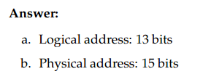

9.16 Consider the following segment table:
Segment Base Length
0 219 600
1 2300 14
2 90 100
3 1327 580
4 1952 96

What are the physical addresses for the following logical addresses?
a. 0,430
b. 1,10
c. 2,500
d. 3,400
e. 4,112
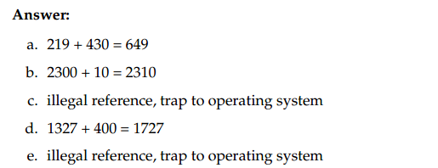

10.2 Assume that you have a page reference string for a process with m frames (initially all empty). The page reference string has length p with n distinct page numbers occur in it. For any page-replacement algorithms,
a. What is a lower bound on the number of page faults?
b. What is an upper bound on the number of page faults?
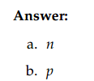

10.11 Consider the following page reference string:

1, 2, 3, 4, 2, 1, 5, 6, 2, 1, 2, 3, 7, 6, 3, 2, 1, 2, 3, 6.

How many page faults would occur for the following replacement algorithms, assuming one, two, three, four, five, six, or seven frames? Remember all frames are initially empty, so your first unique pages will all cost one fault each.

LRU replacement
FIFO replacement
Optimal replacement
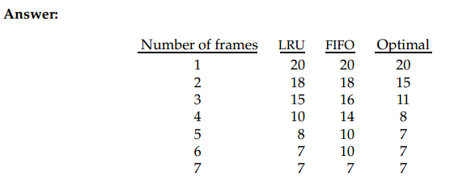

11.7 Explain the purpose of the open and close operations.
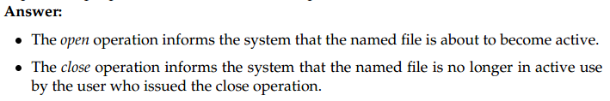

11.9 Give an example of an application in which data in a file should be accessed in the following order:
a. Sequentially
b. Randomly
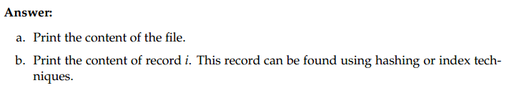

11.12 Consider a system that supports 5000 users. Suppose that you want to allow 4990 of these users to be able to access one file.
a. How would you specify this protection scheme in UNIX?
b. Could you suggest another protection scheme that can be used more effectively for
this purpose than the scheme provided by UNIX?
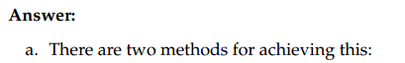
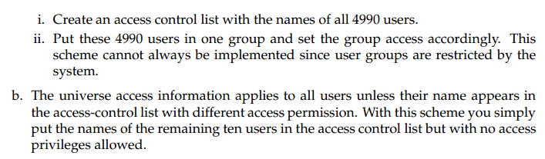

12.1 Consider a file currently consisting of 100 blocks. Assume that the file control block (and
the index block, in the case of indexed allocation) is already in memory. Calculate how
many disk I/O operations are required for contiguous, linked, and indexed (single-level)
allocation strategies, if, for one block, the following conditions hold. In the contiguousallocation case, assume that there is no room to grow in the beginning, but there is room to grow in the end. Assume that the block information to be added is stored in memory.
a. The block is added at the beginning.
b. The block is added in the middle.
c. The block is added at the end.
d. The block is removed from the beginning.
e. The block is removed from the middle.
f. The block is removed from the end.
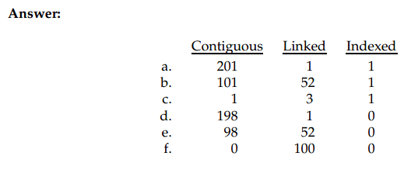

13.2 Consider the following I/O scenarios on a single-user PC.
a. A mouse used with a graphical user interface
b. A tape drive on a multitasking operating system (assume no device preallocation is
available)
c. A disk drive containing user files
d. A graphics card with direct bus connection, accessible through memory-mapped
I/O
For each of these I/O scenarios, would you design the operating system to use buffering,
spooling, caching, or a combination? Would you use polled I/O, or interrupt-driven I/O?
Give reasons for your choices.
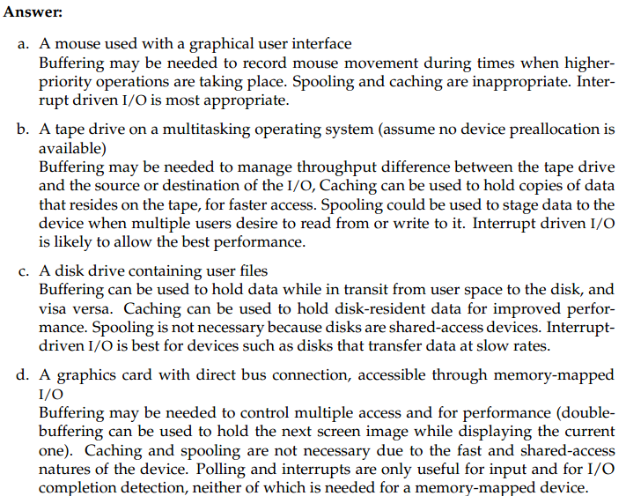

14.2 Suppose that a disk drive has 5000 cylinders, numbered 0 to 4999. The drive is currently
serving a request at cylinder 143, and the previous request was at cylinder 125. The queue
of pending requests, in FIFO order, is
86, 1470, 913, 1774, 948, 1509, 1022, 1750, 130
Starting from the current head position, what is the total distance (in cylinders) that
the disk arm moves to satisfy all the pending requests, for each of the following diskscheduling
algorithms?
a. FCFS
b. SSTF
c. SCAN
d. LOOK
e. C-SCAN
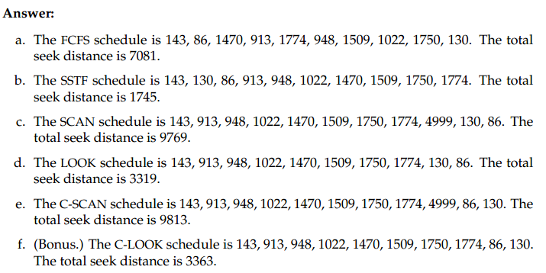

1.1 1.6 2.3 2.5 3.7 6.3 6。4 7.8 8.13 9.5 9.8 10.11 12.1 14.2

