Shell命令
- 目录和文件操作：
- pwd/cd/cat
- rmdir/mkdir[-p, --parents]
- rm/cp[-f, --force][-i, --interactive][-R,-r, --recursive]
- mv[-f, --force][-i, --interactive]
- ln[-f, --force][-i, --interactive][-s, --symbolic]
- chmod[-R, --recursive]
The format of a symbolic mode is `[ugoa...][[+-=][rwxXstugo...]...][,...] `read (r), write (w), execute (or access for directories) (x),execute only if the file is a directory or already has execute permission for some user (X), set user or group ID on execution (s), sticky (t), the permissions granted to the user who owns the file (u), the permissions granted to other users who are members of the file's group (g), and the permissions granted to users that are in neither of the two preceding categories (o)
- 目录下操作命令：
- ls [–l][-a, --all][-F, --classify]
- more
- find [path...] [expression]
default path is the current directory; default expression is –print expression may consist of: operators, options, tests, and actions:
normal options:
-depth/-maxdepth LEVELS/-mindepth LEVELS
tests (N can be +N or -N or N): -empty/-gid N/-group NAME/-links N/-name PATTERN/ -perm [+-]MODE/-type [bcdpflsD]/-uid N/-user NAME
actions: -delete/-printf FORMAT/-print/-fprint0 FILE/-fprint FILE/-ls/-quit/-exec COMMAND ; -exec COMMAND {} + -ok COMMAND ;
- 文本文件操作命令：
- grep/sort/diff
- wc[–l][-w][-c]
系统调用
- pid_t fork(void);
fork() creates a child process that differs from the parent process only in its PID and PPID
On success, the PID of the child process is returned in the parent's thread of execution, and a 0 is returned in the child's thread of execution. On failure, a -1 will be returned in the parent's context, no child process will be created, and errno will be set appropriately.
int execl(const char *path, const char *arg, ...);
- exec
int execlp(const char *file, const char *arg, ...);
int execle(const char *path, const char *arg , ..., char * const envp[]);
int execv(const char *path, char *const argv[]);
int execvp(const char *file, char *const argv[]);
- wait, waitpid
pid_t wait(int *status);
pid_t waitpid(pid_t pid, int *status, int options);
The call wait(&status) is equivalent to: waitpid(-1, &status, 0);
The value of pid can be:
< -1 meaning wait for any child process whose process group ID is equal to the absolute value of pid.
-1 meaning wait for any child process.
0 meaning wait for any child process whose process group ID is equal to that of the calling process.
>0 meaning wait for the child whose process ID is equal to the value of pid.
wait(): on success, returns the process ID of the terminated child; on error, -1 is returned.
- int kill(pid_t pid, int sig);
- signal
typedef void (*sighandler_t)(int);
sighandler_t signal(int signum, sighandler_t handler);

System Calls

Invoking System Calls

System call invocation in an application program such as fork();

Wrapper routine in libc standard library fork() { ... " int ox80" };

System call handler

system_call

sys_fork()

ret_from_sys_call()

iret;

System call service routine: sys_fork() { }

Initializing System calls

start_kernel

//init/main.c

trap_init

//arch/i386/kernel/traps.c

// sets up the IDT entry corresponding to vector 128

set_system_gate(SYSCALL_VECTOR = 0x80,

&system_call);

_set_gate( gate_addr = idt_table+n,

type =15, dpl = 3, addr);

Initializing System calls

#define _set_gate(gate_addr,type,dpl,addr) \

do { \

int __d0, __d1; \

__asm__ __volatile__ ("movw %%dx,%%ax\n\t" \

"movw %4,%%dx\n\t" \

"movl %%eax,%0\n\t" \

"movl %%edx,%1" \

:"=m" (*((long *) (gate_addr))), \

"=m" (*(1+(long *) (gate_addr))), "=&a" (__d0), "=&d" (__d1) \

:"i" ((short) (0x8000+(dpl<<13)+(type<<8))), \

"3" ((char *) (addr)),"2" (__KERNEL_CS << 16)); \

} while (0)

System Call Handler

pushl %eax # save orig_eax

SAVE_ALL # save the registers

GET_CURRENT(%ebx) # get the current ID

cmpl $(NR_syscalls),%eax # check system call

jae badsys

testb $0x02,ptrace(%ebx) # PT_TRACESYS

jne tracesys

call *SYMBOL_NAME(sys_call_table)(,%eax,4)

movl %eax,EAX(%esp) # save the return value

ALIGN

.globl ret_from_sys_call # return

.globl ret_from_intr

Parameter Passing

System call parameters are usually passed to the system call handler in the CPU registers, then copied onto the Kernel Mode stack.

The length of each parameter cannot exceed the length of a register, that is 32 bits.

The number of parameters must not exceed size since the Intel Pentium has a very limited number of registers. (eax, ebx, ecx, edx, esi, edi).

Verifying Parameters

All system call parameters must be carefully checked before the kernel attempts to satisfy a user request.

Whenever a parameter specifies an address, the kernel must check whether it is inside the process address space. (verify_area, access_ok)

Accessing the process address space get_user(x,ptr) // include/asm-i386/uaccess.h __get_user_x

Memory Addressing

Memory Addressing: 3 addresses

Logical address

Consists of a segment and an offset.

Included in the machine language instruction to specify the address of operand or of an instruction.

Linear address

A single 32-bit unsigned integer

Can be used to address up to 4GB

Physical address

Used to address memory cells included in memory chips.

Corresponding to the electrical signals sent along the address pins of the microprocessor to the memory bus.

Address translation

Logical address à SEGMENTATION à Linear address

Linear address à PAGING à Physical address

Memory Addressing: I386 segmentation

Real-mode

Segment selectors

Protected-mode

Segment selectors

Segment descriptor table registers

Segment descriptors

Memory Addressing: I386 segmentation

Segment registers

cs: code segment register

ds: data segment register

ss: stack segment register

es, fs, gs: additional data segment registers.

Memory Addressing: I386 segmentation

IDT, GDT, LDT registers

IDTR: Interrupt descriptor table register

GDT maintains a list of most segments and may contain special “system” descriptors.

GDTR: Global descriptor table register

IDT maintains a list of interrupt service routines.

LDTR: Local descriptor table register

LDT is optional, can extends range of GDT, is allocated to each task when multitasking is enabled.

Memory Addressing: I386 segmentation

Segment descriptors define

Base address (32 bits)

segment limit(20 bits)

Type of segment (4 bits)

Privilege level of segment (2 bits)

Whether segment is physically present (1 bit)

Whether segment has been accessed before (1 bit)

Granularity of limit field (1 bit)

Size of operands within segment (1 bit)

Intel reserved flag (1 bit)

User-defined flag (1 bit)

Memory Addressing: Linux segmentation

lgdt gdt_descr

// arch/i386/kernel/head.S

gdt_descr:

// 16 bit for limit

// 32 bit for base

.word GDT_ENTRIES*8-1

SYMBOL_NAME(gdt):

.long SYMBOL_NAME(gdt_table)

Memory Addressing: Linux segmentation

ENTRY(gdt_table) [arch/i386/kernel/head.S]

// 8 bits for BASE 31:24

// 8 for G--D/B--0¡ªAVL LIMIT

// 8 for P--DPL--S TYPE--A

// 24 for BASE 23:0 and 16 for LIMIT 15:0

.quad 0x0000000000000000 /* NULL descriptor */

.quad 0x0000000000000000 /* not used */

.quad 0x00cf9a000000ffff /* 0x10 k */

/* cf9a = 1100-1111-1001-1010 */

.quad 0x00cf92000000ffff /* 0x18 k */

/* cf92 = 1100-1111-1001-0010 */

.quad 0x00cffa000000ffff /* 0x23 u */

/* cffa = 1100-1111-1111-1010 */

.quad 0x00cff2000000ffff /* 0x2b u */

/* cff2 = 1100-1111-1111-1010 */

Memory Addressing: Linux segmentation

// include/asm-i386/segment.h

// 13 bits for index

// 1 bit for GDT or LDT

// 2 bits for RPL (Requestor Privilege Level)

#define __KERNEL_CS 0x10 // 2-0-0

#define __KERNEL_DS 0x18 // 3-0-0

#define __USER_CS 0x23 // 4-0-3

#define __USER_DS 0x2B // 5-0-3

Memory Addressing: I386 Paging

Address bits 31 to 22 select one of 1024 PDEs in the page directory

Address bits 21 to 12 select one of 1024 PTS in the page table

Address bits 11 to 0 select one of 4096 bytes in the page

Registers CR3 locates the base address of the page directory

PDE locates the base address of the page table

PTE locates the base address of the page

Memory Addressing: I386 Paging

Memory Addressing: I386 Paging

Memory Addressing: I386 Paging

Memory Addressing: Linux Paging

The Linux paging model:

Linear addresses

à Page global directory (PGD)

à Page middle directory (PMD)

Page table

à Physical addresses

Memory Addressing: Linux Paging

// include/asm-i386/pgtable-2level.h

#define PGDIR_SHIFT 22

#define PTRS_PER_PGD 1024

/*

* the i386 is two-level, so we don't really have any

* PMD directory physically.

*/

#define PMD_SHIFT 22

#define PTRS_PER_PMD 1

#define PTRS_PER_PTE 1024

Memory Addressing: Linux Paging

// include/asm-i386/page.h

pgt_t

pmd_t

pte_t

// include/asm-i386/pgalloc.h

pgd_alloc

get_pgd_fast

get_pgd_slow

MEMORY MANAGEMENT

Page Frame Management

// node NUMA

typedef struct pglist_data {

//include/linux/mmzone.h

} pg_data_t;

// zone descriptor

typedef struct zone_struct{

//include/linux/mmzone.h

} zone_t;

// page descriptor

typedef struct page {

//include/linux/mm.h

} mem_map_t;

Page Frame Management

// numa.c

static bootmem_data_t contig_bootmem_data;

pg_data_t contig_page_data = { bdata: &contig_bootmem_data };

// mm/memory.c

mem_map_t* mem_map;

Page Frame Management

start_kernel //init/main.c

setup_arch //arch/i386/kernel/setup.c

paging_init //arch/i386/kernel/init.c

zone_sizes_init //arch/i386/kernel/init.c

free_area_init //mm/page_alloc.c

free_area_init_core //mm/page_alloc.c

build_zonelists //mm/page_alloc.c

start_kernel //init/main.c

mem_init //arch/i386/kernel/setup.c

Page Frame Management

__get_free_pages

// mm/page_alloc.c

alloc_pages

// include/linux/mm.h

_alloc_pages

//mm/page_alloc.c

alloc_pages_pgdat

// NUMA

__alloc_pages // buddy

//mm/page_alloc.c

rmqueue

Page Frame Management

free_pages

// mm/page_alloc.c

__free_pages

__free_pages_ok

Memory Area Management

The memory is organized in caches, one cache for each object type. (e.g. inode_cache, dentry_cache, buffer_head, vm_area_struct) Each cache consists of many slabs (they are small (usually one page long) and always contiguous), and each slab contains multiple initialized objects.

Each cache can only support one memory type (GFP_DMA, GFP_HIGHMEM, normal). If you need a special memory type, then must create a new cache for that memory type.

In order to reduce fragmentation, the slabs are sorted in 3 groups: full slabs with 0 free objects, partial slabs, empty slabs with no allocated objects

If partial slabs exist, then new allocations come from these slabs, otherwise from empty slabs or new slabs are allocated.

Memory Area Management

typedef struct kmem_cache_s kmem_cache_t;

// include/linux/slab.h

typedef struct slab_s slab_t

// mm/slab.c

Memory Area Management

cache_cache: The first cache contains the cache descriptors of the remaining caches used by the kernel.

Twenty-six additional caches contain geometrically distributed memory areas. The table, called cache_sizes (whose elements are of type cache_sizes_t), points to the 26 cache descriptors associated with memory areas of size 32, 64, 128, 256, 512, 1,024, 2,048, 4,096, 8,192, 16,384, 32,768, 65,536, and 131,072 bytes, respectively.

Memory Area Management

// Interfacing the Slab Allocator

// with the Buddy System

kmem_getpages

__get_free_pages

kmem_freepages

free_pages

kmem_cache_grow

kmem_slab_destroy

Memory Area Management

kmalloc

//mm/slab.c

__kmem_cache_alloc

//mm/slab.c

__kmem_cache_alloc

//mm/slab.c

Noncontiguous Memory Management

struct vm_struct{ //include/linux/vmalloc.h

unsigned long flags;

void* addr; //the linear address

unsigned long size;

struct vm_struct* next;

};

struct vm_struct* vmlist; // mm/vmalloc.c

Noncontiguous Memory Management

get_vm_area // mm/vmalloc.c

vmalloc //include/linux/vmalloc.h

Noncontiguous Memory Management

__vmalloc

get_vm_area

vmalloc_area_pages

pgd_offset_k

pgd_index

pmd_alloc

pte_alloc

alloc_area_pte

alloc_area_pmd

Noncontiguous Memory Management

vfree

vmfree_area_pages

pgd_offset_k

free_area_pmd

free_area_pte

Virtual File System

VFS: Introduction

The Virtual File System (also known as Virtual Filesystem Switch or VFS) is a kernel software layer that handles all system calls related to a standard Unix file system.

Its main strength is providing a common interface to several kinds of filesystems.

An example

$ cp /floppy/TEST /tmp/test

# where /floppy is the mount point of an MS-DOS diskette # /tmp is a normal Second Extended Filesystem (Ext2)

# directory.

VFS: File model

VFS supports three main classes of filesystems:

Disk-based filesystems (ext2, HPFS, NTFS, VFAT, iso9660)

Network filesystems (NFS, SMB)

Special filesystems (/proc, /dev/pts)

VFS File Model

superblock: to store information concerning a mounted filesystem. (Filesystem control block)

inode: to store general information about a specific file. (File control block)

dentry: to store information about the linking of a directory entry with the corresponding file.

file: to store information about the interaction between an open file and a process.

VFS: VFS system calls

mount, umount

sysfs, statfs, fstatfs, ustat, stat, fstat, lstat, access

chroot, chdir, fchdir, chown, fchown, lchown, chmod, fcmod,

getcwd, mkdir, rmdir, readdir, getdents

link, unlink, rename, readlink, symlink

open, close, creat, umask, dup, dup2, fcntl, select, poll, truncate, ftruncate, lseek, _llseek, read, write, readv, writev, sendfile, pread, pwrite

mmap, munmap

fdatasync, fsync, sync, msync

flock

mknod

socket, coonect, bind, protocols, ...

VFS: Data structures

struct super_block //include/linux/fs.h

struct file_system_type //include/linux/fs.h

struct super_operations //include/linux/fs.h

struct inode //include/linux/fs.h

struct inode_operations //include/linux/fs.h

struct file //include/linux/fs.h

struct file_operations //include/linux/fs.h

struct dentry //include/linux/dcache.h

struct dentry_operations //include/linux/dcache.h

struct task_struct //include/linux/sched.h

struct fs_struct //include/linux/fs_struct.h

struct files_struct //include/linux/sched.h

struct file //include/linux/fs.h

VFS: Filesystem registering

start_kernel // init/main.c

vfs_caches_init

bdev_cache_init

register_filesystem

register_filesystem // fs/super.c

find_filesystem

static struct file_system_type *file_systems;

VFS: Filesystem mounting

Mounting the root filesystem

start_kernel

vfs_caches_init

mnt_init

init_mount_tree

do_kern_mount(

const char *fstype = "rootfs",

int flags = 0,

char *name = "rootfs",

void *data = NULL);

VFS: Filesystem mounting

Mounting a generic filesystem

sys_mount //fs/namespace.c

copy_mount_options

do_mount

do_remount

do_loopback

do_move_mount

do_add_mount

do_kern_mount

sys_umount //fs/namespace.c

do_umount

VFS: sys_open

sys_open (fs/open.c)

getname (fs/namei)

// to read the file pathname

// from the process address space

do_getname

strncpy_from_user

get_unused_fd (fs/open.c)

// to find an empty slot in current-files-fd.

filp_open

open_namei

dentry_open

fd_install

VFS: sys_read

sys_read (fs/read_write.c)

fget

// to derive from fd the address file of

// the corresponding file object and

// increments the usage counter file->f_count

locks_verify_area

// to check whether there are mandatory locks

// for the file portion to be accessed.

// invokes file->f_op->read to do the job

fput

// to decrement the usage counter file->f_count

VFS: sys_write

sys_write (fs/read_write.c)

fget

// to derive from fd the address file of

// the corresponding file object and

// increments the usage counter file->f_count

locks_verify_area

// to check whether there are mandatory locks

// for the file portion to be accessed.

// invokes file->f_op->write to do the job

fput

// to decrement the usage counter file->f_count

VFS: sys_close

sys_close (fs/open.c)

FD_CLR

__put_unused_fd

filp_close

flush

fcntl_dirnotify

locks_remove_posix

fput

The ext2 Filesystem

Introduction

minix Filesystem: Linux was inspired by minix.

Extended Filesystem (Ext FS): It included several significant extensions, but offered unsatisfactory performance.

Ext2: Besides including several new features, it is quite efficient and robust and has become the most widely used Linux filesystem.

Ext3: compatible with the old Ext2 filesystem and a journaling filesystem

Disk data structures

Disk data structures: MBR

OFFSET LENGTH NOTE

0x000 0x1BE Booting the kernel

0x1BE 0x010 Partition 1

0x1CE 0x010 Partition 2

0x1DE 0x010 Partition 3

0x1EE 0x010 Partition 4

0x1FE 0x002 0xAA55

Disk data structures: Partition entry

OFFSET LENGTH NOTE

-----------------------------------------------------

00h 1 80h = active partition / 00h = not active

01h 1 begin of partition (head number)

02h 1 begin of partition (sector number) [*]

03h 1 begin of partition (cylinder number) [*]

04h 1 partition ID

05h 1 end of partition (head number)

06h 1 end of partition (sector number) [*]

07h 1 end of partition (cylinder number) [*]

08h 4 rel. sectors (# sec. to begin of partition)

0Ch 4 number of sectors in partition

-----------------------------------------------------

Note: CHS/LBA

Disk data structures

To read in the raw data

dd if=/dev/hda bs=512 count=1 >/tmp/dump_hda

To view binary data

od -tx1 -Ax /tmp/dump_hda

To disassemble binary code.

ndisasm /tmp/dump_hda

# see GRUB source code

Disk data structures

An ext2 partition consists of

one boot block

and many block groups

A block group consists of

A copy of the filesystem's superblock

A copy of the group of block group descriptors

A data block bitmap

A group of inodes

An inode bitmap

A chunk of data that belongs to a file; i.e., a data block

Disk data structures: ext2_super_block

struct super_block

struct ext2_super_block

struct ext2_group_desc

struct inode

struct ext2_inode_info

struct ext2_dir_entry_2

Disk data structures

To Dump filesystem information

dumpe2fs /dev/had*

To dump filesystem data and view it

dd

cc

To compare the data

Memory data structures

Type Disk data structure Memory data structure Caching

Superblock ext2_super_block ext2_sb_info Cached

Group descriptor ext2_group_desc ext2_group_desc Cached

Block bitmap Bit array in block Bit array in buffer Fixed

Inode bitmap Bit array in block Bit array in buffer Fixed

Inode ext2_inode ext2_inode_info Dynamic

Data block Unspecified Buffer page Dynamic

Free inode ext2_inode None Never

Free block Unspecified None Never

The Ext2 Filesystem Initialization

1. Initializes the superblock and the group descriptors.

2. Optionally, checks whether the partition contains defective blocks; if so, it creates a list of defective blocks.

3. For each block group, reserves all the disk blocks needed to store the superblock, the group descriptors, the inode table, and the two itmaps.

4. Initializes the inode bitmap and the data map bitmap of each block group to 0.

5. Initializes the inode table of each block group.

6. Creates the /root directory.

7. Creates the lost+found directory, which is used by e2fsck to link the lost and found defective blocks.

8. Updates the inode bitmap and the data block bitmap of the block group in which the two previous directories have been created.

9. Groups the defective blocks (if any) in the lost+found directory.

The Ext2 Filesystem Operation

Ext2 superblock operation

struct super_block

struct super_operations

static struct super_operations

Ext2 Inode Operations:

struct inode

struct inode_operations

ext2_file_inode_operations

struct file_operation

ext2_file_operations

Process Management

PCB

struct task_struct (include/linux/sched.h)

union task_union (include/linux/sched.h)

free_task_struct() // include/asm-i386/process.h

alloc_task_struct() // include/asm-i386/process.h

init_task_union (arch/i386/kernel/init_task.c)

init_task

current (include/asm-i386/current.h)

PCB

// kernel/sched.c

struct task_struct * init_tasks[NR_CPUS] = {&init_task, };

// (include/linux/sched.h)

#define for_each_task(p) for (p = &init_task ; (p = p->next_task) != &init_task ; )

// SET_LINKS

// REMOVE_LINKS

PCB: Running list

struct task_struct;

struct list_head run_list;

// (kernel/sched.c)

add_to_runqueue

move_last_runqueue

move_first_runqueue

PCB: PidHash

task_struct

struct task_struct *pidhash_next;

struct task_struct **pidhash_pprev;

struct task_struct *pidhash[PIDHASH_SZ];

// kernel/fork.c

// (include/linux/sched.h)

hash_pid

unhash_pid

find_task_by_pid

PCB: Wait queue

// include/linux/wait.h

__add_wait_queue

__add_wait_queue_tail __remove_wait_queue

PCB: Parenthood relatinoships

Parenthood relationships among processes

struct task_struct {

......

struct task_struct *p_opptr, // original parent

*p_pptr, // current parent

*p_cptr, // youngest child

*p_ysptr, // yonger sibling

*p_osptr; // older sibling

......

}

sys_fork, sys_clone, sys_vfork

// arch/i386/kernel/process.c

sys_fork

do_fork

sys_clone

do_fork

sys_vfork

do_fork

// kernel/fork.c

do_fork

do_fork

alloc_task_struct // get memory for the task_struct

get_exec_domain

// current

// get_current (include/asm-i386/current.h)

copy_flags, get_pid

init_waitqueue_head, init_completion, init_sigpending, init_timer

copy_files, copy_fs, copy_sighand, copy_mm, copy_thread

SET_LINKS, hash_pid

sys_exit

// kernel/exit.c

sys_exit

do_exit

__exit_mm

__exit_files;

__exit_fs;

exit_sighand;

exit_thread;

put_exec_domain

exit_notify

schedule

Process Switching

asmlinkage void schedule(void)

// kernel/sched.c

switch_to(prev,next,last)

// include/asm-i386/system.h

void __switch_to(struct task_struct *prev_p, struct task_struct *next_p)

// arch/i386/kernel/process.c

Booting

The CPU

After receiving an active level on its RESET input pin

Optional built-in self-test (BIST): The EAX register should be 0; otherwise, you may have a faulty processor

The EDX register contains processor type (DH) and revision infos (DL).

The physical address at which the first instruction must be placed is FFFFFFF0 (BIOS). This is exactly 16 bytes before the absolute high end of the 4GB address space.

CS is F000 and IP is FFF0 à 000FFFF0 for 286

Other CPUs boost all CS-relative addresses after reset.

The BIOS

The BIOS performs the following four operations

Executes a series of tests on the computer hardware. POST(Power-on Self-Test)

Initializes the hardware devices (IRQs and I/O ports)

Searches for an operating system to boot.

Copies the contents of the boot sector into RAM, starting from physical address 0x00007C00, then jumps into that address and executes the code just loaded. (This code is just the boot loader)

The BIOS Bootstrap Loader function is invoked via int 0x19, with %dl containing the boot device 'drive number'. This loads track 0, sector 1 at physical address 0x7C00 (0x07C0:0000).

The Boot Loader: Floppy disks

Move itself from address 0x00007C00 to address 0x00090000

Set up the Real Mode stack.

Set up the disk parameter table used by the BIOS to handle the floppy device driver

Invoke a BIOS procedure to display a "loading" message

Invoke a BIOS procedure to load the setup() code of the kernel image from the floppy disk and puts it in RAM starting from address 0x00090200.

Invoke a BIOS procedure to load the rest of the kernel image from the floppy disk and puts the image in RAM starting either low address 0x00010000 or high address 0x00100000

Jump to the setup() code

For more, see arch/i386/boot/{bootsect.S, setup.S, video.S}

The Boot Loader: Hard disks

Booting Linux from hard disks

Use lili or grub to load the kernel into the RAM

Jumps to the setup() code

The setup() Function

setup() (start_of_setup (arch/i386/boot/setup.S))

Read second hard drive DASD type

Check that LILO loaded us right

Check old loader trying to load a big kernel

Determine system memory size

Get video adapter modes

Get Hard Disk parameters

Check for Micro Channel (MCA) bus

Check for mouse

Check for APM BIOS support

Prepare to move to protected mode (LMSW)

Jump to the startup_32 assembly language function (linux/arch/i386/kernel/head.S)

The startup_32() Function

startup_32 (linux/arch/i386/kernel/head.S)

Set segments to known values

Initialize page tables

Enable paging

Clear BSS first so that there are no surprises...

Start system 32-bit setup. Initialize eflags.

Copy bootup parameters out of the way.

Check CPU type (check_x87)

Configure for SMP

Jump to start_kernel

The start_kernel() Function

Take a global kernel lock (it is needed so that only one CPU goes through initialisation).

Perform arch-specific setup (memory layout analysis, copying boot command line again, etc.).

Print Linux kernel "banner" containing the version, compiler used to build it etc. to the kernel ring buffer for messages. This is taken from the variable linux_banner defined in init/version.c and is the same string as displayed by cat /proc/version.

Initialise traps.

Initialise irqs.

Initialise data required for scheduler.

Initialise time keeping data.

Initialise softirq subsystem.

Parse boot commandline options.

Initialise console.

The startup_32() Function

If module support was compiled into the kernel, initialise dynamical module loading facility.

If "profile=" command line was supplied, initialise profiling buffers.

kmem_cache_init(), initialise most of slab allocator.

Enable interrupts.

Calculate BogoMips value for this CPU.

Call mem_init() which calculates max_mapnr, totalram_pages and high_memory and prints out the "Memory: ..." line.

kmem_cache_sizes_init(), finish slab allocator initialisation.

Initialise data structures used by procfs.

The startup_32() Function

fork_init(), create uid_cache, initialise max_threads based on the amount of memory available and configure RLIMIT_NPROC for init_task to be max_threads/2.

Create various slab caches needed for VFS, VM, buffer cache, etc.

If System V IPC support is compiled in, initialise the IPC subsystem. Note that for System V shm, this includes mounting an internal (in-kernel) instance of shmfs filesystem.

If quota support is compiled into the kernel, create and initialise a special slab cache for it.

Perform arch-specific "check for bugs" and, whenever possible, activate workaround for processor/bus/etc bugs. Comparing various architectures reveals that "ia64 has no bugs" and "ia32 has quite a few bugs", good example is "f00f bug" which is only checked if kernel is compiled for less than 686 and worked around accordingly.

The startup_32() Function

Set a flag to indicate that a schedule should be invoked at "next opportunity" and create a kernel thread init() which execs execute_command if supplied via "init=" boot parameter, or tries to exec /sbin/init, /etc/init, /bin/init, /bin/sh in this order; if all these fail, panic with "suggestion" to use "init=" parameter.

Go into the idle loop, this is an idle thread with pid=0.
Memory Addressing:
3 addresses
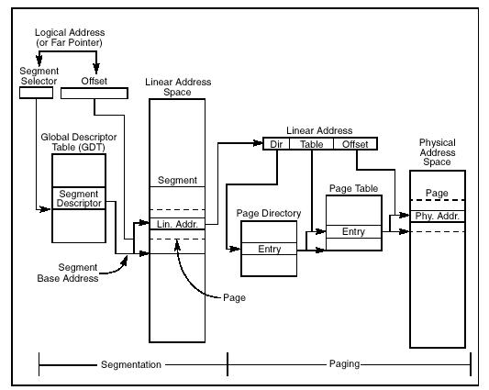
I386 segmentation
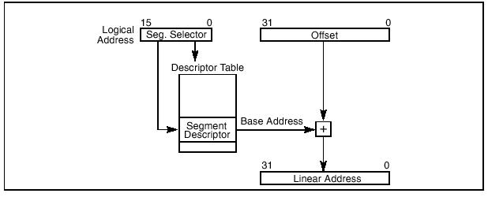

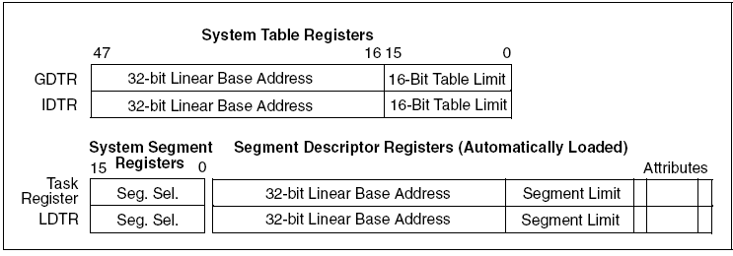
I386 Paging
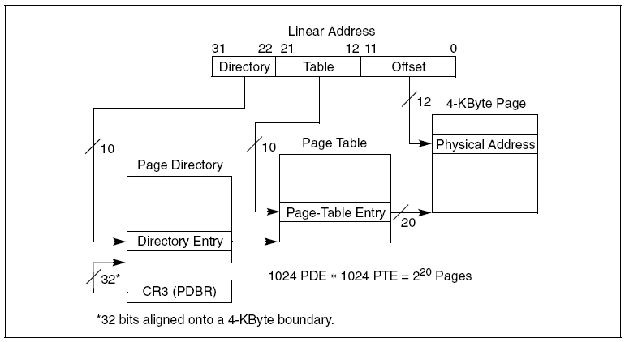
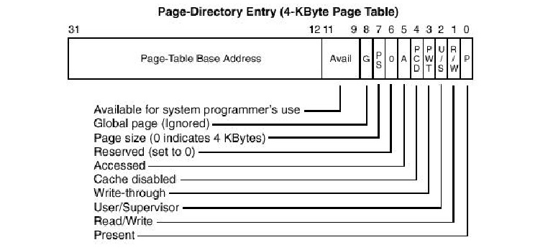
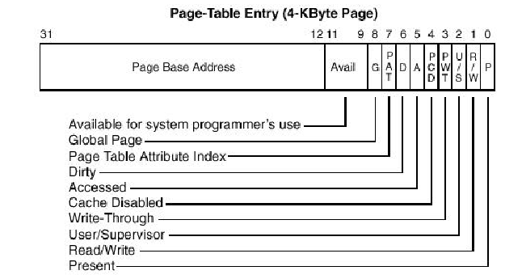
Page Frame Management
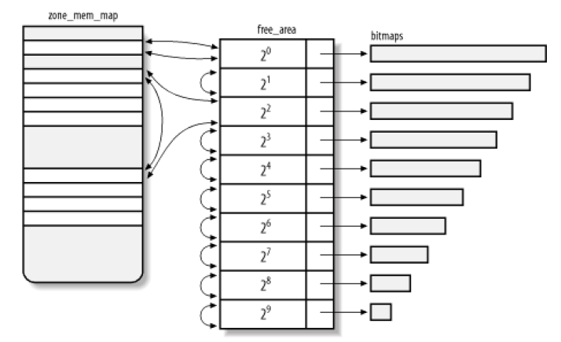
Memory Area Management
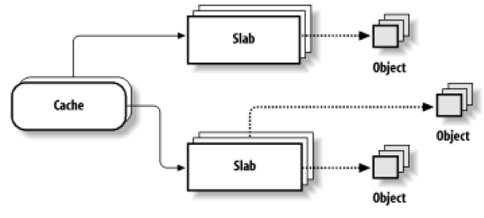
VFS: Interaction with processes
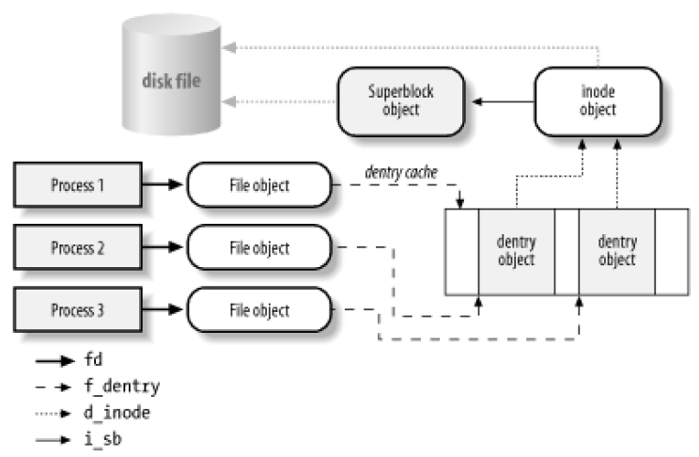
Disk data structures
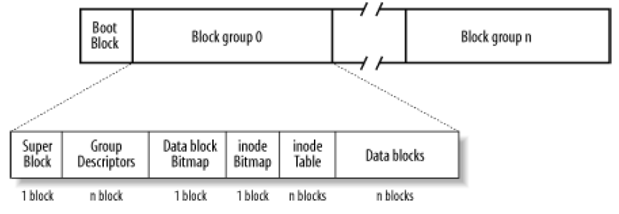
Processes ◊The Ext2
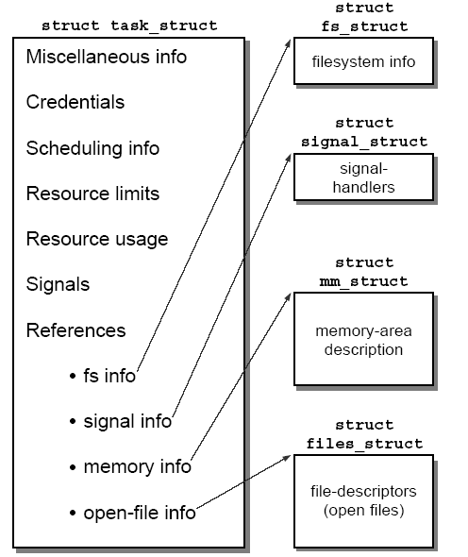

PCB task_struct
