浙江大学2013–2014学年秋学期
《数据结构基础》课程期末考试试卷(A)
课程号： 211C0020_，开课学院：_计算机科学与技术_
考试试卷：√A卷、B卷（请在选定项上打√）
考试形式：√闭、开卷（请在选定项上打√），允许带____无___入场
考试日期： 2013 年 11 月 12 日,考试时间： 120 分钟
诚信考试，沉着应考，杜绝违纪。
考生姓名： 学号： 所属院系： _
题序 | 一 | 二 | 三 |  |  |  |  | 四 | 总 分
得分
评卷人

Answer Sheet

Part I (20)
1. d | 2. a | 3. c | 4. a | 5. b
6. a | 7. d | 8. c | 9. c | 10. d
Part II (21)
1.
①_ A[ – –j ] > Pivot _____
②_ Swap( &A[ i ], &A[ Right – 1 ] ) .
③_ Qselect( A, k, Left, i – 1 ); _____
④_ k > i + 1 ____ _
2. ① Enqueue( T->Left, Q ); ②_ T->Right; __
③_ Enqueue( T->Right, Q ); ___
Part III (44)
1.
(a) 3,2,4,1,6,5 (b)
6
1
5
3
4
2

2.
i | 0 | 1 | 2 | 3 | 4 | 5 | 6 | 7 | 8 | 9 | 10
H[i] | 22 | 16 |  |  | 15 | 27 | 17 | 39 |  | 21 | 32

3.
2, –3, 2, 5, –6, 5, 5, 5, 8

4.
(a)
v1
v2
v3
v4
v5
∧
∧
∧
∧
∧
v5
v2
v2
v4

V3, v2, v4
(b) v1, v3, v4, v5, v2

5.
(a) 8
(b) V1, V4, V5, V6
(c) V1, 2, 3, 4, 5, 6 或者 V1, 2, 3, 5, 4, 6

Part IV (15)
int FindHeight( int Tree[], int N )
{ int i, maxH;
int *h = malloc(sizeof(int) * N) ;

for (i=0 ; i<N ; i++) h[i] = -1 ;
maxH = -1 ;
for (i=0 ; i<N ; i++)
if (h[i] == -1) {
h[i] = FindH(Tree, h, i) ;
if (h[i] > maxH) maxH = h[i] ;
}
}

int FindH( int Tree[], int h[], int i )
{ if (h[i] != -1) return h[i] ;
if (Tree[i] == -1) h[i] = 0 ;
else h[i] = 1 + FindH(Tree, h, Tree[i]) ;
return h[i] ;
}

T(N) = O(N)

NOTE: Please write your answers on the answer sheet.
注意：请将答案填写在答题纸上。

- Please select the answer for the following problems. (20 points)

- In a singly linked list of length N without the dummy head node, suppose that the probability of accessing any element in any position is the same, then the average number of pointer moves to access an element must be .
a. N/2 b. (N+1)/2 c. (N-2)/2 d. (N-1)/2

- When using a stack to convert the infix expression a+b*c+(d*e+f)*g to a postfix expression, what symbols are inside the stack when “f” is read?
a. +(+ b. +(*+ c. +*+(*+ d. abcde

- Which of the following algorithms is the one that gives { 12, 9, 11, 8, 7, 4, 5, 13, 23 } after the second run of sorting in ascending order?
a. Merge Sort b. Insertion Sort c. Heap Sort d. Radix Sort

- For any binary tree, the orderings of its leaf nodes in preorder, inorder and postorder traversals are ____.
a. the same b. not the same c. uncertain d. none of the above

- Which of the following array is the result of building the maxheap from 6, 4, 3, 5, 8, 9, 12, 10 with the O(N) algorithm?
a. 12,10,6,4,8,9,3,5 b. 12,10,9,5,8,6,3,4
c. 12,9,10,6,8,3,4,5 d. 6,4,8,3,5,9,12,10

- Let T be a tree of N(≥8) nodes created by union-by-size without path compression, then the minimum depth of T may be
a. 1 b. logN c. N-1 d. N/2

- Which of the following statements about HASH is true?
a. the expected number of probes for insertions is greater than that for successful searches in linear probing method
b. insertions are generally quicker than deletions in separate chaining method
c. if the table size is prime and the table is at least half empty, a new element can always be inserted with quadratic probing
d. all of the above

- If an undirected acyclic graph G has 21 edges and 4 connected components, then what is the number of vertices that G may have?
a. 22 b. 24 c. 25 d. cannot be determined

- For an undirected graph G, suppose that the following edge set is obtained after performing DFS starting at V₀: {(V₀,V₁), (V₀,V₄), (V₁,V₂), (V₁,V₃), (V₄,V₅), (V₅,V₆)}. Which of the following is an impossible edge of G?
a. (V₀,V₂) b. (V₀,V₆) c. (V₁,V₅) d. (V₄,V₆)

- Given a directed acyclic graph G. If V_{i} is printed ahead of V_{j} during the topological sort, which of the following statements is always False?
a. there is an edge <V_{i}, V_{j}> in G b. there is a path from V_{i} to V_{j}
c. there is no edge <V_{i}, V_{j}> in G d. there is a path from V_{j} to V_{i}
- Given the function descriptions of the following two (pseudo-code) programs, please fill in the blank lines. (21 points)

- The function is to place the k-th smallest element at the k-th position (with index k-1) in a list of N elements A[]. The initial function call is Qselect(A, k, 0, N-1). (12 points)

void Qselect( ElementType A[], int k, int Left, int Right )
{ int i, j;
ElementType Pivot;

if ( Left + Cutoff <= Right ) {
Pivot = Median3( A, Left, Right ); /*the pivot is hidden at A[Right-1]*/
i = Left; j = Right – 1;
for( ; ; ) {
while ( A[++i] < Pivot ) { }
while ( ①_____________ ) { }
if ( i < j )
Swap( &A[i], &A[j] );
else break;
}
②______________________________;
if( k <= i )
③____________________________;
else if (④___________ )
Qselect( A, k, i + 1, Right );
}
else
InsertionSort( A + Left, Right - Left + 1 );
}

- The function is to list out the nodes of a binary tree in "level-order". (9 points)

void Level_order ( Tree T )
{ Queue Q;

if ( !T ) return;
Q = CreateQueue( MaxElements );
Enqueue( T, Q );
while ( !IsEmpty( Q ) ){
T = Front_Dequeue ( Q ); /* return the front element and delete it from Q */
ListOut ( T );
if ( T->Left )
①____________________;
if ( ②________________ )
③____________________;
}
}

- Please write or draw your answers for the following problems on the answer sheet. (44 points)

- An inorder binary tree traversal can be implemented in a non-recursive way with a stack. Suppose that when a 6-node binary tree (with the keys numbered from 1 to 6) is traversed, the stack operations are: push(1); push(2); push(3); pop(); pop(); push(4); pop(); pop(); push(5); push(6); pop(); pop(). Please do the following:
  - find the in-order traversal sequence of the tree; (6 points) and
  - draw the binary tree. (6 points)

- Given a hash table of size 11 and the hash function h(x)=x%11. Assume that the alternating quadratic probing (with the collision resolving function being +i² and –i² alternatively) is used to solve collisions. Please fill in the hash table with the input numbers { 17, 32, 15, 27, 39, 22, 21, 16 }. (4 points)

- The array representation of a disjoint set is given by { 2, –3, 2, 6, -4, 5, 5, -2, 8 }. Please list the resulting array after invoking Union(Find(4),Find(9)) with union-by-size and path-compression. Please keep in mind that the elements are numbered from 1 to 9. (6 points)

- Given the adjacency list representation of a directed graph. Suppose that the BFS sequence starting from v1 is {v1, v3, v2, v4, v5}. Please do the following:
  - fill in the blank nodes in the figure; (3 points) and
  - list the DFS sequence starting from v1. (5 points)
v1
v2
v3
v4
v5
∧
∧
∧
∧
∧
v5
v2
v2
v4

- For the given directed weighted graph, please do the following:
- find the earliest completion time of V₆; (4 points)  - list all the vertices of which the earliest completion time is equal to its latest completion time; (4 points) and  - list the vertices in the order of output when applying Dijkstra algorithm to find the shortest path from V₁ to all other vertices. (6 points) | 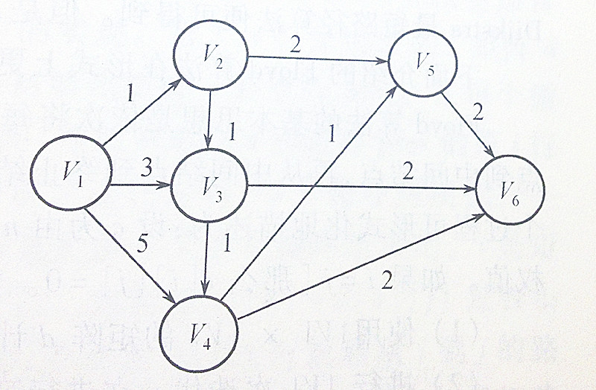

- Given a tree of N nodes with the nodes numbered from 0 to N–1. Represent it by the array Tree[ ] with Tree[node] = parent of node, and Tree[root] = –1. Please describe the fastest algorithm that finds the height of the tree (assume that the height of the root is 0). (15 points)

