浙江大学2011–2012学年 夏学期
《 PHYSICS I 》课程期末考试试卷
课程号： 061R0060 ，开课学院：_理学院_
考试试卷：A卷√、B卷（请在选定项上打√）
考试形式： 闭 卷，允许带_计算器、字典_入场
考试日期： 2013年 06 月 30 日,考试时间： 120 分钟
诚信考试，沉着应考，杜绝违纪。
考生姓名： 学号： 所属院系： _
题序 | 一 | 二 | 三 | 四 | 五 | 六 | 七 | 八 | 总 分
得分
评卷人
I. Multiple-choice: (there is one correct answer only, score of 2 for each)
1. A B C D | 2. A B C D | 3. A B C D | 4. A B C D | 5. A B C D
6. A B C D | 7. A B C D | 8. A B C D | 9. A B C D | 10. A B C D
II. Put a correct answer in the space (score of 2 for each)
(1) | (2) | (3) | (4) | (5)
(6) | (7) | (8) | (9) | (10)
(11) | (12) | (13) | (14) | (15)
(16) | (17) | (18) | (19) | (20)

III. Calculation problems (score of 8 for each):
1. A billiard ball, with radius R and mass m initially at rest on the ground, is given a sharp impulse by a cue held horizontally. The ball leaves the cue with a speed v_{o}. Under the friction force between the ball and ground, the speed of the ball is 5v_{o}/7 after it rolls without slipping.
(1) What is the height of the cue above the ground?
H
v_{o}
(2) What is the kinetic energy when the ball just leaves the cue?
(3) What is the kinetic energy after the ball rolls without slipping?

2. A simple harmonic plane wave moves in x direction, it can be described by a function of 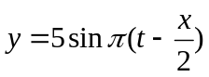. After the wave reflected by a solid wall at x = 8,
(1) Find a function to describe the reflection wave;
(2) Find a function to describe the standing wave;
(3) Find the position where the amplitude of oscillation has zero value in the region from 0 to 8

3. An electron with mass m is at rest, it is collided with another electron with kinetic energy K. After collision a new particle is produced.
(1) To calculate the total energy of two electrons;
(2) To calculate the total momentum of two electrons;
(3) To calculate the rest mass of the new particle

4. One mole ideal diatomic gas undergoes a cycle as shown in a P-V diagram. In the process AB, the gas expanded from V_{o} to 2V_{o} with constant temperature T_{o}. The process BC is a constant pressure one and the process CA is an adiabatic one. (1) To calculate the pressure, temperature and volume of the gas at C point; (2) The change in entropy at the process BC.
p
V
C
B
A
V_{o} 2V_{o}

5. A chamber is filled with an ideal diatomic gas. The pressure in the chamber is 10⁵ pa at temperature of 27℃. The diameter of gas molecule is 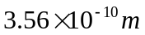. (1) To calculate the density of the gas in the chamber (the number of molecule in 1 m³); (2) To calculate the kinetic energy in average of one molecule; (3) To calculate the mean free path of the molecule. (Boltzmann constant 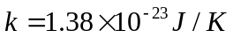)

I . Multiple choices (one correct answer only, score of 2 for each):
1. A particle with mass m moves in x direction under a force of 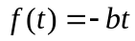, the particle starts its motion with a velocity of v₀. The time to stop its motion is
A. 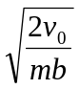 B. 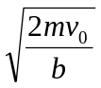 C. 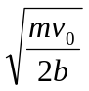 D. 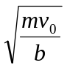
2. A particle with mass m starts fall in air under a drag force of 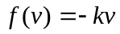. The velocity at 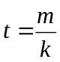 is given by
A. 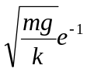 B. 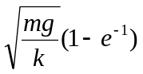 C. 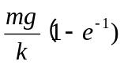 D. 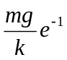
3. A solid cylinder rolls without slipping on a table surface, the ratio of rotational kinetic energy to total kinetic energy is
A.  B.  C. D. 
4. A wind blows through two big bulidings at a speed of 20.0 m/s. If the density of air is 1.2 kg/m³, The size of a window is 1.5×1.5 m², the force acting on the window is
A. 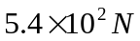 B. 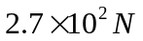 C. 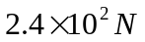 D. 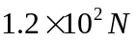
5. A man spins on ice with angular velocity ₀. The man reduces the rotational inertia from I₀ to I₀/3 after he contract his arm, the changes in kinetic energy is
A. 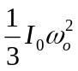 B. 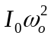 C. 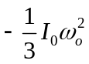 D. 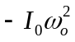
6. The energy for accelerating an electron from rest to with a speed of 0.1c is E, The energy for accelerating an electron with speed from 0.8c to 0.9c is
A. 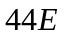 B. 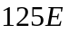 C. 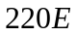 D. 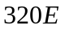
7. A policeman sends a 10⁵ Hz supersonic wave behind a moving car. The policeman receives an echo from the car with a frequency of 7.9×10⁴ Hz. If the speed of sound is 340 m/s, the speed of the car is
A. 30 m/s B. 35 m/s C. 40 m/s D. 45 m/s
8. One mole ideal gas undergoes a free expansion process. The volume changes from  to 3V₀, the change in entropy of the gas is given by
A. 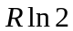 B. 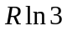 C. 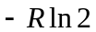 D. 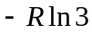
9. During the expanded of an ideal gas, it did a work of 8 J and sent out a heat of 10 J. The change in inner energy is
A. 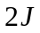 B. 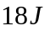 C. 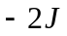 D. 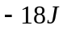
10. One mole ideal gas is expanded from V_{o} to 2V_{o} in a reversible adiabatic process. If the temperature of the gas decreases 25%, the gas may be
A. monatomic gas B. diatomic gas C. polyatomic gas D. other gas

II. Put a correct answer in the space (score of 2 for each)
1. A particle travels in x-y plane dependent on 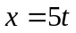 (m) and 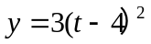(m). At t =4s, the magnitude of centripetal acceleration is (1) and tangential acceleration is (2) .a

2. A particle with mass m moves in x direction under a force of 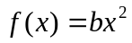. It starts its motion from the original point. The velocity at x₀ point is (3) .
3. The potential energy of a diatomic molecule is given by 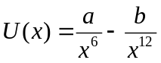, here a and b are positive constant, x is the separation between two atoms. When the molecule is at equilibrium state the separation between two atoms is (4) , the potential energy is (5) .
M

F

4. A cylinder, with mass M, moves under a force F acting on its edge. The cylinder rolls on a table surface without slipping, the acceleration of mass center of the cylinder is (6) , the friction force between the cylinder and table is (7) .

5. Two protons, with rest mass m, are accelerated to kinetic energy K. After collision between two protons, a new particle is produced. The rest mass of the resulting particle is (8) .

6. A particle, mass of 0.1kg, is connected with a massless spring. It vibrates with a function of 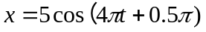. The total energy of the oscillator is (9) .

7. The displacement of an oscillator is given by x =x_{m}cos(ωt+φ). If the object is initially at x_{m}/2 with a positive velocity, and it comes back its original position firstly after 1 second, then the angular frequency  = (10) and phase constant φ= (11) .

8. The figure shows a plot of a simple harmonic transverse wave at t, The angular friquency is (12) , the phase constant is (13)
y (m)

x(m)

0 2 5 8 11 14
2
1

-1
-2
u =6.0 m/s

9. A chamber filled with nitrogen molecule, the mean free path of nitrogen molecule in the chamber is λ. An electron is accelerated with high speed and goes into the chamber, the mean free path of the electron in the chamber is (14) .

10. Eight identical molecules are in two boxes, four are in each box. The volume of the left box is twice as that of right one. After two boxes are brought together, the change in entropy is (15) , After two boxes are brought together and one molecule is in the left box, the change in entropy is (16) ,

11. A Carnot engine operates between 500 K and 300 K. If it discharges 60 J heat into the low-temperature reservoir, then the output net work is (17) .
m m
12. Two balls, mass of m, is connected with a massless spring with the force constant k. They can roll on a table surface without slipping, the angular frequency of the ball oscillating is (18) .

13. Two identical chambers filled with ideal gas hydrogen and argon respectively, At the beginning the presure and temperature of hydrogen and argon is same. After argon gas adsorbs heat, the increase in temperature is ΔT. After hydrogen gas adsorbs same heat, the increase in temperature is (19) .
14. When an ideal gas undergoes a process, in this process pV² =constant. At the beginning the volume of gas is V₀, with increase in temperature from T₀ to 2T₀, the volume of gas is (20)

