一、Mark each statement true or false
1、Both DFA and NFA can recognize regular set.
2、Context free grammar can generate language L = {a^{n}b^{n}c^{m} | n >=0 , m>=0}
3、Intermediate
Code generation depends on detailed information about the target architecture, and doesn’t care the characteristics of the source language.
4、A display is a data structure that may be used as a alternative to static links for maintaining access to the variables.
5. A grammar is ambiguous if it has two different derivations for a sentence.
6. In grammar, nullable symbol can only derive the empty string.
7. All LR(0) grammars can be parsed by SLR parser.
8.There might be shift-reduce, shift-shift and reduce-reduce conflicts during the LR parsing.

二、Single Choice
1、Which of the following string can be defined by the regular expression ((b|c)*a(b|c)*a) (b|c)*.
[A] abbcab [B] aaaa [C] abbbbbc [D] bbacc
- the output of the scanner is:
[A] token [B] syntax tree [C] target code [D] intermediate code
3、Lex is a tool that ( )
[A] break the source file into individual words, or tokens
[B] analyze the phrase structure of the program
[C] is a lexical analyzer generator
[D] is a parser generator
4、 In the following which is(are) not commonly found in a stack frame (activation record)?
[A] return address [B] static variables
[C] saved registers [D] arguments
5、which does the operation pushing the return address in the stack frame?
[A] the caller procedure
[B] the called procedure
[C] the operation system
[D] CPU
6. Which action is not in a LR Parsing table?
[A] Shift [B] Push [C] Accept [D] Reduce
7. In the production B→αAγ, Which would not be in the FOLLOW(A) Set?
[A] ε [B] FIRST(γ) [C] FOLLOW(B) [D] $
8. Which element would not appear in the stack of LR parser?
[A] nonterminal [B] terminal [C] state [D] $
9. Which grammar parser below is the most powerful?
[A] LL(1) [B] LR(0) [C] SLR [D] LR(1)
10. the parsing method of YACC is ( )
[A] LALR(1) [B]LR(1) [C] SLR(1) [D] LL(1)

三、Questions
- Describe and explain the main translation phases of a compiler. （7 cents）
Answer:

2、Please explain the meaning of the binding {g → string, a→ int }. (5 cents)
Answer:

3、Apply the state minimization algorithm to the following DFA. Then give a regular expression to describe this language. (10 cents)
d
d
a
b
b
b
b
c
c
a
b
b
a
0
1
3
4
5
6
2

Answer:

4. Consider the following statement: (10 cents)
if (a>b) x = x-2 else y=y+1
Please use Intermediate Representation Tree to describe the above code.
Answer:

5. Given the grammar
A→ A A
A→ ( A )
A→ ε
Drawing two different parsing trees for the string ( ), showing that it is ambiguous. (7 cents )
Answer:

6. Consider the following grammar (20 cents)
S→A S→B
A→ e A→ f
B→ ( C ) C→ S D
D→ S D D→
a. Calculate nullable, FIRST and FOLLOW for nonterminals in the grammar.
b. Construct the LL(1) parsing table for the grammar.
c. Show that the grammar is LL(1).
Answer:

7. Construct the LR(0) states for this grammar, and then determine whether it is an SLR grammar, give the SLR parsing table. ( 15 cents )
0 S→B $ 1 B→ d P 2 B→ d ( E ) 3 P→ 4 P→ (E)
5 E→B 6 E→B, E
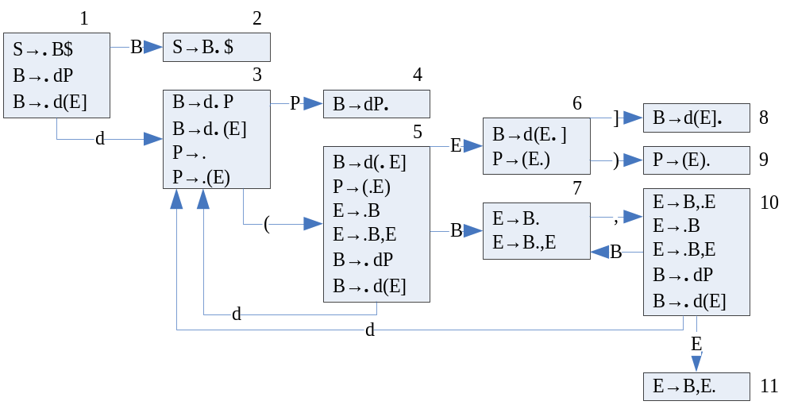Answer:
）
9
10

