  浙江大学电气工程学院 | 模拟与数模混合集成电路 | 吴晓波，赵梦恋
2018-2019学年夏学期 | 模拟与数模混合集成电路 | 2018年5月

Exercise 2
- Calculate the value of CGB, CGS, and CGD for an n-channel device with a length of 1 μm and a width of 5 μm. Assume VD = 2 V, VG = 2.4 V, and VS = 0.5 V and let VB = 0 V. Use model parameters from following tables.
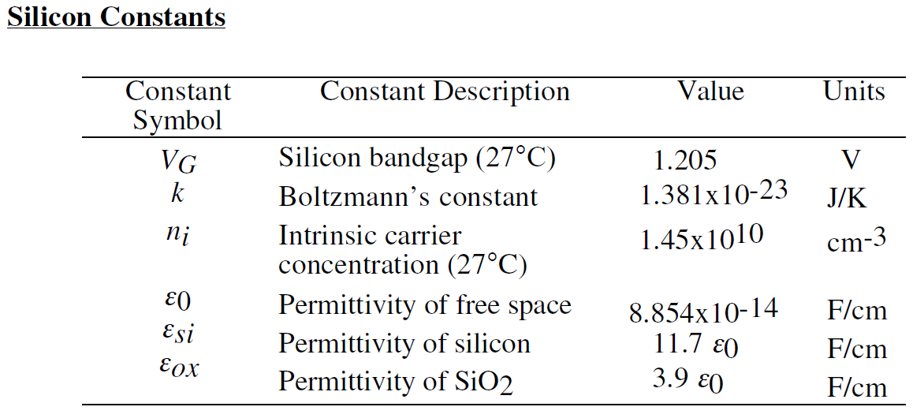
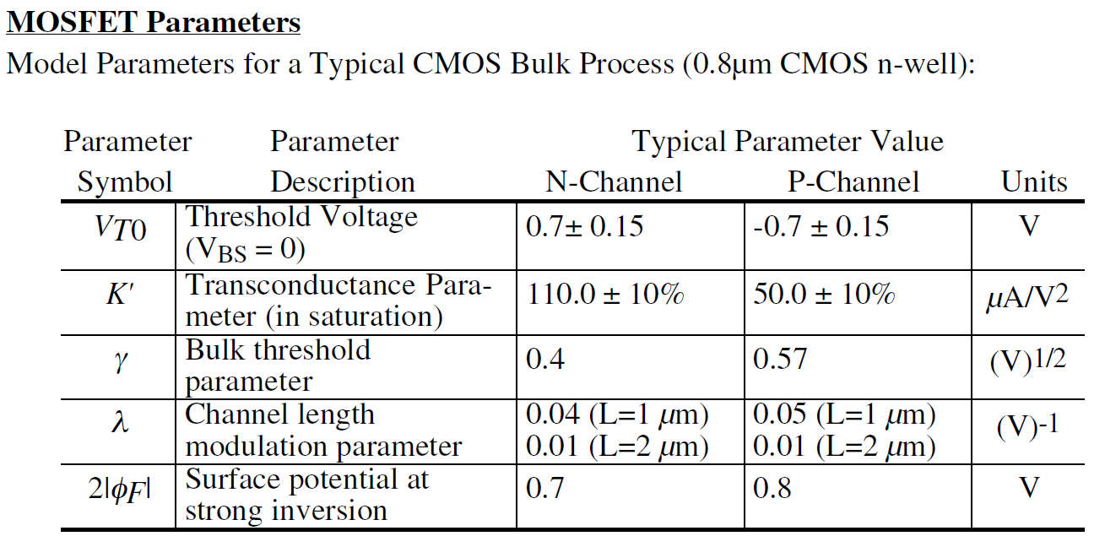
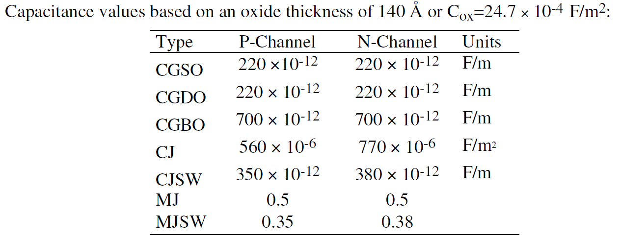

Answer:
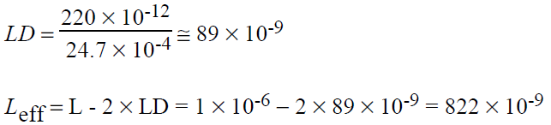
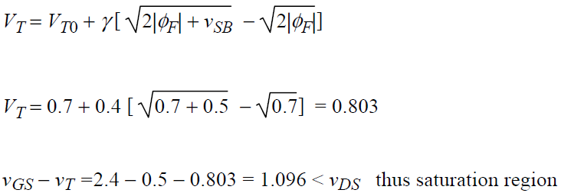
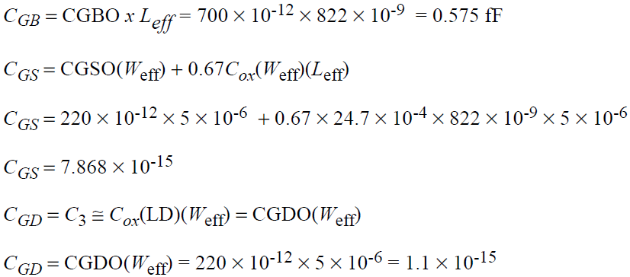

- An NMOS with W=50μm and L=0.5μm operates in the saturated region and its layout is folded shown as Fig. 2-1. Calculate the all capacitances by using the parameters in Table2-1 and C_{ox}=3.8×10⁻³ F/m, V_{R}=0.6V. Assume that the minimum size (lateral) of S/D region is 1.5μm.
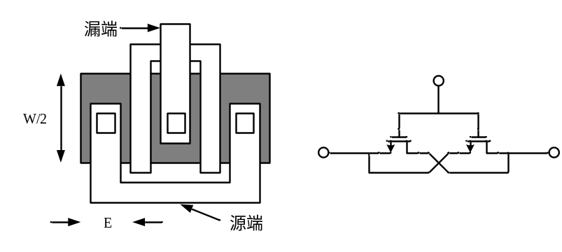
Figure 2-1

Answer:
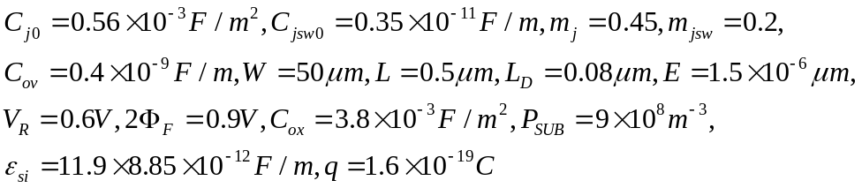
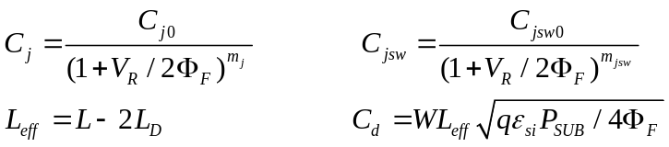

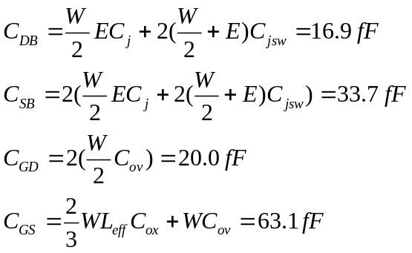
C_{GB}：栅-衬底电容在三极管区和饱和区通常被忽略，因为反型层在栅和衬底之间起了“屏蔽”的作用。换句话说，如果栅电压发生变化，电荷是由源和漏提供，而不是由衬底提供。
- There is an N-type current source, I_{D} is 0.5mA, and the drain-source voltage V_{DS} must more than 0.4V when it works as a current source. If the maximum output resistance is 20 KΩ, determine the length and width of the device by using the parameters in Table 2.1.

Answer:
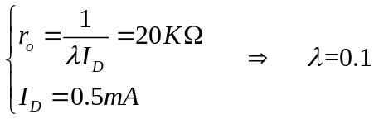
From the table2.1, L can be determined as L=0.5um.
Calculating W
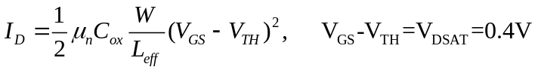
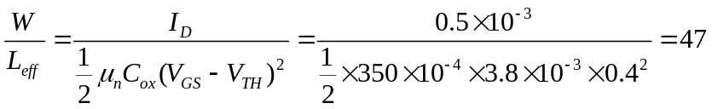
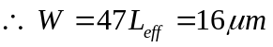

- Calculate the transfer function vout(s)/vin(s) for the circuit shown in Fig. P3.3-1. The W/L of M1 is 2μm/0.8μm and the W/L of M2 is 4μm/4μm. Note that this is a small-signal analysis and the input voltage has a dc value of 2 volts.
提示：判断M1工作在Linear Region，可视为一电阻；M2则为一电容。
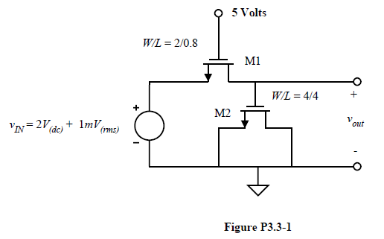

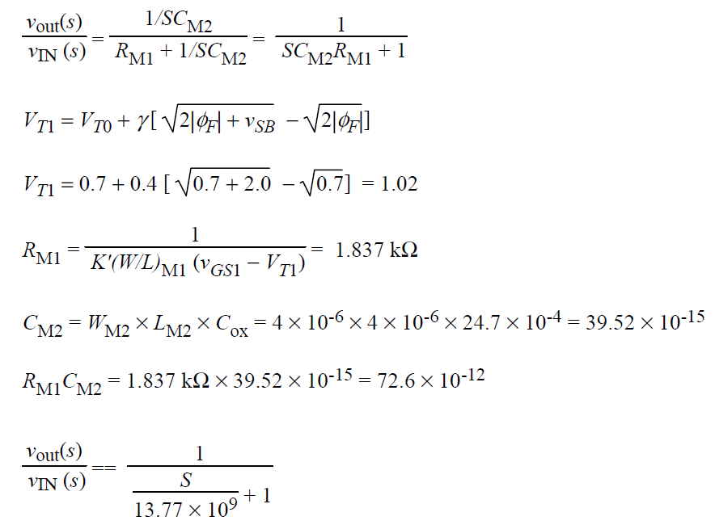

- The layout of an n-channel MOSFET is shown in Fig.2.3. What is this device’s width and length?

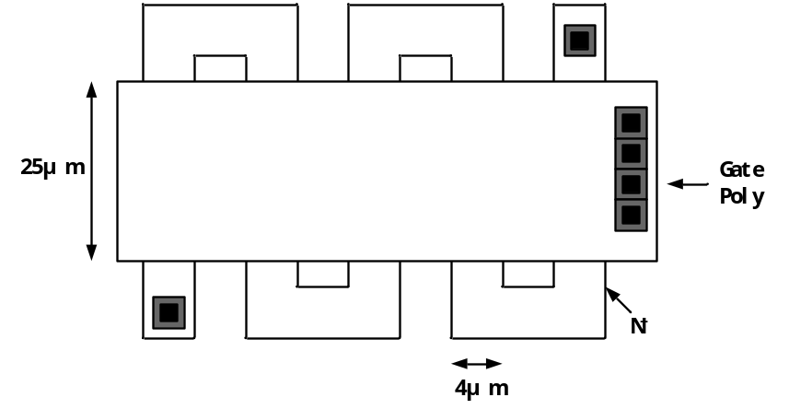
Figure 2.3

Answer:
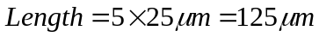
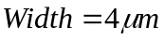
- A “ring” MOS structure is shown in Fig. 2.4. Explain how the device operates and estimate its equivalent aspect ratio. Calculate the drain junction capacitance of the structure.
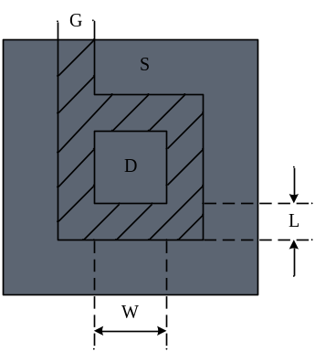
Figure 2.4

Answer:
Width/length ratio is 4W/L
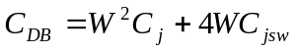

- The layout of a circuit fabricated in n-well technology is shown as Fig.2.5. Give the corresponding schematic and mark the W/L sizes of each transistor. Assume 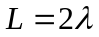, 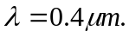
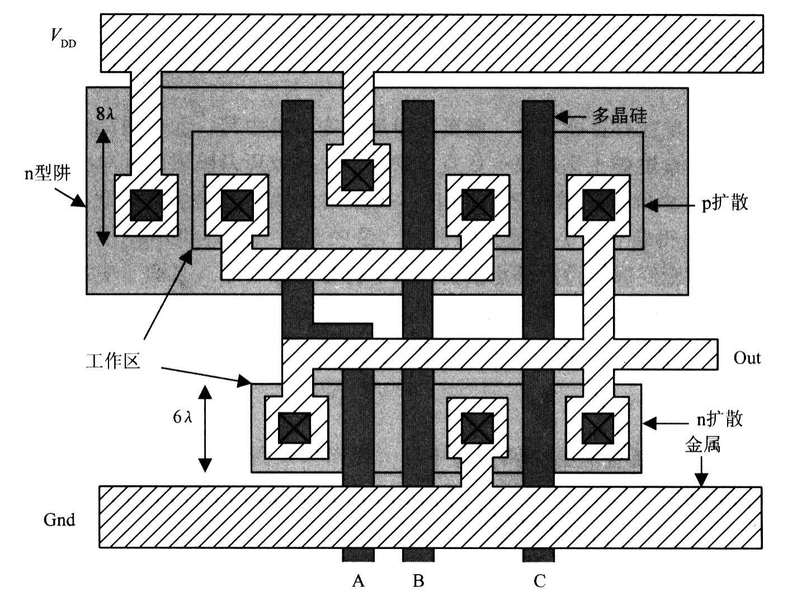
Figure 2.5

Answer:
Schematic
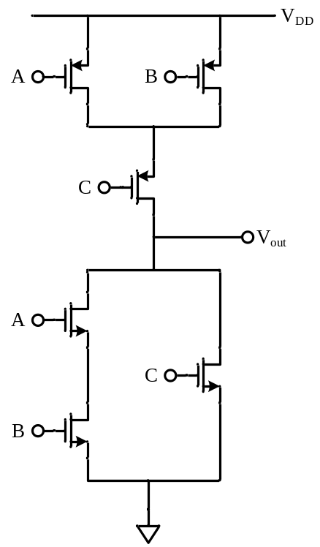
Out=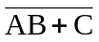
W/L of N-MOSFET: 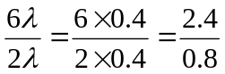
W/L of P-MOSFET: 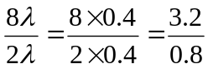

Table 2.1
NMOS Model
LEVEL=1 | VTO=0.7 | GAMMA=0.45 | PHI=0.9
PSUB=9e+14 | LD=0.08e-6 | UO=350 | LAMBDA=0.1
TOX=9e-9 | PB=0.9 | CJ=0.56e-3 | CJSW=0.35e-11
MJ=0.45 | MJSW=0.2 | CGDO=0.4e-9 | JS=1.0e-8
PMOS Model
LEVEL=1 | VTO=-0.8 | GAMMA=0.4 | PHI=0.8
PSUB=5e+14 | LD=0.09e-6 | UO=100 | LAMBDA=0.2
TOX=9e-9 | PB=0.9 | CJ=0.94e-3 | CJSW=0.32e-11
MJ=0.5 | MJSW=0.3 | CGDO=0.3e-9 | JS=0.5e-8

上表给出的是0.5μm工艺level 1 MOS SPICE 模型参数的典型值，其中的参数定义如下：
VTO: VSB=0时的阈值电压 （单位：V）
GAMMA: 体效应系数 （单位：V^{1/2}）
PHI: 2Ф_{F} （单位：V）
TOX: 栅氧厚度 （单位：m）
NSUB: 衬底掺杂浓度 （单位：cm⁻³）
LD: 源/漏侧扩散长度 （单位：m）
UO: 沟道迁移率 （单位：cm2/(v/s)）
LAMBDA: 沟道长度调制系数 （单位：V⁻¹）
CJ: 单位面积的源/漏结电容 （单位：F/m²）
CJSW: 单位长度的源/漏侧壁结电容 （单位：F/m）
PB: 源/漏结内建电势 （单位：V）
MJ: CJ公式中的幂指数 （无单位）
MJSW: CJSW等式中的幂指数 （无单位）
CGDO: 单位宽度的栅/漏交叠电容 （单位：F/m）
CGSO: 单位宽度的栅/源交叠电容 （单位：F/m）
JS: 源/漏结单位面积的漏电流 （单位：A/m²）

