Compilation Principle Homework 6

Jinyan XU, 3160101126, Information Security

7.4 Draw the stack of activation records for the following Pascal program, showing the control and access links, after the second call to procedure c. Describe how the variable x is accessed from within c.

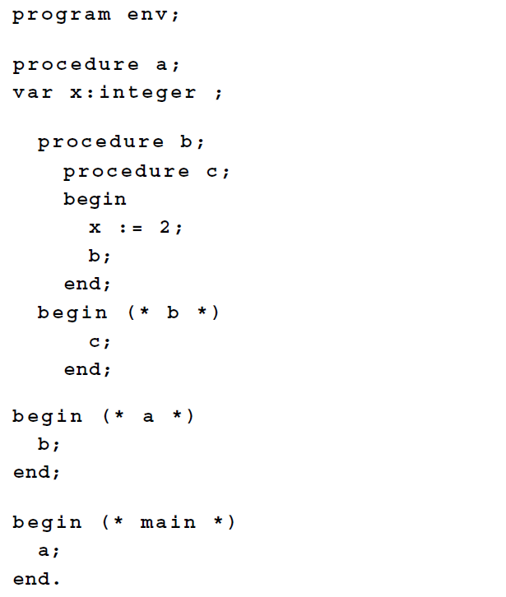

|  |
| --- |
| **Answer：**  Variable x is defined in procedure a, so if procedure wants to access variable x, it must use its access link to procedure b, then use the access link of procedure b to procedure a. In procedure a, it can get the address of the variable x. |

7.15 Given the output of the following program (written with C syntax) using the four parameter passing methods discussed in Section 7.5.

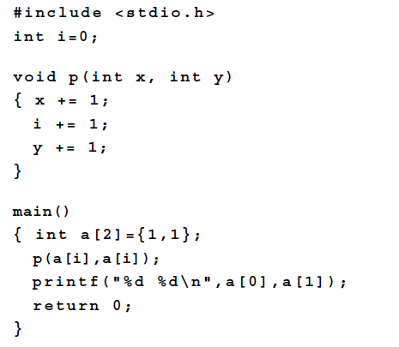

|  |
| --- |
| **Answer:**  Pass by value: 1 1  Pass by reference: 3 1  Pass by value-result: 2 1  Pass by name: 2 2 |