**Quiz 3 for Software Engineering Course May 26, 2022**

**Name: Student ID: Group ID: Score:**

**Please give brief answers to the following questions:**

1. **For the software projects, a series of stakeholders are involved. Please list at least three types of stakeholders and give a brief explanation for them.**

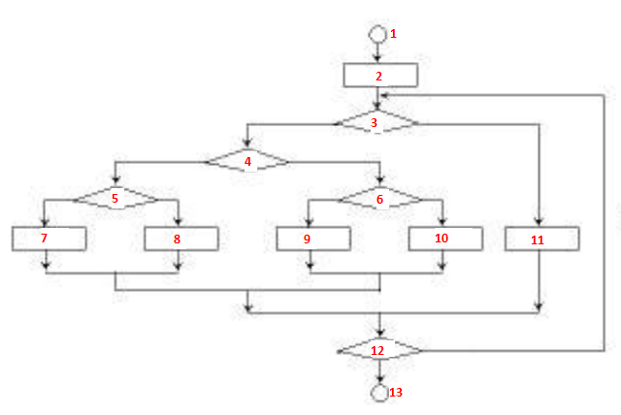

1. **According to the right flowchart, suppose all the Predicate**

**Node 5 is complex condition and other nodes are single conditions.**

**Please answer following questions:**

**(1) What is the value of Predicate Node number, *P* ?**

**(2) What is the value of the Cyclomatic Complexity, *V(G)*?**

**(3) Please list all independent logical paths for testing.**

**3. There are two conventional estimation methods: LOC (lines of code) approach and FP (function point) approach. Suppose the burdened labor rate =$8000 per month. For a type of software project, the average productivity is 625 LOC person-month (i.e. LOC/pm) and 6.4 FP/pm, respectively, and the total estimated lines of code are 35000 and 370FP, respectively. Please answer following questions.**

**(1) What are the costs of per LOC and per FP? In term of person-months (pm), what are the total estimated project cost by above two estimation methods, respectively?**

1. **Why do FP-based metrics have advantages over LOC-based metrics in some aspects?**