|  |  |  |
| --- | --- | --- |
| 浙江大学电气工程学院 | **模拟与数模混合集成电路** | 吴晓波，赵梦恋 |
| 2018-2019学年夏学期 | 2018年5月 |

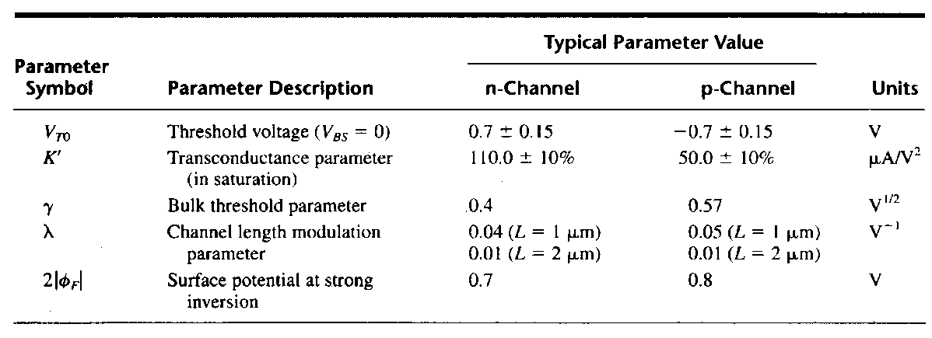

Table 5.1

5-1 Assume that W/L ratios of Figure 5.1 are (W/L)1 = 2μm/1μm and (W/L)2 = (W/L)3 = (W/L)4 =1μm/1μm. Find the dc value of *vIN* that will give a dc current in M1 of 110μA. Calculate the small signal voltage gain and output resistance using the parameters of Table 5.1. Assume λ=γ=0.



Figure 5.1

Solution:





(For Tab.4.1 Vin=1.61V, Av=-8.77V/V, Rout=36.3KΩ)

5-2 Calculate the output resistance and the minimum output voltage, while maintaining all devices in saturation, for the circuits shown in Figure 5.1. Assume that *i*OUT is actually 10μA. Use Table 5.1 for device model information.



Fig 5.1

解：









5-3 Design M3 and M4 of Figure 5.2(a) so that the output characteristics are identical to the circuit shown in Figure 5.2(b). It is desired that *i*OUT is ideally 10uA.

 

1. (b)

Figure 5.2

解:

For getting 

In Fig.5.2a),  

Thus to ensure 

We must have 



In Fig. 5.2b) *i*4= *i*3= *i*1











And we get *V*MIN in Fig.5.2(a): 

 and 

In Fig.5.2(a): 









5-4 A reference circuit is shown in figure 5.3, assume that (W/L)1=(W/L)3=4, (W/L)2=(W/L)4=1, please calculate the expression of VREF.



Figure 5.3

解：

2VT

5.5 As the circuits shown in Figure 5.4, *IREF*=0.3mA and *γ*=0. Using the model parameters in Table 5.1,

(a)Calculatethe voltage *Vb* when *VX*=*VY*;

(b) If Vb is 100mV smaller than the value in (a), calculate the deviation of Iout from 300μA.



Figure 5.4

解：

a)



b)

