**习题6**

Table 4.1

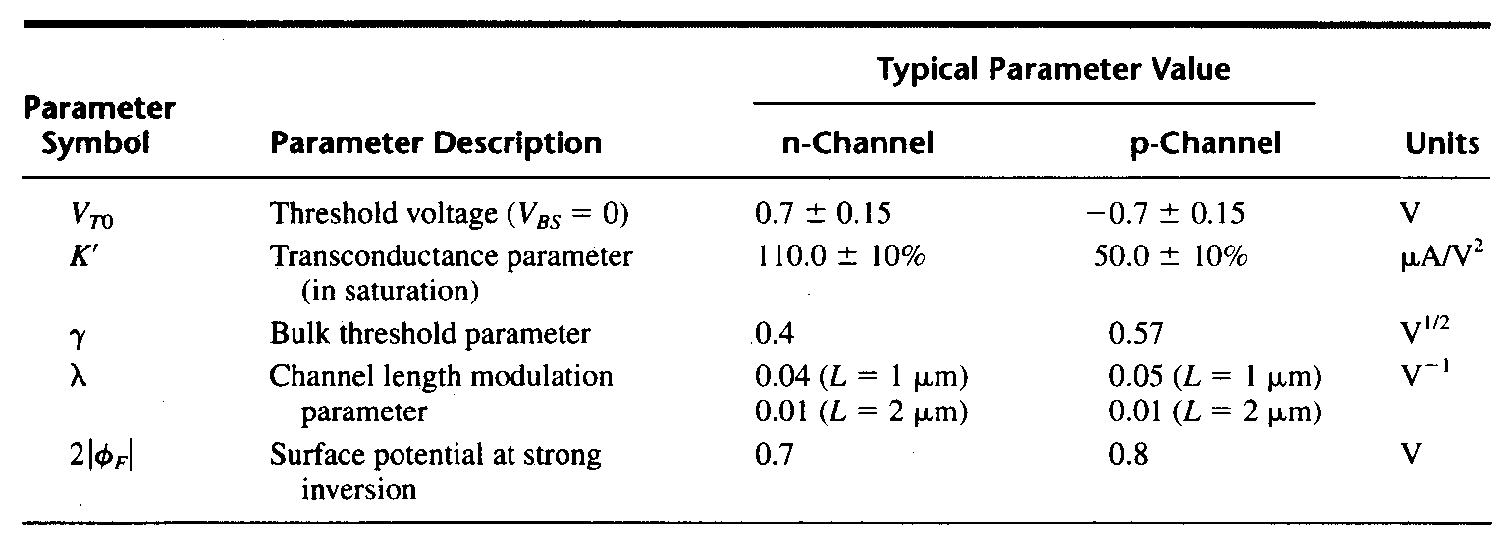

4.1 Calculate the differential transconductance *gmd* and the differential voltage gain *Av* of an n-channel input differential amplifier shown in Figure 4.1 , with the parameters shown in table 4.1. Consider Iss=100μA, and W1/L1=W2/L2=W3/L3=W4/L4=1. Assuming all the channel lengths are equal to 1μm, and VDD=5V. If W1/L1=W2/L2=10W3/L3=10W4/L4=10, repeat the calculation



Figure 4.1

解：





4.2 Calculate the maximum(VIC(max)) and the minimum input common-mode voltages (VIC(min)), and the input common mode voltage range (ICMR) of an n-channel input differential amplifier shown in Figure 4.1, with the parameters shown in table 4.1. Assume all MOSFETs are in saturation, all the (W/L)s are equal to 10μm/1μm, ISS=10μA, and VDD=5V.

解：

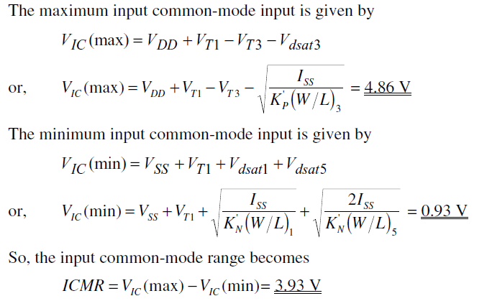

4.3 Find the value of the unloaded differential-transconductance, gmd, and the unloaded differential-voltage gain, Av, for the p-channel input differential amplifier of Figure 4.2 when ISS=10μA and ISS=1μA. What is the slew rate of the differential amplifier if a 100 pF capacitor is attached to the output? Assuming W1/L1=W2/L2=W3/L3=W4/L4=1, and all the channel lengths are equal to 1μm. Use the transistor parameters of Table 4.1.



Figure 4.2

解：

a) Given ISS=10μA,



Given ISS=1μA



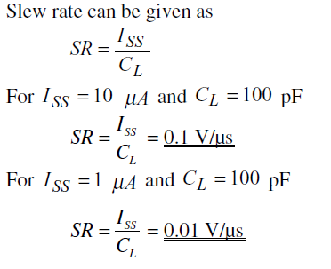

b)

4.4 In the circuit of Fig 4.3, assume that ISS=1mA, VDD=3V and W/L=50/0.5 for all the transistors. And ID5=ID6=0.8(ISS/2).

(a) Determine the voltage gain.

(b) Calculate Vb.

(c) If ISS requires a minimum voltage of 0.4V, what is the maximum differential output swing?



Figure 4.3

解：

a)

b)



c)













4.5 The circuit shown in Figure 4.4 called a folded-current mirror differential amplifier and is useful for low values of power supply. Assume that all W/L values of each transistor is 100. Using the parameters shown in table 4.1,

a) Find the maximum input common mode voltage, VIC(max) and the minimum input common mode voltage, VIC(min). Keep all transistors in saturation for this problem.

b) What is the input common mode voltage range, ICMR?

c) Find the small signal voltage gain, *vout/vin*, if *vin* = *v1 - v2*.

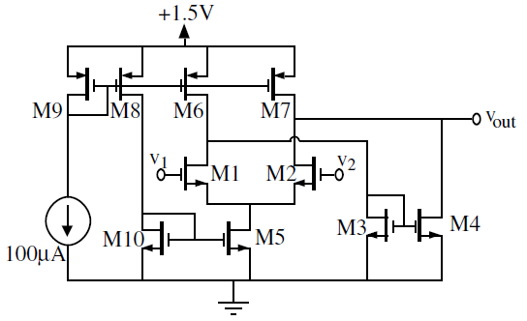

Figure 4.4

解：

a)

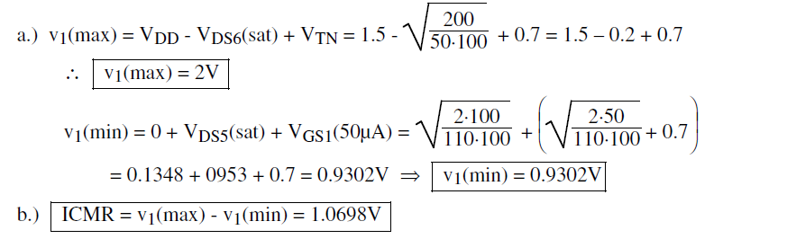

b) 

c)