|  |  |  |
| --- | --- | --- |
| 浙江大学电气工程学院 | **模拟与数模混合集成电路** | 吴晓波，赵梦恋 |
| 2018-2019学年夏学期 | 2019年6月 |

Table 7.1

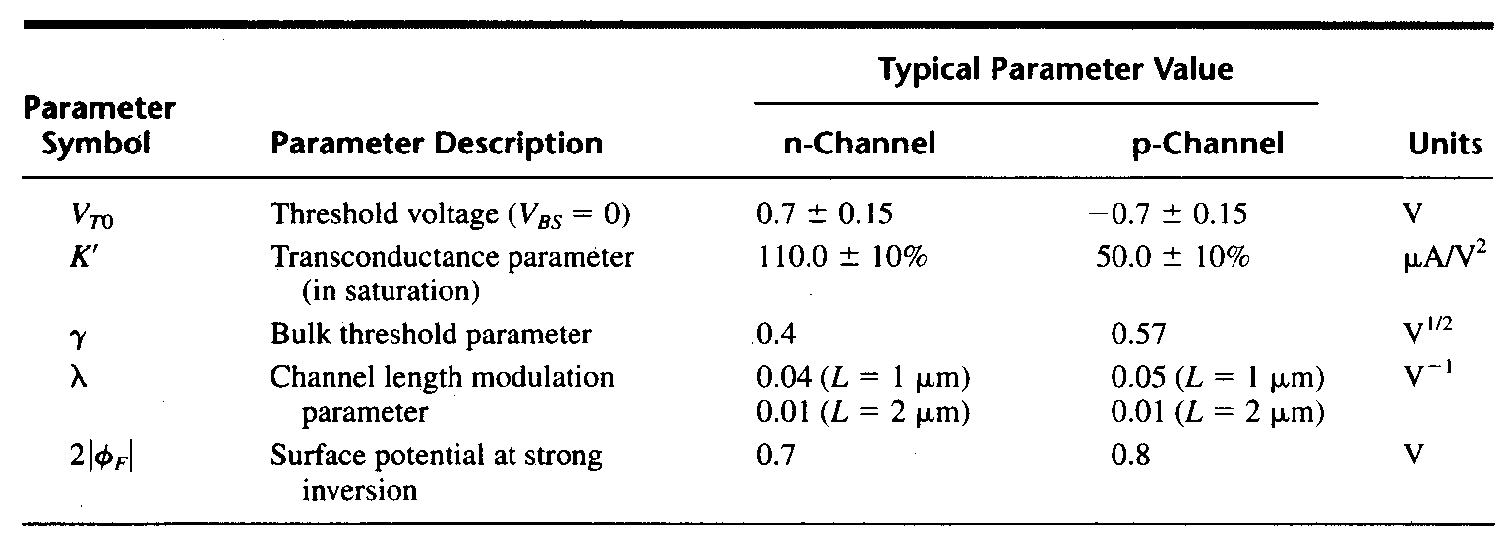

7.1 The circuit shown in Figure 7.1 called a folded-current mirror differential amplifier and is useful for low values of power supply. Assume that all W/L values of each transistor is 100. Using the parameters shown in table 7.1,

a) Find the maximum input common mode voltage, VIC(max) and the minimum input common mode voltage, VIC(min). Keep all transistors in saturation for this problem.

b) What is the input common mode voltage range, ICMR?

c) Find the small signal voltage gain, *vout/vin*, if *vin* = *v1 - v2*.

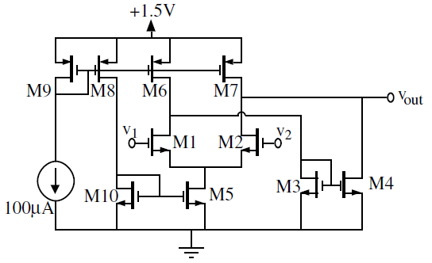

Figure 7.1

**Solution:**



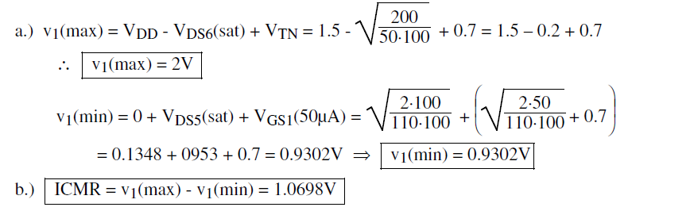

b) 

c.)

7.2 In the op amp of Fig 7.2, (W/L)1-8=100/0.5, ISS=1mA, and Vb1=1.7V. Assume that γ=λ=0. VDD=3V.

(a) What is the maximum allowable input CM level?

(b) What is VX?

(c) What is the maximum allowable output swing if the gate of M2 is connected to the output? (make sure that M2 and M4 work in saturation region)

(d) What is the acceptable range of Vb2?



Fig 7.2

解：

(a)







(b)



解得VX=1.984V

(c)

M2和M4均工作在饱和区，所以





且有

整理得

所以

(d)

, 且，所以



且

7.3 Suppose the circuit of Fig 7.3 is designed with ISS equal to 1mA, ID9-ID12 equal to 0.5mA, and (W/L)9-12=100/0.5. VDD=3V, λ=0.

(a) What CM level is required at X and Y?

(b) If ISS requires a minimum voltage of 400mV, choose the minimum dimensions of M­1-M8 to allow a peak-to-peak swing of 200mV at X and at Y, assume that M1-M4 are of the same size and M5-M8 are of the same size.

(c) Give the expression of the overall voltage gain.



Fig 7.3

解：

(a)





(b)

VX摆幅为200mV，所以VXmax=2.084V，VXmin=1.884V









(c)



7.4 Consider the amplifier of Fig 7.4, where (W/L)1-4=50/0.5 and ISS=I1=0.5mA. λp=0.2 and λn=0.1.

(a) Estimate the poles at nodes X and Y by multiplying the small-signal resistance and capacitance to ground. Assume that CX=CY=0.5pF. What is the phase margin for unity-gain feedback?

(b) If CX=0.5pF, what is the maximum tolerable value of CY that yields a phase margin for 60° for unity-gain feedback?



Y

X

Fig 7.4

解：

(a)

, 









低频增益为：

所以增益交点对应频率为：，



(b)



设不变，解得

解得