Term Definitions & Design Calculations for Anaerobic Membrane Bioreactor (anMBR)

Table of Contents
1. Design.……………………………………………………………………………………………….. p. 2

2. Determination of Volume of Concrete....…...………………………………………………………... p. 4

3. Piping……………………………………………………………………………………………….... p. 7
3.1 Air Manifold.………………………………………………………………..……………... p. 7
3.2 Air Header.…………………………………………………………………..……………... p. 8
3.3 Permeate Collector…………………………………………………………..…………....... p. 9
3.4 Permeate Header…………………...………………………………………..……………. p. 10

4. Pumping…………………………………………………………………………………………...... p. 11
4.1 Pump Design Steps.……………………………...…………………...……..………..…... p. 11
4.2 Permeate Pumping …………………………………………………………...…………... p. 11
4.3 Drain Pumping.…….……………………………………...………..…………..….....…... p. 13
4.4 Electricity Consumption...…………………………………...………..…………..….…... p. 15

5. Gas Blowing...……………...……………………………………………………………..……….... p. 16
5.1 Brake Horsepower Calculations...…………………………………………..………...….. p. 16

6. Membrane.………………………………………………………………………………………….. p. 17

1. Design
Input Parameters Needed for Calculation
Flow rate, Q (m³/day)
Flux across membrane, J (m³/day-m²)
Number of trains, N

Train. A train is defined as a concrete tank that contains 2 rows of membrane cassettes. The cross-section of a single train is shown in the figure below

Figure- Cross-section of a Single Train
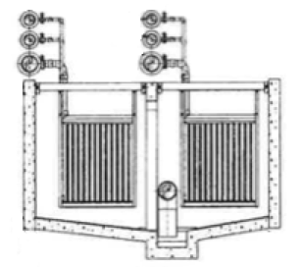

A_{module}, (ft²). Nominal Membrane Surface Area of 1 membrane module. Assume ZeeWeed* 500D Module is used (A_{module} = 340 ft²).

A_{cassette}, (ft²). Nominal Membrane Surface Area of 1 membrane cassette. Assume there are 48 membrane modules in one membrane cassette. (i.e. A_{cassette} = 48 × A_{module} )

Number of Cassettes per Train, n. The number of cassettes in each train is determined by the permeate flow (Q) required and membrane flux (J) assumed.

n = Q / N / J / A_{cassette}

Length of a Single Train, Length (ft). The length of each train can be estimated based on the number of membrane cassettes in the train.

Width of a Single Train, Width (ft). The width of each train is assumed to be 20 ft.

Depth of a Single Train, Width (ft). The depth of each train is assumed to be 12 ft.

Volume of a Single Train, V_{train} (ft³). The volume of each train can be calculated by the equation below:

V_{train} = Length × Width × Depth

Hydraulic Retention Time, HRT (hr). HRT can be determined by the equation below:

HRT = V_{train} / (Q / N)

The table below shows the relationship between the number of cassettes per train (n) and different characteristic lengths.

Tank& Building Dimensions (Unit: ft)
Cassettes ‘n’ per train | ‘A’ | ‘B’ | ‘C’ | ‘D’ | ‘E’ | ‘F’
5 | … | 27’– 4” | 18’– 8” | 69’– 6” | 17’– 0” | 6’– 0”
6 | … | 27’– 4” | 18’– 8” | 69’– 6” | 17’– 0” | 6’– 0”
7 | … | 27’– 4” | 18’– 8” | 69’– 6” | 17’– 0” | 6’– 0”
8 | … | 27’– 4” | 18’– 8” | 69’– 6” | 17’– 0” | 6’– 0”
9 | … | 27’– 4” | 18’– 8” | 69’– 6” | 17’– 0” | 6’– 0”
10 | … | 27’– 4” | 18’– 8” | 69’– 6” | 17’– 0” | 6’– 0”
11 | … | 29’– 6” | 18’– 8” | 69’– 6” | 17’– 0” | 6’– 0”
12 | … | 29’– 6” | 18’– 8” | 69’– 6” | 17’– 0” | 6’– 0”
13 | … | 29’– 6” | 18’– 8” | 69’– 6” | 17’– 0” | 6’– 0”
14 | … | 29’– 6” | 18’– 8” | 69’– 6” | 17’– 0” | 6’– 0”
15 | … | 29’– 6” | 18’– 8” | 69’– 6” | 17’– 0” | 6’– 0”
16 | 55’– 0” | 29’– 6” | 18’– 8” | 69’– 6” | 17’– 0” | 6’– 0”
17 |  | 31’– 8” | 18’– 8” | 69’– 6” | 17’– 0” | 6’– 0”
18 | 61’– 8” | 31’– 8” | 18’– 8” | 69’– 6” | 17’– 0” | 6’– 0”
19 |  | 31’– 8” | 22’– 0” | 76’– 8” | 17’– 0” | 6’– 0”
20 | 68’– 4” | 31’– 8” | 22’– 0” | 76’– 8” | 17’– 0” | 6’– 0”
21 |  | 31’– 8” | 22’– 0” | 76’– 8” | 17’– 0” | 6’– 0”
22 | 75’– 0” | 31’– 8” | 22’– 0” | 76’– 8” | 17’– 0” | 6’– 0”
23 |  | 35’– 0” | 22’– 0” | 76’– 8” | 17’– 0” | 6’– 0”
24 | 81’– 8” | 35’– 0” | 22’– 0” | 76’– 8” | 17’– 0” | 6’– 0”
25 | … | 35’– 0” | 22’– 0” | 76’– 8” | 17’– 0” | 6’– 0”
26 | … | 35’– 0” | 22’– 0” | 76’– 8” | 17’– 0” | 6’– 0”
27 | … | 35’– 0” | 22’– 0” | 76’– 8” | 17’– 0” | 6’– 0”
28 | … | 35’– 0” | 22’– 0” | 76’– 8” | 17’– 0” | 6’– 0”
29 | … | 38’– 4” | 22’– 0” | 76’– 8” | 17’– 0” | 6’– 0”
30 | … | 38’– 4” | 22’– 0” | 76’– 8” | 17’– 0” | 6’– 0”
31 | … | 38’– 4” | 22’– 0” | 76’– 8” | 17’– 0” | 6’– 0”
32 | … | 38’– 4” | 22’– 0” | 76’– 8” | 17’– 0” | 6’– 0”
33 | … | 38’– 4” | 22’– 0” | 76’– 8” | 17’– 0” | 6’– 0”
34 | … | 38’– 4” | 22’– 0” | 76’– 8” | 17’– 0” | 6’– 0”
Δ/per train | 3’– 4” | Step | Step | Step | Constant | Constant

where, ‘A’ = Length of each train = 5/3 + (3 + 4/12) × n
‘B’ = Width of pump house
‘C’ = Width of blower house
‘D’ = Length of blower house

2. Concrete
The figure below shows the concrete composition of the membrane trains (tanks), which can be divided into three portions: Portion I (shown in green), Portion II (shown in blue), and Portion III (shown in greenish-blue).

Figure- Concrete Composition

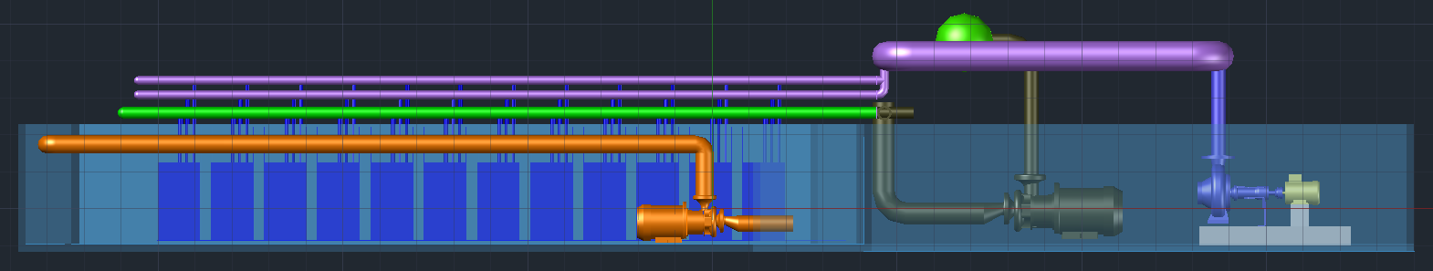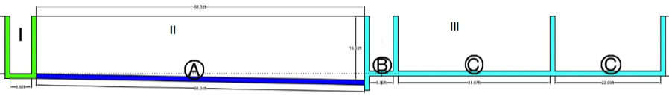

Wall thickness, t_{wall} (ft). Minimum wall thickness is 12”. If the depth of wall is over 12’, 1’ is added to wall thickness for every foot of depth over 12’.

Slab thickness, t_{slab} (ft). The thickness of slab concrete can be determined by the equations below, but the slab must be 12” thick in minimum.
t_{slab} = t_{wall} + 2”

Portion I. This portion is called membrane distribution channel, which is used to distribute the influent mixed liquor (Q) into N membrane trains.
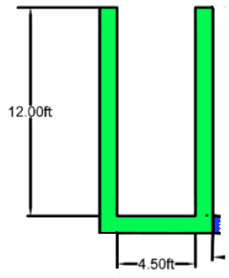
- Width of Distribution Channel, W_{dist} [ft].

W_{dist} = 4.5 [ft]

- Width of N Trains, W_{N_trains} (ft). For a N-train membrane tank, there are (N - 1) shared walls (each wall is 1 ft wide). So, the width of N trains can be calculated as:

W_{N_trains} = (Width + 2 × t_{wall}) × (N trains) – (t_{wall}) × (N -1 shared walls)

- Volume of Walls, V_{wall_I} (ft³). The volume of concrete needed to build the walls in portion I can be calculated as:

V_{wall_I} = Depth × t_{wall} × (2 × W_{N_trains} + 2 × W_{dist})

- Volume of Slabs, V_{slab_I} (ft³). The dimension of the slab is W_{N_trains} in length, 6.5 ft in length, and 1 ft in depth. So the volume of concrete needed to build the slab in portion I can be calculated as:

V_{slab_I} = W_{N_trains} × (W_{dist}＋ 2 × t_{wall}) × t_{slab}

Portion II. This is composed of multiple membrane trains, which are separated by concrete walls. Each train has a cross-section shown in the Figure below.

Figure- Cross-section of a Single Membrane Train
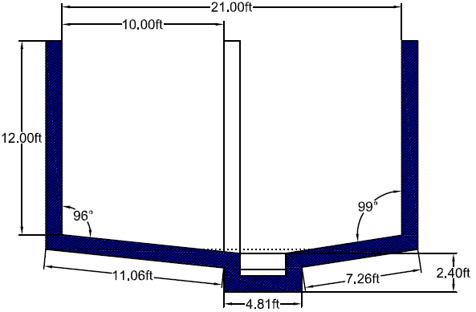

Figure- Cross-section of N Membrane Trains
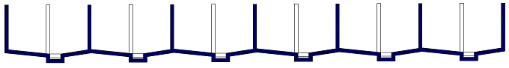

- Volume of Walls, V_{wall_II} (ft³). For a N-train membrane tank, the total number of walls equals (N+1). Each wall is 12 ft high, 1 ft wide, and L ft long. So, the total volume of concrete needed for building all the walls of N membrane trains can be calculated as:

V_{wall_II} = Depth × t_{wall} × (N + 1) × Length

- Volume of Slabs, V_{slab_II} (ft³). As shown in the Type-A cross-section, the slab is not flat. The total volume of concrete needed for building the slabs of N membrane trains can be calculated as:

V_{slab_II} = N × (11.06 ft + 2.4 ft + 4.81ft + 2.4 ft + 7.26 ft) × t_{slab} × Length

Portion III. This portion consists of the membrane effluent channel (B) and the area (C) that has the permeate piping and pumping equipment.

Portion III

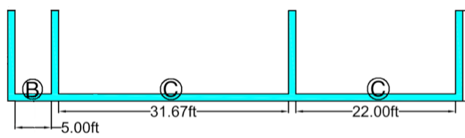
- Width of Effluent Channel, W_{eff} [ft].

W_{eff} = 5 [ft]

- Volume of Walls, V_{wall_III_B} (ft³). Adjacent membrane tank collectors share a common concrete wall (shown above), so the volume of concrete needed to build the walls (Portion III, C) can be calculated as:

V_{wall_III_B} = Depth × t_{wall} × [2 × W_{N_trains} + 2 × W_{eff}]

- Volume of Slabs, V_{slab_III_B} (ft³). The slab (Portion III, B) is of W_{N_trains} wide, (5 + 2 ft) long, and 1 ft deep. So, the volume of concrete needed to build the slab (Portion III, B) can be calculated as:

V_{slab_III_B} = W_{N_trains} × (W_{eff} + 2 × t_{wall}) × t_{slab}

- Volume of Walls, V_{wall_III_C} (ft³). The volume of concrete needed to build the walls (Portion III, C) can be calculated as:

V_{wall_III_C} = Depth × t_{wall} × (2 × W_{N_trains} + 2 × ‘B’ + 2 × ‘C’)

- Volume of Slabs, V_{slab_III_C} (ft³). The slab (Portion III, C) is of W_{N_trains} wide, (‘B’ + ‘C’ + 1 ft) long, and 1 ft deep. So, the volume of concrete needed to build the slab can be calculated as:

V_{slab_III_C} = W_{N_trains} × (‘B’ + t_{wall} + ‘C’) × t_{slab}

Wet Well. Wet well is designed to store mixed liquor that needs to be recycled.
- Depth of Wet Well, D_{well} (ft). The depth is assumed to be 12 ft.
- Width of Wet Well, W_{well} (ft). The width is assumed to be 8 ft.
- Length of Wet Well, L_{well} (ft). The length is assumed to be 8 ft.
- Thickness of Wall of Wet Well, t_{wall_well} (ft). The thickness of wall is assumed to be 1 ft.
- Thickness of Slab of Wet Well, t_{slab_well} (ft). The thickness of slab can be calculated by:

t_{slab_well} = t_{wall_well} + 2/12

- Volume of Walls, V_{wall_well} (ft³). The volume of walls can be calculated by:

V_{wall_well} = (D_{well} - t_{slab_well}) * {L_{well} * t_{wall_well} + (W_{well} – 2 × t_{wall_well}) * t_{wall_well}}

- Volume of Slabs, V_{slab_well} (ft³). The volume of slabs can be calculated by:

V_{_slab_well} = t_{slab_well} * L_{well} * W_{well}

3 Piping
The major pipe composition is air supply manifold, air header, permeate collector, permeate header, drain header, and CIP header.

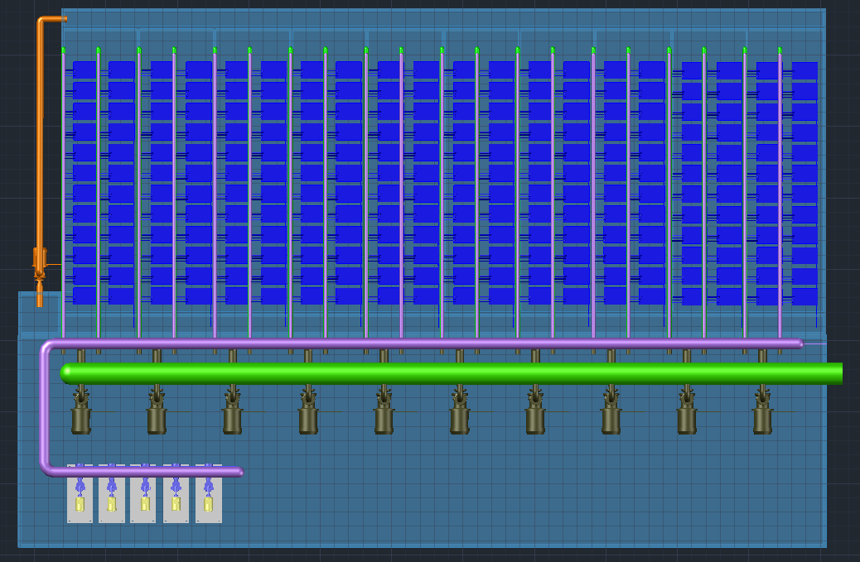

3.1 Air Supply Manifold
The highlighted pipe in the figure below represents the air supply manifold, which is composed of three different types of pipes A, B, and C. The specifications of each type of pipe are listed in the table below.

Figure- Air Supply Manifold
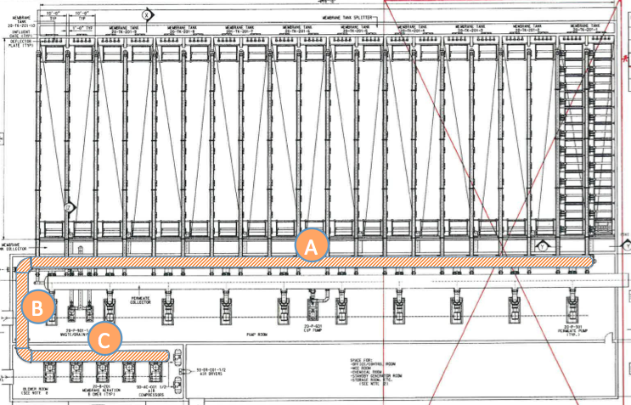

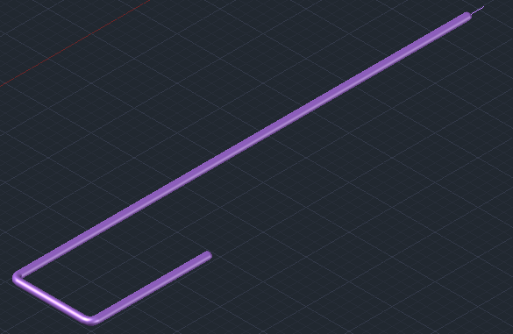

Table- Air Supply Manifold Specifications
Air Supply Manifold | A | B | C
Pipe Model Number | 36”, SCH.10.304L SS | 30”, SCH.10.304L SS | 30”, SCH.40 C.S.
Material | 304L Stainless Steel | 304L Stainless Steel | Carbon Steel
O.D. (inch) | 36.000 | 30.000 | 30.000
Wall Thickness (inch) | 0.312 | 0.312 | 0.688
Length, L_{asm} (ft) | (21 + 2)×N - (N - 1) ×1 | ‘B’ | ‘D’
Linear density, lbs/in³ (g/cm³) | 0.29 (8.03) |  | 7.85 (approximately)
- Carbon Steel refers to non-stainless steel
- Density of 304L stainless steel is from:
http://www.aksteel.com/pdf/markets_products/stainless/austenitic/304_304L_Data_Sheet.pdf
- N = Number of trains
- The length ‘B’ and ‘D’ is dependent on the number of cassettes in each train. (See table on pg. 3)
- 21 ft is the width of each train (including the 1-inch splitter in the middle of the train)

3.2 Air Header
The highlighted pipes in the figure below represent the air headers. There are 2 air headers connecting to each row of membrane modules and 4 air headers in total in each train. The specifications of air header are listed in the table below.

Figure- Air Header
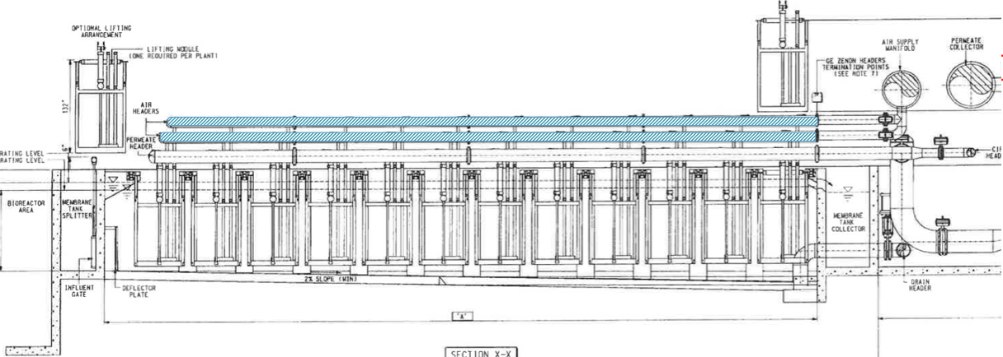
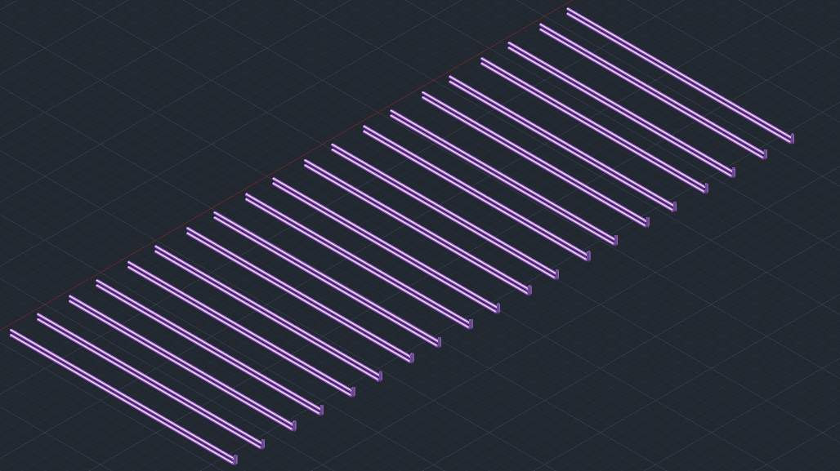

Table- Air Header Specifications
Pipe Model Number | 14”, SCH. 10s, 316L SS
Material | 316 Stainless Steel
O.D. (inch) | 14.000
Wall Thickness (inch) | 0.188
# of trains | N
Length Per Train, L_{ah} (ft) | L
Total Length, 4N* L_{ah} (ft) | 4N × L
Density, lbs/in³ (g/cm³) | 0.29 (7.99)
- Density 316L stainless steel is from:
http://www.aksteel.com/pdf/markets_products/stainless/austenitic/316_316L_Data_Sheet.pdf
- L = Length of each train
- There are 4 air headers in each train, and there are N trains in total.

3.3 Permeate Collector
The highlighted pipe in the figure below represents the permeate collector. The permeate collector changes in diameter along the direction of permeate flow. There are 4 different sections of permeate collector, shown as A, B, C, D respectively in the figure below. The specifications of the permeate collector are listed in the table below.

Figure- Permeate Collector
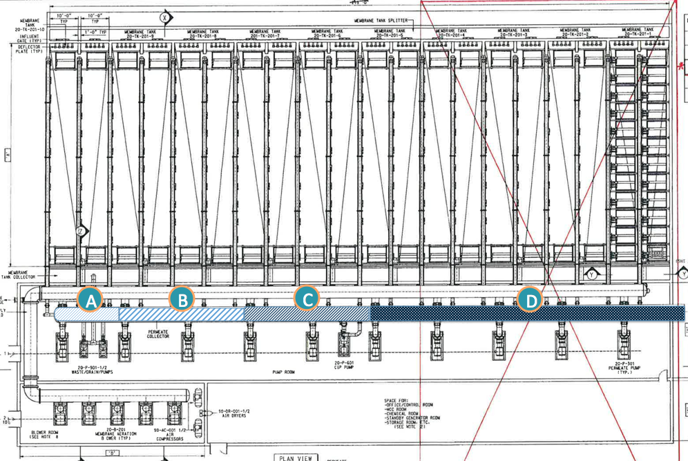
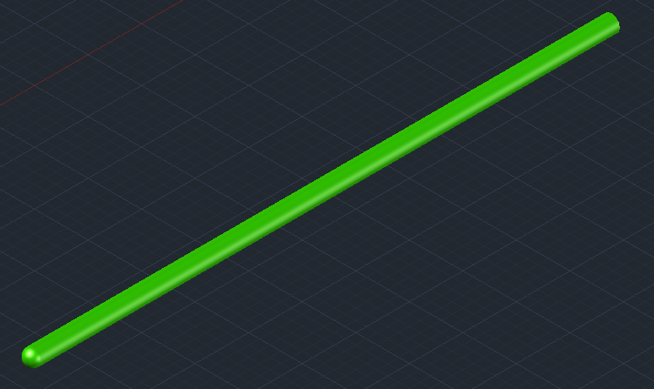

Table- Permeate Collector Specifications
Permeate Collector | A | B | C | D
Pipe Model Number | 12”, SCH. 10s, 316L SS | 20”, SCH. 10s, 316L SS | 24”, SCH. 10s, 316L SS | 30”, SCH. 10s, 316L SS
Material | 316L Stainless Steel
O.D. (inch) | 12.750 | 20.000 | 24.000 | 30.000
Wall Thickness (inch) | 0.180 | 0.218 | 0.250 | 0.312
Length, L_{pc} (ft) | 21 | 2×21 | 2×21 | (21 + 2)×N - (N - 1) ×1 - 5×21
Density, lbs/in³ (g/cm³) | 0.29 (7.99)
- Section A connects to 1 permeate header; section B connects to 2 permeate headers; section C connects to 2 permeate headers; section D connects to the rest permeate headers.
- Density of 316L stainless steel is from:
http://www.aksteel.com/pdf/markets_products/stainless/austenitic/316_316L_Data_Sheet.pdf
- L = Length of each train
- 21 ft is the width of each train (including the 1-inch splitter in the middle of the train)

3.4 Permeate Header
The highlighted pipe in the figure below represents the permeate header. There is one permeate header connecting to each row of membrane modules and 2 permeate headers in total in each train. The specifications of the permeate header are listed in the table below.

Figure- Permeate Header
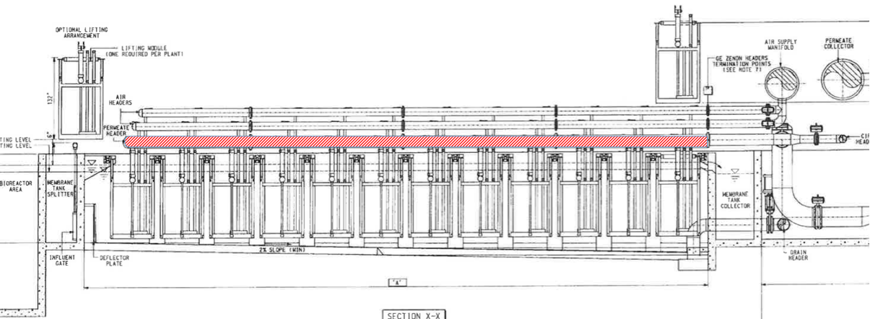
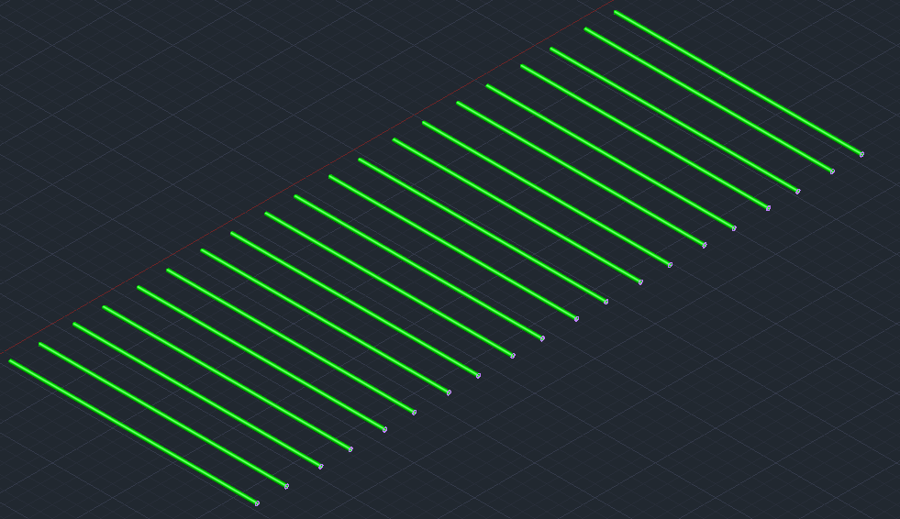

Table- Permeate Header Specifications
Pipe Model Number | 10”, SCH. 10s, 316L SS
Material | 316L Stainless Steel
O.D., inch | 10.750
Wall Thickness, inch | 0.165
# of trains | N
Length, L_{ah} | L
Total Length, 2N* L_{ah} | 2N × L
Density, lbs/in³ (g/cm³) | 0.29 (7.99)
- Density of 316L stainless steel is from:
http://www.aksteel.com/pdf/markets_products/stainless/austenitic/316_316L_Data_Sheet.pdf
- L = Length of each train
- There are 2 permeate headers in each train, and there are N trains in total.

4. Pumping

4.1 Pump Selection Steps
Step #1: Determine the total dynamic head (TDH) of the system based on a given design flow rate (Q).

Step #2: Choose a pump that has a pumping capacity greater than the design flow rate (Q).

Step #3: Confirm the NPSHA (Net Positive Suction Head Available) of the system is larger than the NPSHR (Net Positive Suction Head Required) of the selected pump.

Step #4: Based on the pump curve of the selected pump, find the head of the pump at the design pumping flow rate (Q). Make sure the head of the pump is larger than TDH of the system.

Step #5: Calculate the Brake Horsepower (BHP) of the pump working at the design pumping flow rate.

Step #6: Calculate the amount of energy input (E_{input}) to drive the pump.

4.2 Permeate Pumping
4.2.1. Total Dynamic Head, TDH_{p} (ft). The total dynamic head of permeate pumping is composed of the static head (H_{ts_p}), the friction head (H_{sf _p}, H_{df_p}), and minor losses (H_{m_p}). TDH_{p} can be calculated by the equation below.

TDH_{p} = H_{ts_p} + H_{sf _p}+ H_{df_p} + H_{m_p}

The terms in the TDH equation above are explained below:

- Suction Static Head, H_{ss_p} (ft). Suction static head of permeate pumping is the elevation difference between the operating water level in the membrane tank and the centerline of the permeate pump. The minimum operating water level is 9’- 7” and the maximum operating water level is 10’- 6” (see figure below). To consider the worse scenario possible, we use 9’- 7” for calculating static suction head. Assume the centerline of the permeate pump is 18” above the slab (assume 12” concrete equipment pad).

H_{ss_p} = (9 + 7/12 ft) – (18/12 ft) = 5.583 ft

- Discharge Static Head, H_{ds_p} (ft). Discharge static head of permeate pumping is the elevation difference between the centerline of the pump and the centerline of the permeate collector (where water is discharged). Assume the permeate collector is the highest point that sets the hydraulics.

H_{ds_p} = O.D./2 + ‘F’ + (12 ft) – (18/12 ft)

where O.D. = Outer diameter of the permeate collector (changing along the permeate collector)
‘F’ = length determined by the number of cassettes per membrane train (see pg. 3)

- Total Static Head, H_{ts_p} (ft). The total static head of permeate pumping can be calculated by the equation below.

H_{ts_p} = H_{ds_p} - H_{ss_p}

Figure - Static Head of Permeate Pumping
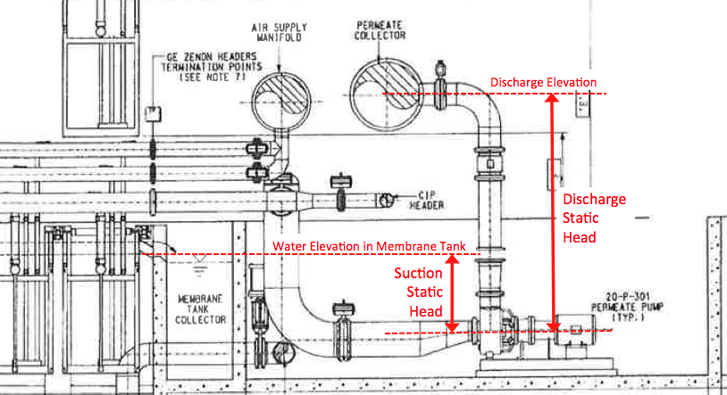
- Suction Friction Head, H_{sf_p} (ft). Suction friction head can be estimated using the Hazen- Williams equation. Suction friction head of permeating pumping refers to the friction loss caused in the suction pipes, which are the permeate headers.

H_{sf_p} = 3.02 L_{ph}Velocity_{ph}^{1.85} C^{-1.85} (D_{ph} /12)^{-1.17}

where L_{ph} = Permeate header length (ft) (Need to consider the length of 2 permeate headers in each train)
V_{ph} = Velocity in the permeate header (ft/s) = 2Q/ (N× πD_{ph}²) (The flow rate in each train is split in half into each permeate header)
Q = Total flow rate (m³/d) (unit conversion: 1 m³/d = 4.087 × 10⁻⁴ ft³/s)
N = Number of trains in service
D_{ph} = Diameter of permeate header (inch)
C = Hazen- Williams coefficient = 100 (20-year pipe) or 140 (new pipe)

- Discharge Friction Head, H_{df_p} (ft). Discharge friction head of permeate pumping refers to the friction loss caused in the discharge pipe, which is the permeate collector.

H_{df_p} = 3.02 L_{pc}Velocity_{pc}^{1.85} C^{-1.85} (D_{pc}/12)^{-1.17}

where L_{pc} = Permeate collector length (ft) (The length varies for each permeate pump)
V_{pc} = Velocity in the permeate collector (ft/s)
D_{pc} = Diameter of permeate collector (inch)

- Minor losses, H_{m_p} [ft]. Minor losses include the losses in 90-degree bends, tees, exit, and entrance, and are calculated using equations below.

H_{m_p} = $Σ$(K $×$Velocity_{pc}² /2g)

  - 90-degree bend: K₁ = 0.30
H_{m_p_1} = 3N $×$ (K₁ $×$Velocity_{ph}² /2g)

  - 2N Tees: K₂ = 0.30
H_{m_p_2} = 2N $×$ (K₂ $×$Velocity_{ph}² /2g)

  - Zero Exit loss: K₃ = 1.0
H_{m_p_3} = 1 $×$ (K₃ $×$Velocity_{pc}² /2g)

  - Zero Entrance loss: K₄ = 0.5
H_{m_p_4} = 0 $×$ (K₄ $×$Velocity_{ph}² /2g)

Where N is the number of membrane trains

4.2.2. Permeate Pump Details
Each permeate pump is responsible for pumping permeate produced in one train, and they all have to overcome the same head at the suction end. At the discharge end, the pump on the furthest left has to overcome the largest friction head and the pump on the furthest right just need to overcome the smallest friction head.

The number of trains in service varies for low flow, high flow and average flow. The table below shows this relationship:

# of trains  constructed | # of membrane trains in service
# of trains  constructed | Average flow | Low flow | High flow
1 | 1 | 1 | 1
2 | 1 | 1 | 2
3 | 2 | 1 | 3
4 | 2 | 1 | 3
5 | 3 | 2 | 4
6 | 4 | 3 | 5
7 | 4 | 3 | 6
8 | 5 | 4 | 7
9 | 6 | 4 | 8
10 | 7 | 5 | 9
11 | 8 | 6 | 10
12 | 8 | 6 | 11
13 | 9 | 6 | 12
14 | 9 | 7 | 13
15 | 10 | 7 | 14
16 | 11 | 8 | 15
17 | 11 | 8 | 16
18 | 12 | 9 | 17
19 | 12 | 9 | 18
20 | 13 | 10 | 19

4.3 Internal Recycle Pumping

Total Dynamic Head, TDH_{IR} [ft]. Total dynamic head of internal recycle pumping can be calculated by:

TDH_{IR} = H_{ts_IR} + H_{sf_IR} + H_{df_IR} + H_{m_IR}

The terms in the equation are explained below:

- Suction Static Head, H_{ss_IR} [ft] = 0 [ft]

- Discharge Static Head, H_{ds_IR} [ft]. Discharge static head of internal recycle pumping is the elevation difference between the centerline of the internal recycle pump and where water is discharged back into the up-flow anaerobic filter.

H_{ds_IR} = 5 [ft] (assumption)

- Total Static Head, H_{ts_IR} [ft]. The total static head of internal recycle pumping is calculated by:

H_{ts_IR} = H_{ds_IR} - H_{ss_IR}

- Suction Friction Head, H_{sf_IR} [ft]. Suction friction head is ignored.

- Discharge Friction Head, H_{df_IR} [ft]. Discharge friction head of permeate pumping refers to the friction loss caused in the discharge pipe, which is the permeate collector.

H_{df_IR} = 3.02 L_{df_IR}Velocity_{IR}^{1.85} C^{-1.85} (D_{IR} /12)^{-1.17}

* Assume Hazen-Williams constant C = 100

- Minor losses, H_{m_IR} [ft]. Minor losses include the losses in 90-degree bends, tees, exit, and entrance, and are calculated using equations below.

H_{m_IR} = $Σ$(K $×$Velocity_{IR}² /2g)

  - Two 90-degree bend: K₁ = 0.30
H_{m_IR_1} = 2 $×$ (K₁ $×$Velocity_{IR}² /2g)

  - Zero Tees: K₂ = 0.30
H_{m_IR_2} = 0 $×$ (K₂ $×$Velocity_{IR}² /2g)

  - One Exit loss: K₃ = 1.0
H_{m_IR_3} = 1 $×$ (K₃ $×$Velocity_{IR}² /2g)

  - One Entrance loss: K₄ = 0.5
H_{m_IR_4} = 1 $×$ (K₄ $×$Velocity_{IR}² /2g)

4.4 Electricity Consumption
Brake Horsepower, BHP. BHP is the amount of horsepower required to drive the pump and can be calculated by the equation below:

$$BHP= \frac{ flow rate × Head}{3960 × Pump Efficiency}$$

where flow rate (gpm) and head (ft) are the x-axis and y-axis respectively on a pump curve.

Energy input, E_{input} (Kw). The amount of energy input into the motor of the pump can be calculated as:

$$E_{input}= \frac{ BHP × 0.746}{Motor Efficiency}$$

* $Motor Efficiency$ is assumed to be 70%

NPSHA (ft). NPAHA is the net positive suction head available, which refers to the net positive suction head for the hydraulic system. The equation for calculating NPAHA is provided below. If the water level is higher than the centerline of the pump, the suction static head term (H_{ss}) should be positive. If the water level is lower than the centerline of the pump, H_{ss} should be negative. (In this case, H_{ss} should positive.)

NPSHA = H_{B} – H_{vp} + H_{ss} - H_{sf}

Where H_{B} = Barometric pressure head (barometric pressure ~12.2 psi)
H_{vp} = Vapor pressure head for water (vapor pressure ~2.89 psi)
H_{ss} = Static head at suction end
H_{sf} = Friction head at suction end

Sample calculations:

NPSHA = (12.2 psi – 2.89 psi)*(2.31 ft /0.983 psi) + (5.583 ft) – (1.8 ft)

5. Gas Blowing
There are 5 blowers (shown in blue in the figure below) used for air scouring for the purpose of membrane fouling control. The blowers are all connected in series directly to the air manifold (shown in orange).

Figure- Blowers and air manifold
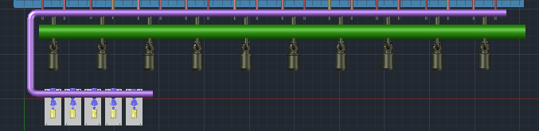

5.1 Brake Horsepower Calculation
There are two different ways to calculate the brake horsepower (BHP) needed for blowers.

Brake Horse Power Calculation

$$BHP=\frac{Adiabatic Horsepower}{Mechanical Efficiency}=\frac{SCFM\left(.23\right)\left[{\left(\frac{14.7+P}{14.7}\right)}^{0.283}-1.0\right]}{Mechanical Efficiency}$$

where
SCFM = Standard Cubic Feet Per Minute (flow rate)
P = Blower discharge pressure in PSIG (gage pressure)

6. Membrane

6.1 Membrane Module

Table- [GE- ZeeWeed* 500D Module]
Max. Shipping Weight (crated) | 26 kg (58 lb)
Membrane Weight | 19.5 kg (43.5 lb)
Stainless Steel Weight | 6.5 kg (14.5 lb)

Assumptions:
1) The weight of packing material is neglected
2) Membrane (PVDF) accounts for ¾ of the weight for each module
3) Stainless structures (supporting membrane) account s for ¼ of the weight of each module

6.2 Membrane Cassette

Table- [GE- ZeeWeed* 500D Cassette]
# of ZeeWeed Modules in each cassette | 48
Shipping Weight (crated) | 1730 kg (3815 lb)
Steel Weight | 482 kg (1031 lb)

Assumptions:
1) The weight of packing material is neglected
2) The weight of steel (including piping, etc.) is calculated by:

Weight of steel = Weight of cassette – Weight of each module * 48

The table is from the document “TYP Zenon MBR Drawing_20121029082809”
Note that the length ‘B’ and ‘D’ is dependent on the number of cassettes in each train. (See table on pg. 3)
All the pipe lengths are not accurate because there are no clear length indicators in the drawing.
The information of air supply manifold is from the document “TYP MBR_20121029083412.pdf”- pg. 4
The information of air header is from the document “TYP MBR_20121029083412.pdf”- pg. 6
The information of permeate collector is from the document “TYP MBR_20121029083412.pdf”- pg. 15
The information of permeate header is from the document “TYP MBR_20121029083412.pdf”- pg. 6
Method from “Sanitaire-Diffused Aeration Design Guide”

