ASSIGNMENT:

Submitted To: Sir. Tahir Shafi

TOPIC:

* Defination of High and Low Level Languages
* Examples of High And Low Level Languages
* Difference Between High And Low Level Language
* Now a days Trending or Popular High Level Language

Low Level Language:

A low-level language is a [programming language](https://www.computerhope.com/jargon/p/programming-language.htm) that provides little or no abstraction of programming concepts and is very close to writing actual machine [instructions](https://www.computerhope.com/jargon/c/compinst.htm). Two good examples of low-level languages are [assembly](https://www.computerhope.com/jargon/a/al.htm) and [machine code](https://www.computerhope.com/jargon/m/machlang.htm).

Essentially low level languages are assembly languages, and the machine language itself.

Example of Low Level Language:

 assembly languages are considered low-level because they are very close to machine languages.

High Level Language:

A ***h***igh-***l***evel ***l***anguage (**HLL**) is a [programming language](https://www.webopedia.com/TERM/P/programming_language.html) such as [C](https://www.webopedia.com/TERM/C/C.html), [FORTRAN](https://www.webopedia.com/TERM/F/FORTRAN.html), or [Pascal](https://www.webopedia.com/TERM/P/Pascal.html) that enables a [programmer](https://www.webopedia.com/TERM/P/programmer.html) to write [programs](https://www.webopedia.com/TERM/P/program.html) that are more or less independent of a particular type of [computer](https://www.webopedia.com/TERM/C/computer.html). Such [languages](https://www.webopedia.com/TERM/L/language.html) are considered high-level because they are closer to human languages and further from [machine languages](https://www.webopedia.com/TERM/M/machine_language.html).

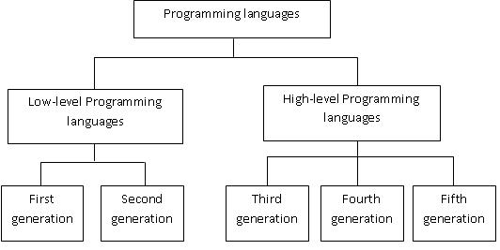

Difference between High and Low Level Language:

Low level language is also known as machine level language and it is written in the form of 0 or 1 and it doesn't requires compilation and the computer can understand easily

High level language is written in a simple English language statement where the user can understand easily while giving command to computer. Since it requires compiler to convert from high level language to low level language.

The difference is very simple

1 high level language is portable whereas low language is not

2 remembering binary codes is very difficult hence high level languageis used more

3 low level language takes less time whereas high level language takes less time

4 debuging high level language is easy as compared to low level language

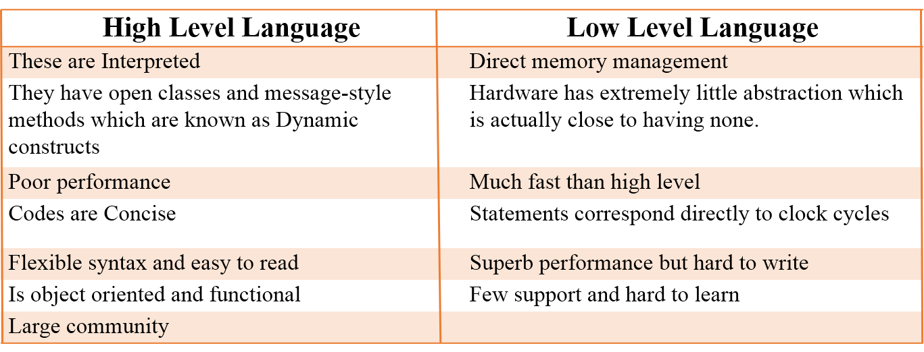

Popular / Trending High Level Language:

Python is a high-level programming language and one of the world's fastest-growing languages. It's an easy language to get started with, but it's often used forhigher-level programming like machine learning and data analysis. One of the mostpopular tutorials for Python is called "Learn Python the Hard Way."