
Radioisotope Power Systems:
Quantum Tunneling in Alpha Decay

Objective This module studies the phenomenon of radioactivity, focusing in more detail on one of the types — alpha decay. Students will be asked to consider it in the context of quantum physics when alpha decay is interpreted as the tunneling of the alpha particle through the nucleus’s potential barrier. Results of modeling this phenomenon based on the WKB (Wentzel–Kramers–Brillouin) approximation will then be applied to solve a problem at the end of the module.

Activity with the interface:
https://qtechedu.centralesupelec.fr/EN/ex8.html

1. General questions. Using the interface answer the following question and perform the suggested calculations:
- Give a definition of radioactivity. What types of radioactivity can be identified?
- What does it mean when we say an element is radioactive?
- What’s the difference between natural and artificial radioactivity?
- Write the nuclear reaction equation for the α-decay of two of the following isotopes: U-238, Po-210, Ra-226, Th-232, Pu-238 and explain your result (what element is formed and how the atomic and mass numbers change etc).
- What are the typical atomic and mass numbers of elements that undergo alpha decay?
- How does the number of undecayed nuclei change with time? Write the decay law.
- What is the definition of half-life?
- Explain how is the decay constant related to the half-life and derive the formula connecting them.
- What does the decay width (λ) represent physically? How is the it related to the mean lifetime (τ) of an unstable state? Give the definitions of these parameters.
- How is α-decay described in terms of quantum-mechanical approaches, and which models are used to calculate the probability of α-particle emission from a nucleus, half-life parameter of radioactive materials?

2. In the “Potential Energy Profile” tab, the potential in which the α-particle is located before and after leaving the nucleus is defined, for use in calculations of the tunneling probability and half-life.
- Using the drop-down menu, select an element: The parameters for the calculation will be inserted by default, and you may adjust them if necessary.
- Fill in the table below.
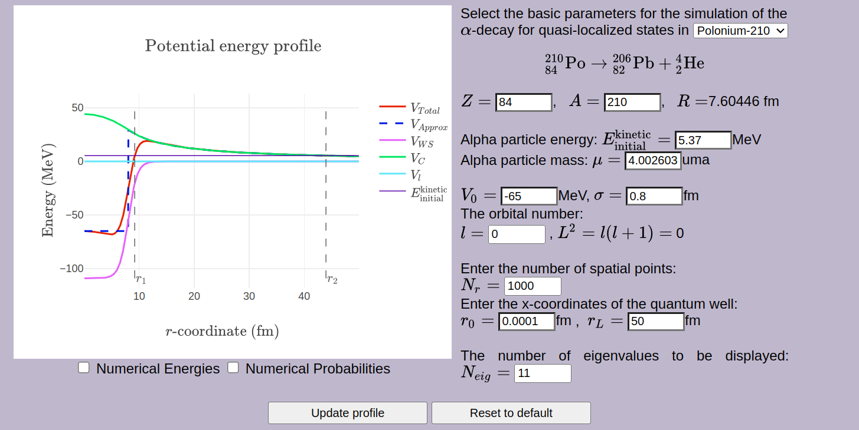 | Attention!  If you choose the 'User Selection' option, you must enter the parameters manually.  To ensure that the reaction you specify is valid, please refer to the data available at:  https://github.com/QtechEdu/LabReports.
- Write the alpha decay reaction for the selected element. Specify the particles obtained as a result of the decay.
______________________________________________________________
- Using the interface, complete the blanks below with each quantity with its units and corresponding description.
Z = | A =
= | μ =
V₀ = | σ =
l = | N_{r} =
r₀ = | r_{L} =
N_{eig} = | R =
- Click button “Run calculation”.
“Reset to default” button allows you to restore the default values.
After selecting the 'Numerical Energies' and/or 'Numerical Probability' options, their values - obtained numerically using the DVR method - will be added to the figure according to the selected number of eigenvalues." to the figure according tho the selected number of eigenvalues.
- Briefly analyze the results based on the obtained graph (what do r₁ and r₂ represent).
- How can the nuclear radius R be estimated for a given nucleus, and what formula is commonly used for this estimation?
- What physical quantities influence the probability of α-decay (energy, potential barrier, nuclear mass, nuclear charge, etc.)?
- What potentials are used to describe the α-particle inside and outside the nucleus (Woods-Saxon model and Coulomb potential)? Which parameters determine their shape?

3. The “Observable” tab presents methods for modeling α-decay in order to obtain parameters such as the decay constant and half-life.
- What is Gamow’s approximation? Explain how the tunneling probability of an alpha particle is obtained in this approach.
- Write down the expression for calculating the tunneling probability of α-decay using the WKB approximation?
- To calculate the half-life, the necessary physical parameter is the decay constant. Explain which principle is used to obtain it in the presented method.
- Compare the results of half-life calculations using the two presented approaches. What are the differences? Why does the number of segments used in the Gamow approximation depend on the values of the decay constant? How can the accuracy of these methods be improved?
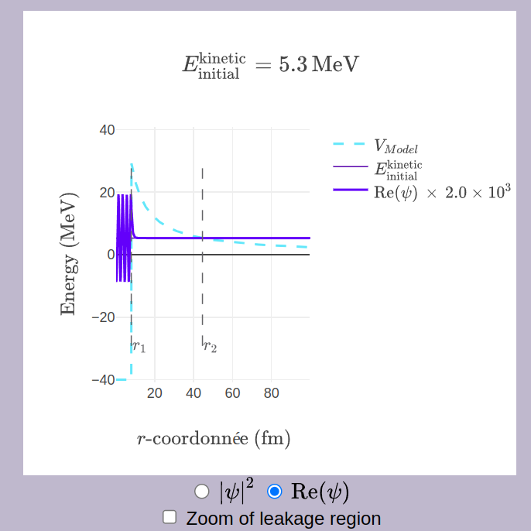 | 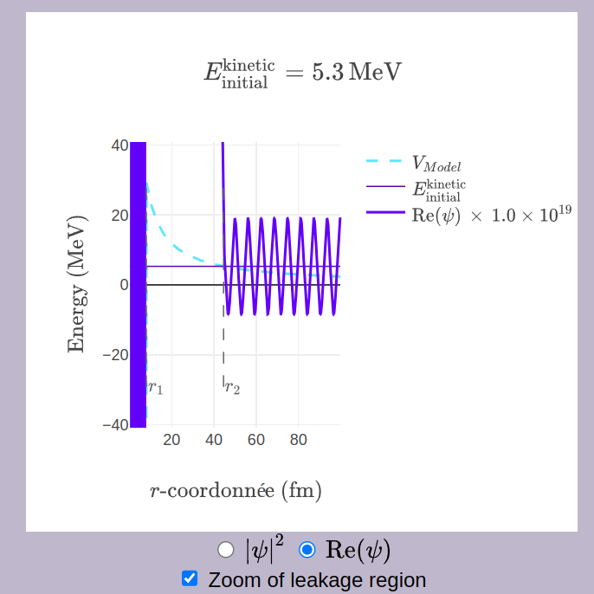
- In the figure, we observe or (with scaling, in the case of a free alpha particle). What does each value represent?
- Using the WKB method, show that .
- What are the limitations of applying the WKB approximation in modeling alpha decay?
- Explain why the WKB/Gamow approaches are considered semi-classical methods.
- Describe the alternative approaches employed in the modeling of alpha decay.

3. In the last section of the “Radioisotope Power Systems: Quantum Tunneling in Alpha Decay” module (https://qtechedu.centralesupelec.fr/EN/ex8.html), the basic principles of operation of the Radioisotope Thermoelectric Generator (RTG) were discussed. Use this module to calculate the missing parameters (specifically, the half-life τ₁/₂ of the radioactive element used in the RTG) to solve the following problems:

A Radioisotope Thermoelectric Generator contains 1 kg of Plutonium-238 (²³⁸Pu). The energy released during the alpha decay of a single nucleus is 5.593 MeV. The generator’s thermocouples convert the thermal energy into electricity with an efficiency of 6%.
- Calculate the thermal power produced by 1 kg of ²³⁸Pu.
- Determine the electrical power output of the RTG.
- If the RTG is used to power electronics on a spacecraft, calculate how its power output will change after 10 years.

Parameters used for calculation:
- Mass of ²³⁸Pu: m= 1 kg
- Energy per alpha particle: Eα = 5.593 MeV
- Thermocouple efficiency is 6%.

Analise how the efficienci of the RTG chenges at different radiactive material using. (Make comparation min between two Th-232, U-238, Po-210, etc.
Suggestion: Specify the laws that will be used to solve the problem. A demonstration of the derivation of the final expression is welcome.

* Atomic units are used https://en.wikipedia.org/wiki/Hartree_atomic_units that are defined as following:
ħ=1 unit of angular momentum,
e=1 unit of charge,
mass of the electron m_{e}=1 unit of mass.
Units of all other quantities are derived from these three units. Atomic units are very convenient in quantum mechanics (atomic, molecular physics). If you see the symbols “a.u.”, it means that one uses atomic units for this quantity.

