
Photoionization

Objective: In this module, we will explore the process of the photoionization, in which a quantum system (atom, molecule, surface of a solid) is illuminated by an electromagnetic radiation (EM) and, as a result, emits an electron. Photoionization is one of the fundamental processes, described accurately only by quantum mechanical methods. Photoelectric effect, which leads to the early development of the quantum theory, could be considered as a particular case of the process. Here, we will consider atomic photoionization, more precisely, photoionization of an atom having, for simplicity, only one electron in the external shell, such as H, Li, Na, K, or similar. The module will focus on calculating (approximately) wave functions of the external electron of the atom. We consider the initial wave function (i.e. before ionization) and the final wave function (after ionization). Then, we apply the theory developed for photon absorption/emission to evaluate the transition probability from the initial to the final state of the system under the influence of the EM radiation. The transition probability is then used to computed the cross section of the photoionization. We consider an application of the developed python code to determination of photoelectric current in a gas subject of the EM radiation. Having studied the module, students will have an understanding of the process, will be familiar with possible applications and prepared to other advanced topics in quantum technology.

Problem:
In the last section of the “Photoionization” module (https://qtechedu.centralesupelec.fr/EN/ex1.html) the basic principles of operation of the photoionization detector (PID) were discussed (in the “Application” tab) .
Imagine that PID is used to measure the concentration of Na vapor in a room under standard condition:
- Pressure P = 101325 Pa
- Temperature T = 298 K.
The detector uses an ultraviolet lamp with photon energy 10.6eV. Calculate the current generated in the detector if the detected concentration is 3.6 ppm.

Parameters for calculation:
- Charge of an electron e = 1.602 . 10⁻¹⁹ C;
- Volume of the ionization chamber V = 1 m³;
- Emitted power of the lamp P_{lamp} = 1 W.

Solution method:

The current in the PID is determined by the rate of ion production, which depends on:

- Concentration of benzene - how many benzene molecules are present in the detector's gas stream.
- Photon flux of the UV lamp - how many photons are available to ionize benzene molecules.
- Photonization cross-section - the probability of a benzene molecule being ionized when hit by a photon.

Once ions are produced, they are collected at the electrodes. The current is proportional to the number of ions collected per unit time:

,
where N_{i} is the number of ions produced per unit time. It is proportional to the volume density of benzene in the PID, the photoionization cross section and the photon flux (current density),

where σ - photoionization cross-section (units of area). For energy photons 10,6 eV,
σ = 29 Mb = × 10⁻²² m⁻².

The number of benzene molecules inside the PID is

where - the ratio of the number of the benzene molecules to the total number of molecules (dimensionless), and are the total number (units of particles) and volume density (particles/m³) of all molecules in the PID ionization chamber, respectively. V is volume of the ionization chamber, which can be obtained from the technical documentation of the PI detector.

We can get n from Ideal gas law ,
where k_{B} = 1.380649 × 10⁻²³ JK⁻¹ is the Boltzmann constant and P is the total pressure of the gas in the chamber. Therefore,

where is photon flux, i.e. the number of photons received by the PID per unit time and per unit area (for example, in units of photons/(s . cm²)). It determines how many UV photons are available to ionize gas molecules in the detector chamber. It is obtained from the intensity of radiation at PID as

where is the photon energy. The intensity of radiation can be obtained dividing the power of radiation, emitted by the lamp, with , where d is the distance from the lamp to the PID.

Combining all the above formulas together, we obtain

To compute the current, you also need the photoionization cross section σ. To obtain σ, use the “Quantum Technology” interface (https://qtechedu.centralesupelec.fr/EN/ex1.html) “Photoionization cross section” module.

Activity with the interface:

Using the interface answer the following question and perform the suggested calculations.
1. The Introductory part:
- Review the derivation of the equation for photoionization (PI) cross section of an atom. What is the main equation for the PI? Review the main steps in the derivation of the formula. What approximations and assumptions are used in the derivation?
- Why is it assumed that only one electron in the outer shell participates in the ionization process? For which systems is this assumption valid (i.e., the one-electron approximation for atoms)? Give examples where the this approximation is NOT correct?
- What are the initial and final energy states of the atom during the ionization process? Describe the process of solving the radial Schrödinger equation for the case of a Coulomb potential for the bound and continuum states.
- What is the physical meaning of the photoionization (PI) cross section, and which quantities determine it? Review the concept of the cross section (in classical and quantum mechanical approaches).

2. In Tab “Coulomb functions for Negative Energies” explore the method for calculating the wave function of an electron in a bound state using Whittaker functions.
- What method is used for solving the Schrödinger equation? Why is the transformation applied?
- What are the Whittaker functions, how are they related to the solution of the Schrödinger equation for the Coulomb potential? How would you calculate these functions for a given energy E?
To visualize the wave function of an electron in bound state, use the interface. The necessary tools are located at the bottom of the tab “Coulomb functions for negative energies” (as shown in the image below).
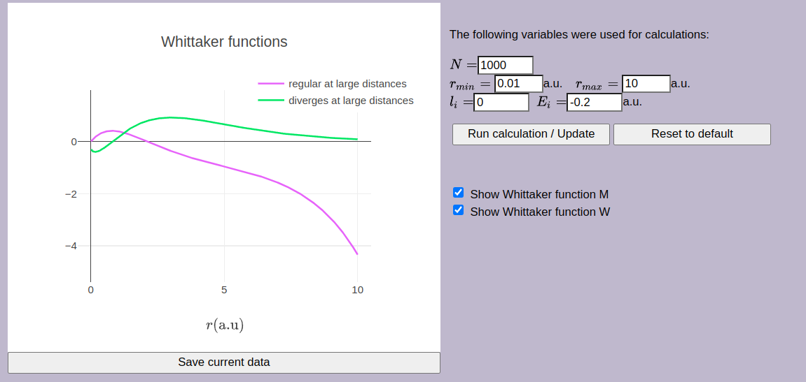 | 1. Use the following parameters:  r_{min} = 0.01 a.u. (bohr)  r_{max} = 10 a.u. (bohr)  l_{i} = 0  E_{i} = -0.2 a.u (hartree)  The mass is 1 a.u. (mass of electron, m_{e})  Click button “Run calculation”.
The “Reset to default” button allows you to restore the default values.
If you need to save the result, click button “Save current data”.
2. Perform calculations for different values of the initial energy: -0.5 a.u., -0.25 a.u.

3. In the tab “Coulomb functions for Positive Energies” a method for calculating the wave function of an electron in a free state following photoionization using Coulomb functions is presented.
- What are the regular (F_{l} (η,z)) and irregular (G_{l} (η,z)) Coulomb wave functions? How do they differ in their physical interpretations?
- Why the Schrödinger equation for E > 0 has to be transformed into a standard form?
- Compare Whittaker functions for bound and continuum states in solving the Schrödinger equation for Coulomb potential. What are the advantages and limitations of each approach?

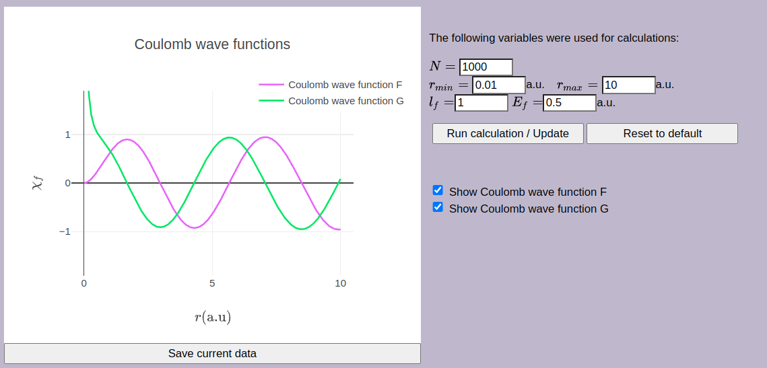 | 1. Use the parameters in the cases:  r_{min} = 0.01 a.u. (bohr)  r_{max} = 10 a.u. (bohr)  l_{i} = 0  E_{i} = 0.5 a.u (hartree)  The mass is 1 a.u. (mass of electron, m_{e})  Click button “Run calculation”.
2. Perform calculations for different values of the final energy: 0.8 a.u., 1 a.u.

4. In the “Photoionization Cross Section” tab, you can calculate the PI cross section for different atoms and different types of transitions. Atoms can be selected using a drop-down menu, which will automatically set the corresponding quantum numbers. Alternatively, you can manually input the quantum numbers by entering values into the designated fields.

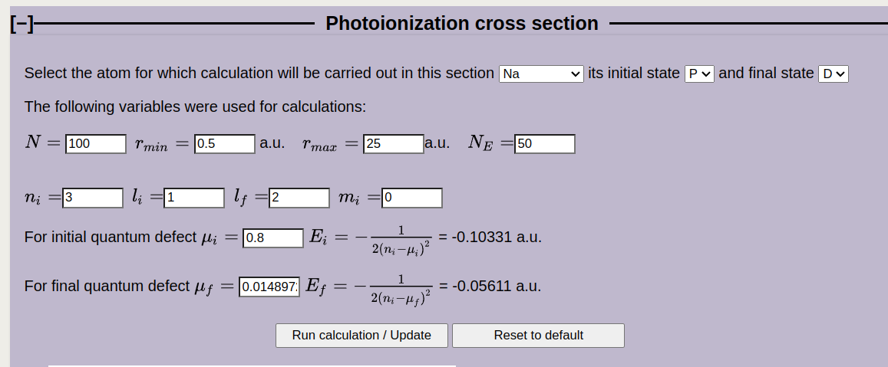 | 1. To find the PI cross section σ^{PI}:  - Select Na and the desired transition () or enter the required values into the fillable boxes.  - The corresponding values of the quantities will automatically appear in the boxes.
2. Using the interface, complete the blanks below with the quantities and their physical names.
N = N_{E} =
r_{min} = a.u.*
r_{max} = a.u.
n_{i} =
l_{i} = , l_{f} =
m_{i} =
μ_{i} = , μ_{i} =
Click button “Run calculation”.
3. Using the resulting figures, determine the PI cross section required to solve the problem.
σ^{PI} = cm².
4. Define the unit of concentration [ppm] and explain how it is converted to SI units [m⁻³].
5. Find the final formula for current I, using the material from “Solution method”. Apply the dimensional method to verify its correctness based on the International System of Units (SI).
6. Calculate the current that the PID shows: I = A, if the relative fraction of Na atoms is 3.6 ppm.
7. Interpret the Resulting Graphs:
- analyze the information presented in the resulting figures;
- provide an explanation of what insights can be drawn from the graphical data.

* Atomic units are used https://en.wikipedia.org/wiki/Hartree_atomic_units that are defined as following:
ħ=1 unit of angular momentum,
e=1 unit of charge,
mass of the electron m_{e}=1 unit of mass.
Units of all other quantities are derived from these three units. Atomic units are very convenient in quantum mechanics (atomic, molecular physics). If you see the symbols “a.u.”, it means that one uses atomic units for this quantity.

