SmartLPM

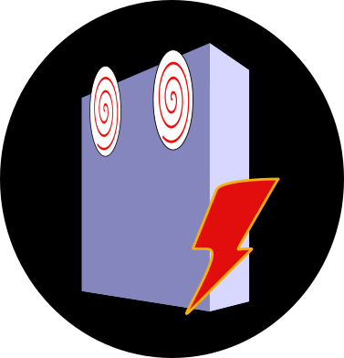
Smart Light Power Measurement (SmartLPM) is a tool for acquiring and sorting light power data automatically. What makes it different from other applications is its ability to classify the incoming data according to user instructions. In order to do this it detects patterns in the illumination data matching predefined sequences. We will call these patterns the data signature of the experiment.

The problem to resolve
The assessment of light power and stability over multiple light sources and different set powers can be time consuming and prone to introducing errors. On the image below we depict illumination sequences for studying the linear response (left) and power stability over long periods of time (right) for an example with four different lasers. The first example consists in 16 phases and the second, if done every 5 minutes along 2h has 96 phases.

The critical problem is the need to reconfigure the acquisition (tuning the power meter and recording the set power) before each phase.
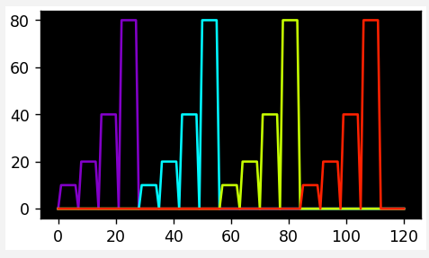
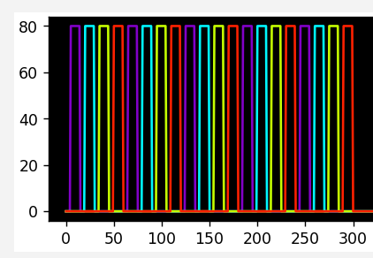
Fig. 1. Pulse sequence for linearity (left) and stability assessment (right) tests. The stability test example has been cropped for illustration purposes.

On the examples above, manually operating the devices in the first experiment would be highly impractical, and in the second experiment -where pulses are interleaved in regular intervals over hours- it becomes unfeasible. Alternatively, the same experiments can be automated. Some microscope control suites provide tools to control external devices, such as power meters, allowing this as demonstrated by the QUAREP-LiMi community [2]. Unfortunately, this is not always possible.

In general, while it is still possible in most modern microscopes to setup the illumination sequences, power meters provide no way to predict them. Until now, unless the microscope has the ability to prepare the power meter for each individual test a human operator remains necessary. SmartLPM was programmed to circumvent this problem.

Semi-automatic power measurement
While automation might initiate all the tests required for quality assessment with the press of one button, for a more general scenario we propose the pressing of two buttons: one to start the illumination and another to start the acquisition. Real-time data processing brings synchronization, tuning and classification without human intervention. To accomplish this SmartLPM offers:
- Direct measurement of optical powers using a power meter device (currently the Thorlabs PM family [1] is supported). This function replicates the standard acquisition mode of the vendor software, here the Optical Power Monitor software from Thorlabs.
- Automatic data parsing (reassignment). The data can be split into groups according to their wavelengths and set powers in an unsupervised manner. This concept is illustrated in fig. 2
- Predictive tuning. There is no need to tune the power meter device manually if the wavelengths are given initially. This is the second and last requirement for running complex power measurement tests automatically.
- Management of the experiment instructions. Different experiment recipes can be created and visualized easily. These recipes can be stored and retrieved for later use.
- Data sorting over files. This function is aimed to work in combination with the QUAREP-LiMi Tool Kit [2] for browsing acquisition data over time.

The data parsing can be done during the acquisition or afterwards, directly on the acquisition data stream or on the contents of a data file.
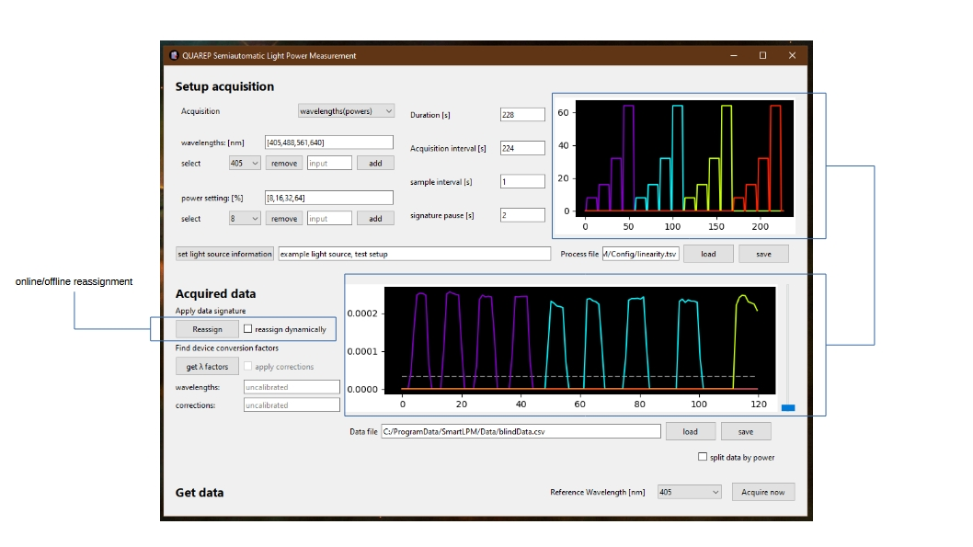
Fig. 2. Automatic data parsing. The acquired data (plot below) is compared to the experiment signature proposed (plot above) leading to the matching pairs. In this example the intensities used creating the test data set do not match the proposed ones.

Although originally developed for microscopes, this software can be used for any illumination device with multiple or tunable wavelengths and adjustable power levels.

Using SmartLPM
To setup and carry out power assessment experiments this software has two separate panels.
Setup panel. On the top panel it is possible to introduce and visualize the test recipes (fig. 3). These fields define how the illumination sequence will be configured at the microscope:
- A list of wavelengths [nm]. New values can be introduced and removed.
- A list of power settings [%]. New values can be introduced and removed.
- Order of the experiment. Loop over all wavelengths available before the next power setting powers(wavelengths) or loop over all power settings available before the next wavelength wavelengths(powers).
- The duration of the experiments [s]. After the given time the acquisition will be terminated.
- The acquisition interval [s]. All the power/wavelength combinations will be repeated for the duration of the experiment. The acquisition interval is the time spent in each of these cycles.
- The sample interval [s]. Sample rate for the data acquisition. For the power meters currently supported this time has to be of at least 1s.
- A signature pause [s]. The software needs pauses to distinguish the different pulses. This number represents the duration of these pauses.
- For data organization the light source information is part of the recipe.
At the moment the duration of the pulses is not taken into account for parsing, as this is done solely by comparing to a threshold.
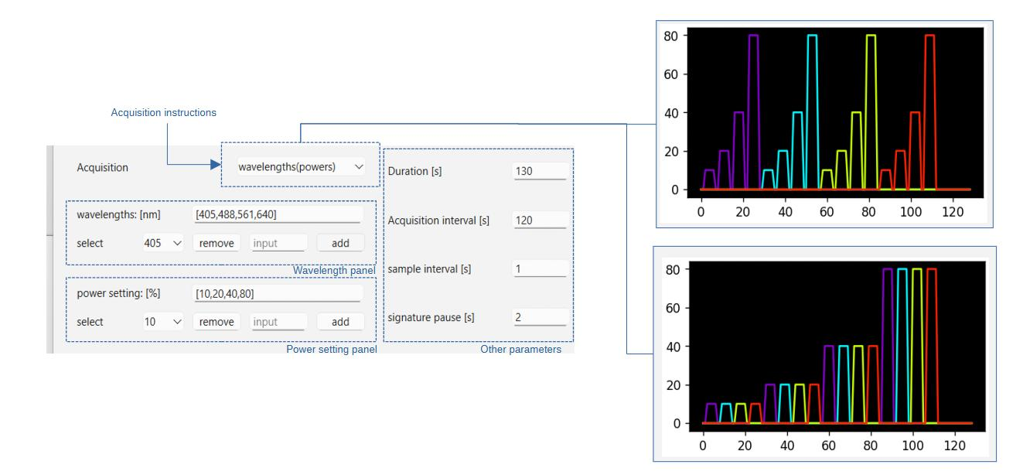
Fig. 3. Data signature generation. User input for the description of the pulse series that will be acquired.
The recipes can be saved as csv files and reloaded for later use. For example purposes there are 3 recipes available: linearity, longStability and shortStability. Additionally, defaultProcess.tsv will open by default.
Acquisition panel. Starting from the bottom right corner, next to the Acquire now button a wavelength from the list introduced above can be chosen for tuning the power meter. In this way the acquisition can be started in a conventional way.
Reassignment (parsing). Once the acquisition starts -or if an existing data file is loaded- we can set a threshold value for pulse parsing. This can be done with the slider on the right or by clicking directly on the plot. For more precise selection over the plot, it is possible to zoom in and out with the mouse wheel. Clicking the right mouse button resets the range.
The threshold will be used to distinguish the pulses for matching them to the data signature defined before. To do this we can press Reassign or check the reassign dynamically tick box to do it once the complete data set is available or during the acquisition. The effect of the reassignment function is shown in fig. 4.

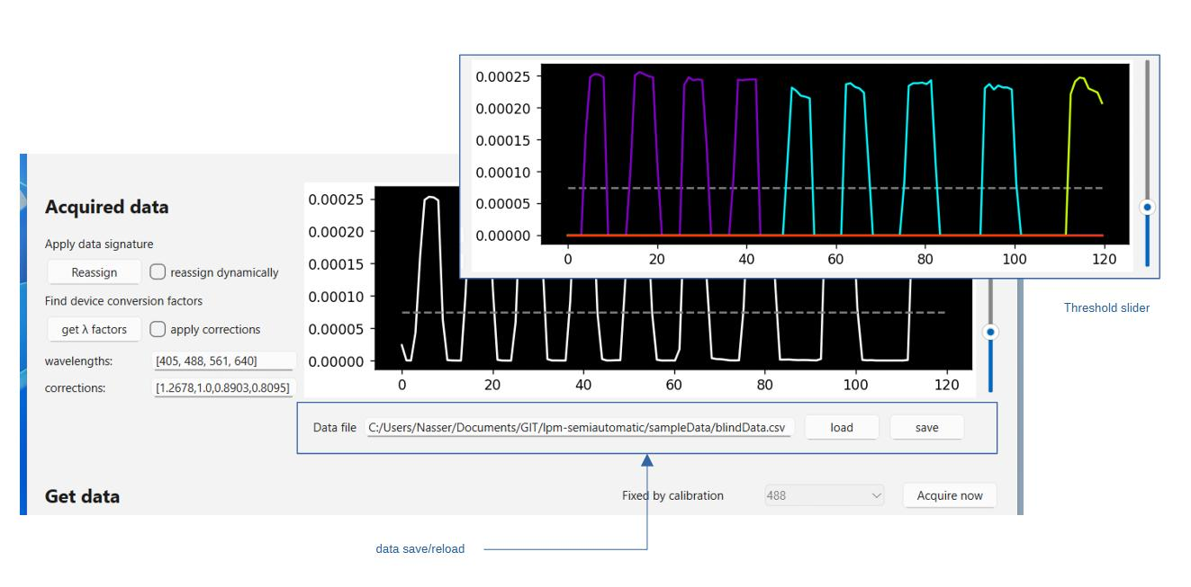
Fig. 4 Acquisition panel. On the left are the controls for the data parsing and predictive tuning and on the right the acquired data is shown (here showing the effect of applying the reassignment function).

Calibration and predictive tuning. If we plan to acquire pulses of multiple wavelengths a the acquired data has to be corrected as described in the predictive tuning section of this manual.
A calibration process will find the appropriate corrections for each wavelength detected. The calibration process consists in the following:
On the system we are going to study we turn on the illumination source that we plan to use as a reference. As an example, a laser of 488nm. The software will run a short test on this source, tuning the power meter at each of the wavelengths listed to use later. Provided that only while tuned at the same wavelength the measured power will be correct the software will find the ratios for all the other tuning settings. The ratio for the reference wavelength will be 1. These ratios are the correction factors that will be applied later.
The calibration process takes only 5s per wavelength and is transparent for the user, but some considerations are important.
- During process the power meter must be illuminated at the reference wavelength.
- The apply corrections tick box is disabled until a calibration is available.
- Once the system is calibrated the set wavelength selector for the power meter disables and set to the reference value.
- Calibration here refers to the finding of correction factors to avoid the manual tuning of the power meter. The power meter itself has to be calibrated and this process has nothing to do with it.
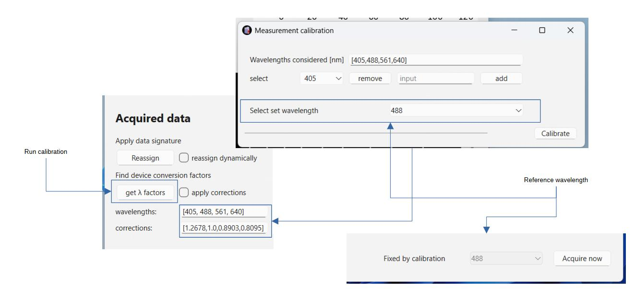
Fig. 5 Calibration procedure

Once the process is calibrated the corrections can be applied during the acquisition or by pressing Reassign with the apply corrections tick box enabled.

The save button.
- Raw data is saved automatically in C:\ProgramData\SmartLPM\Data with the format YYYYMMDD-HHMM_raw.txt.
- If the data has been parsed the save button will create one file per wavelength, under C:\ProgramData\SmartLPM\Data\Light Sources, using the light source information filled initially.
By default the following rules are applied:
- With more than one set intensity, the recipy assumes a linearity check: all measured powers will be stored with their corresponding set intensities. To get one file per set intensity use the split data by power check box.
- If wavelengths are tested only once but for more 30 minutes (1800 s) or if wavelengths are interleaved in a single test during more than 30 minutes in total it is assumed to be a long stability check.
- In all other cases the software assumes a short stability check.

References
[1] Thorlabs TLPM drive: https://www.thorlabs.com/software_pages/ViewSoftwarePage.cfm?Code=OPM
[2] QUAREP-LiMi Tool Kit: https://github.com/QUAREP-LiMi/QUAREP-LiMi-Tool-Kit
[3] SmartLPM: https://github.com/QUAREP-LiMi/SmartLPM

How SmartLPM works
SmartLPM is not very smart, but does some simple but effective classification. The two key ideas implemented are the automatic data parsing and predictive tuning.

Automatic data parsing
By parsing illumination pulses this software classifies and corrects the illumination powers acquired in real time. Instead of electronic signals the microscope and the power meter communicate though the same optical data being collected (fig.6).
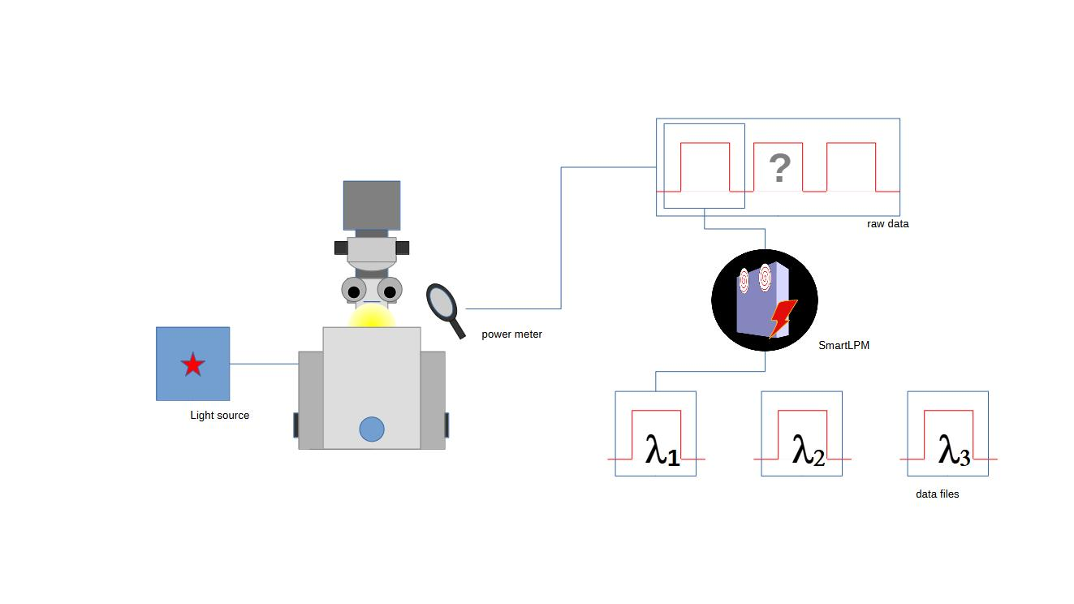
Fig. 6. Real time parsing. The data from different illumination is classified according to given instructions. Each set is saved into a separate file.

In practice the only requirement is to set the illumination as sequences of pulses and pauses. In future releases other ways of parsing data might be introduced but we found this approach very robust and relatively easy to setup in most microscopes.

Predictive Tuning
The optical power presented by a power meter is the result of multiplying the photocurrent generated on the sensor by its spectral responsivity. Because responsivities are a function of the illumination wavelength setting up a power meter with the wrong value leads to incorrect power estimations. In this case it is still possible to retrieve the correct optical power by multiplying this estimation by the correct to applied ratio of responsivities (fig 7). We can use a reference beam of known wavelength to find these ratios by measuring its intensity with the power meter tuned at different set wavelengths. When the set wavelength coincides with the light source the ratio will be 1 and in all other cases it will be the inverse of the applicable correction factor.
Once calibrated in this way it is possible to let the power meter run continuously tuned at the reference wavelength. For every wavelength the power estimations will be corrected automatically. The data signature provided has the information to choose the appropriate correction factor for each pulse.
Considering the shape of the responsivity curves (figure below) we recommend to use reference wavelengths in the center of the spectral range used.
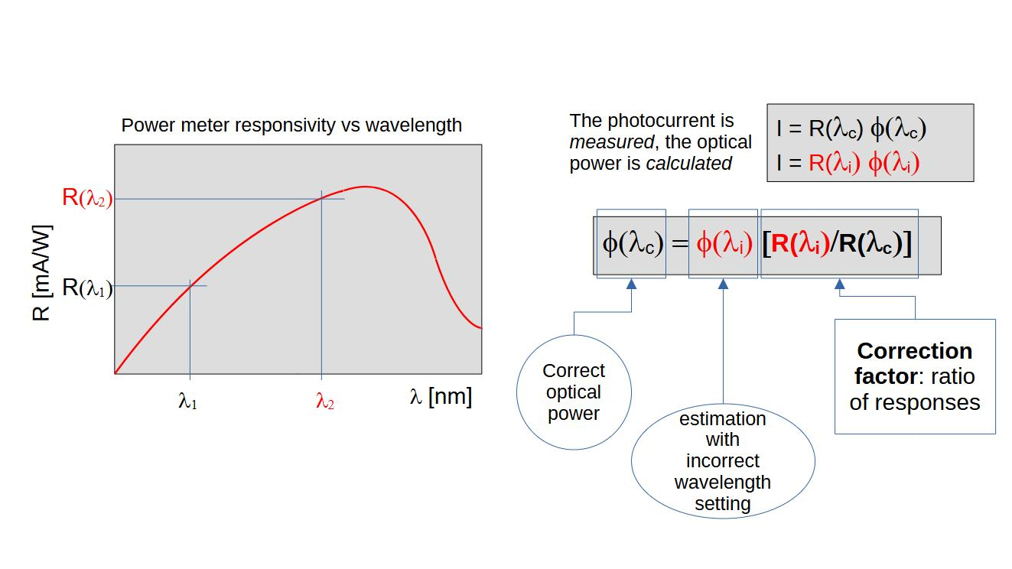
Fig. 7 Typical responsivity curve of a power meter device and how to correct power estimations. In red we have the illumination power estimated tuning the power meter at an arbitrary wavelength and how the correct power can be retrieved.

Appendix I. Concepts used in this manual
SmartLPM is a tool for the measurement of highly monchromatic light sources as lasers or other devices if the light is collected after a narrow band-pass filter. A use case is the quality assessment of microscopes in general, where the performance of illumination devices impacts imaging aspects as bleaching, phototoxicity or the ability handle images intensities in a quantitative manner.

Illumination power is the total energy per unit time -typically in milliwatt (mW)- transported by light. Relevant illumination powers in microscopy are the output of the laser devices and the power delivered to a sample during an imaging experiment.

Irradiance is the illumination power per unit area either emitted, collected or traversing a surface. - typically expressed in mW/μm²-. In microscopy it is more relevant to know this number as the signal intensities and other effects on the sample depend on it. Nevertheless, for a given light path (objective, filters, etc.) the irradiance must be proportional to the illumination power.

Optical power meters. Unlike spectrometers, where it is possible to know how much power an illumination device produces at every wavelength within certain range, optical power meters provide a single number, assuming that all the light collected has a given wavelength. There is no spatial information either: only the light illuminating the sensor area is detected, and its power is averaged along the response time of the device.

Measuring optical powers in a microscopes

To ensure the correct operation of microscopes it is necessary to measure the illumination power and stability of each light source. This can be done measuring powers over time together with the corresponding wavelengths and set powers. The contents of the files generated by the QUAREP-LiMi tools for this purpose have the structure shown below:

timestamp wavelength power
2024-06-27 10:32:54.713 488 80 2.84024952684
2024-06-27 10:32:55.747 488 80 2.8464990042
2024-06-27 10:32:56.713 488 80 2.84486841114
2024-06-27 10:32:57.713 488 80 2.84345842012
2024-06-27 10:32:58.715 488 80 2.84513334112
2024-06-27 10:32:59.714 488 80 2.84220336708
2024-06-27 10:33:00.713 488 80 2.83964277532
2024-06-27 10:33:01.714 488 80 2.84453576236
...

In future releases the time might be used for parsing, as it would be possible to tune the power meter on schedule. This possibility was discarded as it could easily cause synchronization problems with the light source.

