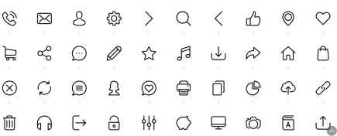

**Web Developer/ Project Manager**

Good

**Microsoft Project**

Excellent

**Address**

63B, Segun Awolowo Str, Ejigbo, Lagos.

**Phone**

08183539658

**E-mail**

[llahsmine@yahoo.com](mailto:llahsmine@yahoo.com)

**Portfolio**

qudhux.netlify.app

Web Development

Communication skills

Data Analysis with Microsoft Excel

**MongoDB**

**JavaScript**

**JQuery**

**HTML/CSS**

**NodeJs**

**SQL**

**Microsoft Excel**

**Yoruba**

**English**

**Arabic**

Intermediate

**Language**

Excellent

Excellent

Excellent

Good

Very good

Very good

Very good

Very good

* Introduced the students to the world of programming.
* Train them on the basics of python language with practical
* Oversaw the students’ projects
* Participated in the updating of the company’s ERP software.
* Trained clients on how to use the company’s software
* Suggested the design for building a generic school timetable

**Software**

**Skills**

* Introduced the Python programming language to the students and teach them the basics
* Oversaw the projects done by each student.
* Developed the UI for the company ERP software
* Suggested the design of how the UI of a generic school timetable should be

**Language**

Excellent

* Received an award for the most outstanding student in my set.

Board Games

Video Games

Sports and exercises

**Software**

Very Good

Good

Good

**Skills**

Interests

2020/09 **JavaScript -** sololearn

2020/08 **ResponsiveWebDesign -** freecodecamp

Web Development

Certifications

2018/01- **Lagos State University (LASU)**

Present

Web Development

Education

2021/09- **Python Tutor**

2021/09 *Learn-with-ease Academy*

Web Development

2022/01- **Frontend Developer**

Present *McBaysel Global System*

Web Development

Experience

An innovative developer with 3 years of experience in developing projects, debugging and training people on HTML, CSS and JavaScript. Eager to learn new technologies and to inherit skills to effective utilization and contribute to the progress of the organization.

**Personal Info**

OSHINAIKE **QUDUS**