Makefile文件

#Modify this to point to the PJSIP location.
#PJBASE=/home/linux/pcminigui/pjproject-2.4.5
#include $(PJBASE)/build.mak
# If your application is in a file named myapp.cpp or myapp.c
# this is the line you will need to build the binary.
Target = testsip
Objects = main.o SipClient.o Lock.o Observer.o Subject.o
all: testsip
testsip: $(Objects)
arm-linux-gcc $(Objects) -o $(Target) `pkg-config --cflags --libs libpjproject`
.cpp.o :
arm-linux-gcc -c -o $@ $< `pkg-config --cflags --libs libpjproject`
.c.o :
arm-linux-gcc -c -o $@ $< `pkg-config --cflags --libs libpjproject`
clean:
rm -f *.o testsip

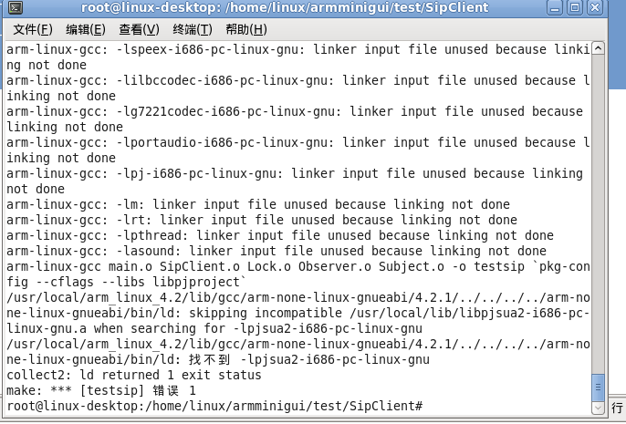

出错：会提示找不到动态链接库 makefile文件直接调用了usr/local/lib/pkgconfig
而不是调用交叉编译器下的pkgconfig所以要改动makefile文件

直接拷贝交叉编译器pkgconfig目录下的libpjproject.pc中的
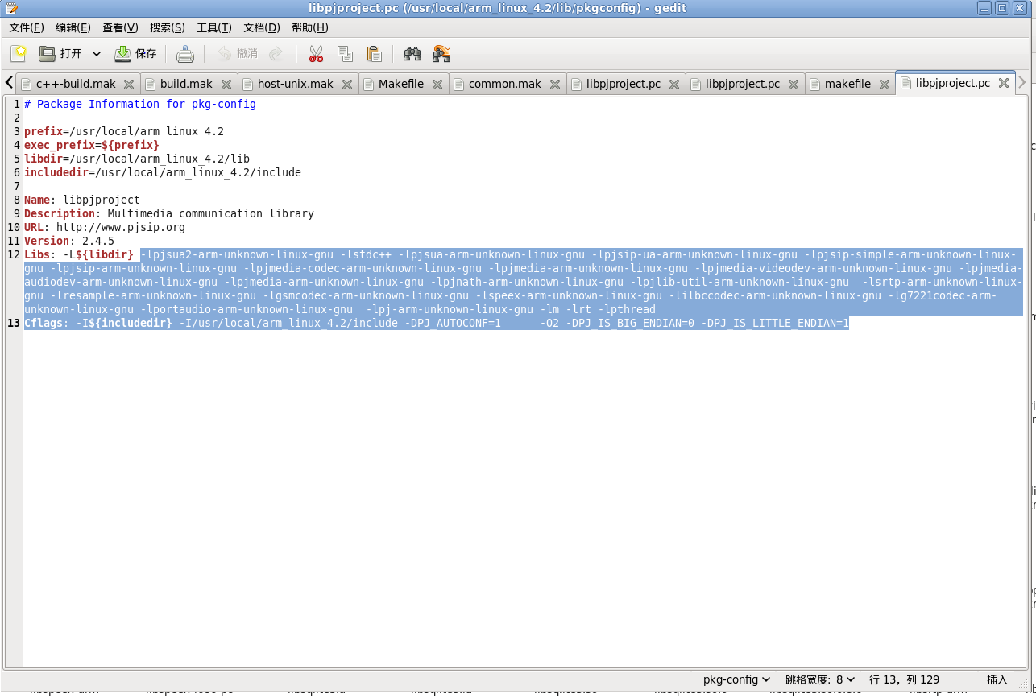

将makefile改为
#Modify this to point to the PJSIP location.
#PJBASE=/home/linux/pcminigui/pjproject-2.4.5
#include $(PJBASE)/build.mak
# If your application is in a file named myapp.cpp or myapp.c
# this is the line you will need to build the binary.
Target = testsip

Objects = main.o SipClient.o Lock.o Observer.o Subject.o

all: testsip

testsip: $(Objects)
arm-linux-gcc $(Objects) -o $(Target) -lpjsua2-arm-unknown-linux-gnu -lstdc++ -lpjsua-arm-unknown-linux-gnu -lpjsip-ua-arm-unknown-linux-gnu -lpjsip-simple-arm-unknown-linux-gnu -lpjsip-arm-unknown-linux-gnu -lpjmedia-codec-arm-unknown-linux-gnu -lpjmedia-arm-unknown-linux-gnu -lpjmedia-videodev-arm-unknown-linux-gnu -lpjmedia-audiodev-arm-unknown-linux-gnu -lpjmedia-arm-unknown-linux-gnu -lpjnath-arm-unknown-linux-gnu -lpjlib-util-arm-unknown-linux-gnu -lsrtp-arm-unknown-linux-gnu -lresample-arm-unknown-linux-gnu -lgsmcodec-arm-unknown-linux-gnu -lspeex-arm-unknown-linux-gnu -lilbccodec-arm-unknown-linux-gnu -lg7221codec-arm-unknown-linux-gnu -lportaudio-arm-unknown-linux-gnu -lpj-arm-unknown-linux-gnu -lm -lrt -lpthread

.cpp.o :
arm-linux-gcc -c -o $@ $< `pkg-config --cflags --libs libpjproject`
.c.o :
arm-linux-gcc -c -o $@ $< `pkg-config --cflags --libs libpjproject`
clean:
rm -f *.o testsip

