***This Document Contains all the necessary Information needed to understand the Design of the Current Accumulator Management System. However, this document will not cover everything about each of the component used to make the AMS. Thus, in case of need for any additional information, please see the table for the specific part to see its datasheet.***

This section of the Schematic shows the connections from the batteries to the Accumulator Management System. MC78M05ACDT voltage regulator is to provide a 5V input to the ACPL-C87A Optocoupler. The specific usage of the optocoupler is meant to separate the High Voltage side from the low voltage side.

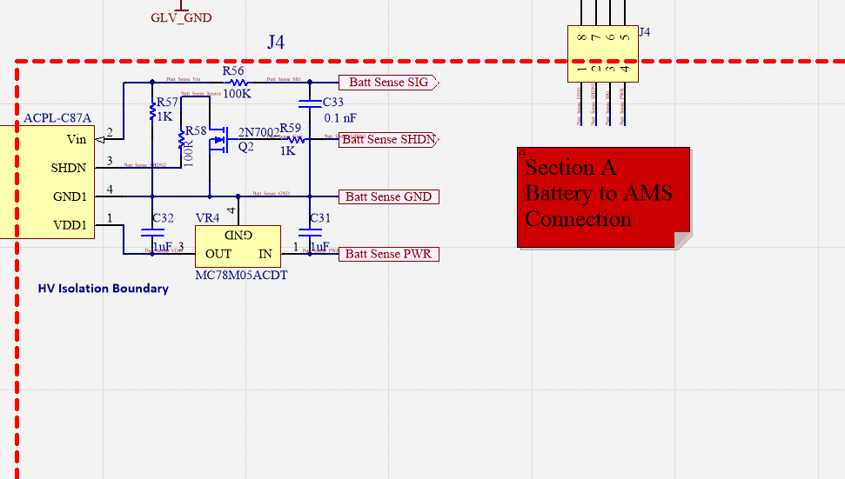

The set-up seeing above is based on the data-sheet recommendations as shown below in (fig 22):

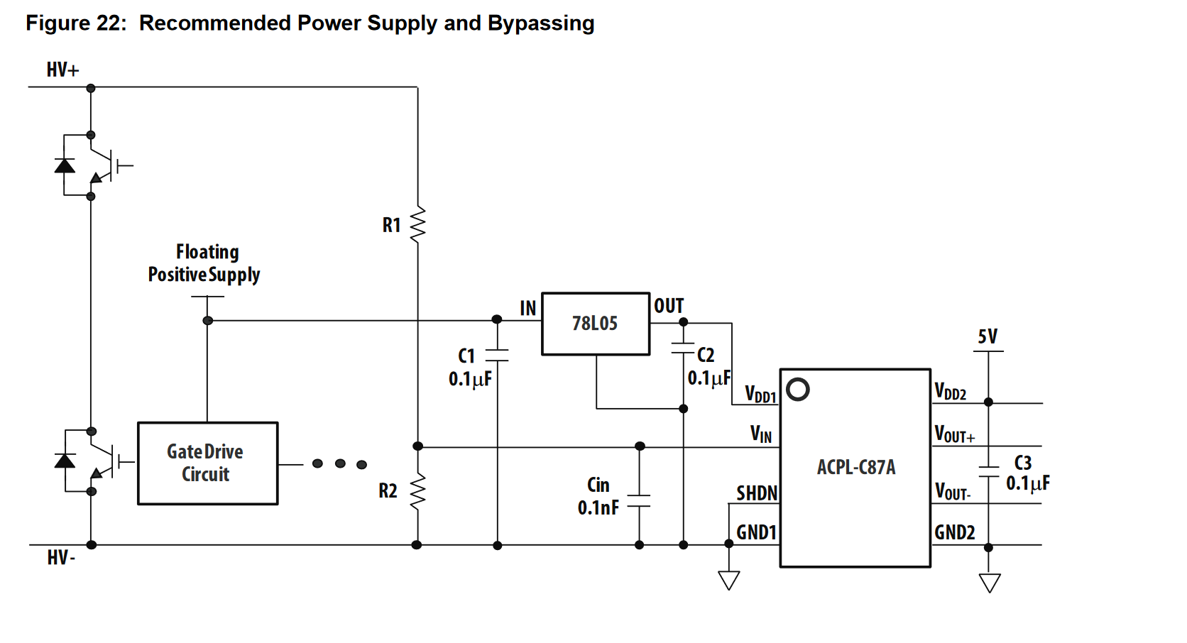

The Only difference between the two setups is that the AMS board will shut down if the SHDN pin has been triggered, this will only occur if the pin for battery SHDN sense a signal to drive the N-Channel MOSFET.

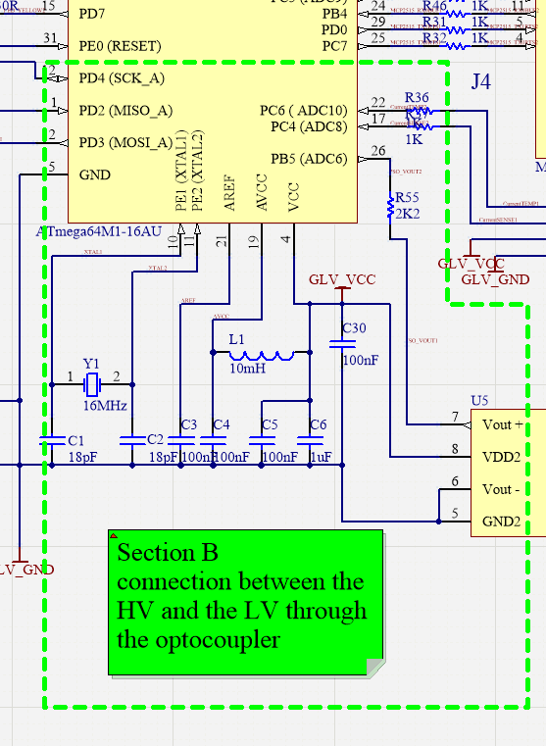

This section of the board features the added 16MHz crystal oscillator and its associated with it. The Section include as the optocoupler connection to the microcontroller.

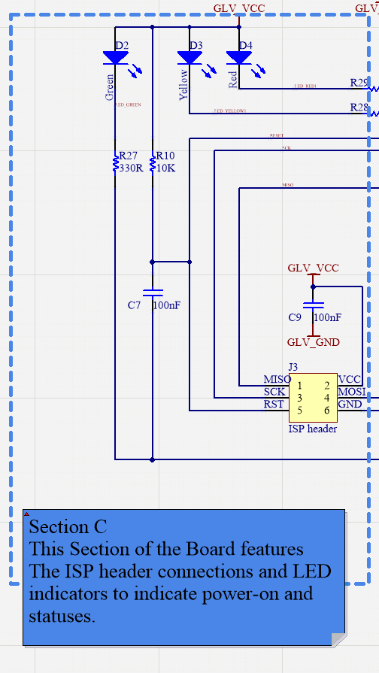

Section D

Linear Voltage regulator, to regulate the BMS LV input to 5 volts to suits each of U2, U3, U4 chips as well as all other section of the board that require 5V as input power.

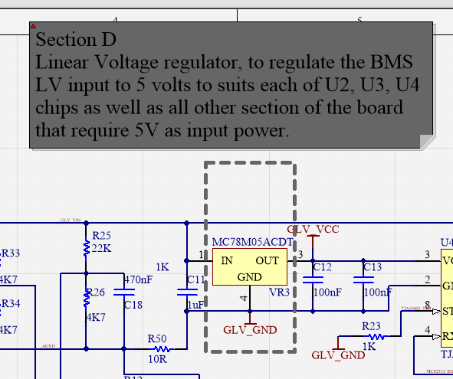

Section E

MCP2515-I/OS This chip is Microchip Technology’s MCP2515 is a stand-aloneController Area Network (CAN) controller that imple-ments the CAN specification, Version 2.0B. It is capableof transmitting and receiving both standard andextended data and remote frames. The MCP2515 hastwo acceptance masks and six acceptance filters thatare used to filter out unwanted messages, therebyreducing the host MCU’s overhead. The MCP2515interfaces with microcontrollers (MCUs) via an industrystandard Serial Peripheral Interface (SPI).

The chip requires an external XTAL crystal Oscillator, and since we have microcontroller running of 16 MHz clock, this external crystal clock has been determined to be 16MHz as well so systems are synchronised.

The MCP2515 require the following crystal set-up:

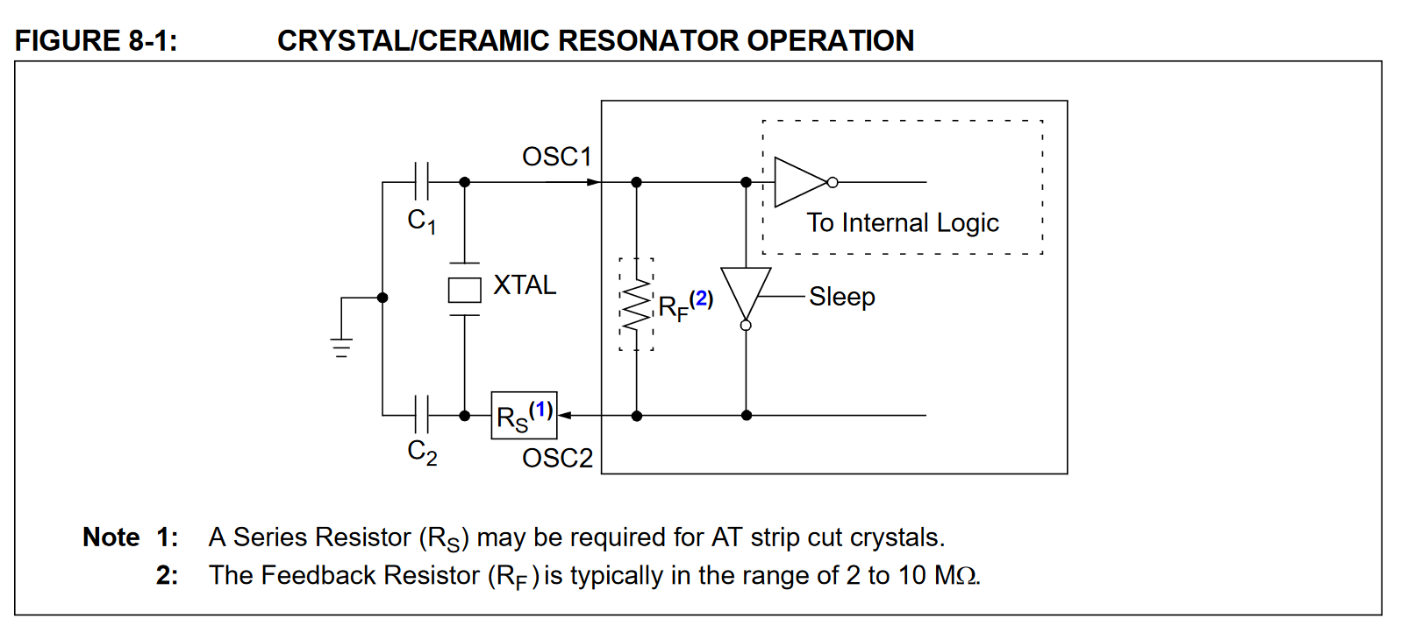

The Load capacitance of the selected oscillator is 12pF, and the CStary(varies from 2pF to 5pF depends how far is the oscillator from the chip) estimated to be 3pF if the component and crystal has been placed as close as possible to the chip:

Therefore, C1, C2 has been calculated to be 18pF.

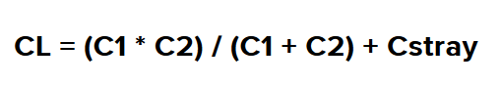



18pF = 2*12 – 2*3

18pF = 24-6 pF

18pF = 18pF

Reference for this calculation is: <https://blog.adafruit.com/2012/01/24/choosing-the-right-crystal-and-caps-for-your-design/>

The chosen crystal is here: ECS-160-12-33Q-JEN-TR

Datasheet: <https://au.mouser.com/datasheet/2/122/ECX-33Q-938166.pdf>

Shift register: