VCU Simulation MATHLAB Simulink

The Simulink model is used for creating a simulation of all the six VCU boards communication and functionality. With the help of MATLAB Simulink library, we were able to simulate CAN communications and create a working logic for the VCU board so that it can be programmed in C with same logic.

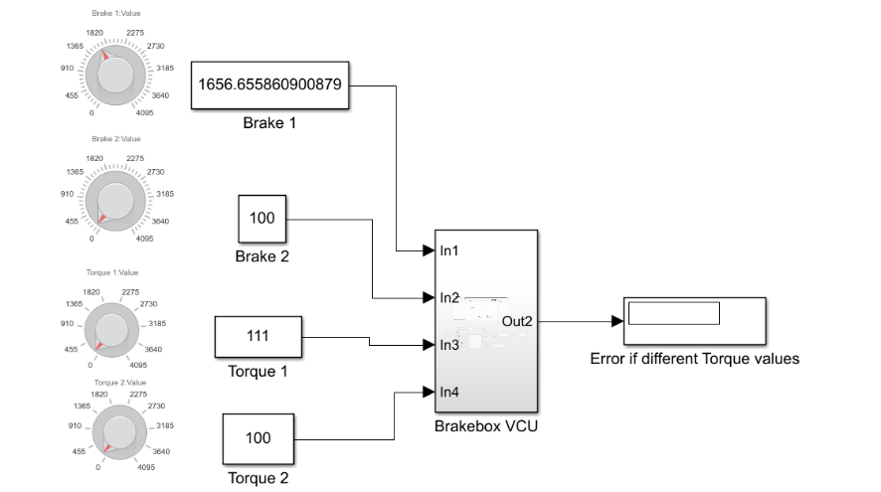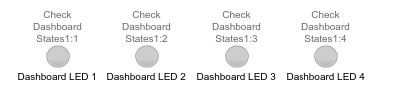Some of the limitations of the simulation is the constant changing ADC values received by the VCU boards that could not be simulated in Simulink. The team instead used objects from the Simulink library such as knobs to change 8-bit, 12-bit or 16-bit values constant variables, buttons for turning RTD, etc. These objects can help a user to change the data received by the boards and behave according to it giving it more realistic simulation.

To use the Simulink the user can adjust the input values of the VCU boards before and/or during the test which can be done through pressing the button, turning knobs, or rewriting the constant values. When running the test, the user needs to use the procedure of turning the car except turning the GSV and the HV. For example, the user must turn the brake values above 100, then press the RTD button to start the accumulator fan. There are Led and displays as outputs on the simulation so that its easier for the user to get results from the simulation in more detail.



Inside the Subsystem this is also an image of the fictional flow diagram of the VCU so that more users can understand the Subsystem logic more clearly and easily.