***Managing NGS Data Generated in QVEU***

*Walker Orr, 11/06/2023*

1. Properly eject from the sequencer the external hard drive containing the primary data from your sequencing run.
2. Plug the drive into a Windows machine located in the QVEU. These hard drives are formatted for Windows; this is why the data must be transferred on a Windows machine. The password will be printed on a sticker on the monitor.
3. Connect to locus on the Windows machine. To do this, open a new Windows Explorer pane. Select “Home > Easy Access > Map As Drive.” You will need your PIV inserted for this, and **the PIV must be inserted for the duration of file copying, so plan accordingly.**

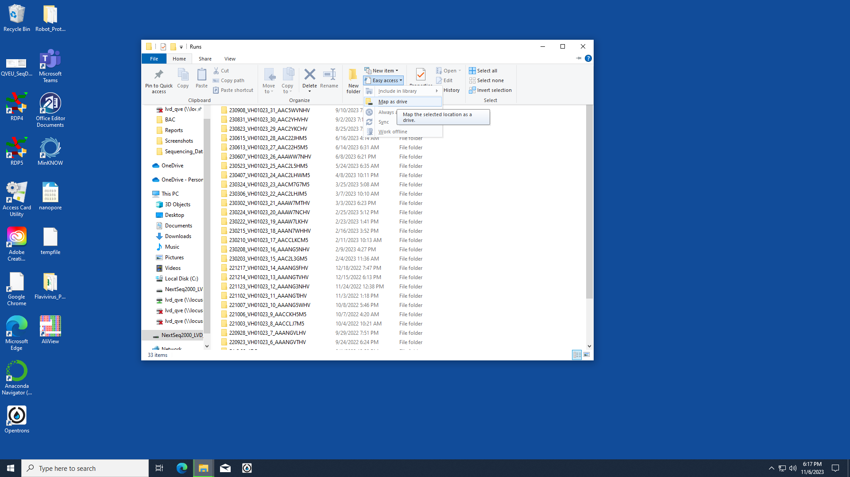

To connect to locus: \\locusdata.niaid.nih.gov\lvd_qve

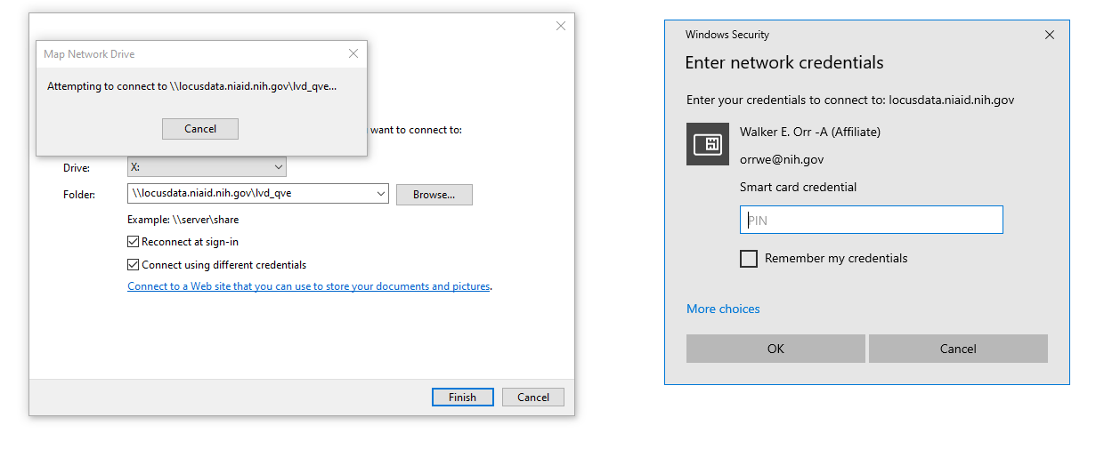

1. Open the QVEU_Sequencing folder on locus. Create a new folder with the next sequential index and a short descriptive name. Copy the sequencing data file from the primary external hard drive and paste it into the QVEU_Sequencing folder.
2. Wait for the data to transfer; this can take quite some time.
3. Carefully eject and return the external hard drive to its home; if it’s the NextSeq LVD hard drive (“NGS DATA”), return it to its place upstairs.
4. Back the data up by transferring it from locus to the QVEU sequencing external hard drive (“QVEU DATA”). This again can take a long time and requires your PIV card.
5. Once the data has been analyzed, delete the sequencing run from its source on the sequencer, to ensure space remains for other users.