Software Engineering
Lab 5
Vedant Sharma
PES2UG24CS577
Section 5-J
27-10-2026
17 - Society Dues
https://github.com/QVedant/L5-society-dues
Issue Table
No. | Issue | Type | Line(s)* | Description | Fix Approach
1 | SQL Injection Vulnerability | Security – Medium | 9 | SQL query was constructed using an f-string, allowing potentially malicious input to alter the query. | Replaced string interpolation with a parameterized SQL query using ? placeholders.
2 | Unsafe Use of eval() | Security – Medium | 21 | The eval() function executes arbitrary Python expressions, which can lead to code execution if the input is untrusted. | Replaced eval() with direct arithmetic using numeric arguments (amount and multiplier).
3 | Hardcoded Password | Security – Low | 5 | A password was stored directly in the source code, exposing sensitive information and triggering Bandit warning B105. | Removed the unused hardcoded password constant from the source file.
4 | Mutable Default Argument | Code Quality – Warning | 8 | Using history=[] as a default argument could cause the same list to be shared across multiple function calls. | Changed the default to None and initialized a new list inside the function when needed.
5 | Inconsistent Function Naming | Code Quality – Convention | 8 | The function name addDue did not follow Python's snake_case naming convention. | Renamed the function to add_due and updated its calls in main().
6 | Missing Docstrings | Code Quality – Convention | Multiple | The module and several functions lacked descriptive docstrings, reducing readability and maintainability. | Added a module docstring and docstrings for the functions.
7 | Inconsistent Return Statements | Code Quality – Refactor | 12–16 | The collect() function did not explicitly return a value when no matching record was found. | Added return None when no matching dues record exists.
8 | Incorrect None Comparison | Style – Flake8 | 29 | The expression rows != None did not follow Python's recommended None comparison style. | Simplified pending() to return the list generated from fetchall() directly.
9 | Lines Exceeding Maximum Length | Style – Flake8 | 4, 13, 15 | Several SQL statements exceeded the configured maximum line length, reducing readability. | Split long SQL statements and function calls across multiple lines.
10 | Missing Blank Lines | Style – Flake8 | 12 | A top-level function was not separated from the preceding code by the required two blank lines. | Added the required blank lines between top-level functions.
11 | Missing Final Newline | Style – Flake8 / Pylint | End of file | The Python file did not end with a newline, triggering Flake8 W292 and Pylint C0304. | Added a newline at the end of the file.

Reflection Questions
1. What is the importance of using multiple static code analysis tools instead of relying on a single tool?
Answer: Each tool focuses on a different aspect of code quality. Pylint identifies programming issues and maintainability problems, Bandit detects potential security vulnerabilities, and Flake8 checks coding style and formatting. Using all three provides a more comprehensive assessment of the program.
2. What security vulnerabilities were identified in the original society_dues.py program, and how were they fixed?
Answer: Bandit identified a hardcoded password, a potential SQL injection vulnerability caused by constructing queries with f-strings, and the unsafe use of eval(). These issues were addressed by removing the unused password, using parameterized SQL queries, and replacing eval() with direct arithmetic using numeric arguments.
3. How does fixing code quality and style issues improve the maintainability of a Python program?
Answer: Following naming conventions, adding docstrings, avoiding mutable default arguments, and formatting code consistently make a program easier to understand, debug, and modify. In this lab, these improvements helped make the functions in society_dues.py clearer and reduced potential programming errors.
4. Why is it necessary to rerun static analysis tools after fixing the reported issues?
Answer: Rerunning the tools verifies that the fixes have resolved the original findings and helps identify any remaining problems. In this lab, the initial Pylint score was 5.81/10, while the updated report showed 9.64/10. Bandit subsequently reported no issues, while Flake8 identified a missing final newline that needed correction. This demonstrates the importance of verifying changes rather than assuming the code is error-free after editing.

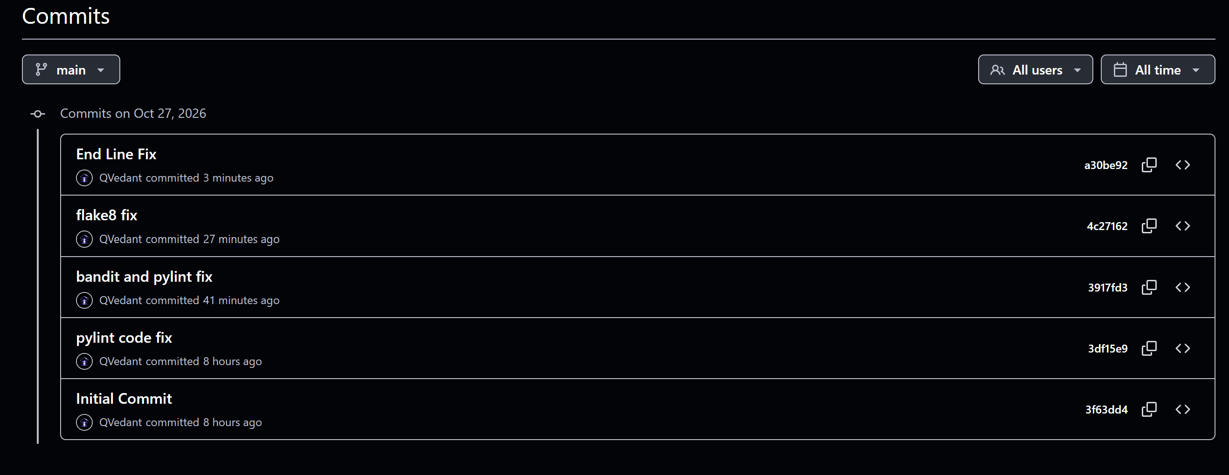

Prefix Reports

Pylint
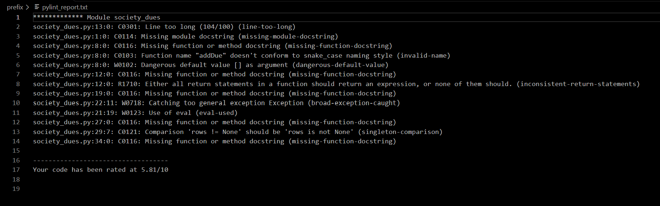

Flake8
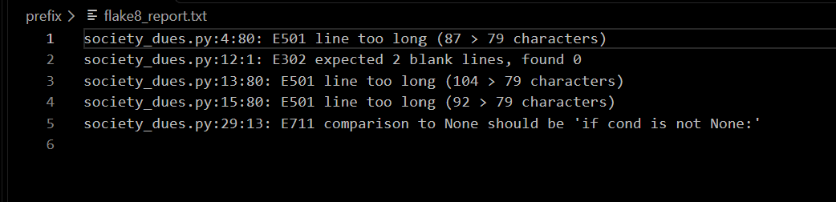

Bandit
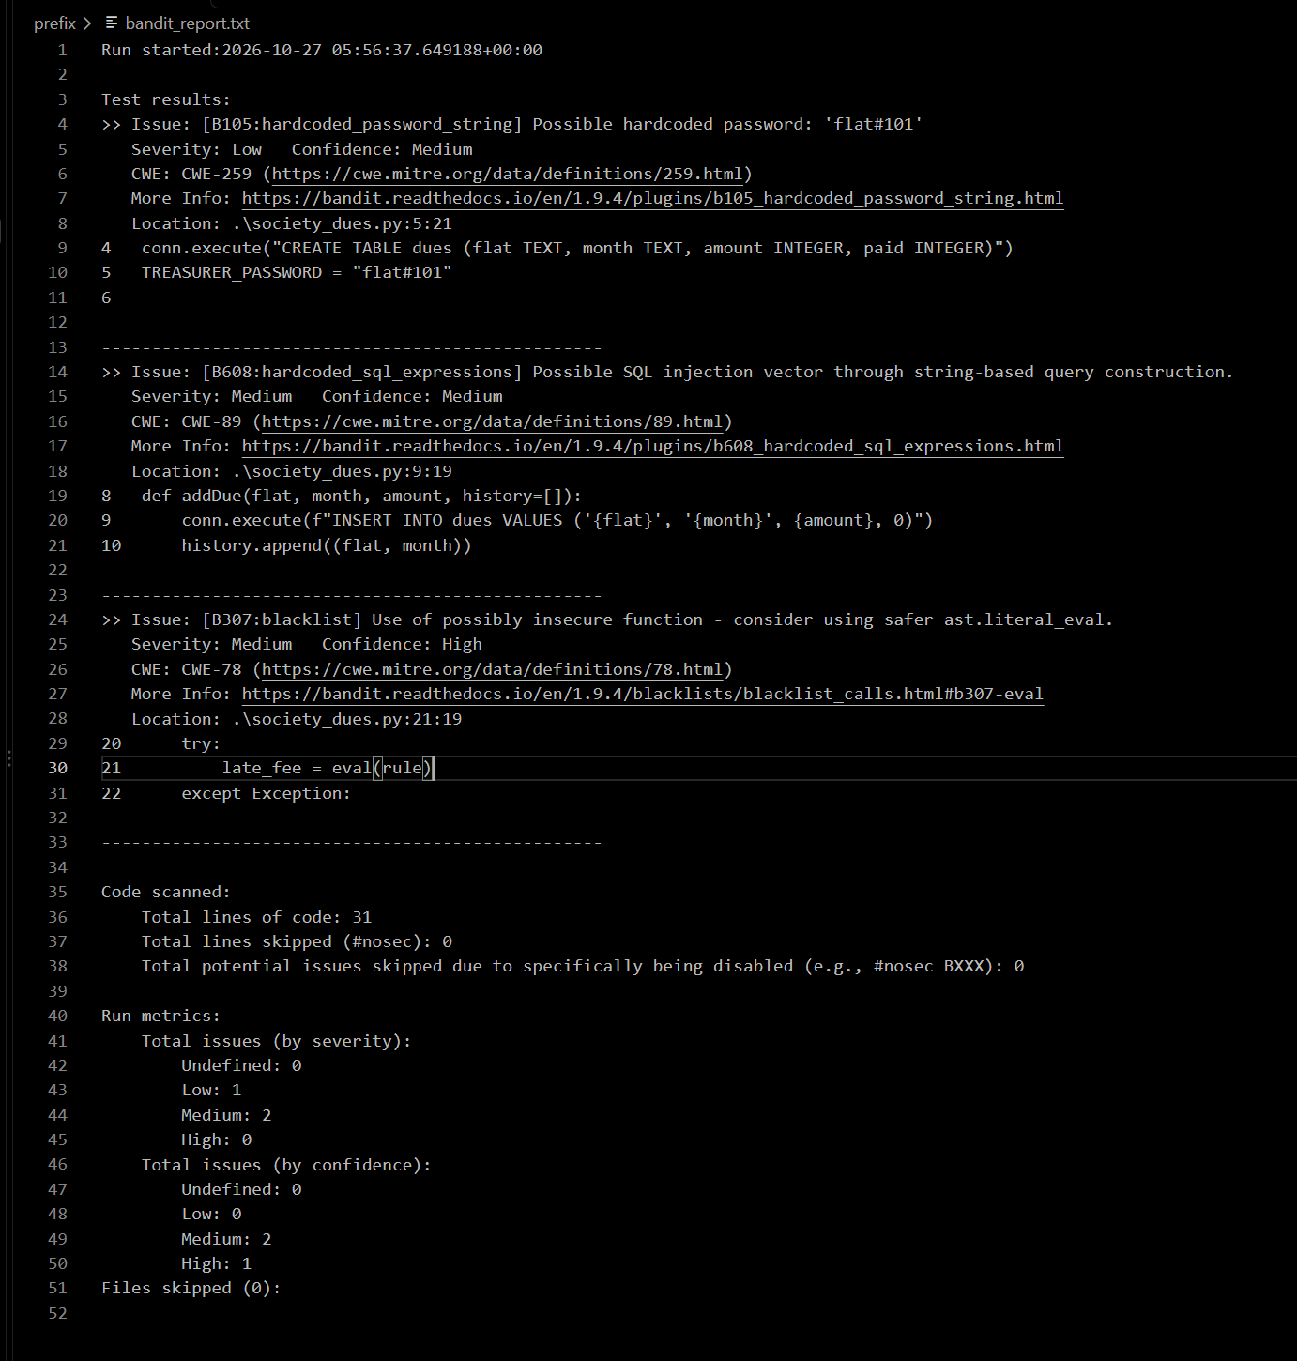

Postfix Reports

Bandit
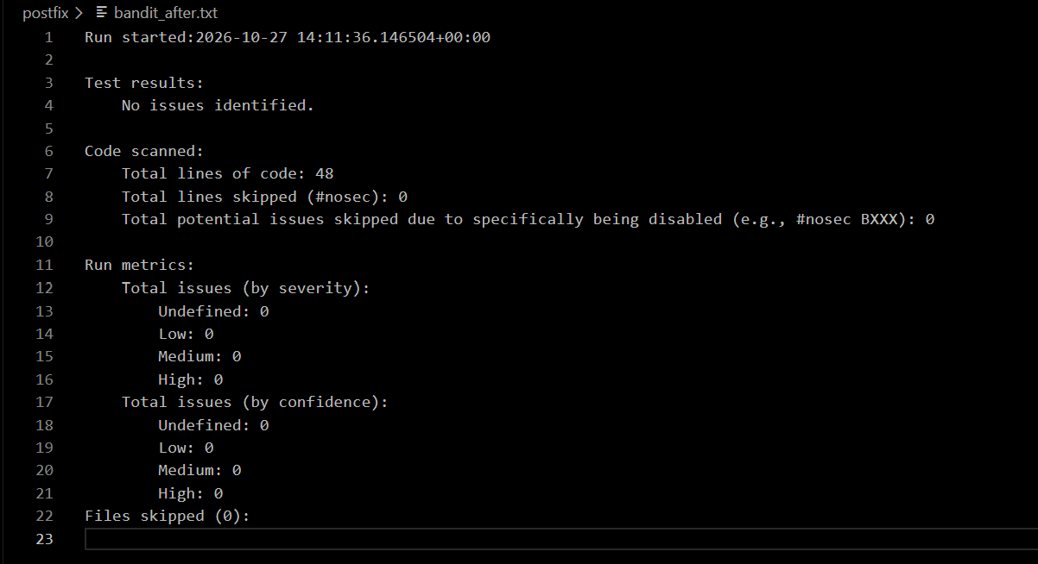
Flake
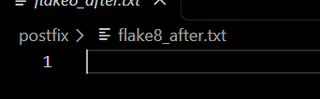
Pylint
