Software Engineering
Lab 6
Vedant Sharma
PES2UG24CS577
Section 5-J
02-11-26

Code Coverage
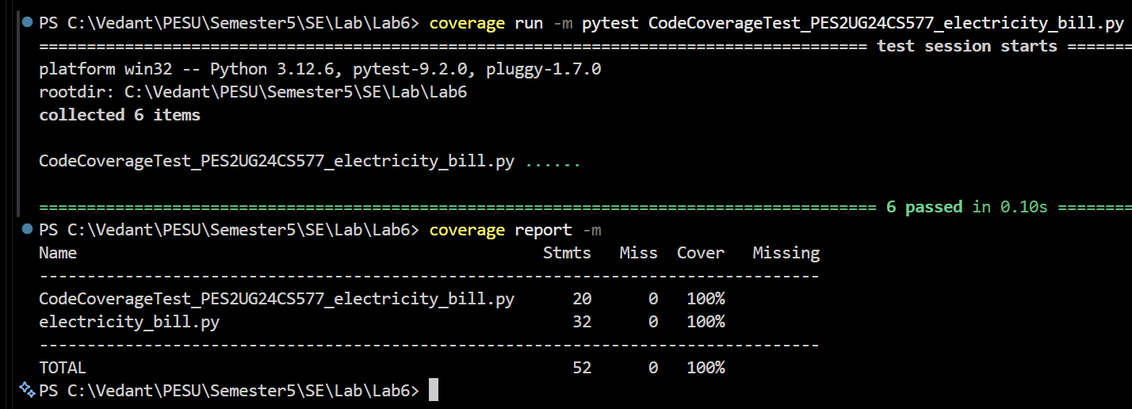

Branch Coverage
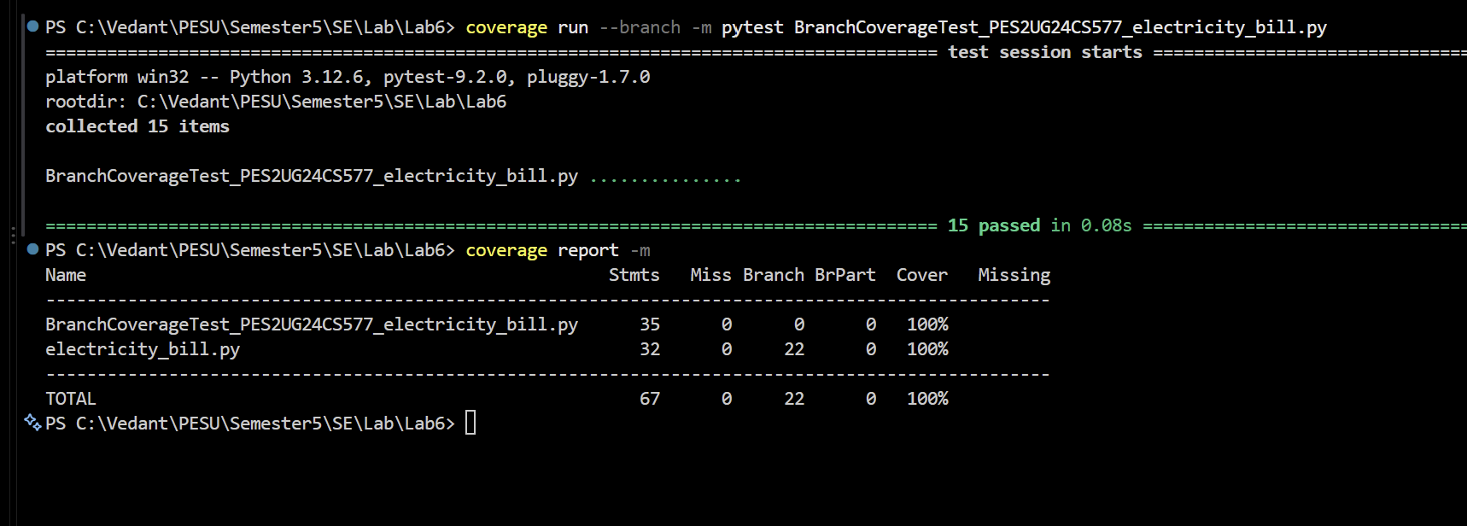

Commits
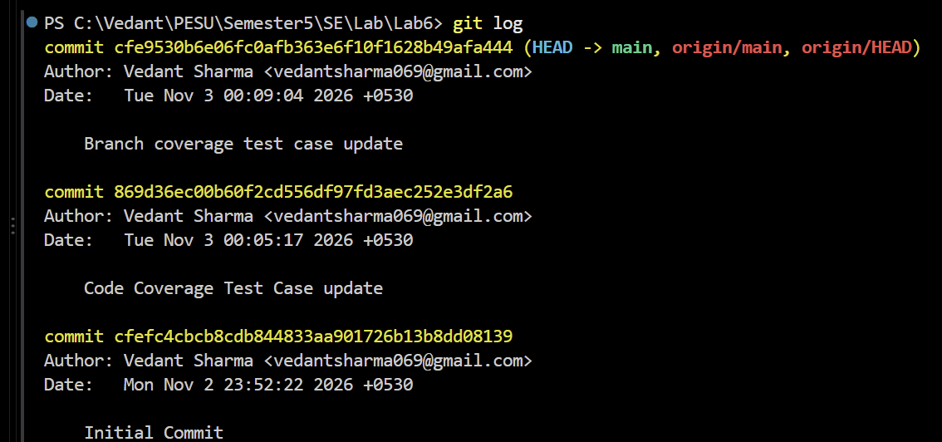

Analysis
Phase 1: Code (Line) Coverage Achieving 100% line coverage confirms that the test suite executes every single line of the application code at least once. While it ensures no code is entirely unreached, this metric can create a false sense of security by ignoring alternate logical pathways and hidden edge cases.
Phase 2: Branch Coverage Branch coverage requires evaluating every control structure to both its True and False outcomes. Achieving 100% branch coverage demonstrates rigorous testing of all possible logical pathways and boundary conditions, forcing the inclusion of scenarios that line coverage misses and ensuring comprehensive test completeness.

Code
CodeCoverageTest_PES2UG24CS577_electricity_bill.py
import pytest
from electricity_bill import energy_charge, late_fee, subsidy

# Example test cases:
def test_low_usage_domestic():
assert energy_charge(50, "domestic") == 200

def test_paid_on_time():
assert late_fee(500, 0) == 0

# Minimum tests to hit every line of code (Line Coverage)
def test_energy_charge_errors():
with pytest.raises(ValueError, match="unknown connection"):
energy_charge(50, "industrial")
with pytest.raises(ValueError, match="invalid units"):
energy_charge(-10, "domestic")

def test_energy_charge_slabs():
assert energy_charge(200, "domestic") == 850
assert energy_charge(400, "commercial") == 4350

def test_late_fee_penalties():
assert late_fee(500, 10) == 50
assert late_fee(2500, 20) == 225

def test_subsidy_benefits():
assert subsidy(50, True, False) == 50
assert subsidy(400, False, True) == 0

BranchCoverageTest_PES2UG24CS577_electricity_bill.py
import pytest
from electricity_bill import energy_charge, late_fee, subsidy

# Example test cases:
def test_low_usage_domestic():
assert energy_charge(50, "domestic") == 200

def test_paid_on_time():
assert late_fee(500, 0) == 0

# --- energy_charge tests ---
def test_energy_charge_unknown_connection():
# Tests the unknown connection ValueError branch
with pytest.raises(ValueError, match="unknown connection"):
energy_charge(50, "industrial")

def test_energy_charge_negative_units():
# Tests the invalid units ValueError branch
with pytest.raises(ValueError, match="invalid units"):
energy_charge(-10, "domestic")

def test_energy_charge_mid_usage():
# Tests the 101-300 unit slab
assert energy_charge(200, "domestic") == 850

def test_energy_charge_high_usage_commercial():
# Tests the >300 unit slab and commercial multiplier
assert energy_charge(400, "commercial") == 4350

def test_energy_charge_exact_boundaries():
# Tests exactly 100 and 300 unit boundaries
assert energy_charge(100, "domestic") == 350
assert energy_charge(300, "commercial") == 2750

# --- late_fee tests ---
def test_late_fee_within_15_days():
# Tests the 1-15 days branch
assert late_fee(500, 10) == 50

def test_late_fee_over_15_days_low_bill():
# Tests >15 days but bill <= 2000
assert late_fee(1000, 20) == 100

def test_late_fee_over_15_days_high_bill():
# Tests >15 days and bill > 2000 (triggers additional penalty)
assert late_fee(2100, 20) == 205

# --- subsidy tests ---
def test_subsidy_senior_low_usage_no_solar():
# Tests senior discount without solar
assert subsidy(100, True, False) == 50

def test_subsidy_not_senior_low_usage_solar():
# Tests solar discount without senior discount
assert subsidy(100, False, True) == 100

def test_subsidy_senior_high_usage_solar():
# Tests solar benefit cancellation (units > 300)
assert subsidy(400, True, True) == 0

def test_subsidy_mid_usage_solar():
# Tests standard solar benefit (units between 101 and 300)
assert subsidy(200, False, True) == 100

def test_subsidy_senior_low_usage_solar():
# Tests combined senior and solar benefits
assert subsidy(50, True, True) == 150

