Urgency signal and dynamic boundary are same? Could they be different?

CoM now only explained as forward, could be backward?

Feedback/reflex gain?

Storyline of the project:

The influence of response effector on decision adaptations due to prior expectations and speed pressure

**Key elements**（decision & motor; speed-acc/ time pressure; prior; continuous flow; muscle difference; decision adaptation）

# Introduction (example)

~~When playing the party game "Egg Smasher," participants are required to perform one of the predetermined actions under a progressively accelerating rhythm (e.g., slapping the box, tapping the table next to the egg, or grabbing up the box to trick the opponent into smashing the egg). However, what factors influence players' decision-making and the formation of their final actions? Is the brain's decision-making process sequential to the execution of actions, or do they occur simultaneously and mutually influence each other? Are muscles in different locations governed by the same strategic control? Does the increasing time pressure compress players' decision-making time or their action execution time? To what extent is the final action decision influenced by an aggressive or conservative game strategy?~~

Ver2:

When catching an object thrown by another person, the arm and fingers continuously adjust their positions in real-time, working in coordination with the brain to determine the optimal grasping point. Upon contact, the fingers and arm dynamically regulate grip force to ensure a stable hold. This process raises several fundamental questions about decision-making and motor execution. Do decisions precede movements in a strictly sequential manner, or do they occur simultaneously, exerting mutual influence? Additionally, do muscles in different locations—such as the proximal arm muscles and distal finger muscles—operate under the same strategic control mechanisms, or do they rely on distinct adaptations? Furthermore, as time pressure increases, does it primarily shorten the decision-making stage, or does it affect movement execution? Lastly, how does an individual’s game strategy (the value of the object), whether aggressive or conservative, shape the final action decision?

# Background and Motivation

~~Current research on decision-making often employs simple actions (such as button presses or mouse clicks), leading to two issues. First, motor processes are oversimplified as mere delays. Second, the focus is primarily on distal muscles (e.g., finger or thumb movements). However, there are inherent physiological and functional differences between the control of muscles in different locations. For example, the connections between the hands and brain regions are more numerous and complex compared to those of the arms. Whether the ‘perception-decision-action’ relationship derived from experiments using distal muscles is the same as that for proximal muscles remains an unresolved question.~~

~~With the assistance of a myoelectric interface, combined with EEG technology, we can more effectively investigate the decision adaptations and differences in the perception-decision-action relationship between muscles in different locations.~~

Ver2:

Current research on decision-making frequently relies on simple motor actions, such as button presses or mouse clicks. This enables perceptual decision-making (PDM) models to treat the motor process as a mere delay, significantly advancing our understanding of evidence accumulation. However, not all sensorimotor processes operate in such a straightforward manner. There is still limited understanding of how other types of movements fit into the ‘perception-decision-action’ framework and how different ‘decision processing level’ interact within this process. A key aspect of this complexity lies in the physiological and functional differences between muscles in different locations. For instance, the neural connections between the hands and brain regions are both more numerous and intricate than those linking the arms to the brain. This distinction raises an important question: Is the perception-decision-action relationship established in experiments using distal muscles applicable to proximal muscles, or do these systems operate under fundamentally different principles? This remains an open question in the field, highlighting the need for further research to uncover how decision-making processes adapt across different muscle groups.

There is growing evidence supporting the continuous flow of information to the motor system, along with increasing research suggesting that decision-making (DM) is ‘embodied’. Given these perspectives, we would expect differences between effectors due to their distinct physiological properties. With the aid of a newly designed myoelectric interface, combined with EEG technology, we can leverage perceptual decision-making (PDM) models to provide a more precise cognitive neuroscience interpretation of these physiological differences at a finer temporal scale. Specifically, our objectives are: 1) To use EMG signals to precisely identify the initiation point of movement, allowing for a clear distinction between the decision stage and motor execution stage within PDM. 2) To demonstrate that physiological differences between muscles manifest at different stages of the PDM process, reflecting how motor-specific properties shape decision-making. 3) To refine existing models to account for the distinct decision-making mechanisms of proximal and distal muscles, ultimately providing a more comprehensive framework for understanding the interaction between perception, decision, and action.

# EEG-Related Literature

## Mathematical Models for ‘Perception-Decision-Action’ Process

Mainstream cognitive neuroscience research employs Sequential Sampling Model (SSM), including the Drift Diffusion Model (DDM), and the more recent neurally informed model (NI) to describe the perception-decision-action process.

SSM suggests that individuals do not acquire all information for decision-making at once. Instead, they rely on sequential sampling steps, gradually accumulating information for decision-making. Each sampling step depends on the prior sensory input, iteratively adding new evidence until a decision threshold is reached. This model allows for strategy adjustments based on the current context to determine whether additional information gathering is necessary. However, SSM cannot distinguish the three critical processes: sensory, cognitive, and motor, limiting its applicability to explain motor control, which is often overlooked in research.

~~The DDM is widely used for two-choice decision-making tasks, emphasizing the ‘drift’ of evidence (bias towards one decision) and its stochastic ‘diffusion’ during accumulation (related to the noise in the real world). The threshold setting influences both decision speed and accuracy. There’s four key elements in DDM: 1) fixed starting point as the starting of the decision making process/ evidence accumulation process; 2) constant decision boundary as the threshold to make the decision; 3) no-decision time including sensory input time and motor execution time; 4) drift rate related to evidence strength.在加速决策任务中，紧迫感信号变得更加明显，反映出大脑对速度压力的适应。这种紧迫感信号可以调节决策信号的流动（例如从感觉区域到运动区域），优先考虑更快的反应，而不是更慎重、更准确的决策。Like the SSM, the DDM lacks sufficient consideration of motor control and decision adaptation. 目前主流的解释是在DDM的基础上加一个塌缩边界it’s difficult to identify the correct model from behaviour alone. Which is why the multilevel view from EEG is so useful。~~

The Drift Diffusion Model (DDM) is widely used to describe two-choice decision-making tasks, emphasizing the ‘drift’ of evidence (a bias toward one decision) and its stochastic diffusion during accumulation, which accounts for real-world noise. The threshold setting plays a crucial role in influencing both decision speed and accuracy. The DDM consists of four key components: (1) a fixed starting point, marking the beginning of the decision-making and evidence accumulation process; (2) a constant decision boundary, serving as the threshold at which a decision is made; (3) non-decision time, which includes sensory input processing and motor execution; and (4) drift rate, which reflects the strength of the accumulated evidence.

In speeded decision tasks, an urgency signal becomes more pronounced, reflecting the brain’s adaptation to time pressure. This urgency signal can modulate the flow of decision signals—such as those from sensory regions to motor areas—favouring faster responses over more deliberate, accuracy-driven decisions. Similar to other Sequential Sampling Models (SSMs), the DDM does not adequately account for motor control and decision adaptation. A common extension to the DDM framework introduces a collapsing decision boundary, which adjusts dynamically over time. However, distinguishing between competing models based on behavioural data alone remains challenging. This is why a multilevel approach, incorporating EEG, is essential for gaining deeper insights into the underlying neural mechanisms of decision-making.

Neurally Informed (NI) model integer neural data alongside behavioural data, providing a more biologically grounded description of decision-making. Unlike traditional models that rely solely on abstract cognitive mechanisms, the NI model explicitly incorporates brain activity, enabling a more accurate representation of the decision process. Similar to the DDM, it retains four core elements: starting point, drift rate, decision threshold, and non-decision time. Additionally，the NI model divides decision-making into three distinct phases: evidence encoding, onset of evidence accumulation, and post-decision motor execution. However, a key distinction lies in the source of evidence accumulation. While the DDM considers evidence strength as the sole driving factor, the NI model include the urgency signal that is independent of sensory evidence and emerges before evidence encoding begins. This urgency signal accelerates decision-making, providing an additional mechanism for time-adaptive decision strategies, much like a collapsing decision boundary. Similarly to DDM, the prior probabilities in NI could be also described as the initial bias towards one direction, which affect the speed of evidence accumulation. Furthermore, the NI model accounts for pre-evidence motor preparation signals, modelled as race-to-threshold dynamics that influence the starting point of the decision process even before stimulus presentation. This framework allows for investigating whether decision strategies vary depending on the effector involved. Specifically, we can examine whether different muscles (e.g., proximal vs. distal) exhibit distinct starting points in decision-making, offering deeper insights into how response effectors shape decision processes.

~~作为对DDM的补全，最新的NI模型在行为数据的基础上还结合了神经数据。这意味着NI模型不仅依赖于抽象的认知机制，而是以实际的大脑活动为基础，更准确地描述决策的过程。The NI model divides the decision-making process into three stages: evidence encoding, onset of evidence accumulation, and the post-decision motor execution phase. By integrating behavioural and EEG data, the NI model enables multilevel understanding of decision-making phases. As DDM, it also has four key elements as DDM: starting point, drift rate, threshold and no-decision time. 对于证据积累的来源，在DDM模型仅与证据强度相关的单一来源的基础上，NI模型还把紧迫性信号归类为独立于证据的，在感官证据被编码前就有的，加速决策过程的另一种证据积累来源。这与collapsing bound一样都解释了决策对时间的适应性。It also accounts for pre-evidence motor preparation signals (race-to-threshold) that influence the starting point before stimulus presentation. For example, the motor preparation stage is modelled as differing starting points. Based on this model, we could check whether the decision strategies might change depending on the muscle that is being used regarding these four key elements (e.g. distinct starting points during decision-making) to get a better explanation of the effect of different response effectors on the decision making process.~~

~~The newer NI model outperforms the DDM in explaining behavioral data, incorporating motor control and decision adaptation concepts.~~ It also has four key elements as DDM: starting point, drift rate, threshold and no-decision time. ~~But it introduces urgency signals that are unrelated to evidence strength, which provide more understanding of drift rate/ collapse threshold . It also accounts for pre-evidence motor preparation signals (race-to-threshold) that influence the starting point before stimulus presentation. Moreover, t~~~~he NI model divides the decision-making process into three stages: evidence encoding, onset of evidence accumulation, and the post-decision motor execution phase. By integrating behavioral and EEG data, the NI model enables multilevel understanding of decision-making phases.~~

~~For example, the motor preparation stage is modelled as differing starting points. Based on this model, we could check whether the decision strategies might change depending on the muscle that is being used check whether different muscles have different strategies regarding these four key elements (e.g. distinct starting points during decision-making) to get a better explanation of the effect of different response effectors on the decision making process.~~

#### Table XXX: Comparison of DDM, and NI Models

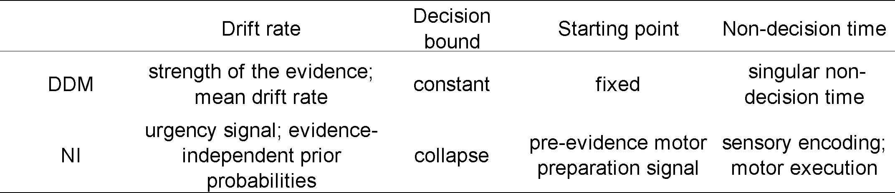

Time pressure studies XXX

Prior expectation studies XXX

## Behavioural Theories and Decision-Motor Interaction

Recent behavioural research categorizes decision models based on the relationship between ‘decision processes’, ‘choices’, and ‘motor preparation’ into three paradigms:

1. Decision-Then-Action (Serial Model):  
   Classical models like SSM and DDM belong to this category, where sensory information is processed first, followed by decision-making, and finally, motor execution.
2. Decision-And-Action (Parallel Model):  
   Represented by the NI model, this paradigm emphasizes a continuous flow of information. Motor signals for planning or execution begin as soon as sensory input is received, meaning that potential motor actions are prepared even before a decision is finalized.
3. Action Feedback Into Decision-Making (Embodied Choice Model):  
   This newer paradigm introduces a feedback loop, where the real-time state of the motor system influences decision-making. It incorporates a commitment effect, predicting fewer Changes of Mind (CoMs) during action execution. This model suggests that decision-making involves continuous interplay between sensory and motor systems, allowing actions to shape decisions in real-time.

#### Figure XXX: Visualization of Three Decision Models

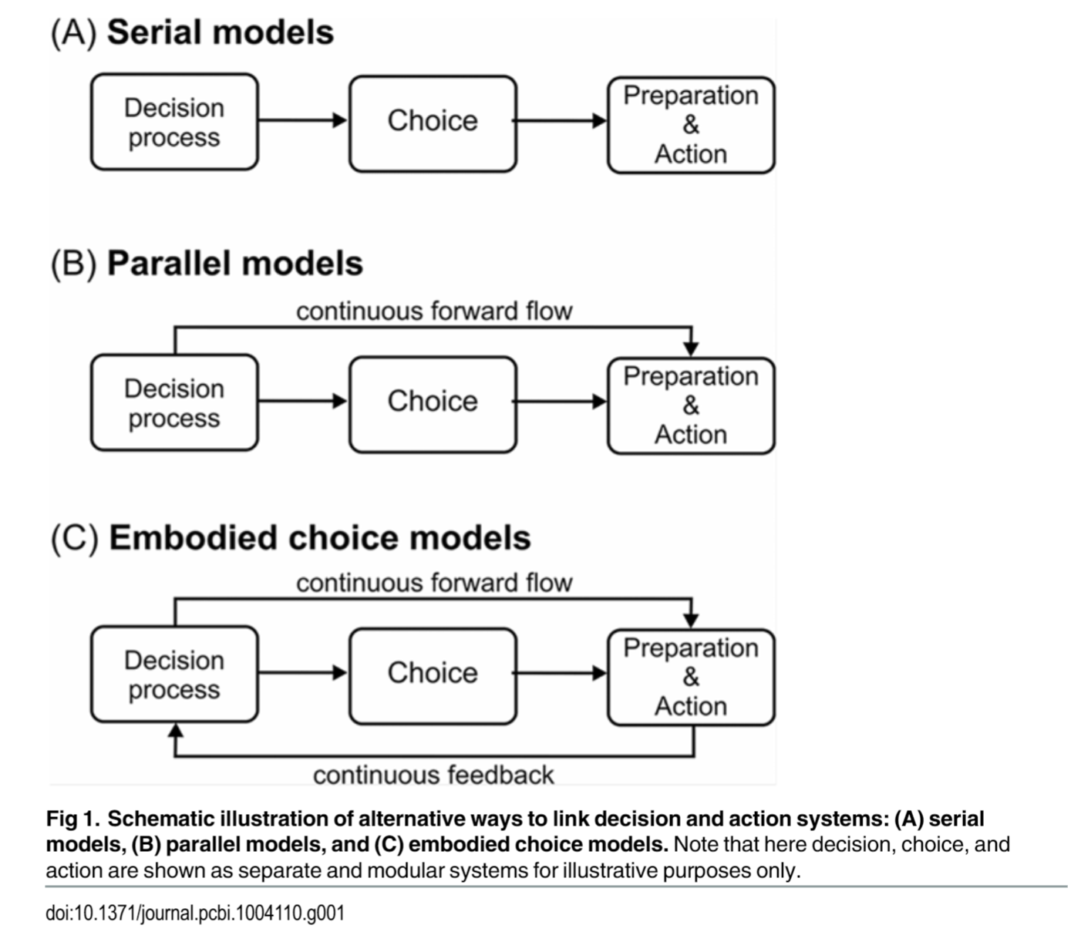

This figure can visually distinguish the characteristics of the decision-then-action, decision-and-action, and embodied choice models.

### 

## Key Features of ideal Decision Models

Studies on ‘decision-and-action’ and ‘action feedback paradigms’ highlight the importance of top-down information flow from sensory inputs to motor systems. This flow enables real-time decision adaptation by continuously integrating new information to adjust motor plans. This means that even before a decision is consciously made, the motor system is already preparing for potential actions. But ‘action feedback paradigms’ shows there’s highly possible that there also exists a ‘continues feedback flow’ from motor area to sensory area. This allows for adjustments in motor preparation based on ongoing sensory input and even for sensory processing to be influenced by the state of motor planning. For example, if a certain action is being prepared, sensory attention may be biased towards information relevant to that action. Additionally, the concept of dynamic decision boundaries could be newly explained by to the idea of ‘feedback loop’, where the level of motor preparation influences decision-making threshold. Or in other words, readiness for action can increase the brain's sensitivity to sensory information. This suggests that motor planning directly affects decision-making systems.

~~Additionally, the concept of dynamic decision boundaries emerges due to continuous flow model (Coles et al., 1985), where the level of motor preparation influences decision-making th. For example, readiness for action can increase the brain's sensitivity to sensory information. This suggests that motor planning directly affects decision-making systems.~~

~~Additionally, the concept of dynamic decision boundaries emerges, where the level of motor preparation influences decision-making. For example, readiness for action can increase the brain's sensitivity to sensory information. This suggests that motor planning directly affects decision-making systems. (Coles et al., 1985)~~

However, confirmation bias may also influence sensitivity to new information, though its relationship with motor preparation remains unclear.

(Doner XXX)

## Changes of Mind (CoM) and Decision Adaptation

V2:

The Change of Mind (CoM) phenomenon plays a crucial role in decision adaptation. CoM occurs when an individual initially makes a decision based on accumulated evidence but subsequently reverses that decision during the execution of movement (Resulaj et al., 2009). In other words, decisions and actions remain modifiable until the final action is fully executed. This phenomenon suggests the existence of two decision boundaries: the initial boundary, which marks the point of early commitment to a decision, and a second boundary, which represents full decision commitment. Once this commitment threshold is crossed, the decision becomes irreversible. While CoM is well explained within the framework of a feedforward loop (continuous flow), it remains unclear whether decision commitment is influenced by response mode. For instance, a key question is whether the timing of decision commitment in CoM is primarily determined by the completion of the motor action after the first threshold is crossed or simply by further evidence accumulation beyond the second threshold. Additionally, it is unknown whether different muscles exhibit distinct CoM mechanisms. Investigating these questions would provide valuable insights into how the motor system contributes to decision-making, ultimately refining the conceptual understanding of CoM.

~~The Change of Mind (CoM) phenomenon is also an important part of decision adaptation. CoM is defined as a situation where a subject initially makes a decision based on accumulated evidence but then reverses that decision during the execution of a movement (Resulaj et al., 2009). In other words, decisions and actions can still be altered before the final action is executed. This implies the existence of two decision boundaries: the initial boundary for early decisions and a second for decision commitment . Once the commitment threshold is crossed, decisions become irreversible. Thus, CoM is well explained from the feedforward loop, but whether the decision commitment is effected by the response mode is not studied. For example, CoM 的decision commitment时间点是更有关于证据的积累超过第一个阈值后开始形成完整动作的完成度，还是仅仅依靠于证据的积累超过第一个阈值后继续超过第二个阈值的证据积累量。以及是否会因为不同肌肉而有机制上的不同。总的来说，motor system在决策中的应用可以更好的补全CoM的概念。~~

~~CoM reinforces the idea that the real-time state of the motor system significantly impacts decision-making .~~

~~The Change of Mind (CoM) phenomenon illustrates that decisions and actions can still be altered before the final action is executed. This implies the existence of two decision boundaries: the initial boundary for early decisions and a second for decision commitment. Once the commitment threshold is crossed, decisions become irreversible. CoM reinforces the idea that the real-time state of the motor system significantly impacts decision-making.~~

## Feedforward flow and Feedback Flow

*Sensory feedback= **proprioceptive here mainly + visual**

Optimal feedback control (OFC) is a neural control theoretical framework that describes how the brain optimally controls movement to minimize cost function and optimize motor performance. OFC believes that motion control relies not only on pre-planned instructions (feedforward control), but also on real-time adjustment of feedback control. The exist of feedback control means the nervous system continuously monitors sensory inputs (*) and adjusts motor outputs in real-time to achieve a desired movement goal. This process relies on sensory feedback (mostly **proprioceptive** here not visual, The hypothesis is that the readiness of the motor system or the completion of the movement will in turn affect the decision-making process and even the sensitivity of accumulated sensory information) to correct deviations from the intended trajectory or action.

Recent study using motor perturbation (e.g. applying vibration to the hand) reveal that reflex gains dynamically adjust under different sensory signal strength and duration。

While most studies focus on forward flow (sensory inputs guiding motor outputs), evidence shows that the real-time state of the motor system also affects the efficiency of sensory areas, such as through reflex gain.

For instance, studies on motor perturbation (e.g. applying vibration to the hand) reveal that reflex gains dynamically adjust sensory signal strength and duration, resembling adjustments to accumulated evidence or decision variables (DV).

This feedback loop between sensory processing and motor planning demonstrates that motor planning is not only influenced by sensory inputs but also by the state of motor preparation. This interaction indicates that sensory and motor systems operate as a dynamic interplay, adjusting decision-making based on both sensory inputs and motor states.

# EMG-Related Literature

## Challenges in Explaining Neuro-Muscular Patterns

Although EEG-based decision models have advanced our understanding of brain decision mechanisms, they fail to adequately explain the neuro-muscular patterns across different muscles. Variations in brain-muscle connectivity strength and muscle fiber types between muscles influence behavioral outcomes.

## EMG decision models

Most EMG decision models focus on distal muscles, leaving the neuro-muscular decision processes of proximal muscles less explored.The latest Double Threshold Diffusion Model (DTDM), a parallel decision model, introduces key advancements:

1. First Boundary: Similar to the Change of Mind (CoM) phenomenon, it represents a partial burst allowing for adjustments.
2. Second Boundary: A commitment threshold beyond which decisions are final and irreversible.
3. Response/Action Preparation: Building upon the NI model, DTDM permits early action initiation even before the accumulated evidence crosses the decision boundary.

The DTDM divides reaction time (RT) into two components: 1) Premotor Time (PMT): Encompasses sensory accumulation and decision-making; 2) Motor Time (MT): Reflects motor execution and aligns with traditional decision models. By integrating EMG data, DTDM achieves greater precision in locating decision commitment time compared to EEG-based models. Which also verifies another study’s result that 300-400 ms of non-decision time can be divided into 220 ms of sensory encoding and 80 ms of motor execution.

## Physiological Insights and Muscle-Specific Findings

Studies reveal that motor delay in the forward loop increases with distance from the brain, e.g., Neck → Biceps → FDI (First Dorsal Interosseous). When feedback loop delays are also considered, reaction times—e.g., visual stimulus to response—become significantly prolonged due to sensory encoding delays. However, it remains unclear whether feedback delays vary across muscles or if all muscles utilize feedback pathways equally.

To better investigate the differences between proximal and distal muscles during the perception-decision-action process, we selected two commonly studied muscles as research targets: the biceps (BCP) and the first dorsal interosseous (FDI). The biceps contain larger motor units and a higher proportion of Type 1 fibers, providing greater resistance to fatigue and supporting sustained and stable movements. Once an action involving the biceps is triggered, it becomes less likely to change mid-execution. Due to their reliance on pre-programmed instructions, the biceps primarily operate under a serial, top-down control model with minimal reliance on feedback loops. According to the Broadman Map, the brain regions controlling the biceps are located closer to the central motor areas, indicating a simpler neural connection. In contrast, the FDI comprises smaller motor units with a higher proportion of Type 2 fibers, enabling faster activation, greater precision, and adaptability, though these muscles are more prone to fatigue. The FDI heavily relies on real-time sensory feedback, functioning through a parallel control model for continuous adjustments during movement. Its extensive connections to brain regions, including the cerebellum and basal ganglia, facilitate fine-tuned motor control and real-time adaptability. These distinctions between the biceps and FDI highlight how muscle fiber composition, motor control strategies, and neural connectivity shape motor planning and execution, offering valuable insights into the differences between proximal and distal muscles under varying sensory and motor demands.

## Evidence from Motor Evoked Potentials (MEP) and TMS

An experiment compared participants resting, observing handwriting, or observing arm movement while recording MEPs with TMS to study motor activation during observation. Key findings include: Motor area inhibition decreases prior to movement only in contracted muscles (e.g. biceps when arm is flexion), not in relaxed muscles (e.g.triceps when arm is flexion). Similar effects were observed with Mu-beta (MB) decreases after post-cue presentation. Interestingly, observing arm movements elicited MEPs in proximal muscles (e.g., biceps) but not in distal muscles (e.g., FDI). These findings suggest fundamental differences in the control strategies of proximal and distal muscles. Proximal muscles favor pre-programmed, top-down serial strategies, while distal muscles rely on feedback loops for real-time adjustments.

## EEG Latency and Amplitude in Proximal vs. Distal Muscles

A study with electrodes placed on various muscles found that EEG latencies increased with the distance of the muscle from the brain (e.g., BCP: 15 ms, FDI: 25 ms). However, EEG amplitudes remained consistent across muscles, indicating no significant differences in the sensorimotor cortex's activation between proximal and distal muscles. But this study did not explain the motor control of different muscles well because all of the responses are automatic responses and not triggered by active motor control.

## Behavioral Framework and Sensory Feedback

A review introduces a three-core framework for motor control: (1) Behavioral Goal (WHAT): the desired action outcome; (2) Body’s Present State (WHERE): the current state of the body; and (3) Motor Commands (HOW): the instructions to achieve the action. This framework underscores the critical role of sensory feedback in facilitating smoother, more accurate, and effortless motor actions. In relation to our project, sensory feedback plays a pivotal role in tasks requiring force maintenance (e.g., maintaining a threshold force). Another study further emphasizes the importance of sensory feedback and top-down continuous flow, demonstrating: (1) reactions to limb feedback occur within 60 ms, with distal muscles requiring an additional 10 ms, and (2) visual feedback requires 90 ms due to sensory encoding delays. This study corroborates previous findings that the time differences between muscles are evident not only in the forward loop but also in the feedback loop. However, due to limitations in measurement precision, it is more reliable to conclude that time differences exist in the forward loop between distal and proximal muscles. For the feedback loop, further research with a more carefully designed experimental setup is needed to confirm these differences.

### 

Thus with above supported literature it’s necessary to study the integration of EMG decision models (e.g., DTDM) with EEG models, in order to provide a more comprehensive understanding of the ‘perception-decision-action’ process. Proximal and distal muscles are highly likely to exhibit distinct motor control strategies, with biceps favoring pre-programmed, serial control and FDI relying on real-time feedback loops. Understanding these differences, particularly in feedback flow and forward flow pathways, can enhance our knowledge of motor planning and execution in response to sensory inputs.

# Research Questions and Hypotheses and Expected Outcomes

Current decision-making research primarily focuses on distal muscles while oversimplifying the influence of motor states. Traditional models, such as the Sequential Sampling Model (SSM), often classify motor processes within perceptual or cognitive stages, neglecting the distinct contributions of motor preparation and execution. To address these limitations, this study investigates whether decision-making processes from sensory to motor areas differ between proximal and distal muscles. Furthermore, it examines whether decision adaptation phenomena, observed in motor preparation signals under manipulated experimental conditions such as speed pressure or prior probabilities, can be consistently observed across different muscle groups. In essence, the study aims to determine if real-time decision adaptation and decision-making strategies are dependent on the muscles involved.

By integrating myoelectric interfaces (EMG) with EEG and behavioral data, this research provides a more precise temporal resolution for analyzing the decision-making processes of finger (FDI) and biceps (BCP) movements. Unlike previous studies that focus predominantly on sensory and cognitive processes, this study incorporates motor-level designs. For example, EMG data allow for the identification of the EMG onset point, which defines the initiation of the final action. This facilitates a more precise temporal division between decision time and motor time. Moreover, the EMG data can identify partial EMG bursts, enabling the investigation of Change of Mind (CoM) events and their timing and frequency across muscle types, further enhancing the granularity of decision adaptation analysis.

The primary hypothesis of the study posits that FDI and BCP exhibit distinct decision-making modes due to their physiological and functional differences. The BCP is expected to align with a decision-then-action sequence, reflecting a more serial process that relies on pre-programmed motor commands. This reliance stems from the biceps’ larger motor units and greater resistance to fatigue. Conversely, the FDI is hypothesized to operate with a decision-with-action-feedback-to-decision strategy, where continuous forward flow and feedback loops simultaneously influence decision-making. These differences are further expected to manifest in the temporal dynamics of motor execution. For instance, BCP is likely to exhibit faster motor times compared to FDI, while FDI is anticipated to show a higher probability and frequency of partial EMG bursts as task difficulty increases.

Further distinctions are expected to emerge in brain region activation, where BCP and FDI are hypothesized to involve different neural pathways and control regions. The premotor time (PMT) and motor time (MT) ratios between these muscles are also likely to differ, reflecting their unique motor preparation and execution strategies. Additionally, decision-making models are expected to reveal that the starting points for BCP and FDI differ due to variations in motor preparation, consistent with prior findings in the field（steinemann2018）.

Overall, this study aims to refine existing decision-making models by providing a detailed comparison of proximal and distal muscles in the perception-decision-action process. By examining the interplay between continuous forward flow and feedback loops, it seeks to offer novel insights into real-time motor decision-making, advancing both theoretical models and experimental methodologies.

# 

# Methods and Experimental Procedure

## Preparation Phase

The experiment is conducted over two days, with the first day dedicated to training and the second day to data recording. The preparation phase lasts 15 minutes for EMG setup and 25 minutes for EEG preparation. Before starting the experiment, participants are asked to sign informed consent and complete a demographic questionnaire, which anonymously records their age, muscle length, and head circumference. Participants also complete the Edinburgh Handedness Inventory to confirm right-hand dominance. Only right-handed individuals aged 18-40 years are included in the study.

For the EMG setup, the target skin areas are cleaned with medical alcohol to reduce impedance. Muscle positions for the FDI and BCP are identified through palpation during voluntary muscle contraction. For EEG preparation, an appropriately sized cap is chosen based on head circumference. The Cz electrode is positioned at the vertex, determined by aligning the nasion-inion line and the preauricular points. Impedance for all electrodes is ensured to be below 10 kΩ before recording.

## Training Phase

The first day’s training phase lasts approximately 40 minutes and begins with participants learning how to control their FDI and BCP muscles. EMG signals are recorded during relaxed states and maximum comfortable contractions to establish MVC (maximum voluntary contraction) values. Non-electrode areas are marked on the skin for reference during the second day's experiment. Muscle activation at 20% MVC is set as the response threshold, and force feedback is displayed as a progress bar on a screen. Participants are instructed to reach the target force as quickly as possible without significantly exceeding it.

Training is divided into two feedback modes: real-time feedback (force size is displayed instantaneously) and delayed feedback (force progression is shown as a replay after the response is detected or at the deadline). Over approximately 20 minutes, participants practice alternating between one set of real-time feedback and two sets of delayed feedback, with each cycle repeated three times. Each set consists of 8 trials, where each muscle is used twice per set.

* + 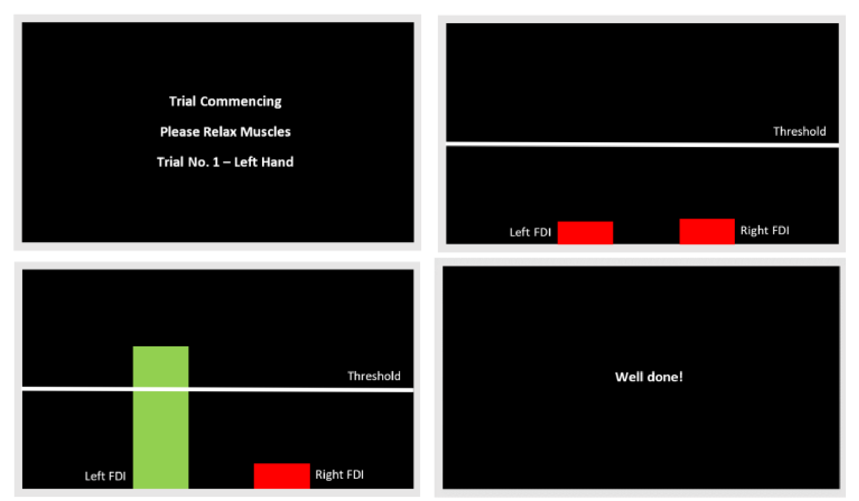Training section (real-time feedback)
  + 10 min EMG calibration
  + 15 min for force control training (20%)
  + 15 min for contrast discrimination task learning

Following the EMG training, participants are introduced to the contrast discrimination task. They use their learned muscle response skills to decide whether a flickering striped circle on the screen tilts toward the right or left. The experiment employs a "ready-steady-go" design:

* Trial initiation: Participants fixate on a central yellow dot while an interleaved grating (neutral, with equal left/right tilt) is displayed.
* Cue period: After 0.6 seconds, the dot turns green, signaling that the grating’s contrast will soon change.
* Evidence presentation: After 0.6 seconds, the evidence phase begins, lasting between 0.8 and 2.5 seconds, depending on response speed. During this phase, the grating tilts left or right with higher contrast.

Muscle responses between 0.2 and 1.8 seconds after the onset of the evidence phase are classified as valid. After the response, evidence remains on the screen for 0.2 seconds before disappearing, ensuring the total trial duration does not exceed 2.5 seconds. Responses that are too fast, too slow, or involve the wrong muscle are recorded, and participants receive immediate feedback. The training phase typically lasts 20 minutes, with the grating contrast gradually decreasing from 0.4 to 0.1 to help participants acclimate. A minimum accuracy rate of 60% is required at each contrast level before moving to the next, with an ideal post-training accuracy of 70%.

## 

## Experimental Phase

The second day is dedicated to data collection. EMG electrodes are placed based on the positions marked during the first day, and MVC values are not re-calibrated. The experiment involves four conditions:

1. Difficulty levels: Two contrast modes (0.14 and 0.07).
2. Muscle usage: FDI and BCP.

Muscle activation is set at 20% MVC, with sensitivity adjustments of ±5% as needed. The experiment consists of 8 blocks, with each block separated by a mandatory 3-minute rest period to alleviate muscle, attention, and visual fatigue. Before each block, participants complete a delay feedback practice session to recalibrate muscle force control and adjust the EMG interface sensitivity. Each block contains 128 trials, with equal distribution across the four experimental conditions. Trials are randomized to avoid predictable patterns. The total data collection phase lasts 85 minutes.

## Data analysis Techniques (to be continued)

## EEG: XXX each find one literiture

* + SSVEP: Steady-state visual evoked potentials to track sensory encoding.
  + CPP: Central parietal positivity for decision-making monitoring.
  + LRP: Lateralized readiness potential for motor preparation assessment.
  + Mu-Beta Oscillations: Indicators of motor readiness and inhibition.
  + NI Modeling: Combines EEG and behavioral data for decision process modeling.

EMG:

* + ENV XXX
  + FzEn XXX

EOG: XXX

This multi-modal approach ensures precise data collection, enabling a detailed analysis of sensory, decision-making, and motor processes in the perception-decision-action framework.