|  |  |  |  |
| --- | --- | --- | --- |
| WiFi routers | Details (MU-MIMO, B.F) | Comments | ~ Price $AUD |
| Synology RT1900 AC | SDB AC-1900 No Yes 3x3 | CNET 2018 Shortlisted; 5G: 586 – 70.9; 2.4G: 122 – 65; 180+ft range; NAS | $150 - $200 |
| Linksys EA8500 | SDB AC-2600 Yes Yes 4x4 DQOS | 5G 437 – 272; 2.4G 138 – 57;175+ft; NAS | $220 - $270 |
| ASUS RT-AC86U | SDB AC-2900 Yes Yes 4x4 DQOS | CNET 2018 Shortlisted; 5G 938 – 293; 2.4G 142; Storage | $250 - $300 |
| D-Link DIR-882 | SDB AC-2600 Yes Yes 4x4 DQOS | CNET 2018 Shortlisted; 5G 927 – 293; 2.4G 164; Storage FTP SAMBA; | $300 - $350 |
| Synology RT2600 AC | SDB AC-2600 Yes Yes 4x4 AMQOS | CNET 2018 Shortlisted; 5G 715 – 423; 2.3G 146 – 81; 150+ft; NAS | $325 - $360 |
| ASUS RT-AC88U | SDB* AC-3100 Yes Yes 4x4 DQOS | CNET 2018 Shortlisted; 5G 643- 345; 2.4G 229 – 102; 170+ft; NAS | $330 - $400 |

Alternative Setups:

* Bridged Router
* mesh router

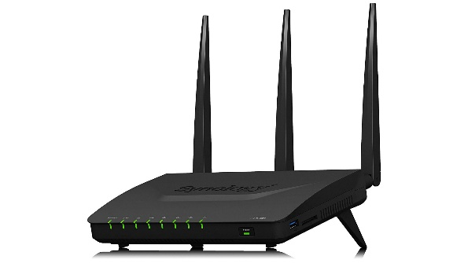 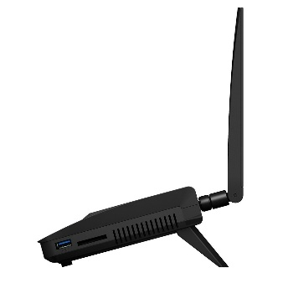

Synology RT1900AC – AC1900 Router

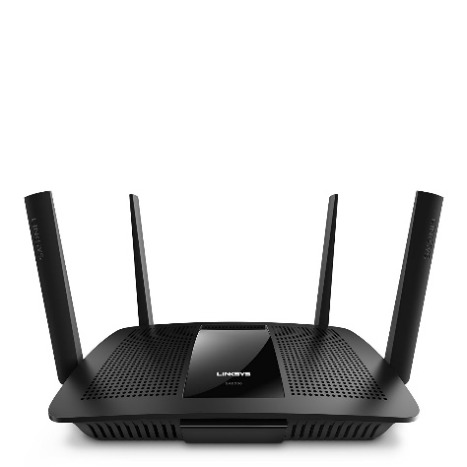 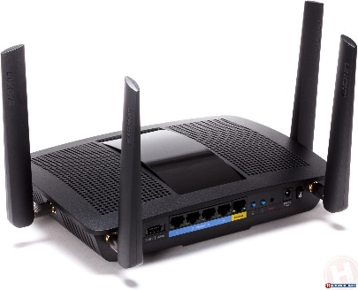

Linksys EA8500 – AC2600 Router

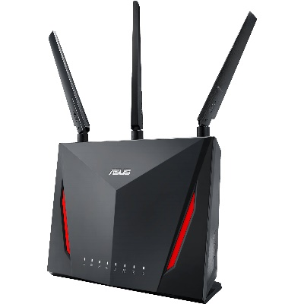 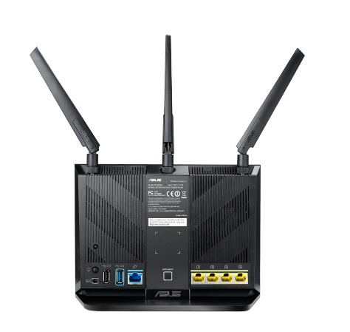

Asus RT-AC86U – AC2900 Router

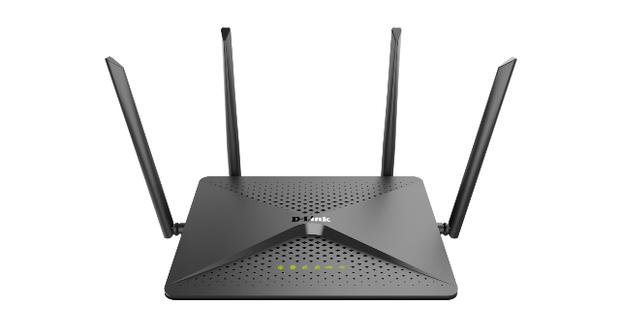 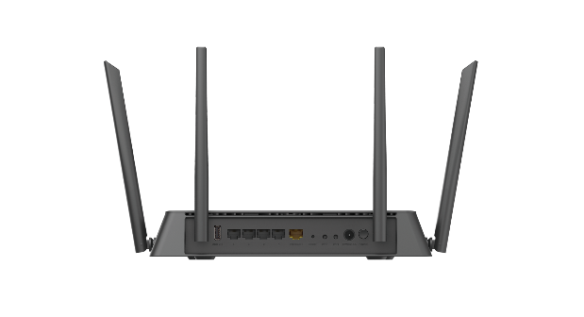

D-Link DIR-882 - AC2600 Router

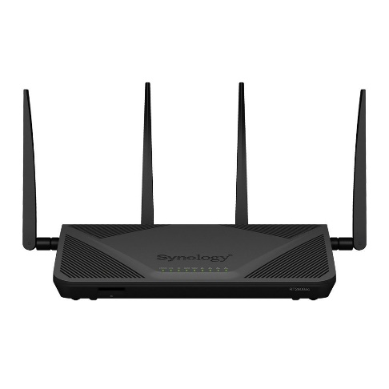 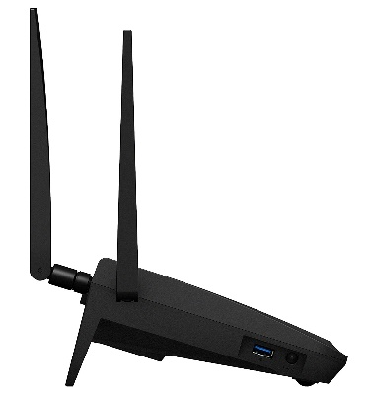

Synology RT2600AC – AC2600 Router

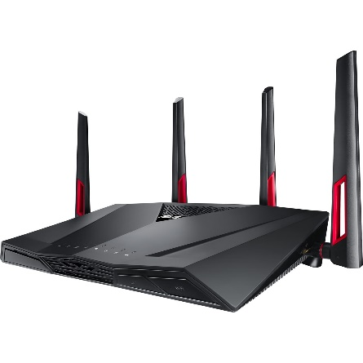 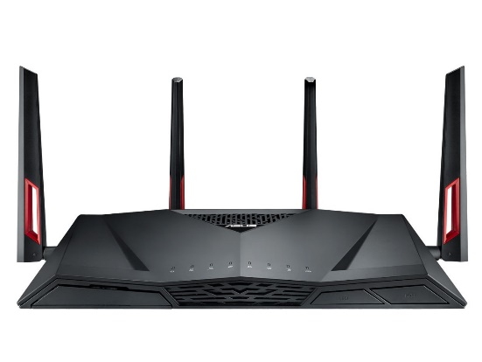

Asus RT-AC88U – AC3100 Router

Synology rt 2600 - 343.80 - <https://www.megabuy.com.au/synology-rt2600ac-router-p741097.html> - ac 2600

ASUS rt ac 68 - 245.*40 -* [*https://www.gearbest.com/wireless-routers/pp_662065.html?vip=72048*](https://www.gearbest.com/wireless-routers/pp_662065.html?vip=72048) *ac 2900*

Synology rt 1900 – 177 - <https://www.mwave.com.au/product/synology-rt1900ac-ac1900-wireless-dual-band-gigabit-router-ab68145> - ac 2600

ASUS rt ac 88 u – 399 - <https://www.shopbot.com.au/r.html?shopId=12223&offerId=213671563&productId=528333> – ac3100

Linksys wrt1900ac – 254.99 - <https://www.mwave.com.au/product/linksys-wrt1900acs-dual-band-wireless-ac1900-smart-wifi-router-nbn-ready-ab73892> ac 1900

D-Link AC2600 – 299 - <https://www.kogan.com/au/buy/d-link-ac2600-mu-mimo-wi-fi-router-dir-882-d-link/?utm_source=shopbot&utm_medium=cpc&utm_campaign=shopbot> ac 2600

Netgear R7000 Nighthawk – 259 - <https://www.mwave.com.au/product/netgear-r7000-nighthawk-ac1900-smart-wifi-router-nbn-ready-ab52776> - ac 1900