1 Create 3 tables

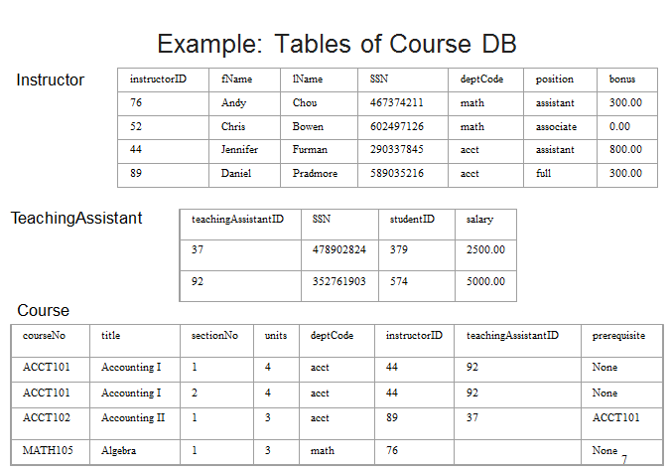

2 operating the tables

Q1: list all details of all teaching assistants

Q2: list the teaching assistant ID, salary, and SSN of all teaching assistants

Q3: list the course title of all courses

Q4: Produce a list of monthly salaries for all teaching assistants, showing teaching assistant ID and monthly salaries

Q5：list the instructor ID and bonus of all instructors who have more than $500.00 bonus

Q6: list all details of all courses with the title Accounting I or Accounting II

Q7: list the instructor ID and bonus of all instructors who have bonus between $400.00 and $800.00

Q8: list the instructor ID and position of instructors who are associate professors or full professors

Q9: list the instructor ID and last name of all instructors whose last names contain character ‘o’

Q10: list all details of the courses that have been assigned an instructor but have not been assigned an teaching assistant

Q11: Q11: list instructor ID, name, and SSN of all instructors, arranged in ascending order of instructorID

Q12: list all details of all courses, with first in ascending order of units, second in ascending order of course No., and then in descending order of section No.

Q13: how many instructors have $300.00 or more bonus?

Q14: how many different course titles are there?

Q15: find the total number of assistant professors and the sum of their bonus

Q16: find the minimum, maximum, and average bonus by instructors

Q17: find the total number of instructors in each department and the sum of their bonus, respectively

Q18: for each position type with more than one instructor, find the total number of instructors and the sum of their bonus