$0-1k/Month Blueprint
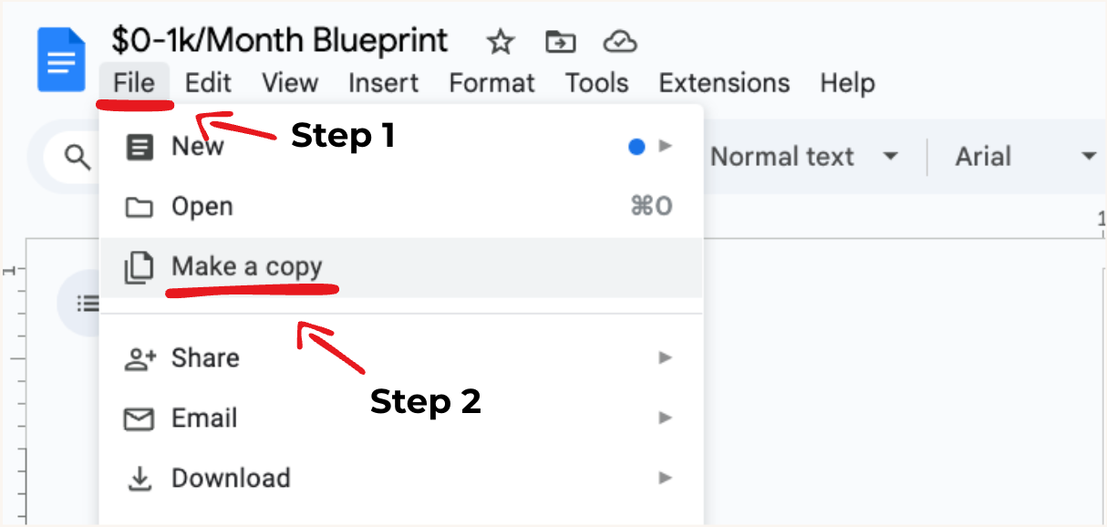

Phase 1: Increasing Our Chances of Success
Goal: Stack the odds in your favor before you even begin by choosing the right kind of book to publish — the kind that gives you a realistic, data-backed path to $1K/month.

Understanding the Landscape
Not all books are created equal — some are much harder to succeed with, especially in 2025’s competitive KDP landscape.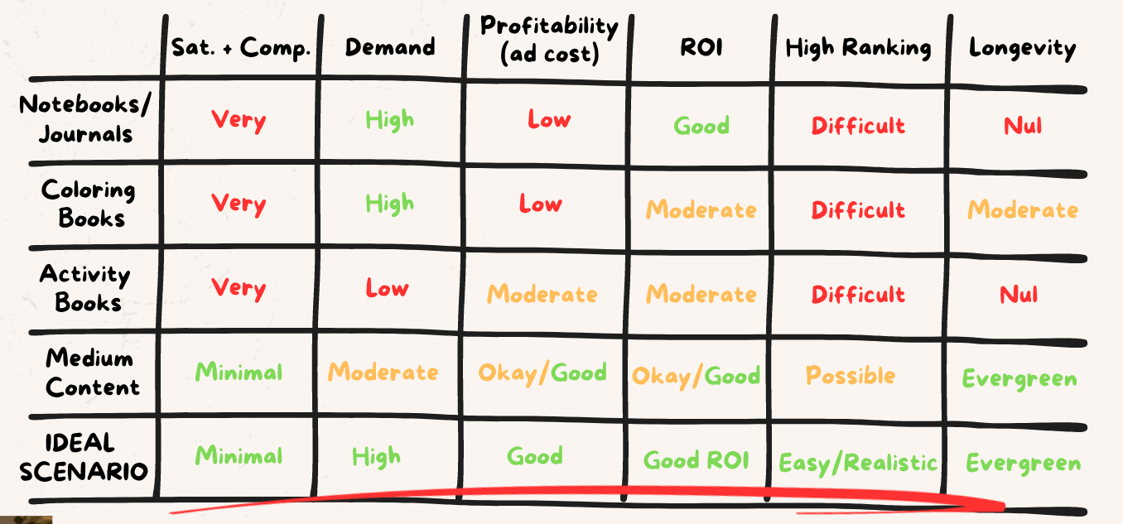

Why High-Content Wins
✅ “Harder” to create – But much easier to sell and rank long-term.
❌ Low-content books might be easier to make but often have:
- High competition
- Low royalty margins
- Low organic ranking potential
AI has made high-content easier than ever: Tools like ChatGPT lower the barrier to entry.

The Math Behind $1K/Month
Use realistic numbers to guide your expectations and plan your strategy.
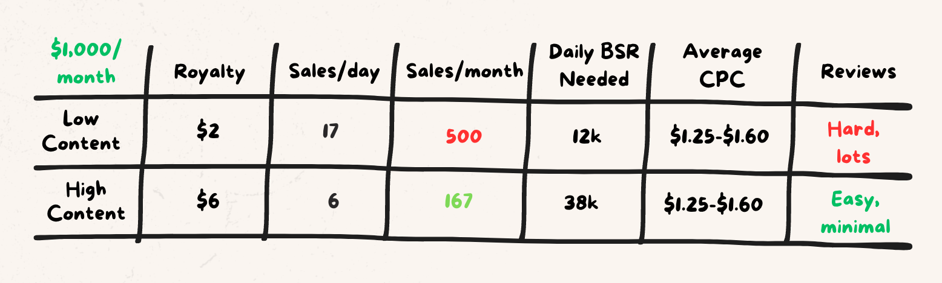
🎯 Pro Tip: Publish 2–3 high-quality books and divide the load.

Set Yourself Up for Profit
Choose books that are easier to rank, easier to convert, and more profitable.
Focus on:
- Evergreen niches
- Lower competition (BSR < 40K, low review counts)
- High perceived value
- Lower ad cost per sale

Key Takeaway
The #1 thing you can do to increase your chances of success is:
"Make it easier before you even start."
Don’t try to force success in saturated, competitive niches. Start smart.

Phase 1 Action Steps
- Understand the pros and cons of low vs. high-content publishing.
- Choose the model (and book type) that maximizes profitability and reduces competition.
- Use data (BSR, reviews, CPC) to guide your expectations.
- Avoid saturated markets, especially if you're new.

Phase 2: Finding Our Topic
Goal: Validate a beginner-friendly, profitable topic before you spend time or money creating your book.

What to Look For
You want a topic that’s:
- ✅ Beginner-friendly to produce (less research-heavy, easier outsourcing)
- ✅ In demand (selling well)
- ✅ Not too competitive (possible to rank)
Examples of beginner-friendly topics:
- Diet & cookbooks
- Fitness for beginners
- Hobby-based guides
- Workbooks

How to Find It
- Browse Amazon manually or with tools like BookBeam.
- Create a list of potential topics (Solving 1 problem for 1 person)

🔹 How to Validate It
Can we sell?
- Is there proof? Multiple books selling with few reviews?
What to look for:
- Books have low reviews (under 200)
- Books are selling well (BSR under 40,000)
- Multiple books are succeeding — not just one outlier (3+)
Can we rank?
- Is it overcrowded?
  - If 3–4+ books have 500+ reviews, it's likely too competitive.

Found a winner? Check these:
- ❌ Trademarked?
- ✅ Evergreen? Does it sell year-round, or is it seasonal?
- ❌ Dominated by big-name authors?
- ✅ Beginner-friendly to produce?
Use these to filter out poor opportunities early.

Tool Tips
Use BookBeam to check:
- BSR of books
- BSR history
Walk through Amazon to analyze competitors and test keywords in real time.

✅ Phase 2 Action Steps
- Create a list of 50-100 potential book topic ideas.
- Validate them using BSR, review counts, and demand signals.
- Choose 1 "winner" that passes all your criteria.
- Move forward to outlining and creation.

Phase 3: Creating Our Book
Goal: Build a market-ready, high-quality book that stands out and actually sells — without wasting time or money.

Step 1: TOC & Outline
Start by reverse-engineering what already works, then add your own twist.
- Study competitor TOCs: Look at structure, flow, and topics covered.
- Map out your own outline: Use what’s working, then improve or simplify it.
- Focus on solving problems better or faster than what’s out there.
- Outsource if needed: Fiverr, The Urban Writers, or Dibbly Create can build outlines for you.
ChatGPT Prompt:
“Based on the top 3 books on "chatgpt for beginners," can you create a rough outline of the table of contents for my book?
Ensure it covers what the book needs to have, as well as have a competitive edge (5-week plan, etc)”

Step 2: Hiring a Writer
Create a great product by working smarter — not harder.
- Use reliable ghostwriters: Platforms like The Urban Writers (TUW) are beginner-friendly. AI/writer option is cheap and fast.
- Provide a clear brief: Include your outline, tone, and goals to avoid rewrites.

Step 3: Title & Cover
Get attention and clicks with a compelling offer before readers even open the book.
Title:
- Clear, benefit-driven, and keyword-friendly
- Use AI to generate 10 title ideas based on competitors and features
- Ensure readers know it’s for them at a glance
ChatGPT Prompt:
“Can you give me 10 title options for my book on Golo Diet for Seniors. Base the structure off the best-selling books on Amazon.
Some desirable attributes inside:
- Complete 21-day meal plan
- Over 75 delicious and easy recipes
- The book helps with weight loss”
Select a winner
Select a winning title that is short, easy to understand, and has a competitive edge from your competitors. It must spark an emotion and exactly what the customer is looking for.
Cover:
- Must stand out and be legible in thumbnail view
- Avoid stock templates — aim for bold, clean, and professional designs
- Use Fiverr, TUW, or ChatGPT to get some designs created
Design Requirements For Cover Designer:
- Title-Focused Layout
- Build the entire design around the title — it should be the clear focal point.
- Use bold, modern, easy-to-read typography.
- Ensure the title is legible at thumbnail size on Amazon.
Stand Out Visually
- Research top-ranking covers under the keyword “[INSERT TARGET KEYWORD HERE]” and design something that clearly pops in comparison.
- Consider contrasting colors or strong visual hierarchy to grab attention.
Minimal & Professional Style
- Keep design elements clean, balanced, and uncluttered.
- Avoid excessive use of icons, badges, or decorative flourishes.
No Stock Photos
- Do not use generic stock photography — opt for:
- Simple shapes or illustrations (if needed)
- Clean textures or subtle graphic elements that support the theme without distracting from the title
Color & Contrast
- Use bold, harmonious color combinations that align with the niche but differentiate from competitors.
- Prioritize contrast between background and text for maximum readability.

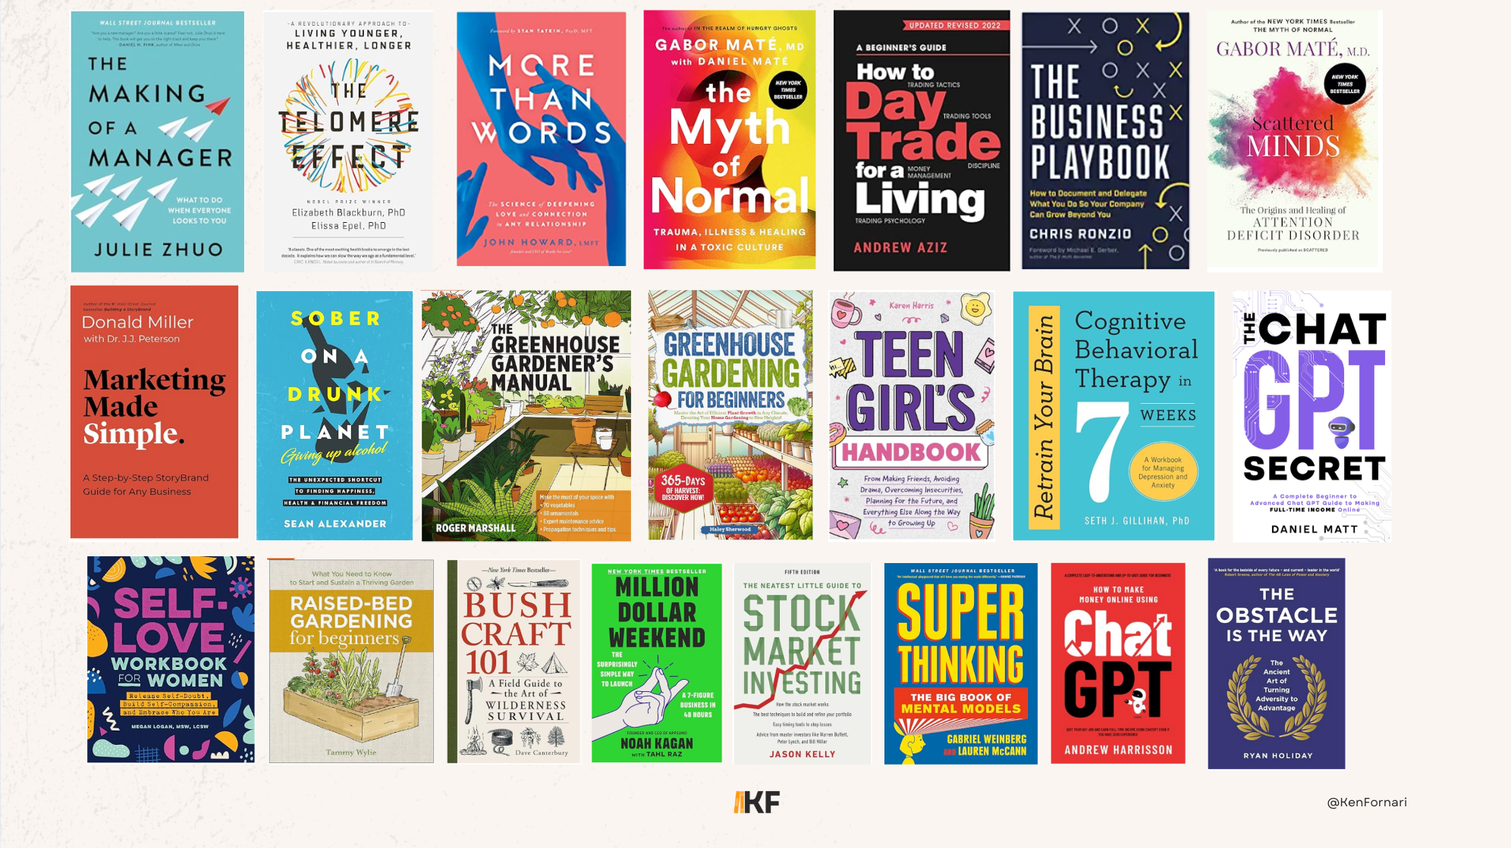

Step 4: Description & A+ Content
Convert browsers into buyers with strong sales copy and visuals.
Use the AIDA framework:
- Attention: Hook them immediately
- Interest: Highlight key features
- Desire: Show transformation or benefit
- Action: Strong, clear call to action
- Use prompts to generate it with AI, then edit manually.

ChatGPT Prompt:
“Create an Amazon book description the AIDA format for my cookbook titled 'The Complete GOLO Diet for Seniors' using typical Amazon formatting: a short, engaging intro paragraph, clear bullet-pointed book features highlighting benefits, and a compelling closing Call to Action (CTA).
Include these important details:
- A complete 21-day meal plan
- Over 75 delicious, easy-to-follow recipes specifically designed for seniors
- Promotes weight loss, improved energy, and better metabolic health
Write in a persuasive, customer-focused tone, similar to best-selling cookbook descriptions on Amazon.”
A+ Content:
- Add visual elements (images, charts, covers)
- Use Canva or outsource to Fiverr/TUW
- Think billboard-style: clean and impactful

Step 5: Formatting
Make sure your book looks and feels polished.
Free or Paid Options:
- Free: Reedsy Editor, Canva (for basic interiors)
- Paid: Vellum ($), Fiverr ($–$$), High-end formatting services ($$$)
- Ensure it's clean, readable, and high quality.

Phase 4: Launching Our Book
Goal: Set your book up for a successful launch by building early reviews, making it highly desirable, and strategically using Amazon ads to generate sales and rankings.

Step 1: Review Prep
Before anything else, set the foundation for launch success.
- Create an account on a review platform like BookBounty.
- Earn review credits by reviewing other books to build "review currency."
- Build up as much as you can to ensure an abundant book launch
This pre-launch review base is one of the most important things you can do to give your book momentum from day one.

Step 2: Learn the Launch Timeline
Your first 30 days should follow this structure:
- Day 1–7: Upload your book, finalize backend settings, and set up A+ Content and pricing strategy. Your book should look "desirable" — strong cover, polished description, social proof starting to come in.
- Day 7–30: Begin driving real traffic. Push Amazon ads, share with your audience, and generate verified sales and reviews.
- Day 30+: Optimize ad performance, increase price if appropriate, and move toward long-term maintenance or scale.

Step 3: Backend Keywords & Categories
Set your book up for visibility on Amazon.
Backend Keywords:
- Do not repeat words already in your title or subtitle.
- Don’t use commas — separate terms with spaces only.
- Use long-tail keyword phrases, e.g., "how to use ChatGPT," not just "AI."
- Use one main keyword phrase per box for better indexing.
Categories:
- Choose categories that are both relevant and winnable.
- Study your competitors to see where similar books are placed.
- Use category tools or browse Amazon directly to pick the best fit.

Step 4: Upload + First 7 Days
The most important setup window.
- Upload your book at a slight discount to encourage conversions and boost rankings.
- Add A+ Content — this builds trust and enhances your listing with visual elements.
- Run a Free Promo (optional) if your review platform recommends it — this can help boost early visibility.
- Start collecting reviews via BookBounty or other review systems.
- Begin driving sales around day 7–10 once your listing is strong.

Step 5: Launch Campaign (Day 7–30)
Time to drive serious traffic and prove your book's value.
- Your listing should now be desirable: quality cover, description, A+ content, early reviews, competitive price.
- Begin running Amazon Ads with a $5/day starting budget.
- Set up 3 essential campaigns:
  - Broad Keyword Campaign (target broad, relevant search terms)
  - Broad Product Campaign (target competing books)
  - Auto Campaign (let Amazon test different targets)
- Bonus campaigns: Manual campaign targeting your main keyword and your main competing product.
Track performance — click-through rate (CTR), conversion rate, and spend — to determine which ads are working.

Step 6: Day 30+ Scale & Maintain
Now that your book has data, it’s time to scale smart.
- Raise your price if the market allows and you have enough reviews.
- Let ads run another 2–3 weeks to gather more data.
- Narrow down to the best-performing ad sets and keywords.
- Push toward 100+ reviews for long-term credibility.
- Once stable, move on to your next book while maintaining your ads.
- Consider creating long-term optimized campaigns using search terms that converted well.
Maintenance Campaigns:
- Maintenance campaign 1: best-performing keywords
- Maintenance campaign 2: best-performing products
- 2-5 sales + 50% ACOS or below.
- $5/day+ (Scale best performing campaigns)

Optional: Audiobook Expansion
- Use ACX or Findaway Voices to publish your audiobook.
- This adds a new revenue stream and boosts overall discoverability.
- Best for books that are educational, engaging, or narrated well.

Phase 5: Scaling to $10K/Month
Goal: Turn a single profitable book into a full-time publishing business by stacking titles, compounding royalties, and building a true brand.

The Scaling Strategy
After each launch, ask:
- Is this book generating consistent sales?
- Are there positive reviews and good rankings?
- Is the market still active with demand?
If yes — great. Continue this brand with a book on a similar topic. If not, consider switching keywords to ensure you are prioritizing demand and your investment doesent go to waste.
Smart Expansion
Book 1: Prove your concept. Learn the process.
Book 2–3:
- Option 1: Target a similar niche or adjacent problem.
- Option 2: Try a new keyword or a completely different topic.
Book 4+:
- Option 1: Bundle books (2–3 books in one volume) to increase perceived value.
- Option 2: Start a new brand or topic if your current one feels saturated.

🔹 Optimize with Every Book
Track what’s working — and double down on it.
Keep improving:
- Titles
- Covers
- Category selections
- Descriptions
- Ads and pricing
If something underperforms, don’t be afraid to pivot or start from scratch.

The 10-Book Goal
"Aim for 10 books — and don’t lift your head until you get there."
- Each new title builds momentum and brings new traffic.
- Bundles and series open up even more earning potential.
- A catalog of 10 high-quality books is often all it takes to hit $5K–$10K/month consistently.

🧭 Full 5-Phase Overview: The $1K/Month KDP Blueprint

Phase 1: Increasing Your Chances of Success
- Focus on high-content books for long-term profitability.
- Avoid saturated low-content niches with low ROI.
- Use data (BSR, CPC, royalty) to choose the right type of book from the start.

Phase 2: Finding a Profitable Topic
- Look for beginner-friendly topics with strong demand and low competition.
- Validate using BSR, review counts, and competitive analysis.
- Choose a topic with evergreen potential and no trademark issues.

Phase 3: Creating a Great Book
- Outline your book based on proven competitor structures.
- Hire a quality writer or use AI tools with clear guidance.
- Craft a compelling title and eye-catching cover.
- Write a persuasive book description and add A+ content.
- Format your book professionally.

Phase 4: Launching for Sales & Reviews
- Prepare with 30+ pre-launch reviews using review platforms.
- Set up your listing with optimized keywords, categories, and visuals.
- Launch ads strategically to drive early sales.
- Optimize your campaigns and continue gathering reviews.

Phase 5: Scaling to $10K/Month
- Evaluate each book’s performance before expanding.
- Build on what works: similar topics, bundles, or new brands.
- Aim for 10 high-quality books to create a consistent income.
- Refine your process and multiply your results.

Don’t Want to Go In Blind?
If you want to follow my exact system in detail and get hand-held guidance throughout every step… You can learn how to do that here: https://link.publishermasteryacademy.com/program

