MADOCALIB ver.2.2 Manual

QZSS Strategy Office, Cabinet Office

Oct 2026, version 007

Contents
1 Overview 1
2 Getting Start 2
2.1 System Requirements 2
2.2 Installation 2
2.3 Quick Start with Sample Data 3
2.4 Quick Start with Downloaded Data 6
3 Usage of Utilities 9
3.1 RNX2RTKP 9
3.1.1 Overview 9
3.1.2 Inputs and Outputs 9
3.1.3 Configuration file 10
3.1.4 CUI Command Reference 14
3.2 CSSR2SSR 15
3.2.1 Overview 15
3.2.2 Inputs and Outputs 16
3.2.3 Configuration file 16
3.2.4 CUI Command Reference 17
3.3 MADOCALIB_GUI 18
3.3.1 Overview 18
3.3.2 Inputs and Outputs 18
3.3.3 Configuration file 18
3.3.4 Screen Flow 19
3.3.5 Screen Descriptions 20
3.3.6 Quick Start with Sample Data 37
Appendix. Specific Processing for MADOCA-PPP 44

Disclaimer of Liability

The Cabinet Office, Government of Japan, Quasi-Zenith Satellite System Services Inc. and other service providers of Quasi-Zenith Satellite System make the MADOCALIB manual (“Document”) available to the public to promote the services using Quasi-Zenith Satellite System (“QZSS”) by development of receivers, applications and so on, and also are aiming for high accuracy and convenience with respect to satellite positioning services and message services of QZSS (collectively “Services”). The Services are freely available to any user. However, the receivers and/or applications developed based on this Document may not receive signals or may receive incorrect signals due to no warranty of the Services. You are therefore highly recommended to ensure appropriate measures to avoid accidents such as redundancy, backup and fail-safe, if you develop receivers and/or applications using the Services for the purpose that will possibly give an impact to human life, body and properties. The Services may be suspended or changed without prior notice in accordance with the decision by Government of Japan. This Document and the Services are available subject to the following terms and conditions. You may use this Document only if you agree to such terms and conditions. You shall be deemed to agree such terms and conditions by using this Document.

(1) With respect to this Document and the information included in this Document, the Cabinet Office, Government of Japan (“CAO”), Quasi-Zenith Satellite System Services Inc. (“QSS”) and other service providers of Quasi-Zenith Satellite System ("Parties") disclaim all warranties of any kind, express or implied, including but not limited to, the followings:
i) warranty of accuracy, completeness, usefulness, and fitness for a particular request or purpose;
ii) warranty that this Document and the information included in this Document will not be changed in to the future; and
iii) warranty that this Document and the information included in this Document do not infringe any third party’s intellectual property rights.
(2) With respect to satellite positioning services and message services (collectively “Services”), CAO, QSS and Parties disclaim all warranties of any kind, express or implied, from any cause whether it is related to Quasi-Zenith Satellite System, other outside systems or not, including but not limited to, the followings:
i) warranty as to service area, accuracy, availability, continuity, and integrity described in this Document;
ii) warranty of usefulness, and fitness for a particular request or purpose; and
iii) warranty that the use of Services does not infringe any third party’s intellectual property rights.
(3) To the extent permitted by applicable laws, CAO, QSS and Parties shall not be responsible and liable for any damages and losses, including but not limited to, direct, indirect, incidental, special or consequential damages, whether under contractual liability, product liability, strict liability, tort liability or otherwise (including intent or negligence), caused by the use of this Document, the information included in this Document and the Services, the inability to use the Services, or the change of this Document and the information included in this Document.

Overview
This manual describes how to use the MADOCA-PPP (Multi-GNSS Advanced Orbit and Clock Augmentation - Precise Point Positioning) [1] test library called MADOCALIB. The purpose of distributing MADOCALIB is to facilitate the user algorithm implementation of MADOCA-PPP. MADOCALIB is constructed based on RTKLIB [2] and functions of PPP-AR and message conversion copyrighted by the third party and provides RNX2RTKP and CSSR2SSR.

RNX2RTKP is a utility for post-process positioning. It implements a processing mode called PPP (Precise Point Positioning) to make use of MADOCALIB. In this processing mode, the following functions are added to RTKLIB ver.2.4.3b34:
- To use the Galileo E1-E5a signal for PPP calculation
- To read the Compact SSR message of MADOCA-PPP
- To select GNSSs to be used for PPP calculation, and
- To select frequencies to be used for PPP calculation for each GNSS
- To process the ionospheric correction data of MADOCA-PPP
- To support triple/quad-frequency PPP
Users can refer to its output as a reference to achieve the performance criteria of MADOCA-PPP.
MADOCALIB also has a processing mode called PPP-AR (Precise Point Positioning-Ambiguity Resolution). Please note that the performance of MADOCA-PPP with the PPP-AR method is currently not defined in the specification documents.

CSSR2SSR is a utility for post-processing conversion of L6E message file containing MADOCA-PPP compact SSR data to RTCM3 SSR message file.

MADOCALIB_GUI is a Windows GUI application that allows users to configure and execute the console-based RNX2RTKP tool and launch RTKPLOT to visualize processing results.

Note: The screenshots in this manual may differ from the actual screens depending on the version of MADOCALIB.

[1] IS-QZSS-MDC-004: https://qzss.go.jp/en/technical/ps-is-qzss/ps-is-qzss.html
[2] RTKLIB: https://github.com/tomojitakasu/RTKLIB.git

Getting Start

System Requirements
The executable binary CUI apps included in the package require Microsoft Windows environment. On the other OS (Linux, etc.) or environment, you have to compile and build CUI apps by yourself.
The executable CUI apps are built with mingw-w64, which can be obtained from the following URL. They have been tested on Windows 11 (64-bit).
URL: https://www.mingw-w64.org/

In addition to the CUI apps, this package includes a GUI application implemented in Python.
The GUI app is provided as standalone executable (.exe) files and was built and tested on Microsoft Windows 11 (64-bit) using Python 3.14.2. When not using the provided executable (.exe), the tkinterdnd2 library is required.
Its operation on Linux or other non-Windows environments has not been tested. It is expected that the GUI app should be rebuilt from the provided Python sources if execution in such environments is required.

Installation
Extract the program package madocalib to appropriate directory <installed_dir>.on the local disk. The directory structure of the package is as below.

<installed_dir> |  |  | Directory where this software is installed
 | \app\consapp |  | The application resources are stored.
 |  | \cssr2ssr | The source files and makefile of CSSR2SSR are stored.
 |  | \rnx2rtkp | The source files, makefile and sample configuration files of RNX2RTKP are stored.
 | \app\guiapp | \madocalib_gui | The source files of MADOCALIB_GUI are stored.
 | \bin |  | Executable binary of apps for Windows
 | \doc |  | Document source files
 | \sample_data |  | Sample data and sample BAT files for apps.
 | \src |  | Source files of MADOCALIB library.

Quick Start with Sample Data
Here are quick start guide for RNX2RTKP and CSSR2SSR using the sample data included in this package.

Open the following folder on “Windows Explorer”.
<installed_dir>\sample_data

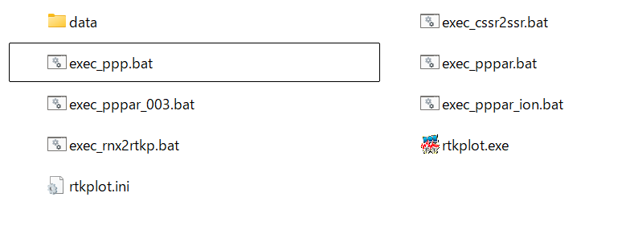

There are BAT files which execute PPP/PPP-AR from 00min00sec to 59min30sec every hour.

exec_ppp.bat : for PPP (no integer ambiguity resolution) by RNX2RTKP
exec_pppar.bat : for PPP-AR (with integer ambiguity resolution) by RNX2RTKP
exec_pppar_ion.bat: for PPP-AR with ionospheric correction by RNX2RTKP
exec_cssr2ssr.bat : for converting cssr to ssr by CSSR2SSR

Double-click on the above BAT file for each scenarios. You can see the command prompt window and get output solution files in the result folder of result_<BAT filename>.

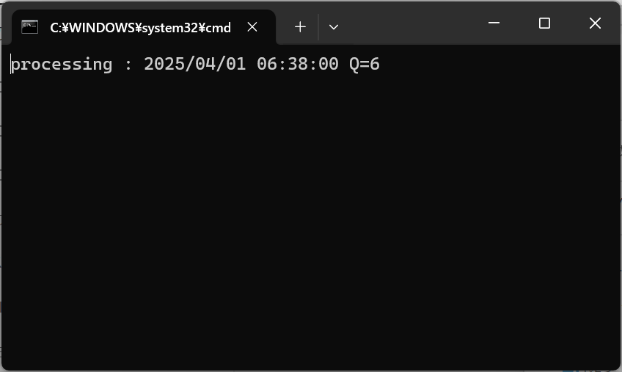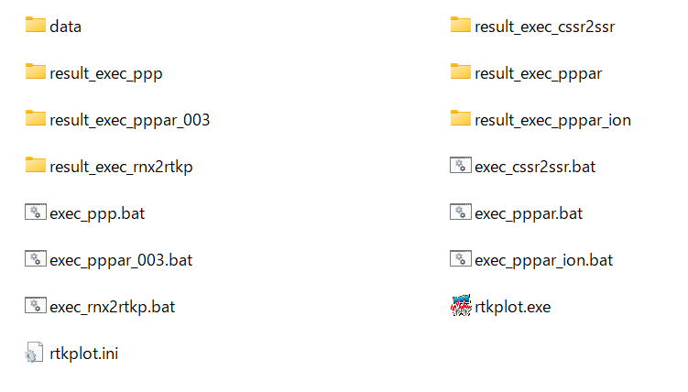

The file output by RNX2RTKP contains the receiver positions calculated by PPP, which can be visualized by RTKPLOT included in RTKLIB package.
The RTKPLOT is included in the folder of sample_data, you can use it to visualize the following steps.

- Double-click rtkplot.exe to start it.
- Click to select the RNX2RTKP output *.pos files in the result folder of result_<BAT filename> to visualize.
- Drag and drop selected *.pos files into the RTKPLOT

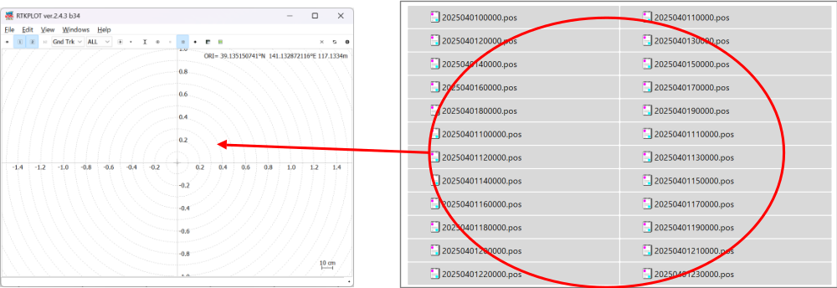

A time series plot can be viewed by selecting “Position” from the pull-down menu in the upper left corner of the RTKPLOT. For the detail of RTKPLOT, see RTKLIB manual [4].
[3] RTKLIB manual: https://github.com/tomojitakasu/RTKLIB/blob/master/doc/manual_2.4.2.pdf

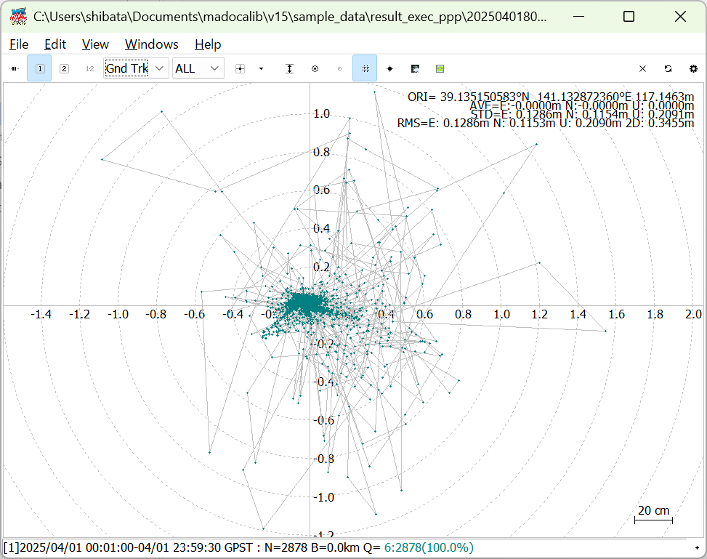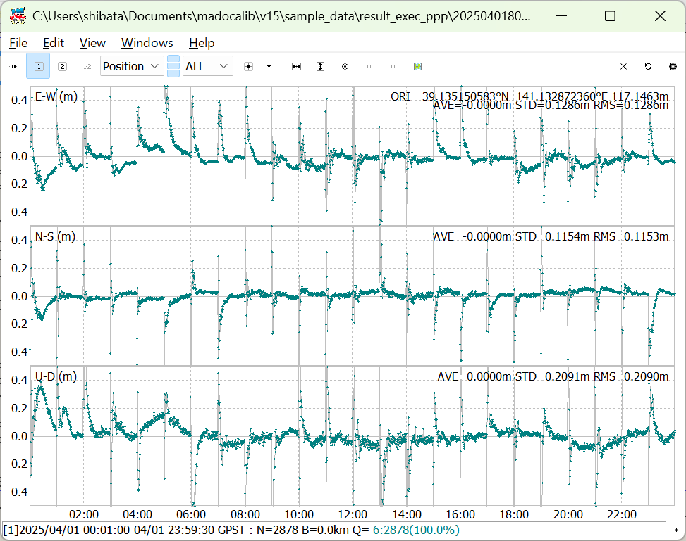

By open each batch file in a text editor, you can see the input data, output data, location of the configuration file, and how to specify the commands used in each.
Sample data corresponding to IS-QZSS-MDC-005 is stored and PPP scenarios are prepared. The sample data are the RINEX files and the L6E messages of PRN 207 on March 28, 2026, in which the PRNs of the BeiDou satellites are rewritten to those after the BeiDou PRN reassignment of April 2026 for testing. The file names of the RINEX files end with _BDSTEST. In addition, sample data corresponding to IS-QZSS-MDC-004 on April 1, 2025, before the reassignment, is stored for exec_pppar_ion.bat.

Sample output results for each scenario are shown below.

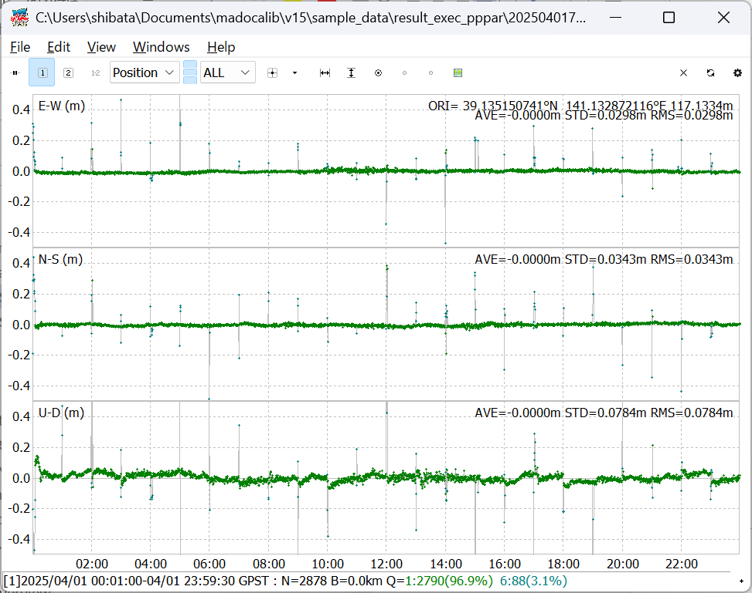
exec_ppp.bat exec_pppar.bat

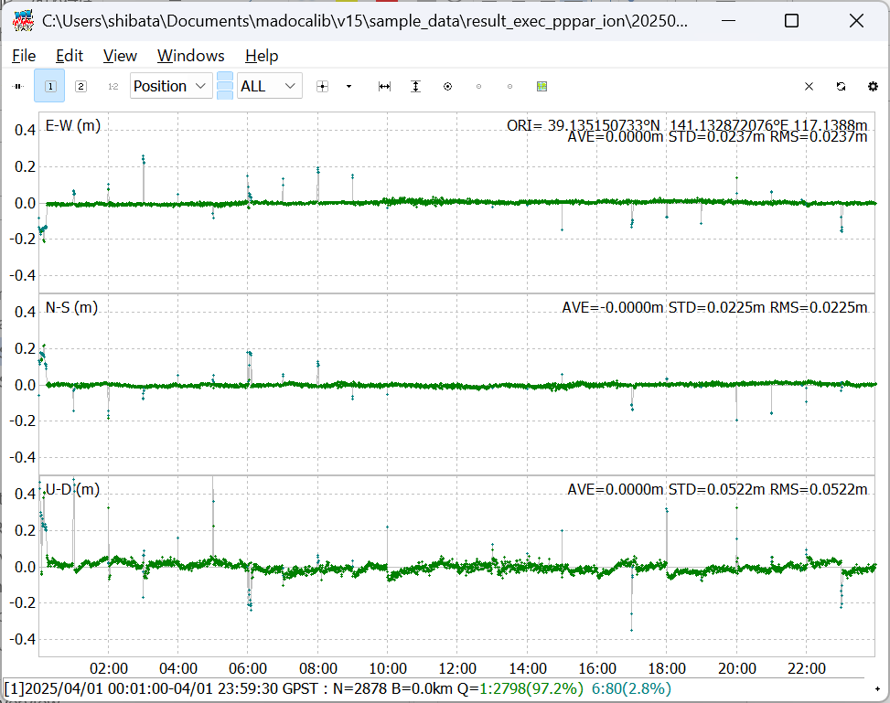
exec_pppar_ion.bat

Quick Start with Downloaded Data
Here is a quick start guide for RNX2RTKP using the downloaded data.

Getting RINEX OBS and NAV files
The RINEX OBS and NAV data can be downloaded from the following IGS’s and MIRAI’s URL.
IGS<https://igs.org/data/#daily_data>
MIRAI<https://go.gnss.go.jp/mirai/miraiarchive/>



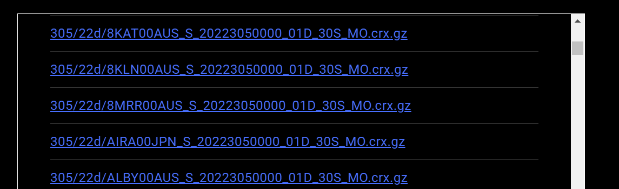

RINEX OBS files are saved in Compact RINEX format, so converting them to RINEX v3 is required. The RNXCMP (a tool that converts the Hatanaka compact RINEX format (extension crx) is used to convert to the commonly used RINEX format (extension rnx)) and can be obtained from the following https://terras.gsi.go.jp/ja/crx2rnx.html
For Windows 64-bit environment, download RNXCMP_4.1.0_Windows_mingw_64bit.

Getting QZSS L6 message files
L6E and L6D archive data file can be downloaded from the following QZSS URL.
https://sys.qzss.go.jp/dod/en/archives.html
Hourly files can be obtained for each PRN number. To perform PPP/PPP-AR in the Asia Oceania region, download the PRN204 and PRN206 files. For further ionospheric correction, please download the PRN200 and PRN201 files.

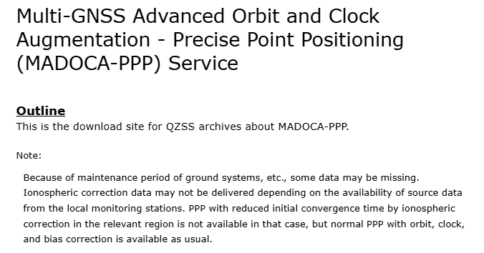

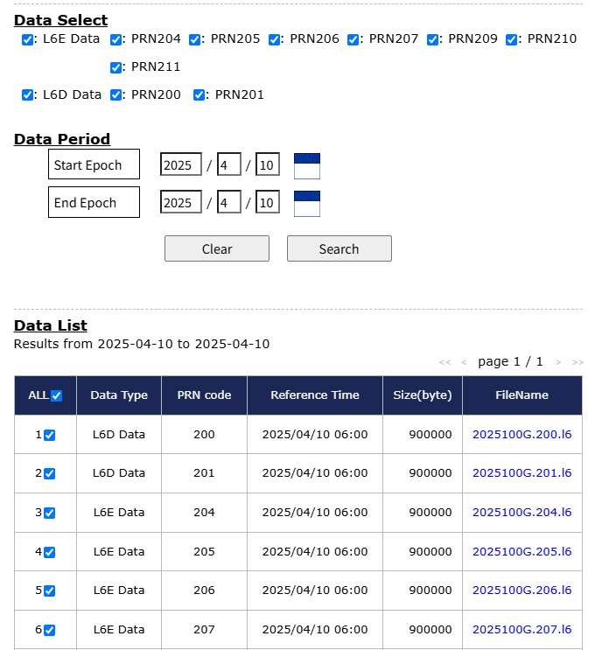

Set up execution commands
Store the downloaded RINEX and L6 files in the following folders respectively.
<installed_dir>\sample_data\data\rinex\obs\<4digit year>\<3digit day of year>
<installed_dir>\sample_data\data\rinex\BRDC\<4digit year>\<3digit day of year>
<installed_dir>\sample_data\data\l6\<4digit year>\<3digit day of year>

Open the batch file in the following folder with a text editor.
<installed_dir>\sample_data\exec_rnx2rtkp.bat

Rewrite the followings to specify the downloaded RINEX OBS, RINEX NAV, L6E message and L6D message.
OBS=data/rinex/obs/%Y/%n/MIZU00JPN_R_%Y%n0000_01D_30S_MO.rnx
NAV=data/rinex/BRDC/%Y/%n/BRDM00DLR_S_%Y%n0000_01D_MN.rnx
L6E1=data/l6/%Y/%n/%Y%n%HU.204.l6
L6E2=data/l6/%Y/%n/%Y%n%HU.206.l6
L6D1=data/l6/%Y/%n/%Y%n%HU.200.l6
L6D2=data/l6/%Y/%n/%Y%n%HU.201.l6

It is recommended that file paths be specified using keywords that are replaced to date/time. See 3.1.2.

Rewrite the following start date/time and end date/time according to the date and time of the analysis
TS_DATE=2026/03/28
TS_TIME=00:00:00
TE_DATE=2026/03/28
TE_TIME=23:59:30

Double-click the batch file to run it. And you can get output files in the following directory.
<installed_dir>\sample_data\data\result_exec_rnx2rtkp

Note. In the batch file, % is replaced with %% to escape the special character % in Windows.

Usage of Utilities

RNX2RTKP

Overview
RNX2RTKP is a utility for post-process positioning. It implements a processing mode called PPP (Precise Point Positioning) to make use of MADOCALIB.

Inputs and Outputs
The input and output files for the RNX2RTKP are as follows.

Inputs
No. | Item | Description
1 | RINEX OBS files | RINEX v3.x Observation files (*.rnx)(*1).
2 | RINEX NAV files | RINEX v3.x Navigation files (*.rnx) (*1).
3 | QZSS L6E files | L6E archive data file which can be downloaded from the following QZSS website (*.PRN.l6) (*1). PRN=204~211  https://sys.qzss.go.jp/dod/en/archives.html
4 | QZSS L6D files | L6D archive data file which can be downloaded from the following QZSS website (*.PRN.l6) (*1). PRN=200,201  https://sys.qzss.go.jp/dod/en/archives.html
5 | ANTEX file | The antenna phase information file (e.g. igs20.atx, igs14.atx) which can be obtained from the following IGS website.( *For monitoring stations that do not use the same combination of antenna and radome used for IGS stations, a dedicated antenna phase information file needs to be used instead of the above file.)  https://cddis.nasa.gov/Data_and_Derived_Products/GNSS/GNSS_product_holdings.html  This file is only used for receive antenna correction.
6 | Configuration file | Configuration file of RNX2RTKP. See 3.1.3.

Outputs
No. | Item | Description
1 | Position Solution file | File containing the receiver's position as calculated by the PPP process (*1). The file is a simple text file, and its format is defined in the RTKLIB manual “B.1 Positioning Solution File” at the following URL.  https://github.com/tomojitakasu/RTKLIB/blob/master/doc/manual_2.4.2.pdf

(*1)
These file path can be specified with the keywords replaced as below

%Y -> yyyy year (4 digits) (2000-2099)
%y -> yy year (2 digits) (00-99)
%m -> mm month (01-12)
%d -> dd day of month (01-31)
%h -> hh hours (00-23)
%H -> a hour code (a-x)
%M -> mm minutes (00-59)
%n -> ddd day of year (001-366)
%W -> wwww gps week (0001-9999)
%D -> d day of gps week (0-6)
%HU-> h hour code (A=0,B=1,C=2,...,X=23)

Configuration file
The keywords which can be included in the configuration file for RNX2RTKP are shown in the following tables.

Item | Description | Configuration File | Notes
Positioning Mode | Set the positioning mode. MADOCALIB supports following options.  - ppp-kine : PPP with kinematic mode  - ppp-static : PPP with static mode | pos1-posmode
Number of Frequencies | Set the used number of frequencies  - l1 : Single frequency. N/A for ppp-* modes.  - l1+2 : Dual-frequency  - l1+2+3 : Triple-frequency  - l1+2+3+4 : Quad-frequency | pos1-frequency
Ionosphere Correction | Set the ionospheric correction option.  - off : Not apply ionospheric correction  - brdc : Apply broadcast ionospheric correction.  - dual-freq : Ionosphere-free linear combination with dual-frequency. This should be selected if PPP is performed.  - est-stec : Estimate ionospheric delay for each satellite. This should be selected if PPP-AR is performed. | pos1-ionoopt
Navigation System | Set the used number of navigation satellite systems.  - 1 : GPS  - 4 : GLONASS  - 8 : Galileo  - 16 : QZSS  - 32 : BeiDou  If you want to use PPP with GPS+GAL+QZS, you should set the sum of these numbers to "25" because GPS is "1", GAL is "8", and QZS is "16". | pos1-navsys
Ionospheric Correction | Set apply for ionospheric correction by L6D.  - off : Not apply ionospheric correction  - on : apply ionospheric correction | pos2-ionocorr | L6D file must be specified as input file when applying the ionosphere correction.
Integer Ambiguity Resolution | Set the strategy of integer ambiguity resolution.  - off : No ambiguity resolution  - continuous : Continuously integer ambiguities are estimated and resolved  - fix-and-hold : Continuously integer ambiguities are estimated and resolved. If the validation OK, the ambiguities are tightly constrained to the resolved values. | pos2-armode
Validation Ratio to Fix Ambiguity | Set the integer ambiguity validation threshold for “ratio-test”, which uses the ratio of squared residuals of the best integer vector to the second-best vector. | pos2-arthres
Std-Dev for Ambiguity Search | Set the maximum standard deviation threshold of the 3D position to start narrow-lane integer ambiguity search (m). | pos2-arthres1
Signal Option for GPS | Set the priority of used signals for GPS.  - L1/L2  - L1/L5  - L1/L2/L5 | pos2-siggps | The actual number of frequencies to be used shall be set by “pos1-frequency”.  If L1/L2/L5 are set and “pos1-frequency” is set to “l1+2”, dual frequencies of L1/L2 are used. (*1)
Signal Option for QZSS | Set the priority of used signals for QZSS.  - L1/L5  - L1/L2  - L1/L5/L2 | pos2-sigqzs | Same as above.
Signal Option for Galileo | Set the priority of used signals for Galileo.  - E1/E5a  - E1/E5b  - E1/E5a/E5b/E6  - E1/E5a/E6/E5b | pos2-siggal | Same as above.
Signal Option for BeiDou-2 | Set the priority of used signals for BeiDou-2.  - B1I/B3I  - B1I/B2I  - B1I/B3I/B2I | pos2-sigbds2 | Same as above.
Signal Option for BeiDou-3 | Set the priority of used signals for BeiDou-3.  - B1I/B3I  - B1I/B2a  - B1I/B3I/B2a | pos2-sigbds3 | Same as above.
BDS-2 Satellites in PRN 1-18 | Specify the satellites in PRN 1-18 to be treated as BDS-2 after the BeiDou PRN reassignment of April 2026. Other satellites are treated as BDS-3. Satellite IDs (C01-C18) may be specified as a comma-separated list or ranges (e.g., C09-C10). For L6 messages recorded before the reassignment, specify C01-C18. | pos2-bds2prn
BDS-3 IGSO Satellites | Specify the BDS-3 IGSO satellites. They are not selected as the reference satellite of the integer ambiguity resolution. Satellite IDs may be specified as a comma-separated list or ranges (e.g., C06-C08). If empty, C06-C08 are used, which are the BDS-3 IGSO satellites after the BeiDou PRN reassignment of April 2026. For L6 messages recorded before the reassignment, specify C38-C40. | pos2-bds3igso

(*1)
The signal option settings mean from left to right: 1st frequency, 2nd frequency, 3rd frequency, 4th frequency. Observation data for the 1st and 2nd frequencies must be required to perform PPP, while observation data for the 3rd and 4th frequencies are optional. Therefore, if the observed data for the frequencies set in 1st freq. and 2nd freq. are not present in one of them, PPP will not be performed properly.
For example, if the following options are set for a receiver outputting observation data of the L1 and L2 frequencies, PPP will be performed in dual-frequency mode internally.
pos1-frequency =l1+2+3
pos2-siggps =L1/L2/L5

However, with the same settings, PPP cannot be performed for observation data of L1 and L5 frequencies. In this case, it should be set up as follows.
pos2-siggps =L1/L5

The following sample files are included on the directory as below.
<installed_dir>\app\consapp\rnx2rtkp\gcc_mingw

sample.conf
Configuration for PPP (no integer ambiguity resolution) whose performance is specified in PS-QZSS. This configuration performs PPP by ionosphere-free linear combination with dual-frequency with GPS, GLONASS, QZSS and Galileo by setting as below.

pos1-navsys =29
pos1-frequency =l1+2
pos1-ionoopt =dual-freq
pos2-armode =off

sample_pppar.conf
Configuration for PPP-AR (with integer ambiguity resolution). This configuration performs PPP-AR with quad-frequency with GPS, GLONASS, QZSS, Galileo and BeiDou by setting as below.

pos1-navsys =61
pos1-frequency =l1+2+3+4
pos2-armode =continuous

sample_pppar_iono.conf
Configuration for PPP-AR with ionospheric correction on L6D message. This configuration performs PPP-AR with ionospheric correction by setting as below.

pos2-ionocorr =on

These sample configuration files are tuned specifically for PPP processing for observation data at 30-second intervals at MIRAI or IGS stations, using the MADOCA-PPP L6 message archive data as augmentation data. Therefore, it is recommended that the parameters especially pos2-arthres and pos2-arthres1 be tuned accordingly for each case where observation data conditions such as data intervals are different.

CUI Command Reference

synopsis:
rnx2rtkp.exe [option]... obsfile navfile l6efile l6dfile [...]

options:
-k file input options from configuration file [off]
-o file set output file [stdout]
-ts ds ts start day/time (ds=y/m/d ts=h:m:s) [obs start time]
-te de te end day/time (de=y/m/d te=h:m:s) [obs end time]
-ti tint time interval (sec) [all]
-x level debug trace level (0:off) [0]
-ant file rcvantfile [specified by conf file]

example:
rnx2rtkp.exe -ts 2025/04/01 00:00:00 -te 2025/04/01 23:59:30 -ti 30
-k sample_pppar_iono.conf -o test.%Y%m%d%h%M%S.pos
MIZU00JPN_R_%Y%n0000_01D_30S_MO.rnx
BRDM00DLR_S_%Y%n0000_01D_MN.rnx
%Y%n%HU.209.l6 %Y%n%HU.200.l6 %Y%n%HU.201.l6

CSSR2SSR

Overview
CSSR2SSR is a utility for post-processing conversion of L6E message file containing MADOCA-PPP compact SSR data to RTCM3 SSR message file.
Convert cssr message file to ssr message file. Supported Compact SSR messages (cssr) and SSR messages (ssr) are as bellow.

[Vendor ID]
"010b" : MADOCA-PPP

[Message Type, Sub Type]
MT4073,1 : mask
MT4073,2 : orbit
MT4073,3 : clock
MT4073,4 : code bias
MT4073,5 : phase bias
MT4073,7 : ura

Supported SSR messages (ssr) are as bellow.

[Message Type]
SSR Message : GPS GLONASS Galileo QZSS BeiDou
--------------------:------------------------------------------------------
SSR Orbit Correction: 1057 1063 1240(*1) 1246(*1) 1258(*1)
Clock Correction: 1058 1064 1241(*1) 1247(*1) 1259(*1)
URA : 1061 1067 1244(*1) 1250(*1) 1262(*1)
Code Bias : 1059(*2) 1065(*2) 1242(*1*2) 1248(*1) 1260(*1)
Phase Bias : 1265(*2) 1266(*2) 1267(*1*2) 1268(*1*2) 1270(*1*2)

[format]
nothing * :RTCM 10403.3
(*1) :Proposal of new RTCM SSR Messages
SSR Stage 1:Galileo,QZSS,SBAS,BDS 2014-04-17 v05
(*2) :Proposal of new RTCM SSR Messages
SSR Stage 2:Satellite Phase Biases 2014-04-17 v05

The signals stored in MADOCA-PPP that are not defined in RTCM SSR utilize the following signal and tracking mode identifiers.

GNSS :Signal and Tracking Mode Identifier
--------:------------------------------------
GPS :16- L5 I+Q
:17- L1 L1C(D+P)
Galileo : 3- E1 B+C
: 7- E5a I+Q
:10- E5b I+Q
BeiDou :13- B2a Q
:14- B2a I+Q

Inputs and Outputs
The input and output files for the CSSR2SSR are as follows.

Inputs
No. | Item | Notes
1 | QZSS L6E file | L6E message file containing MADOCA-PPP compact SSR (CSSR) data.

Outputs
No. | Item | Notes
1 | RTCM3 SSR message file | RTCM3 SSR message file.

Configuration file
There is no configuration file for the CSSR2SSR.

CUI Command Reference

synopsis:
cssr2ssr.exe [options] file

options:
-td y/m/d date for message time (y=year,m=month,d=day)
-o file output ssr file
-d dump debug log on decoding cssr [default : no dump]
-bds2prn list BDS-2 satellites in PRN 1-18 (GNSS ID 3), e.g. C09,C10
(other satellites in GNSS ID 3 are BDS-3) [default : no BDS-2]
For L6 messages recorded before the reassignment,
specify C01-C18.
file input l6E message file

example:
cssr2ssr.exe -td 2025/04/01 -bds2prn C01-C18 -o 202509100.204.rtcm3
202509100.204.l6

MADOCALIB_GUI

Overview
MADOCALIB_GUI is a Windows GUI application that enables users to configure and execute the console‑based RNX2RTKP, and to start RTKPLOT to visualize the processing results.
For an overview of the MADOCALIB_GUI workflow, follow the conceptual diagram below.
Input and Run
ANTEX file
QZSS L6 files
RINEX NAV file
Load and Edit
MADOCALIB_GUI
RNX2RTKP
Configuration file
Save
RINEX OBS file
Select Input files
Position Solution file
Output
RTKPLOT
Plot
Start

Inputs and Outputs
The inputs and outputs follow the definitions provided in the RNX2RTKP application.
For details, see 3.1.2.

Configuration file
The configuration file follows the definitions provided in the RNX2RTKP application.
For details, see 3.1.3.

Screen Flow
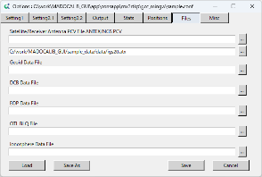
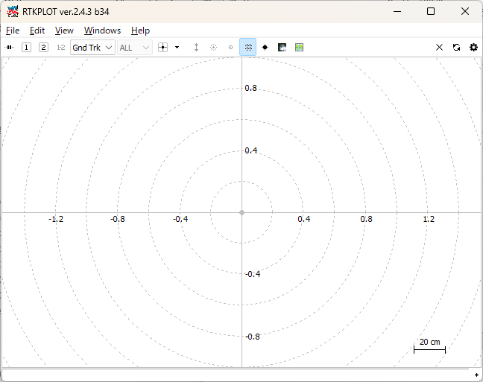
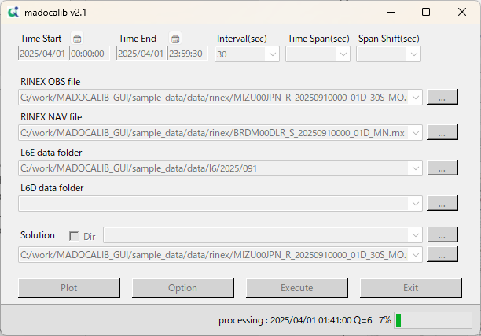
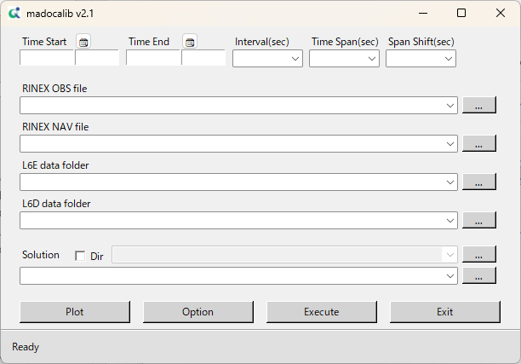
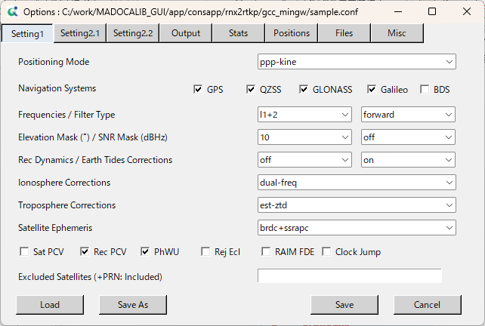
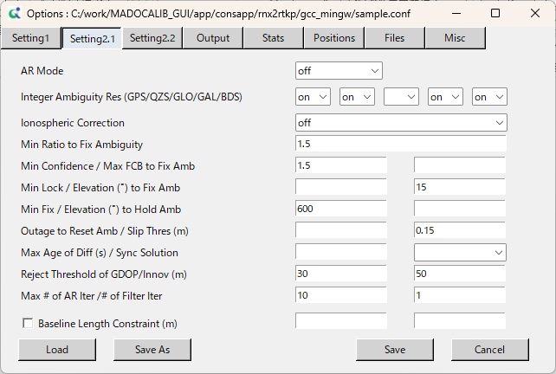
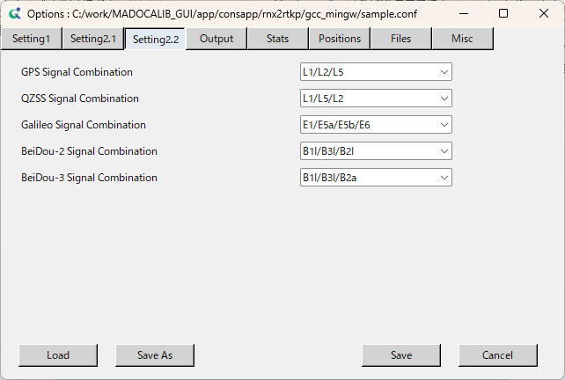
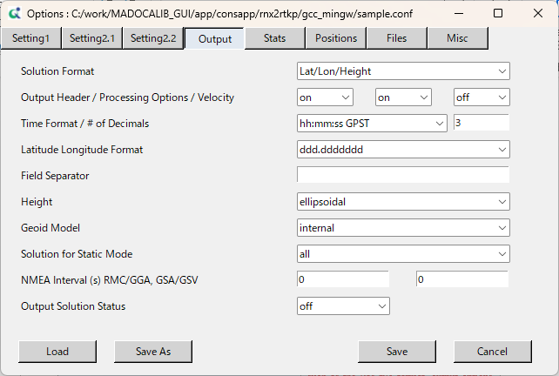
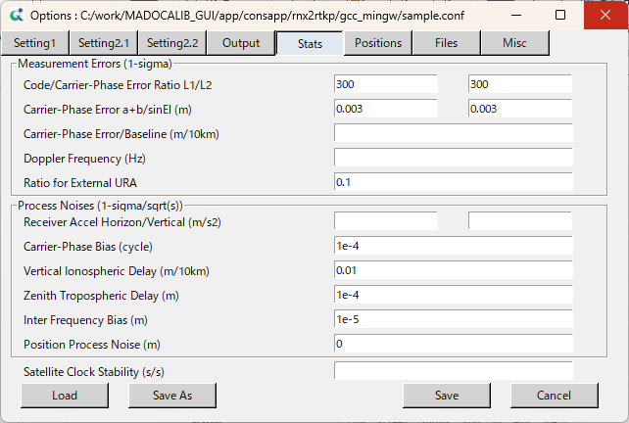
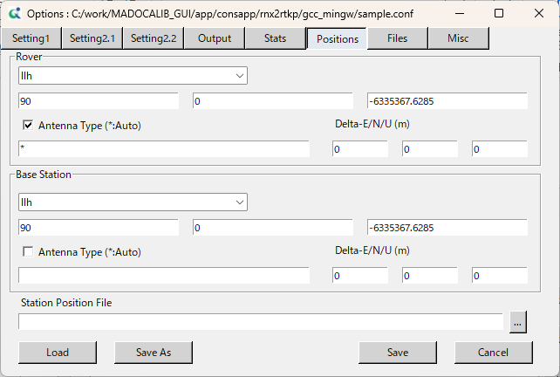
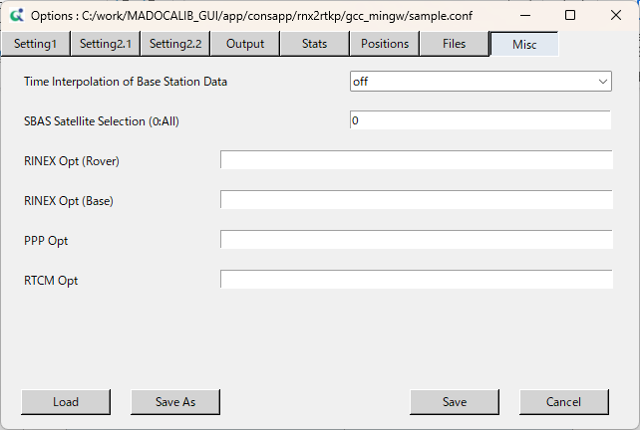
The screen flow of MADOCALIB_GUI is as follows:
The Configuration file editing screens can be switched using the tab buttons.
RTKPLOT
Setting1
Misc
Files
Positions
Stats
Output
Setting2.2
Setting2.1
Main
Main

Screen Descriptions

Main
This is the first screen displayed when start MADOCALIB_GUI. From this screen, It is possible to perform the following actions:
- Select various input files for RNX2RTKP
- Specify the output directory
- Configure the start/end time, interval, and positioning span
- Start RTKPLOT
- Open the Configuration file editor
- Execute RNX2RTKP
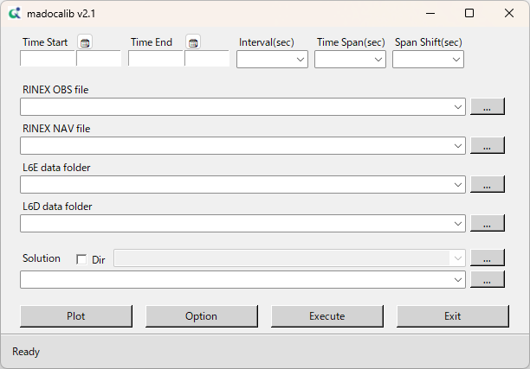
- Exit the application

Screen Area | Descriptions
Time Start | Required field.  The start date and time of the positioning process.  When a RINEX OBS file is selected, the value is filled automatically; manual input is also possible.  The date/time can be selected from the GUI using the calendar button.  It should be earlier than Time End.
Time End | Required field.  The end date and time of the positioning process.  When a RINEX OBS file is selected, the value is filled automatically; manual input is also possible.  The date/time can be selected from the GUI using the calendar button.  It should be later than Time Start.
Interval(sec) | Required field.  The execution interval of the positioning process in seconds.  When a RINEX OBS file is selected, the value is filled automatically; manual input is also possible.
Time Span(sec) | Optional field.  The duration of a single positioning process in seconds.  When this option is set, positioning is performed repeatedly from Time Start to Time End at the specified span interval.  If repeated processing is executed, multiple .pos files are generated.  The generated .pos files are stored in a folder named <result_exec>, automatically created in the same directory as the path specified in Solution. Each .pos filename corresponds to the start date and time of the individual processing span (YYYYMMDDhhmmss.pos).  Details are shown in "Operational Image of Time Span and Span Shift".
Span Shift(sec) | Optional field.  The interval between spans in seconds, used together with Time Span.  If left blank, the value is treated as identical to Time Span.  Details are shown in "Operational Image of Time Span and Span Shift".
RINEX OBS file | Required field.  The file can be selected using the dialog button or by dragging and dropping it into the text area.
RINEX NAV file | Required field.  The file can be selected using the dialog button or by dragging and dropping it into the text area.
L6E data folder | Required field.  The folder containing L6E files can be selected using the dialog button or by dragging and dropping it into the text area.
L6D data folder | Optional field.  The folder containing L6D files can be selected using the dialog button or by dragging and dropping it into the text area.
Solution | Required field.  When a RINEX OBS file is selected, the value is filled automatically; manual input is also possible.  An output path or folder can be selected using the dialog button or by dragging and dropping an item into the text area.  When Dir is unchecked, a full output file path should be specified.  When Dir is checked, an output directory and filename should be specified.
Plot | Starts RTKPLOT.  If a pos file is specified in Solution, it is automatically loaded.
Option | Opens the screen for editing the configuration file.  When the cursor is placed over the Option button, a tooltip displays the path of the currently loaded configuration file.
Execute | Executes RNX2RTKP using the current settings.
Exit | Exits the application.  The current settings are saved upon exit.
Status bar | Displays the status of the application.  The progress of RNX2RTKP is shown in the lower-right area of the status bar.  Messages in the lower-left area include:  Ready  The application is idle.  Done!  The positioning process has completed successfully.  Conf saved!  The configuration file has been saved.  madocalib: {any}  Standard error output from RNX2RTKP.  No .l6 files found in the selected folder. Please check and try again.  It is expected that the folder should contain L6E/L6D files.  Warning: path error load {path}  The configuration file could not be loaded.  Warning: No such conf file.  The specified configuration file does not exist.  No such {path}  RTKPLOT or RNX2RTKP executable not found.  No such OBS file  No OBS file has been specified.  No such NAV file  No NAV file has been specified.  No such L6E files  No L6E file has been specified.  Error Start/End Date  Time Start or Time End has not been specified.  Error Interval  Interval has not been specified.

Operational Image of Time Span and Span Shift
00:00:00
00:30:00
01:00:00
01:30:00
02:00:00
Span Shift
Time Span
Span Shift
PPP processing
Time Span
PPP processing
PPP processing
・
・

e.g.) Time Start : 2025/04/01 00:00:00 Time End : 2025/04/01 23:59:30 Interval(sec) : 30
Time Span(sec) : 3600 Span Shift(sec) : 1800
Time Span
20250401000000.pos
20250401003000.pos
20250401010000.pos

Setting1
This screen allows you to edit the Configuration file.
It is possible to configure basic positioning parameters such as positioning mode and frequency settings.
Across all Configuration file editing screens, It is possible to load another Configuration file, overwrite the current file, or save it under a new name.

Screen Area | Descriptions
Screen Tab | A tab button used to switch between configuration screens.  Each screen provides access to a different set of parameters.
Save | Overwrites the currently loaded configuration file with the latest settings.
Cancel | Closes the current screen.
Load | Loads another configuration file.
Save As | Saves the current settings under a new file name.
Configuration Edit | Refer to the following table for details on the parameters available in each configuration file.
Except for the functions within Configuration Edit, the Save and Load operations behave in the same way across all screens.

GUI Item | Configuration file | Notes
Positioning Mode | pos1-posmode
Navigation Systems | pos1-navsys
Frequencies | pos1-frequency
Filter Type | pos1-soltype
Elevation Mask (°) | pos1-elmask
SNR Mask (dBHz) | pos1-snrmask_r
Rec Dynamics | pos1-dynamics
Earth Tides Corrections | pos1-tidecorr
Ionosphere Corrections | pos1-ionoopt
Troposphere Corrections | pos1-tropopt
Satellite Ephemeris | pos1-sateph
Sat PCV | pos1-posopt1
Rec PCV | pos1-posopt2
PhWU | pos1-posopt3
Rej Ecl | pos1-posopt4
RAIM FDE | pos1-posopt5
Clock Jump | pos1-posopt6
Excluded Satellites (+PRN: Included) | pos1-exclsats
The configuration file follows the definitions provided in the RNX2RTKP application.
For details, see 3.1.3.

Setting2.1
This screen allows you to edit the Configuration file.
It is possible to enable or disable Ambiguity Resolution (AR), select satellite systems, and configure AR-related thresholds.

GUI Item | Configuration file | Notes
AR Mode | pos2-armode
Integer Ambiguity Res (GPS) | pos2-arsys
Integer Ambiguity Res (QZS) | pos2-arsys
Integer Ambiguity Res (GLO) | pos2-gloarmode
Integer Ambiguity Res (GAL) | pos2-arsys
Integer Ambiguity Res (BDS) | pos2-arsys
Ionospheric Correction | pos2-ionocorr
Min Ratio to Fix Ambiguity | pos2-arthres
Min Confidence | pos2-arthres1
Max FCB to Fix Amb | pos2-arthres2 | Not used by RNX2RTKP.
Min Lock | pos2-arlockcnt | Not used by RNX2RTKP.
Elevation (°) to Fix Amb | pos2-arelmask
Min Fix | pos2-arminfix
Elevation (°) to Hold Amb | pos2-elmaskhold
Outage to Reset Amb | pos2-aroutcnt
Slip Thres (m) | pos2-slipthres
Max Age of Diff (s) | pos2-maxage | Not used by RNX2RTKP.
Sync Solution | pos2-syncsol | Not used by RNX2RTKP.
Reject Threshold of GDOP | pos2-rejgdop
Innov (m) | pos2-rejionno
Max # of AR Iter | pos2-armaxiter
# of Filter Iter | pos2-niter
Baseline Length Constraint (m) | pos2-baselen | Not used by RNX2RTKP.
Baseline Length Constraint (m) | pos2-basesig | Not used by RNX2RTKP.
The configuration file follows the definitions provided in the RNX2RTKP application.
For details, see 3.1.3.

Setting2.2
This screen allows you to edit the Configuration file.
It is possible to select the signals and frequencies to be used for each GNSS system.

GUI Item | Configuration file | Notes
GPS Signal Combination | pos2-siggps
QZSS Signal Combination | pos2-sigqzs
Galileo Signal Combination | pos2-siggal
BeiDou-2 Signal Combination | pos2-sigbds2
BeiDou-3 Signal Combination | pos2-sigbds3
BeiDou-2 Satellites in PRN 1-18 | pos2-bds2prn
BeiDou-3 IGSO Satellites | pos2-bds3igso
The configuration file follows the definitions provided in the RNX2RTKP application.
For details, see 3.1.3.

Output
This screen allows you to edit the Configuration file.
It enables you to configure output settings such as the Pos file format, output options, and time systems/time formats.

GUI Item | Configuration file | Notes
Solution Format | out-solformat
Output Header | out-outhead
Processing Options | out-outopt
Velocity | out-outvel
Time Format | out-timesys
# of Decimals | out-timendec
Latitude Longitude Format | out-degform
Field Separator | out-fieldsep
Height | out-height
Geoid Model | out-geoid
Solution for Static Mode | out-solstatic
NMEA Interval (s) RMC/GGA | out-nmeaintv1
NMEA Interval (s) GSA/GSV | out-nmeaintv2
Output Solution Status | out-outstat
The configuration file follows the definitions provided in the RNX2RTKP application.
For details, see 3.1.3.

Stats
This screen allows you to edit the Configuration file.
It is possible to configure parameters related to estimation, such as carrier-phase bias settings.

GUI Item | Configuration file | Notes
Code/Carrier-Phase Error Ratio L1/L2 | stats-eratio1
Code/Carrier-Phase Error Ratio L1/L2 | stats-eratio2
Carrier-Phase Error a+b/sinEl (m) | stats-errphase
Carrier-Phase Error a+b/sinEl (m) | stats-errphaseel
Carrier-Phase Error/Baseline (m/10km) | stats-errphasebl | Not used by RNX2RTKP.
Doppler Frequency (Hz) | stats-errdoppler
Ratio for External URA | stats-uraratio
Receiver Accel Horizon (m/s2) | stats-prnaccelh
Receiver Accel Vertical (m/s2) | stats-prnaccelv
Carrier-Phase Bias (cycle) | stats-prnbias
Vertical Ionospheric Delay (m/10km) | stats-prniono
Zenith Tropospheric Delay (m) | stats-prntrop
Inter Frequency Bias (m) | stats-prnifb
Position Process Noise (m) | stats-prnpos
Satellite Clock Stability (s/s) | stats-clkstab | Not used by RNX2RTKP.
The configuration file follows the definitions provided in the RNX2RTKP application.
For details, see 3.1.3.

Positions
This screen allows you to edit the Configuration file.
It is possible to configure the receiver antenna position input method, antenna type, and related settings.

GUI Item | Configuration file | Notes
Rover | ant1-postype
Rover | ant1-pos1
Rover | ant1-pos2
Rover | ant1-pos3
Antenna Type (*:Auto) | ant1-anttype
Antenna Type (*:Auto) | ant1-anttype
Delta-E/N/U (m) | ant1-antdele
Delta-E/N/U (m) | ant1-antdeln
Delta-E/N/U (m) | ant1-antdelu
Base Station | ant2-postype
Base Station | ant2-pos1
Base Station | ant2-pos2
Base Station | ant2-pos3
Antenna Type (*:Auto) | ant2-anttype
Antenna Type (*:Auto) | ant2-anttype
Delta-E/N/U (m) | ant2-antdele
Delta-E/N/U (m) | ant2-antdeln
Delta-E/N/U (m) | ant2-antdelu
Station Position File | file-staposfile
The configuration file follows the definitions provided in the RNX2RTKP application.
For details, see 3.1.3.

Files
This screen allows you to edit the Configuration file.
It is possible to specify external files used for positioning, such as ANTEX files.
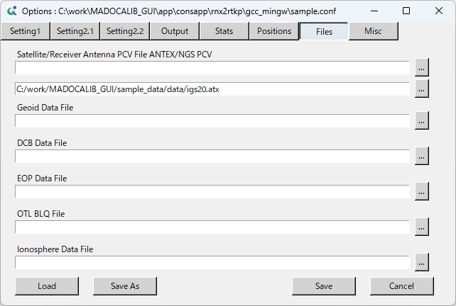

GUI Item | Configuration file | Notes
Satellite/Receiver Antenna PCV File ANTEX/NGS PCV | file-satantfile
Satellite/Receiver Antenna PCV File ANTEX/NGS PCV | file-rcvantfile
Geoid Data File | file-geoidfile
DCB Data File | file-dcbfile
EOP Data File | file-eopfile
OTL BLQ File | file-blqfile
Ionosphere Data File | file-ionofile
The configuration file follows the definitions provided in the RNX2RTKP application.
For details, see 3.1.3.

Misc
This screen allows you to edit the Configuration file.
It is possible to configure auxiliary settings such as time interpolation of reference station data, in addition to the main parameters.

GUI Item | Configuration file | Notes
Time Interpolation of Base Station Data | misc-timeinterp
SBAS Satellite Selection (0:All) | misc-sbasatsel
RINEX Opt (Rover) | misc-rnxopt1
RINEX Opt (Base) | misc-rnxopt2
PPP Opt | misc-pppopt
RTCM Opt | misc-rtcmopt
The configuration file follows the definitions provided in the RNX2RTKP application.
For details, see 3.1.3.

Quick Start with Sample Data
Below is the Quick Start Guide for MADOCALIB_GUI.
This guide demonstrates how to perform positioning using the bundled RNX2RTKP. Using the configuration files included in <installed_dir>\sample_data, you will execute PPP (without integer ambiguity resolution).

- Running PPP Processing for a Full Day
Open the following folder in Windows Explorer:
<installed_dir>\sample_data

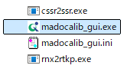
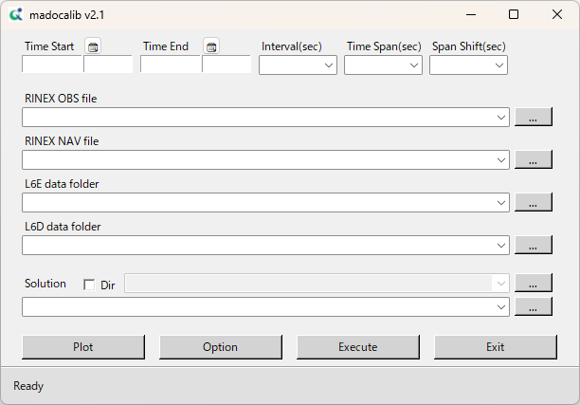
Double‑click madocalib_gui.exe to start the application.

Drag and drop the RINEX OBS file located in <installed_dir>\sample_data\data\rinex\obs\2026\087.
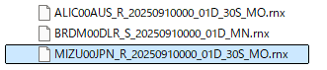
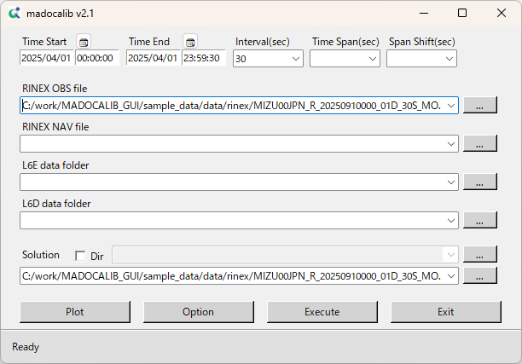
Time Start, Time End, Interval, and the output destination for the pos file will be filled in automatically.

Drag and drop the RINEX NAV file located in <installed_dir>\sample_data\data\rinex\BRDC\2026\087.
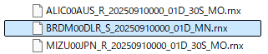
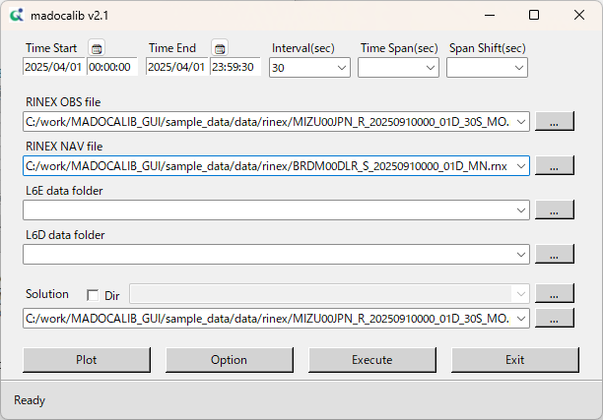

Drag and drop the folder <installed_dir>\sample_data\data\l6\2026\087.
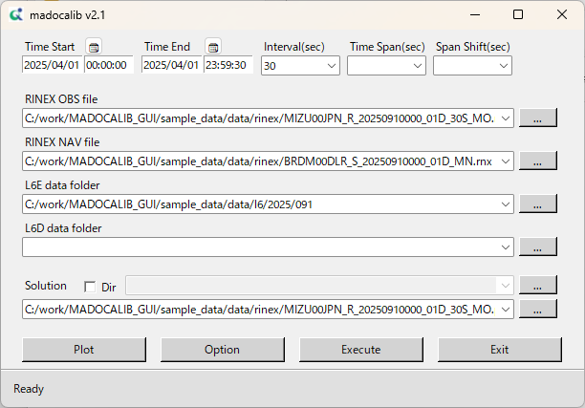
The 087 folder contains L6E data that corresponds to the Time Start and Time End range.

Click Execute.
The results for a full day will be generated.
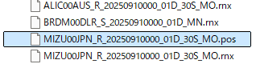
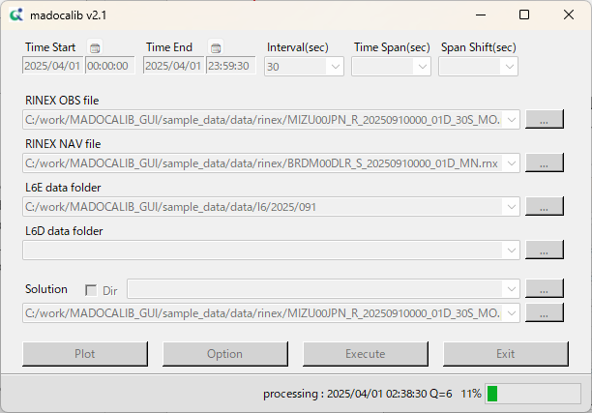
<installed_dir>\sample_data\data\rinex\obs\2026\087

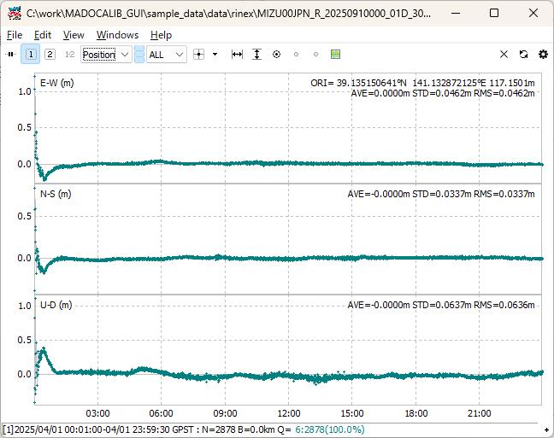
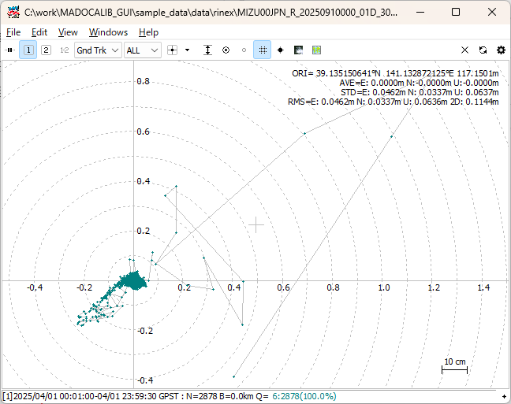
Click “PLOT” to start RTKPLOT. The generated .pos file will be plotted automatically.

- Running PPP Processing Using Ionospheric Correction
Drag and drop the RINEX OBS file MIZU00JPN_R_20250910000_01D_30S_MO.rnx located in <installed_dir>\sample_data\data\rinex\obs\2025\091.
Drag and drop the RINEX NAV file located in <installed_dir>\sample_data\data\rinex\BRDC\2025\091.
Drag and drop the folder <installed_dir>\sample_data\data\l6_is-qzss-mdc-004\2025\091 into the L6E data folder box.
Drag and drop the folder <installed_dir>\sample_data\data\l6_is-qzss-mdc-004\2025\091 into the L6D data folder box.
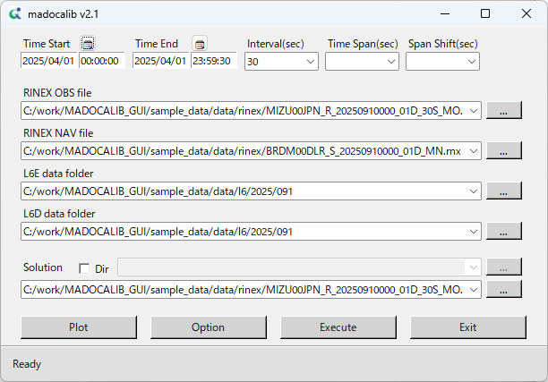
The 091 folder contains L6D data that corresponds to the Time Start and Time End range.

Enter any desired name for the Solution File.
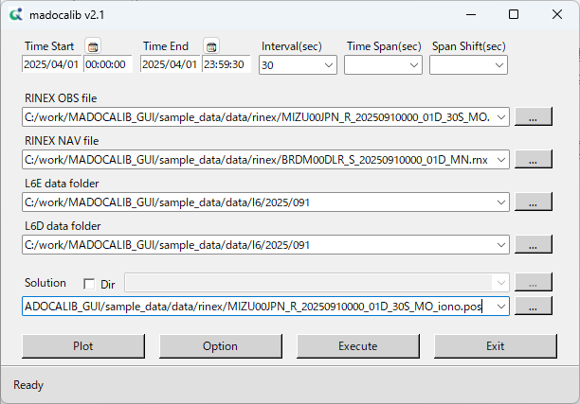
A different file name is used to avoid overwriting the previous file.

Click Option.

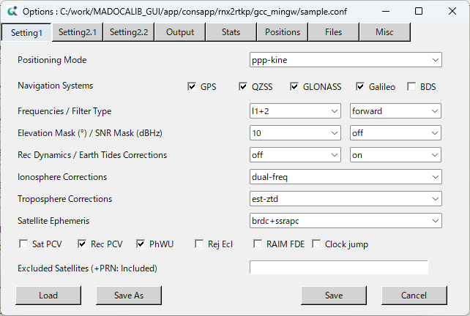
Click Load.

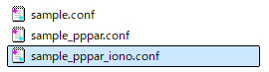
Select the <installed_dir>\app\consapp\rnx2rtkp\gcc_mingw\sample_pppar_iono.conf in the file selection dialog and open it.

Click ×(Close).
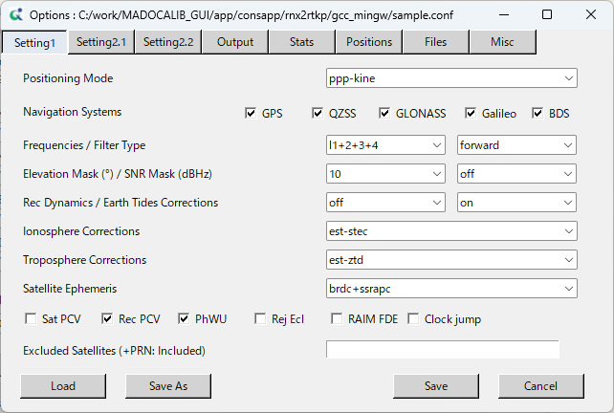

Click Execute.
The results for a full day will be generated.
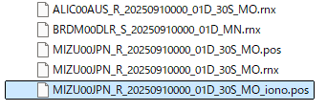
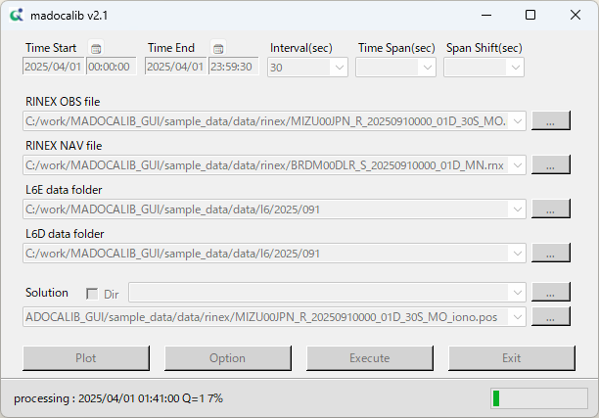
<installed_dir>\sample_data\data\rinex\obs\2026\087

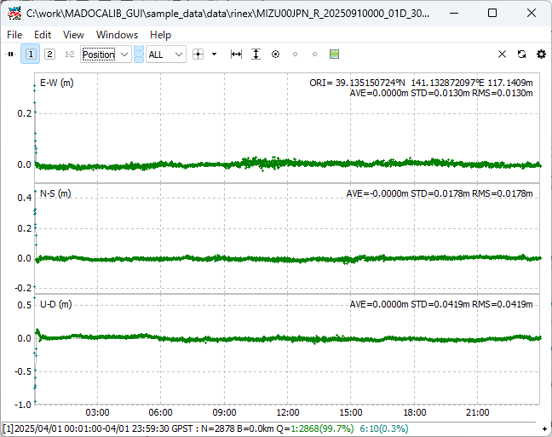
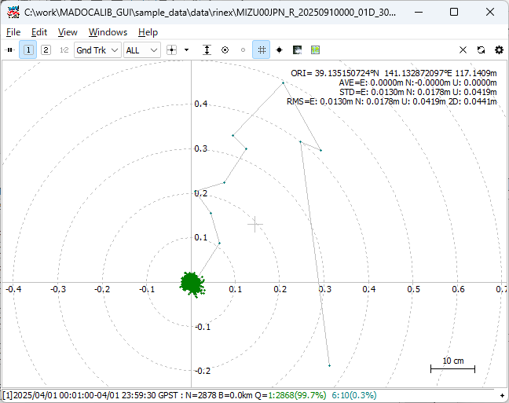
Click “PLOT” to start RTKPLOT. The generated .pos file will be plotted automatically.

- Running PPP Processing at 1-Hour Intervals
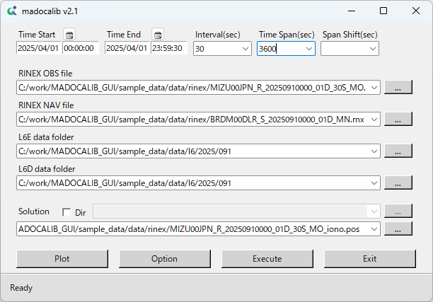
Enter 3600 (1 hour) in the Time Span field and click Execute.

A folder named <result_exec> will be created in the output directory.
One .pos file will be generated for each hour.
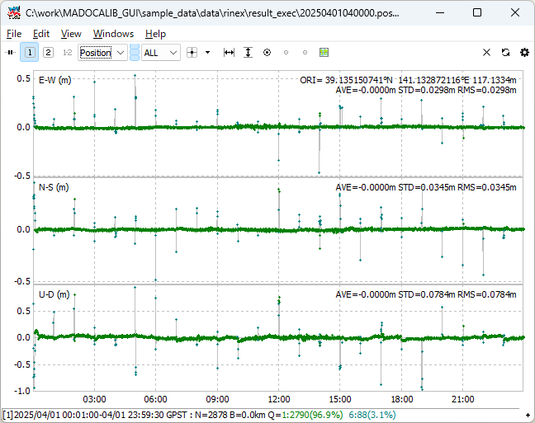
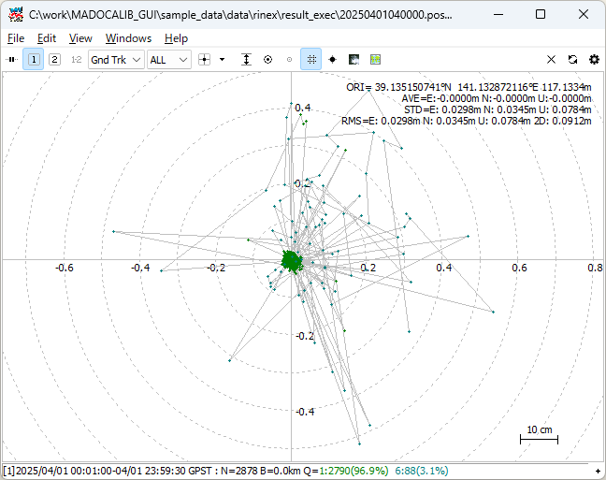
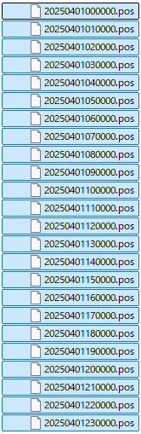
Drag and drop selected *.pos files into RTKPLOT to visualize the results.

Appendix. Specific Processing for MADOCA-PPP
This section outlines the specific processing of MADOCA-PPP within the MADOCALIB source files. In the source files located in the folder of <installed_dir>\src, the following files are relevant to MADOCA-PPP processing.

mdccssr.c
There are decode functions for MADOCA-PPP Compact SSR messages in QZSS L6E signal defined in chapter 4 of IS-QZSS-MDC. The main functions are as follows.

function | Description
input_qzssl6e() | Stack QZSS L6E message and synchronize frame with L6 preamble.
decode_qzss_l6emsg() | Decode QZSS L6E message and convert to RTCM SSR.  Decode L6 message header, frame recognition, call decode functions of each subtypes.
decode_mcssr_mask() | Decode Sub Type 1 Mask.
decode_mcssr_oc() | Decode Sub Type 2 GNSS Orbit Corrections.
decode_mcssr_cc() | Decode Sub Type 3 GNSS Clock Corrections.
decode_mcssr_cb() | Decode Sub Type 4 GNSS Satellite Code Bias.
decode_mcssr_pb() | Decode Sub Type 5 GNSS Satellite Phase Bias.
decode_mcssr_ura() | Decode Sub Type 7 GNSS URA.
mcssr_sel_biascode() | Select MADOCA-PPP code bias, phase bias code from observation code.  IS-QZSS-MDC section 5.5.3.1 Applicable Signals of Code/Phase Bias

mdciono.c
There are decode functions for MADOCA-PPP ionospheric correction messages in QZSS L6D signal defined in section 6.3 of IS-QZSS-MDC. The main functions are as follows.

function | Description
input_qzssl6d() | Stack QZSS L6D message and synchronize frame with L6 preamble.
decode_qzss_l6dmsg() | Decode QZSS L6D message and store ionospheric corrections.  Decode L6 message header, frame recognition, call decode functions of each message types.
decode_miono_coverage() | Decode Message Type 1 STEC coverage message.
decode_miono_correction() | Decode Message Type 2 STEC correction message.
miono_get_corr() | Get MADOCA-PPP ionospheric correction data using the user position.

ppp.c
There are functions for PPP processing performed by EKF (extended Kalman filter) based on the observation equations defined in section 5.5 of IS-QZSS-MDC. The main functions are as follows.

function | Description
pppos() | PPP processing for observation data of an epoch.  Execute time propagation (called “temporal update” in the source file) of EKF states, generate residuals of pseudorange and carrier phase, measurement update of EKF, and ambiguity resolution.
udstate_ppp() | Execute time propagation (temporal update) of EKF states such as receiver position, clocks, tropospheric parameters, ionospheric parameters, inter-frequency bias for 3rd/4th and phase bias.
corr_meas() | Pseudorange and carrier phase correction by SSR code/phase correction, antenna correction and phase wind-up correction.
ppp_res() | Generate residuals of pseudorange and carrier phase based on observation equations defined in section 5.5.5 of IS-QZSS-MDC.

ppp_ar.c
There are functions for integer ambiguity resolution (AR). The MADOCALIB employs cascading ambiguity resolution (CAR) method of fixing extra-wide-lane (EWL), wide-lane (WL) and narrow-lane (NL) ambiguities sequentially for multi-frequency AR instead of fixing full set of ambiguities simultaneously employed up to version 1.4.
The EWL ambiguities are derived by combining the ambiguities of the 2nd and 3rd frequencies, as well as those of the 2nd and 4th frequencies. The WL ambiguities are derived by combining the ambiguities of the 1st and 2nd frequencies. The NL ambiguities are ambiguities of 1st frequency such as L1, E1 and B1I. Integer ambiguity searches of EWL and WL are performed by simple rounding, while that for NL is performed by LAMBDA method.
The main functions are as follows.

function | Description
ppp_amb_ILS() | Ambiguity resolution by ILS (integer-least-square).  Generate single-difference between satellites, search and fix extra-wide-lane, wide-lane and narrow-lane ambiguities and update EKF states.
gen_sat_sd() | Generate single-difference (SD) between satellites.
search_amb_ewl() | Search extra-wide-lane integer ambiguity.
search_amb_wl() | Search wide-lane integer ambiguity.
gen_sd_matrix_n1() | Generate SD-matrix of narrow-lane ambiguity.
search_amb_lambda() | Search integer ambiguity by LAMBDA.
update_states() | Update EKF states with integer ambiguity constraints.

ppp_iono.c
There are functions for MADOCA-PPP ionospheric correction. In the MADOCALIB, the ionospheric corrections are added as a pseudo-observation to the EKF, thus constraining the states of ionospheric estimate to the ionospheric correction value. Also, before constrain by the ionospheric correction, the system bias between the delay by the STEC correction message and the delay by the estimated are removed described in section 6.5.2.2 of IS-QZSS-MDC.
The main functions are as follows.

function | Description
const_iono_corr() | Constraint to ionospheric correction.  Estimate and removed system biases and constraint to external ionosphere correction.

Concluded

