MADOCALIB ver.2.0 Manual

QZSS Strategy Office, Cabinet Office

May 2025, version 005

Contents

1 Overview 1

2 Getting Start 2

2.1 System Requirements 2

2.2 Installation 2

2.3 Quick Start with Sample Data 3

2.4 Quick Start with Downloaded Data 6

3 Usage of Utilities 9

3.1 RNX2RTKP 9

3.1.1 Overview 9

3.1.2 Inputs and Outputs 9

3.1.3 Configuration file 10

3.1.4 CUI Command Reference 14

3.2 CSSR2SSR 15

3.2.1 Overview 15

3.2.2 Inputs and Outputs 16

3.2.3 Configuration file 16

3.2.4 CUI Command Reference 17

Appendix. Specific Processing for MADOCA-PPP 18

**Disclaimer of Liability**

The Cabinet Office, Government of Japan, Quasi-Zenith Satellite System Services Inc. and other service providers of Quasi-Zenith Satellite System make the MADOCALIB manual (“Document”) available to the public to promote the services using Quasi-Zenith Satellite System (“QZSS”) by development of receivers, applications and so on, and also are aiming for high accuracy and convenience with respect to satellite positioning services and message services of QZSS (collectively “Services”). The Services are freely available to any user. However, the receivers and/or applications developed based on this Document may not receive signals or may receive incorrect signals due to no warranty of the Services. You are therefore highly recommended to ensure appropriate measures to avoid accidents such as redundancy, backup and fail-safe, if you develop receivers and/or applications using the Services for the purpose that will possibly give an impact to human life, body and properties. The Services may be suspended or changed without prior notice in accordance with the decision by Government of Japan. This Document and the Services are available subject to the following terms and conditions. You may use this Document only if you agree to such terms and conditions. You shall be deemed to agree such terms and conditions by using this Document.

(1) With respect to this Document and the information included in this Document, the Cabinet Office, Government of Japan (“CAO”), Quasi-Zenith Satellite System Services Inc. (“QSS”) and other service providers of Quasi-Zenith Satellite System ("Parties") disclaim all warranties of any kind, express or implied, including but not limited to, the followings:

i) warranty of accuracy, completeness, usefulness, and fitness for a particular request or purpose;

ii) warranty that this Document and the information included in this Document will not be changed in to the future; and

iii) warranty that this Document and the information included in this Document do not infringe any third party’s intellectual property rights.

(2) With respect to satellite positioning services and message services (collectively “Services”), CAO, QSS and Parties disclaim all warranties of any kind, express or implied, from any cause whether it is related to Quasi-Zenith Satellite System, other outside systems or not, including but not limited to, the followings:

i) warranty as to service area, accuracy, availability, continuity, and integrity described in this Document;

ii) warranty of usefulness, and fitness for a particular request or purpose; and

iii) warranty that the use of Services does not infringe any third party’s intellectual property rights.

(3) To the extent permitted by applicable laws, CAO, QSS and Parties shall not be responsible and liable for any damages and losses, including but not limited to, direct, indirect, incidental, special or consequential damages, whether under contractual liability, product liability, strict liability, tort liability or otherwise (including intent or negligence), caused by the use of this Document, the information included in this Document and the Services, the inability to use the Services, or the change of this Document and the information included in this Document.

# Overview

This manual describes how to use the MADOCA-PPP (Multi-GNSS Advanced Orbit and Clock Augmentation - Precise Point Positioning) [1] test library called MADOCALIB. The purpose of distributing MADOCALIB is to facilitate the user algorithm implementation of MADOCA-PPP. MADOCALIB is constructed based on RTKLIB [2] and functions of PPP-AR and message conversion copyrighted by the third party and provides RNX2RTKP and CSSR2SSR.

RNX2RTKP is a utility for post-process positioning. It implements a processing mode called PPP (Precise Point Positioning) to make use of MADOCALIB. In this processing mode, the following functions are added to RTKLIB ver.2.4.3b34:

- To use the Galileo E1-E5a signal for PPP calculation

- To read the Compact SSR message of MADOCA-PPP

- To select GNSSs to be used for PPP calculation, and

- To select frequencies to be used for PPP calculation for each GNSS

- To process the ionospheric correction data of MADOCA-PPP

- To support triple/quad-frequency PPP

Users can refer to its output as a reference to achieve the performance criteria of MADOCA-PPP.

MADOCALIB also has a processing mode called PPP-AR (Precise Point Positioning-Ambiguity Resolution). Please note that the performance of MADOCA-PPP with the PPP-AR method is currently not defined in the specification documents.

CSSR2SSR is a utility for post-processing conversion of L6E message file containing MADOCA-PPP compact SSR data to RTCM3 SSR message file.

[1] IS-QZSS-MDC-004: <https://qzss.go.jp/en/technical/ps-is-qzss/ps-is-qzss.html>

[2] RTKLIB: <https://github.com/tomojitakasu/RTKLIB.git>

# Getting Start

## System Requirements

The executable binary CUI Aps included in the package require Microsoft Windows environment. On the other OS (Linux, etc.) or environment, you have to compile and build CUI Aps by yourself.

The executable CUI Aps are built by mingw-w64 which can be obtained from the following and tested on Windows 11 (64bit).

URL: <https://www.mingw-w64.org/>

## Installation

Extract the program package madocalib to appropriate directory <*installed_dir*>.on the local disk. The directory structure of the package is as below.

|  |  |  |  |
| --- | --- | --- | --- |
| <*installed_dir*> |  |  | Directory where this software is installed |
|  | \app\consapp |  | The application resources are stored. |
|  |  | \cssr2ssr | The source files and makefile of CSSR2SSR are stored. |
|  |  | \rnx2rtkp | The source files, makefile and sample configuration files of RNX2RTKP are stored. |
|  | \bin |  | Executable binary of APs for Windows |
|  | \doc |  | Document source files |
|  | \sample_data |  | Sample data and sample BAT files for APs. |
|  | \src |  | Source files of MADOCALIB library. |

## Quick Start with Sample Data

Here are quick start guide for RNX2RTKP and CSSR2SSR using the sample data included in this package.

Open the following folder on “Windows Explorer”.

<*installed_dir*>\sample_data

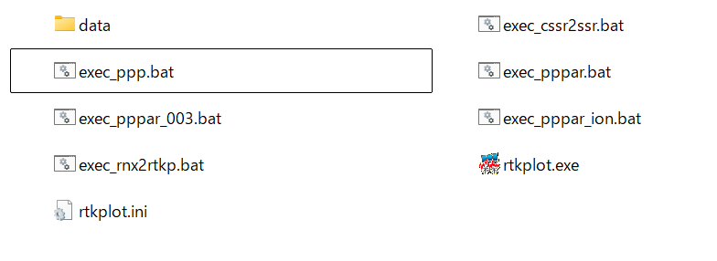

There are BAT files which execute PPP/PPP-AR from 00min00sec to 59min30sec every hour.

exec_ppp.bat : for PPP (no integer ambiguity resolution) by RNX2RTKP

exec_pppar.bat : for PPP-AR (with integer ambiguity resolution) by RNX2RTKP

exec_pppar_ion.bat: for PPP-AR with ionospheric correction by RNX2RTKP

exec_cssr2ssr.bat : for converting cssr to ssr by CSSR2SSR

Double-click on the above BAT file for each scenarios. You can see the command prompt window and get output solution files in the result folder of result_<*BAT filename*>.

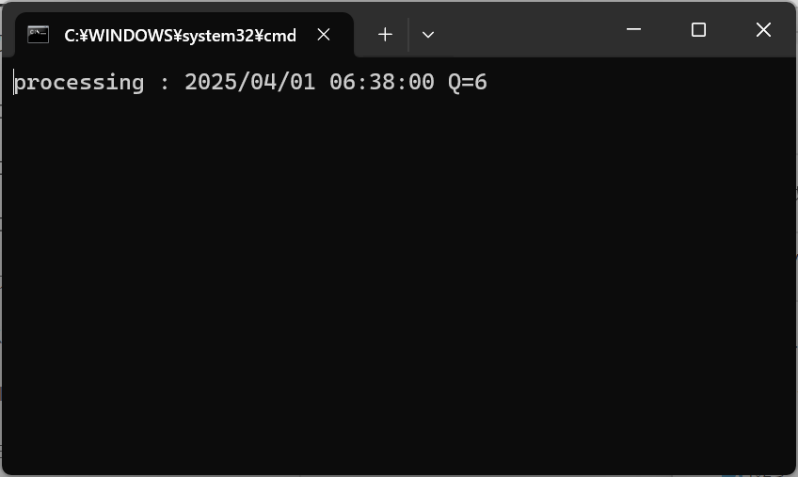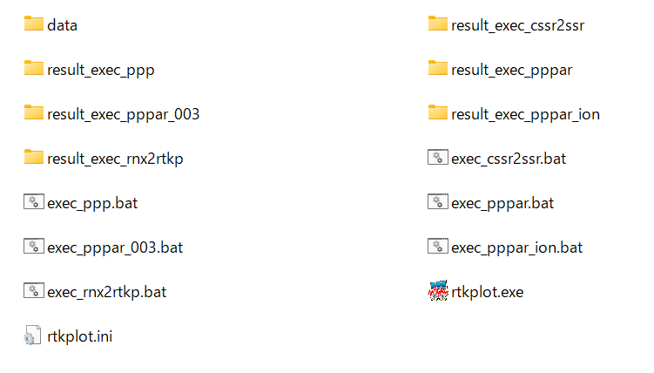

The file output by RNX2RTKP contains the receiver positions calculated by PPP, which can be visualized by RTKPLOT included in RTKLIB package.

The RTKPLOT is included in the folder of sample_data, you can use it to visualize the following steps.

* Double-click rtkplot.exe to start it.
* Click to select the RNX2RTKP output *.pos files in the result folder of result_<*BAT filename*> to visualize.
* Drag and drop selected *.pos files into the RTKPLOT



A time series plot can be viewed by selecting “Position” from the pull-down menu in the upper left corner of the RTKPLOT. For the detail of RTKPLOT, see RTKLIB manual [4].

[3] RTKLIB manual: <https://github.com/tomojitakasu/RTKLIB/blob/master/doc/manual_2.4.2.pdf>

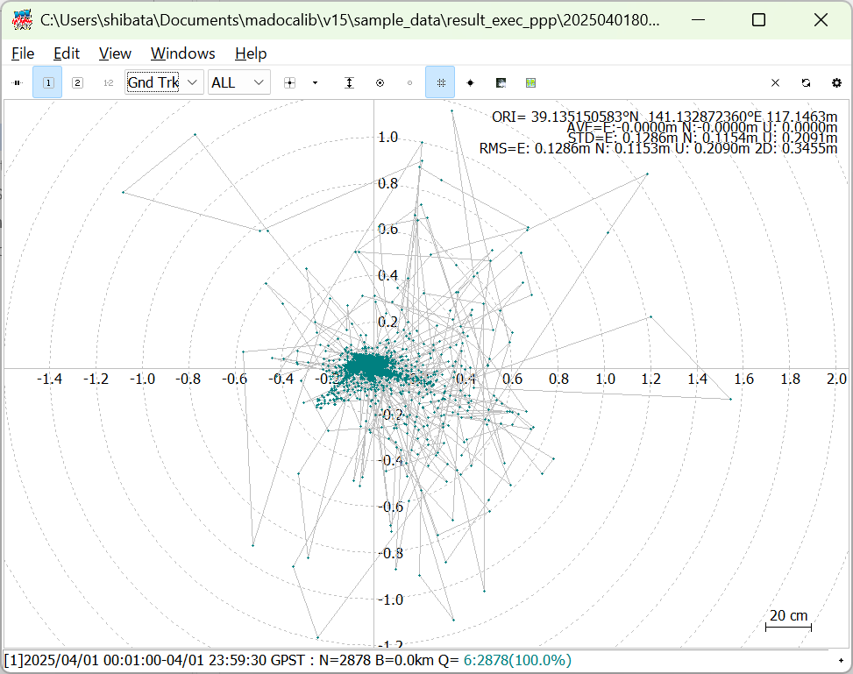 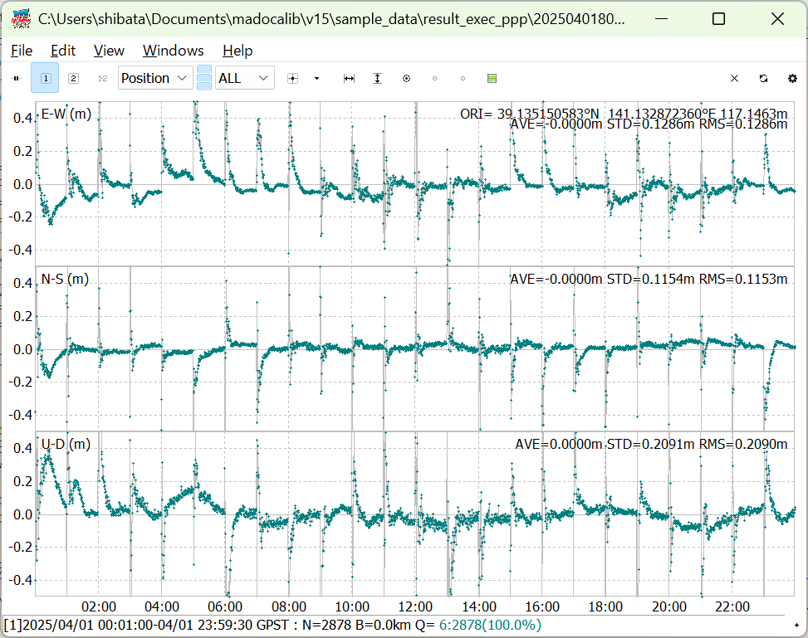

By open each batch file in a text editor, you can see the input data, output data, location of the configuration file, and how to specify the commands used in each.

In MADOCALIB version 2.0, sample data corresponding to IS-QZSS-MDC-004 is stored and PPP scenarios are prepared. In addition, sample data corresponding to IS-QZSS-MDC-003 is also stored, and scenarios using these data are prepared in the following batch files. If you want to evaluate data corresponding to editions prior to the IS-QZSS-MDC-004, please utilize this scenario.

exec_pppar_003.bat: for PPP-AR (with integer ambiguity resolution) by RNX2RTKP

Sample output results for each scenario are shown below.

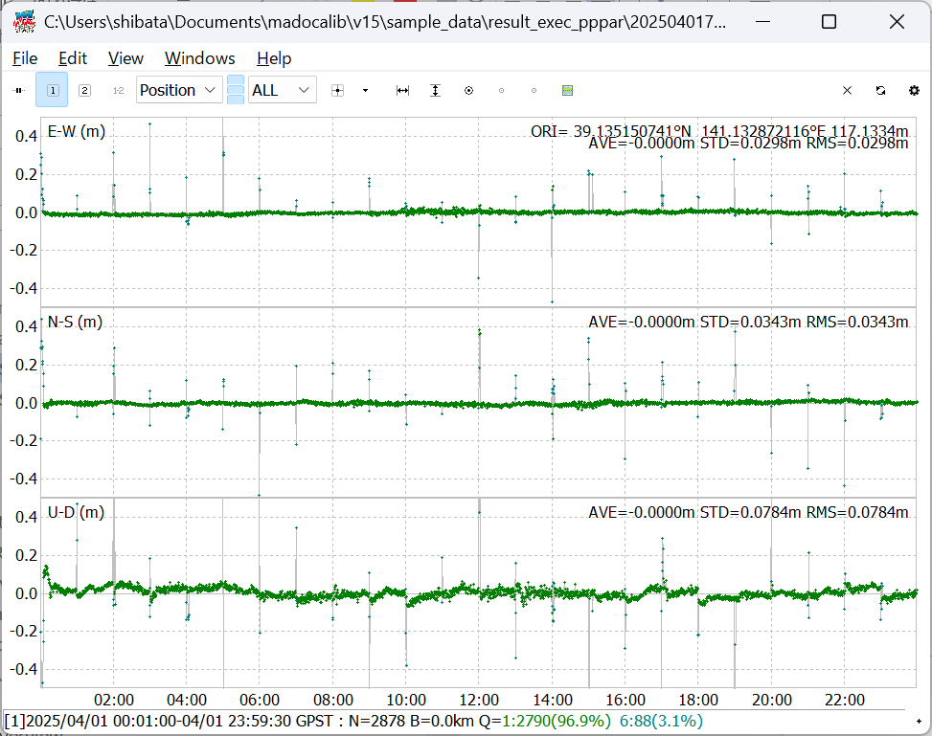

exec_ppp.bat　　　　　　　　　　 　　　exec_pppar.bat

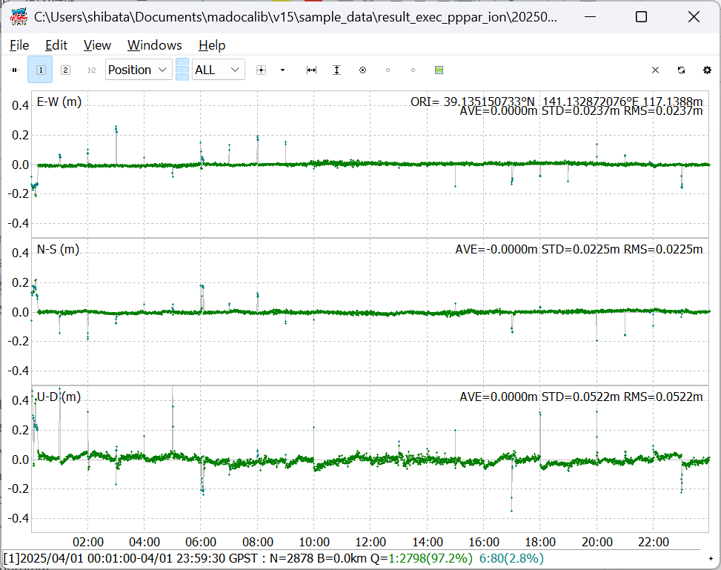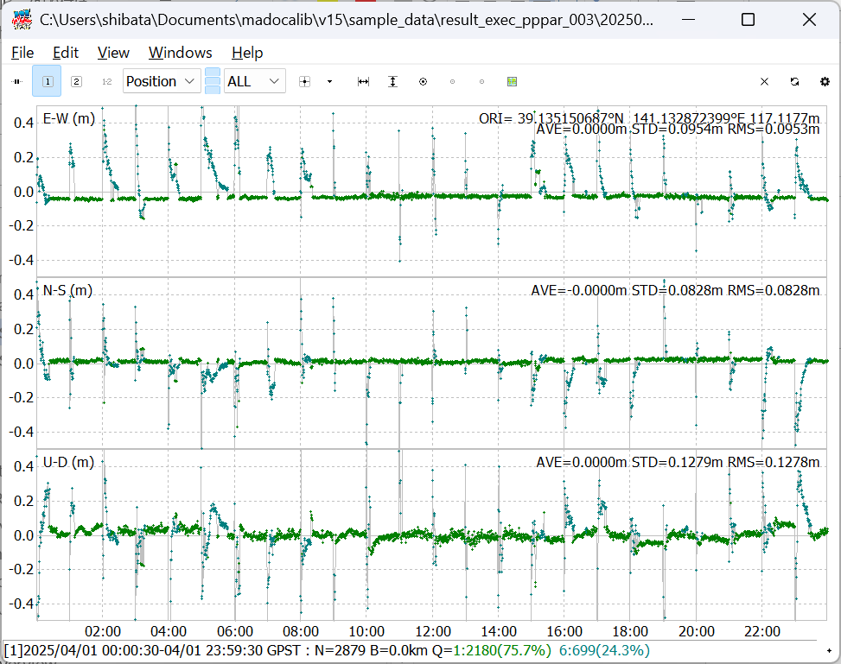

exec_pppar_ion.bat　 　　　　　　　　exec_pppar_003.bat

## Quick Start with Downloaded Data

Here is a quick start guide for RNX2RTKP using the downloaded data.

Getting RINEX OBS and NAV files

The RINEX OBS and NAV data can be downloaded from the following IGS’s and MIRAI’s URL.

IGS<https://igs.org/data/#daily_data>

MIRAI<<https://go.gnss.go.jp/mirai/miraiarchive/>>

RINEX OBS files are saved in Compact RINEX format, so converting them to RINEX v3 is required. The RNXCMP (a tool that converts the Hatanaka compact RINEX format (extension crx) is used to convert to the commonly used RINEX format (extension rnx)) and can be obtained from the following <https://terras.gsi.go.jp/ja/crx2rnx.html>

For Windows 64-bit environment, download RNXCMP_4.1.0_Windows_mingw_64bit.

Getting QZSS L6 message files

L6E and L6D archive data file can be downloaded from the following QZSS URL.

<https://sys.qzss.go.jp/dod/en/archives.html>

Hourly files can be obtained for each PRN number. To perform PPP/PPP-AR in the Asia Oceania region, download the PRN204 and PRN206 files. For further ionospheric correction, please download the PRN200 and PRN201 files.

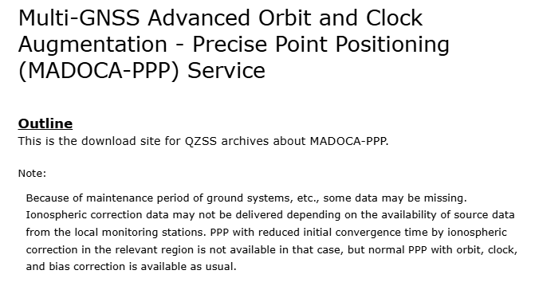

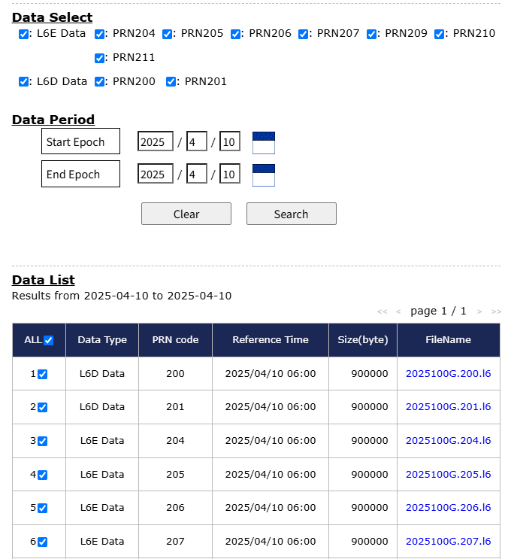



Set up execution commands

Store the downloaded RINEX and L6 files in the following folders respectively.

<*installed_dir*>\sample_data\data\rinex

<*installed_dir*>\sample_data\data\l6\<*4digit year*>\<*3digit day of year*>

Open the batch file in the following folder with a text editor.

<*installed_dir*>\sample_data\exec_rnx2rtkp.bat

Rewrite the followings to specify the downloaded RINEX OBS, RINEX NAV, L6E message and L6D message.

OBS=data/rinex/MIZU00JPN_R_%Y%n0000_01D_30S_MO.rnx

NAV=data/rinex/BRDM00DLR_S_%Y%n0000_01D_MN.rnx

L6E1=data/l6/%Y/%n/%Y%n%HU.204.l6

L6E2=data/l6/%Y/%n/%Y%n%HU.206.l6

L6D1=data/l6/%Y/%n/%Y%n%HU.200.l6

L6D2=data/l6/%Y/%n/%Y%n%HU.201.l6

It is recommended that file paths be specified using keywords that are replaced to date/time. See 3.1.2.

Rewrite the following start date/time and end date/time according to the date and time of the analysis

TS_DATE=2025/04/01

TS_TIME=00:00:00

TE_DATE=2025/04/01

TE_TIME=23:59:30

Double-click the batch file to run it. And you can get output files in the following directory.

<*installed_dir*>\sample_data\data\result_exec_rnx2rtkp

Note. In the batch file, % is replaced with %% to escape the special character % in Windows.

# Usage of Utilities

## RNX2RTKP

### Overview

RNX2RTKP is a utility for post-process positioning. It implements a processing mode called PPP (Precise Point Positioning) to make use of MADOCALIB.

### Inputs and Outputs

The input and output files for the RNX2RTKP are as follows.

**Inputs**

|  |  |  |
| --- | --- | --- |
| No. | Item | Description |
| 1 | RINEX OBS files | RINEX v3.x Observation files (*.rnx)(*1). |
| 2 | RINEX NAV files | RINEX v3.x Navigation files (*.rnx) (*1). |
| 3 | QZSS L6E files | L6E archive data file which can be downloaded from the following QZSS website (*.*PRN*.l6) (*1). PRN=204~211  <https://sys.qzss.go.jp/dod/en/archives.html> |
| 4 | QZSS L6D files | L6D archive data file which can be downloaded from the following QZSS website (*.*PRN*.l6) (*1). PRN=200,201  <https://sys.qzss.go.jp/dod/en/archives.html> |
| 5 | ANTEX file | The antenna phase information file (e.g. igs20.atx, igs14.atx) which can be obtained from the following IGS website.( *For monitoring stations that do not use the same combination of antenna and radome used for IGS stations, a dedicated antenna phase information file needs to be used instead of the above file.)  <https://cddis.nasa.gov/Data_and_Derived_Products/GNSS/GNSS_product_holdings.html>  This file is only used for receive antenna correction. |
| 6 | Configuration file | Configuration file of RNX2RTKP. See 3.1.3. |

**Outputs**

|  |  |  |
| --- | --- | --- |
| No. | Item | Description |
| 1 | Position Solution file | File containing the receiver's position as calculated by the PPP process (*1). The file is a simple text file, and its format is defined in the RTKLIB manual “B.1 Positioning Solution File” at the following URL.  <https://github.com/tomojitakasu/RTKLIB/blob/master/doc/manual_2.4.2.pdf> |

(*1)

These file path can be specified with the keywords replaced as below

%Y -> yyyy year (4 digits) (2000-2099)

%y -> yy year (2 digits) (00-99)

%m -> mm month (01-12)

%d -> dd day of month (01-31)

%h -> hh hours (00-23)

%H -> a hour code (a-x)

%M -> mm minutes (00-59)

%n -> ddd day of year (001-366)

%W -> wwww gps week (0001-9999)

%D -> d day of gps week (0-6)

%HU-> h hour code (A=0,B=1,C=2,...,X=23)

### Configuration file

The keywords which can be included in the configuration file for RNX2RTKP are shown in the following tables.

|  |  |  |  |
| --- | --- | --- | --- |
| Item | Description | Configuration File | Notes |
| Positioning Mode | Set the positioning mode. MADOCALIB supports following options.  - ppp-kine : PPP with kinematic mode  - ppp-static : PPP with static mode | pos1-posmode |  |
| Number of Frequencies | Set the used number of frequencies  - l1 : Single frequency. N/A for ppp-* modes.  - l1+2 : Dual-frequency  - l1+2+3 : Triple-frequency  - l1+2+3+4 : Quad-frequency | pos1-frequency |  |
| Ionosphere Correction | Set the ionospheric correction option.  - off : Not apply ionospheric correction  - brdc : Apply broadcast ionospheric correction.  - dual-freq : Ionosphere-free linear combination with dual-frequency. This should be selected if PPP is performed.  - est-stec : Estimate ionospheric delay for each satellite. This should be selected if PPP-AR is performed. | pos1-ionoopt |  |
| Navigation System | Set the used number of navigation satellite systems.  - 1 : GPS  - 4 : GLONASS  - 8 : Galileo  - 16 : QZSS  - 32 : BeiDou  If you want to use PPP with GPS+GAL+QZS, you should set the sum of these numbers to "25" because GPS is "1", GAL is "8", and QZS is "16". | pos1-navsys |  |
| Ionospheric Correction | Set apply for ionospheric correction by L6D.  - off : Not apply ionospheric correction  - on : apply ionospheric correction | pos2-ionocorr | L6D file must be specified as input file when applying the ionosphere correction. |
| Integer Ambiguity Resolution | Set the strategy of integer ambiguity resolution.  - off : No ambiguity resolution  - continuous : Continuously integer ambiguities are estimated and resolved  - fix-and-hold : Continuously integer ambiguities are estimated and resolved. If the validation OK, the ambiguities are tightly constrained to the resolved values. | pos2-armode |  |
| Validation Ratio to Fix Ambiguity | Set the integer ambiguity validation threshold for “ratio-test”, which uses the ratio of squared residuals of the best integer vector to the second-best vector. | pos2-arthres |  |
| Std-Dev for Ambiguity Search | Set the maximum standard deviation threshold of the 3D position to start narrow-lane integer ambiguity search (m). | pos2-arthres1 |  |
| Signal Option for GPS | Set the priority of used signals for GPS.  - L1/L2  - L1/L5  - L1/L2/L5 | pos2-siggps | The actual number of frequencies to be used shall be set by “pos1-frequency”.  If L1/L2/L5 are set and “pos1-frequency” is set to “l1+2”, dual frequencies of L1/L2 are used. (*1) |
| Signal Option for QZSS | Set the priority of used signals for QZSS.  - L1/L5  - L1/L2  - L1/L5/L2 | pos2-sigqzs | Same as above. |
| Signal Option for Galileo | Set the priority of used signals for Galileo.  - E1/E5a  - E1/E5b  - E1/E5a/E5b/E6  - E1/E5a/E6/E5b | pos2-siggal | Same as above. |
| Signal Option for BeiDou-2 | Set the priority of used signals for BeiDou-2.  - B1I/B3I  - B1I/B2I  - B1I/B3I/B2I | pos2-sigbds2 | Same as above. |
| Signal Option for BeiDou-3 | Set the priority of used signals for BeiDou-3.  - B1I/B3I  - B1I/B2a  - B1I/B3I/B2a | pos2-sigbds3 | Same as above. |

(*1)

The signal option settings mean from left to right: 1st frequency, 2nd frequency, 3rd frequency, 4th frequency. Observation data for the 1st and 2nd frequencies must be required to perform PPP, while observation data for the 3rd and 4th frequencies are optional. Therefore, if the observed data for the frequencies set in 1st freq. and 2nd freq. are not present in one of them, PPP will not be performed properly.

For example, if the following options are set for a receiver outputting observation data of the L1 and L2 frequencies, PPP will be performed in dual-frequency mode internally.

pos1-frequency =l1+2+3

pos2-siggps =L1/L2/L5

However, with the same settings, PPP cannot be performed for observation data of L1 and L5 frequencies. In this case, it should be set up as follows.

pos2-siggps =L1/L5

The following sample files are included on the directory as below.

<*installed_dir*>\app\consapp\rnx2rtkp\gcc_mingw

sample.conf

Configuration for PPP (no integer ambiguity resolution) whose performance is specified in PS-QZSS. This configuration performs PPP by ionosphere-free linear combination with dual-frequency with GPS, GLONASS, QZSS and Galileo by setting as below.

pos1-navsys =29

pos1-frequency =l1+2

pos1-ionoopt =dual-freq

pos2-armode =off

sample_pppar.conf

Configuration for PPP-AR (with integer ambiguity resolution). This configuration performs PPP-AR with quad-frequency with GPS, GLONASS, QZSS, Galileo and BeiDou by setting as below.

pos1-navsys =61

pos1-frequency =l1+2+3+4

pos2-armode =continuous

sample_pppar_iono.conf

Configuration for PPP-AR with ionospheric correction on L6D message. This configuration performs PPP-AR with ionospheric correction by setting as below.

pos2-ionocorr =on

These sample configuration files are tuned specifically for PPP processing for observation data at 30-second intervals at MIRAI or IGS stations, using the MADOCA-PPP L6 message archive data as augmentation data. Therefore, it is recommended that the parameters especially pos2-arthres and pos2-arthres1 be tuned accordingly for each case where observation data conditions such as data intervals are different.

### CUI Command Reference

synopsis:

rnx2rtkp.exe [option]... obsfile navfile l6efile l6dfile [...]

options:

-k file input options from configuration file [off]

-o file set output file [stdout]

-ts ds ts start day/time (ds=y/m/d ts=h:m:s) [obs start time]

-te de te end day/time (de=y/m/d te=h:m:s) [obs end time]

-ti tint time interval (sec) [all]

-x level debug trace level (0:off) [0]

-ant file rcvantfile [specified by conf file]

example:

rnx2rtkp.exe –ts 2025/04/01 00:00:00 –te 2025/04/01 23:59:30 –ti 30

–k sample_pppar_iono.conf -o test.%Y%m%d%h%M%S.pos

MIZU00JPN_R_%Y%n0000_01D_30S_MO.rnx

BRDM00DLR_S_%Y%n0000_01D_MN.rnx

%Y%n%HU.209.l6 %Y%n%HU.200.l6 %Y%n%HU.201.l6

## CSSR2SSR

### Overview

CSSR2SSR is a utility for post-processing conversion of L6E message file containing MADOCA-PPP compact SSR data to RTCM3 SSR message file.

Convert cssr message file to ssr message file. Supported Compact SSR messages (cssr) and SSR messages (ssr) are as bellow.

[Vendor ID]

"010b" : MADOCA-PPP

[Message Type, Sub Type]

MT4073,1 : mask

MT4073,2 : orbit

MT4073,3 : clock

MT4073,4 : code bias

MT4073,5 : phase bias

MT4073,7 : ura

Supported SSR messages (ssr) are as bellow.

[Message Type]

SSR Message : GPS GLONASS Galieo QZSS BeiDou

--------------------:------------------------------------------------------

SSR Orbit Correction: 1057 1063 1240(*1) 1246(*1) 1258(*1)

Clock Correction: 1058 1064 1241(*1) 1247(*1) 1259(*1)

URA : 1061 1067 1244(*1) 1250(*1) 1262(*1)

Code Bias : 1059(*2) 1065(*2) 1242(*1*2) 1248(*1) 1260(*1)

Phase Bias : 1265(*2) 1266(*2) 1267(*1*2) 1268(*1*2) 1270(*1*2)

[format]

nothing * :RTCM 10403.3

(*1) :Proposal of new RTCM SSR Messages

SSR Stage 1:Galileo,QZSS,SBAS,BDS 2014-04-17 v05

(*2) :Proposal of new RTCM SSR Messages

SSR Stage 2:Satellite Phase Biases 2014-04-17 v05

The signals stored in MADOCA-PPP that are not defined in RTCM SSR utilize the following signal and tracking mode identifiers.

GNSS :Signal and Tracking Mode Identifier

--------:------------------------------------

GPS :16- L5 I+Q

:17- L1 L1C(D+P)

Galileo : 3- E1 B+C

: 7- E5a I+Q

:10- E5b I+Q

BeiDou :13- B2a Q

:14- B2a I+Q

### Inputs and Outputs

The input and output files for the CSSR2SSR are as follows.

**Inputs**

|  |  |  |
| --- | --- | --- |
| No. | Item | Notes |
| 1 | QZSS L6E file | L6E message file containing MADOCA-PPP compact SSR (CSSR) data. |

**Outputs**

|  |  |  |
| --- | --- | --- |
| No. | Item | Notes |
| 1 | RTCM3 SSR message file | RTCM3 SSR message file. |

### Configuration file

There is no configuration file for the CSSR2SSR.

### CUI Command Reference

synopsis:

cssr2ssr.exe [options] file

options:

-td y/m/d date for message time (y=year,m=month,d=day)

-o file output ssr file

-d dump debug log on decoding cssr [default : no dump]

file input l6E message file

example:

cssr2ssr.exe -td 2025/04/01 -o 202509100.204.rtcm3 202509100.204.l6

# Appendix. Specific Processing for MADOCA-PPP

This section outlines the specific processing of MADOCA-PPP within the MADOCALIB source files. In the source files located in the folder of <*installed_dir*>\src, the following files are relevant to MADOCA-PPP processing.

mdccssr.c

There are decode functions for MADOCA-PPP Compact SSR messages in QZSS L6E signal defined in chapter 4 of IS-QZSS-MDC. The main functions are as follows.

|  |  |
| --- | --- |
| function | Description |
| input_qzssl6e() | Stack QZSS L6E message and synchronize frame with L6 preamble. |
| decode_qzss_l6emsg() | Decode QZSS L6E message and convert to RTCM SSR.  Decode L6 message header, frame recognition, call decode functions of each subtypes. |
| decode_mcssr_mask() | Decode Sub Type 1 Mask. |
| decode_mcssr_oc() | Decode Sub Type 2 GNSS Orbit Corrections. |
| decode_mcssr_cc() | Decode Sub Type 3 GNSS Clock Corrections. |
| decode_mcssr_cb() | Decode Sub Type 4 GNSS Satellite Code Bias. |
| decode_mcssr_pb() | Decode Sub Type 5 GNSS Satellite Phase Bias. |
| decode_mcssr_ura() | Decode Sub Type 7 GNSS URA. |
| mcssr_sel_biascode() | Select MADOCA-PPP code bias, phase bias code from observation code.  IS-QZSS-MDC section 5.5.3.1 Applicable Signals of Code/Phase Bias |

mdciono.c

There are decode functions for MADOCA-PPP ionospheric correction messages in QZSS L6D signal defined in section 6.3 of IS-QZSS-MDC. The main functions are as follows.

|  |  |
| --- | --- |
| function | Description |
| input_qzssl6d() | Stack QZSS L6D message and synchronize frame with L6 preamble. |
| decode_qzss_l6dmsg() | Decode QZSS L6D message and store ionospheric corrections.  Decode L6 message header, frame recognition, call decode functions of each message types. |
| decode_miono_coverage() | Decode Message Type 1 STEC coverage message. |
| decode_miono_correction() | Decode Message Type 2 STEC correction message. |
| miono_get_corr() | Get MADOCA-PPP ionospheric correction data using the user position. |

ppp.c

There are functions for PPP processing performed by EKF (extended Kalman filter) based on the observation equations defined in section 5.5 of IS-QZSS-MDC. The main functions are as follows.

|  |  |
| --- | --- |
| function | Description |
| pppos() | PPP processing for observation data of an epoch.  Execute time propagation (called “temporal update” in the source file) of EKF states, generate residuals of pseudorange and carrier phase, measurement update of EKF, and ambiguity resolution. |
| udstate_ppp() | Execute time propagation (temporal update) of EKF states such as receiver position, clocks, tropospheric parameters, ionospheric parameters, inter-frequency bias for 3rd/4th and phase bias. |
| corr_meas() | Pseudorange and carrier phase correction by SSR code/phase correction, antenna correction and phase wind-up correction. |
| ppp_res() | Generate residuals of pseudorange and carrier phase based on observation equations defined in section 5.5.5 of IS-QZSS-MDC. |

ppp_ar.c

There are functions for integer ambiguity resolution (AR). The MADOCALIB employs cascading ambiguity resolution (CAR) method of fixing extra-wide-lane (EWL), wide-lane (WL) and narrow-lane (NL) ambiguities sequentially for multi-frequency AR instead of fixing full set of ambiguities simultaneously employed up to version 1.4.

The EWL ambiguities are derived by combining the ambiguities of the 2nd and 3rd frequencies, as well as those of the 2nd and 4th frequencies. The WL ambiguities are derived by combining the ambiguities of the 1st and 2nd frequencies. The NL ambiguities are ambiguities of 1st frequency such as L1, E1 and B1I. Integer ambiguity searches of EWL and WL are performed by simple rounding, while that for NL is performed by LAMBDA method.

The main functions are as follows.

|  |  |
| --- | --- |
| function | Description |
| ppp_amb_ILS() | Ambiguity resolution by ILS (integer-least-square).  Generate single-difference between satellites, search and fix extra-wide-lane, wide-lane and narrow-lane ambiguities and update EKF states. |
| gen_sat_sd() | Generate single-difference (SD) between satellites. |
| search_amb_ewl() | Search extra-wide-lane integer ambiguity. |
| search_amb_wl() | Search wide-lane integer ambiguity. |
| gen_sd_matrix_n1() | Generate SD-matrix of narrow-lane ambiguity. |
| search_amb_lambda() | Search integer ambiguity by LAMBDA. |
| update_states() | Update EKF states with integer ambiguity constraints. |

ppp_iono.c

There are functions for MADOCA-PPP ionospheric correction. In the MADOCALIB, the ionospheric corrections are added as a pseudo-observation to the EKF, thus constraining the states of ionospheric estimate to the ionospheric correction value. Also, before constrain by the ionospheric correction, the system bias between the delay by the STEC correction message and the delay by the estimated are removed described in section 6.5.2.2 of IS-QZSS-MDC.

The main functions are as follows.

|  |  |
| --- | --- |
| function | Description |
| const_iono_corr() | Constraint to ionospheric correction.  Estimate and removed system biases and constraint to external ionosphere correction. |

Concluded