LAPORAN TUGAS MINGGU KE-10
MATA KULIAH PEMROGRAMAN DASAR
MATERI STRUCT



QAQA QUSHAYYI QATRUNNADA
25/561242/TK/63401
TEKNOLOGI INFORMASI
FAKULTAS TEKNIK

PERTANYAAN DAN PENGERJAAN

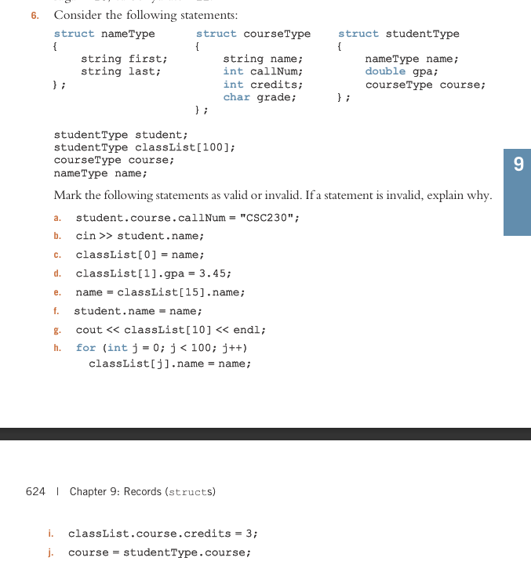
- Exercise no 6, valid or invalid (why).

- Invalid
student.course.callNum has integer as it’s data type. “CSC230” is string literal. Integer cannot use string since it has different type, also C++ treat both differently.
- Invalid
cin >> student.name is a struct of type nameType. It’s like a package that hold two separate thing, first and last. Input operator >> can only read data into basic, built-in types. Since student.name doesn’t explicitly tell to read into first or last. It doesn’t able to automatically split or decide where to go.
- Invalid
classList[0] is a single variable of type studentType, from classList[100] that contain 100 items, each has 3 object. name is a single variable of type nameType, each has 2 object. Both have different types, so there is a mismatch.
- Valid
classList[1].gpa is object from studentType, gpa has double data type. So, assign 3.45 to classList[1].gpa is valid since 3.45 is double.
- Valid
name is a nameType variable, and classList[15].name is a studentType variable that of nameType. Both are from the same type struct nameType. Therefore struct assignment can be done.
- Valid
Same as e, which both are of type nameType. Therefore it’s valid.
- Invalid
classList[10] is a struct studentType, it hold 2 struct and 1 variable as integer. The output stream operator << cannot directly print out struct. It need to print out it’s member individually.
- Valid
classList[j].name and name is of type nameType, both are the same struct, just like e and f. Struct also allow for loop, and h is standard for loop. That loop also run 100 times, perfectly matches the size of classList as array.
- Invalid
classList is array, to do an assignment it need to specify where to put it, therefore it needs index. classList.course.credits didn’t had an index, so it’s too general that cannot be done.
- Invalid
studentType is a type, not a single variable that can use dot operator. Then, it becomes invalid.

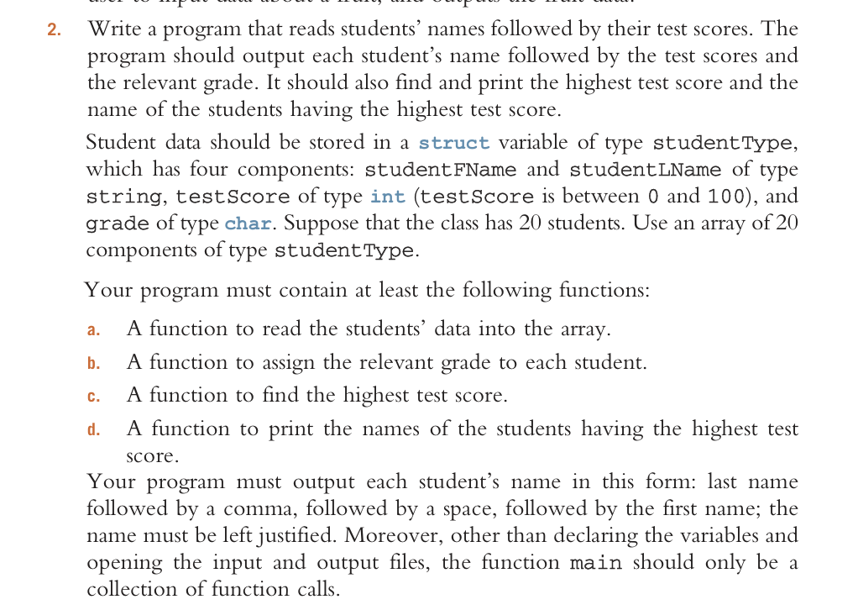
- Programming exercise no 2, student test score. Jelaskan cara kerja kode program yang dibuat. Agar dilengkapi dengan screenshot hasil ketika program dijalankan.

Link GitHub: https://github.com/QaQusQa/Struct-Pemrograman-Dasar.git
How the program works:
When the program is runs, the function readStudentData() will be called. It will tell the user to input 20 students, each first and last name, and test score, if wanted can use dummy data, based on struct studentType. This data will be read and stored in array named listOfStudent (aliased as theList).
Variable test score will be evaluated by function assignGrade() based on criteria range to assign grade, can be A, B, through E, which then will be stored as grade in theList, then listOfStudent.
Next, all test score data will be evaluated to find the highest score. This can be done by calling function findHighestScore() to iterate each score, comparing one by one, from index 0 to index 19 (total 20 index). This function will give a return index of the highest grade.
Once the index that has highest score it’s found, function whoIsHighest() is called, then the corresponding full name, first and last name is also discovered. This information will be displayed at the end of the program use the format needed. All the other student name, test score, and grade will also be displayed using displayAllStudent() function, can be used to re-checking.

