LEARN TO RIDE

High-quality **Western and English** riding lessons, focusing on safety and including instruction on horse care, saddling a horse, and other aspects of horsemanship.

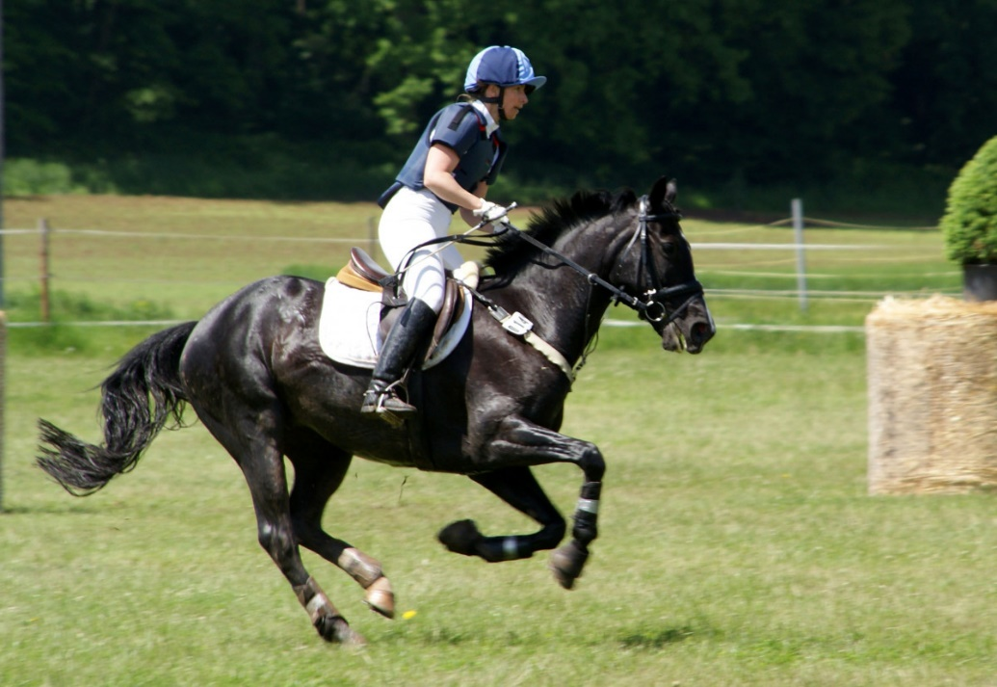

• Novice to advanced instruction for children and adults

• Indoor and outdoor arenas

• $40 per hour for private lessons; $25 for group lessons

CALL TRI-VALLEY STABLES AT 555-2030 TODAY!