**Food & Culture:**

**Miami's diverse cuisine features Cuban, Latin American, and Caribbean flavours. Try Cuban sandwiches, seafood ceviche, and mojitos. Dive into culture with salsa, music, and art.**

071 609 2683

MiamiTravels@gmail.com

MiamiTravels.com

@Miami Travels

**Contact Details**

**MOBILE NUMBER:**

**EMAIL ADDRESS:**

**WEBSITE:**

**SOCIAL MEDIA:**

**Miami**

**TRAVEL &**

**TOURS**

**ABOUT OUR**

**COMPANY**

123

Long street, Cape Town

Welcome to MiamiTravels! Your ultimate guide to exploring the magic of Miami. From sun-kissed beaches to pulsating nightlife, we make your Miami dreams a reality. Let's embark on an adventure together

**AWARDS &**

**RECOGNITIONS**

For pricing and options,

please email us at

hello@reallygreatsite.com

or call us at

+123-456-7890.

Airline Ticketing and

Reservations

Fare Computations

Itinerary Planning

Hotel Reservations

Airport Transfers

Vacation Packages

Tour Packages

Travel Insurance

We have been

recognized as one of the

best travel agencies in

the Asia-Pacific region

since 2000.

**WE OFFER:**

**BOOK AN**

**APPOINTMENT**

**NOW**

**Places to Stay**

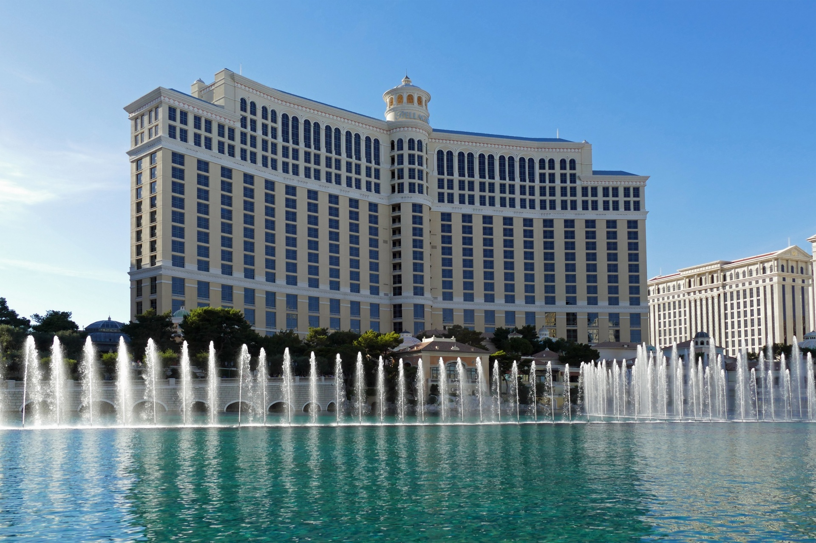

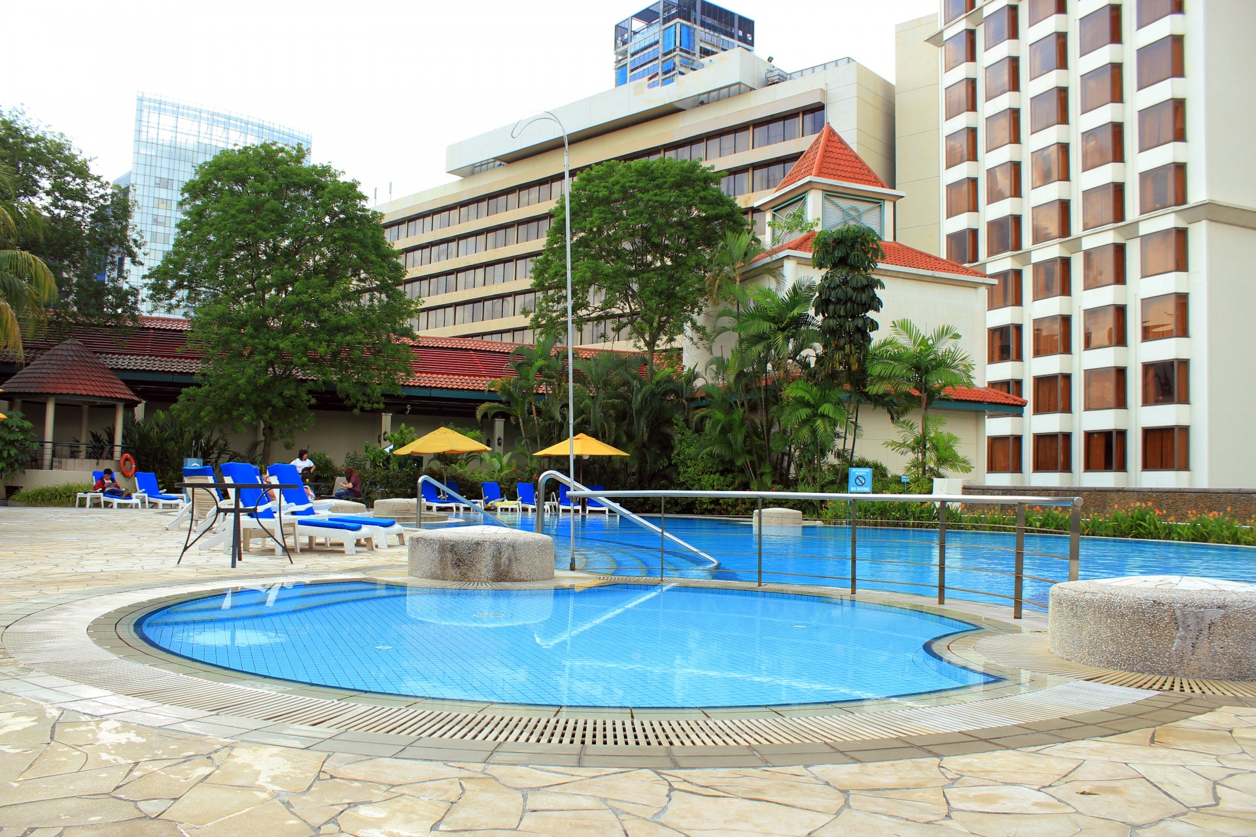

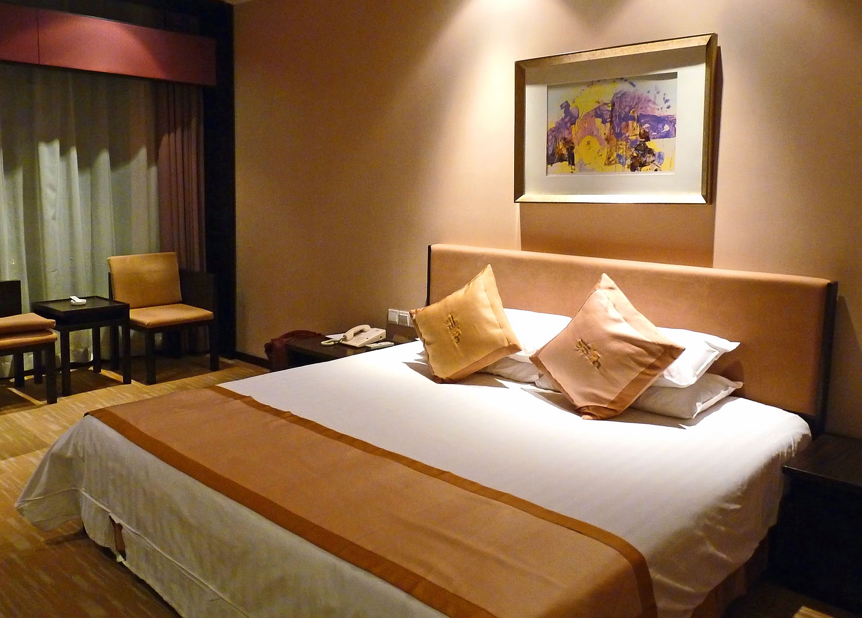

## **Things to do in Miami**

1. Explore South Beach: Relax on the pristine white sands, stroll along Ocean Drive, and admire the colourful Art Deco buildings.
2. Visit Little Havana: Immerse yourself in Cuban culture with authentic cuisine, live music, and vibrant street art.
3. Discover Wynwood Walls: Marvel at the vibrant murals and graffiti art in this trendy neighbourhood known for its artistic flair.
4. Experience the Everglades: Take an airboat tour through the unique ecosystem of mangroves and sawgrass marshes, and spot alligators and exotic birds.
5. Shop at Bay side Marketplace: Shop for souvenirs, enjoy waterfront dining, or take a scenic boat tour of Biscayne Bay.
6. Attend a Sporting Event: Catch a basketball game at the American Airlines Arena or watch a football match at Hard Rock Stadium.

## **Destination Overview**

Miami, located in southeastern Florida, is renowned for its stunning beaches, vibrant nightlife, and diverse cultural scene. The city boasts a unique blend of Latin American and Caribbean influences, evident in its cuisine, music, and art. From the iconic Art Deco architecture of South Beach to the lush greenery of the Everglades, Miami offers something for every traveler.