


Informatics Institute of Technology

Module Name : Algorithms: Theory, Design and Implementation
Mode Code : 5SENG003C.2
Assessment Type: Coursework

Graph Acyclicity Algorithm

Name: Qaaed Usaim
UOW Number : W2153368
IIT Number : 20240279

- A short explanation of your choice of data structure and algorithm.
Data Structure Used – Adjacency List
The graph is depicted using an adjacency list. Each key in the map is a vertex, and its corresponding value is a HashSet of vertices it is leading to.
Adjacency Lists were chosen instead of adjacency matrix because an adjacency matrix requires O(V²) space regardless of the number of edges, which is wasteful for sparse graphs whereas adjacency list uses O(V + E) space, which is much more efficient. Also, the main operation of the sink elimination algorithm is identifying and removing sinks if an adjacency list is used, checking whether a vertex is a sink is an O(1) operation, as it involves checking if its neighbor set is empty. In comparison, an adjacency matrix would require scanning an entire row, resulting in an O(V) cost per vertex.
HashMap and HashSet were chosen specifically because both provide O(1) average case performance for insertion, deletion and lookup. This is important because finding and removing sinks the core operations of the algorithm need to be performed as efficiently as possible.
Algorithm
The algorithm used is based on the concept of a sink (a sink is a vertex with no outgoing edges).
Acyclic graphs always have a sink is a key concept here because if you follow any path in an acyclic graph a vertex can never be revisited, you will eventually reach a dead.
Note – This algorithm is to find the acyclic graphs.
- If the graph is empty that means the graph is acyclic (return yes)
- If there is no sink , a cycle must be present , the graph is cyclic (return no)
- If it’s none of the above remove the sink found and repeat.
  - The sink is removed because removing a vertex cannot introduce another cycle. Which means the remaining graph is also acyclic and might have a sink
If at any point no sink can be found, it means every remaining vertex has at least one outgoing edge. In a finite graph this can only happen if the vertices form a cycle, so the algorithm correctly returns no.

- A run of your algorithm on two small benchmark examples, one of which is acyclic and the other one isn’t. This should include the supporting information as described in Task 4.
The program was first run using the acyclic graph with 40 vertices since a small benchmark example was needed.

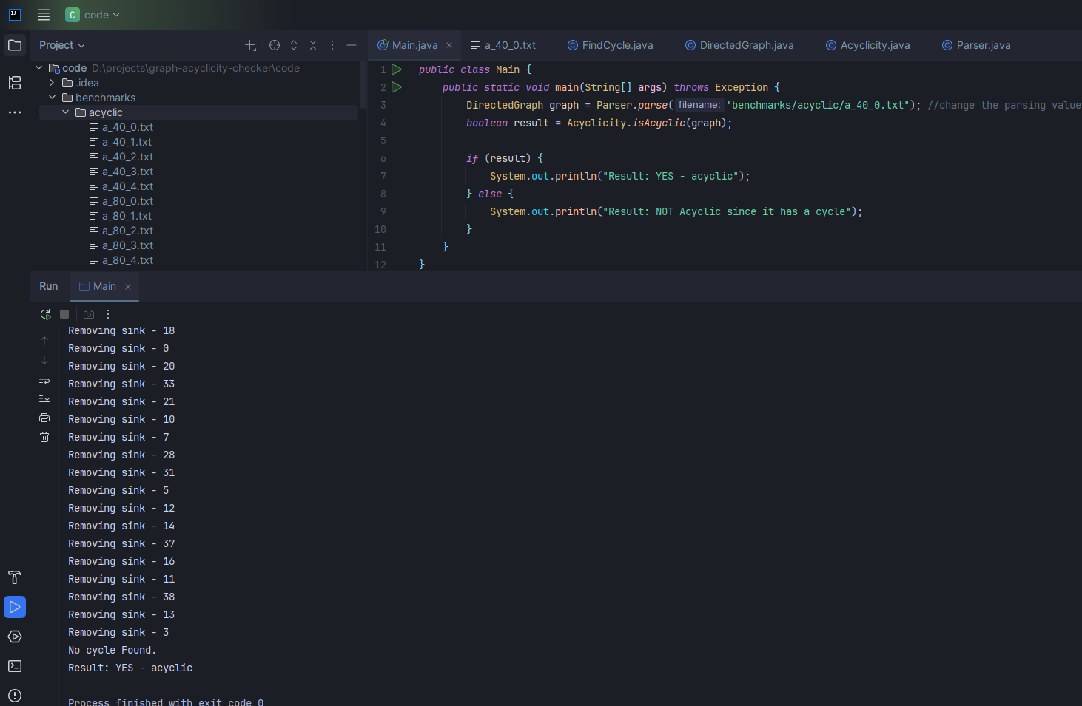
Figure 1 - Acyclic Graph Benchmark Example
Acyclic Graph Benchmark Output -
Removing sink - 24
Removing sink - 19
Removing sink - 1
Removing sink - 8
Removing sink - 23
Removing sink - 22
Removing sink - 2
Removing sink - 17
Removing sink - 34
Removing sink - 6
Removing sink - 35
Removing sink - 30
Removing sink - 25
Removing sink - 29
Removing sink - 39
Removing sink - 36
Removing sink - 15
Removing sink - 4
Removing sink - 26
Removing sink - 9
Removing sink - 27
Removing sink - 32
Removing sink - 18
Removing sink - 0
Removing sink - 20
Removing sink - 33
Removing sink - 21
Removing sink - 10
Removing sink - 7
Removing sink - 28
Removing sink - 31
Removing sink - 5
Removing sink - 12
Removing sink - 14
Removing sink - 37
Removing sink - 16
Removing sink - 11
Removing sink - 38
Removing sink - 13
Removing sink - 3
No cycle Found.
Result: YES – acyclic

The program was then run using the cyclic graph with 40 vertices since a small benchmark example was needed.
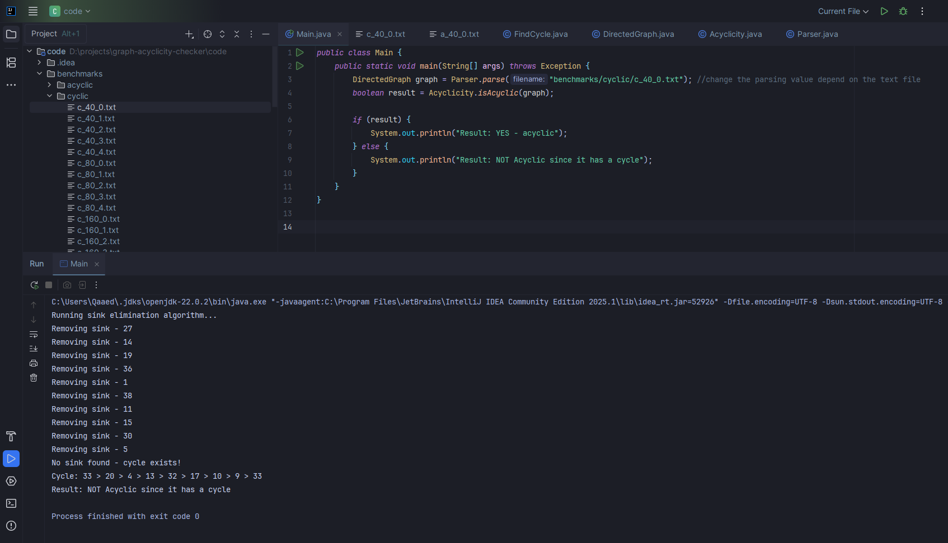
Figure 2 - Cyclic Graph Benchmark Example
Cyclic Graph Benchmark Output
Running sink elimination algorithm...
Removing sink - 27
Removing sink - 14
Removing sink - 19
Removing sink - 36
Removing sink - 1
Removing sink - 38
Removing sink - 11
Removing sink - 15
Removing sink - 30
Removing sink - 5
No sink found - cycle exists!
Cycle: 33 > 20 > 4 > 13 > 32 > 17 > 10 > 9 > 33
Result: NOT Acyclic since it has a cycle

- A performance analysis of your algorithmic design and implementation. This can involve both empirical data using the doubling hypothesis, and purely theoretical considerations, as discussed in the lectures and tutorials. It should include a suggested order-of-growth classification (Big-O notation).

