1) The LTV is the percentage of the loan to the purchase price.  Therefore one minus the LTV is the loan amount.  In the valuation report it appears the formula used the LTV percentage as the loan percentage.

This makes everything thereafter wrong.  So please have this fixed as soon as possible so I can audit the remaining calculations.  
  
Conclusion:  
 1 – LTV = Loan Amount  
  
my reply:  You mentioned that the LTV is the percentage of the loan to the purchase price, but since LTV is already provided as an input field in the system (and we are not calculating it), I’d like to better understand your point.

Just to confirm, I’m assuming that by “LTV” you are referring to the "Financing LTV Percent" field on the input page of the Excel worksheet. Please let me know if that’s correct.

Also, could you kindly point me to the specific field or formula in the Excel sheet where the intended logic is applied so I can assure consistency.

2)

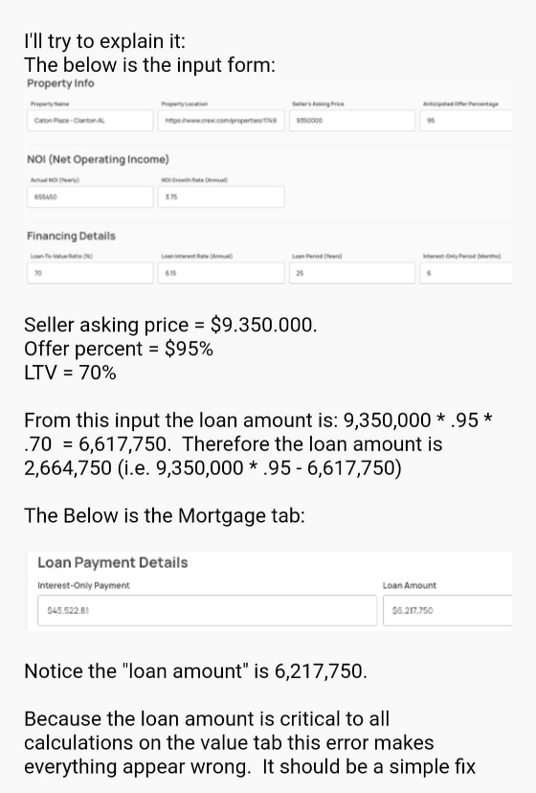

Conclusion:  
AskingPrice \* OfferPercent – LTV = Loan Amount  
  
my reply: The formula I implemented matches your original guidance exactly:

Loan Amount = Asking Price (D6) × Offer % (D7) × LTV % (D13)

For your example:

$9,350,000 × 0.95 × 0.70 = $6,217,750

However in your recent message you calculated loan amount $6,617,750 (which is a typo i think and should be $6,217,750). Then you calculated equity ($2,664,750) as:

Asking Price × Offer % − Loan Amount.

This wasn’t mentioned in the guide. Should we add equity calculations to the outputs or adjust the loan amount formula entirely?

3) Interesting that the team calculated the loan amount correctly to calculate the reserve for the input form. But did it wrong for the mortgage calculation.

LTV.  is Loan to Value.    The mortgage amount is the purchase price - LTV amount.

Adjust your use of the loan amount formula  
  
Conclusion:  
PurchasePrice – LTV = MortgageAmount