

**Project**

“CS-351 (Artificial Intelligence)”

Name: **Muhammad Qais Sultani 2018314**

**Rizwan Ali Jandan 2018395**

**Shahzaib Hayat 2018425**

Section: **CS**

Instructor: **Sir Fawad Hussain**

Submission Date: **6th of June 2021**

**Abstract:**

The project is to make model that could classify Chest X-Ray Images into Corona Positive and Corona Negative through different machine learning and Artificial intelligence tools in python. We have chosen a dataset containing images of chest x-rays both corona positive and negative, on which We have applied Convolutional Neural Networks, and generated a model to predict any new chest x-ray image for corona virus detection.

**Introduction:**

The datasets contains all the images separated in two different folders, named as ‘Normal’ and ‘Covid’. First, the images and its labels are imported into separate lists. Then these lists are converted into numpy arrays. For the initials we have to import some important dependencies, which made all of the complex work easier like; cv2 helps reading and manipulating data, matplotlib is used for graphical representing the data and its features, tensorflow.keras is used to create our neural network model and sklearn is used for preprocessing, data encoding, normalization and for classifications of data. One important thing to remember is that, we have used transfer learning in our model for which we have made use of VGG16 model’s features.

**Data Preprocessing:**

Now, since images were imported as 3D matrices storing each pixel color value(0-255), therefor this unnormalized data is converted into its normalized form. About the labels that were ‘Normal’ and ‘Covid’ which we got from the folder names, this is a text data that a neural network can not process, therefor it is converted into numerical categorical form. Now, data is divided into training and testing sets and are feeded in our model.

**Feature Engineering:**

Before feeding the data into the model, we have done one more thing that is, the sizes of image data were not all same so the generated matrices also have the different dimensions, but this characteristic of the data will lead to biased training and predictions. So, the resizing of the images are also done using cv2 library. Augmentation of images is also done to generate more data since we were using dataset having only 100 covid and 100 normal images.

**Model:**

The Model we made uses transfer learning which means that, our model will get all the trained weights biases and Nodes directly from an already trained model. This already trained model we used is VGG16 which was trained on thousands of images from ‘imagenet’. We dropped the last 3 dense layers and added our own 1 flatten layer and 2 dense layers. We set the training of pretrained weights to false cause they are already trained and able to extract the features from the images. We have just trained weights that are of layers we added exclusively, and we also added dropouts to avoid over-fitting. At the end we set lost function to binary cross entropy. We have used Adam optimizer along with 1x10-3 learning rate with with wight decay updating inversely the epochs. Model then feed with the training split of the dataset and starts training with batch size of 8.

**Comparison and Performance Evaluation:**

After training, model then feed with the testing split of the dataset to predict the output. This predicted output is then compared with the provided output to calculate the accuracy score of the model, which fortunately appeared to be 100%.

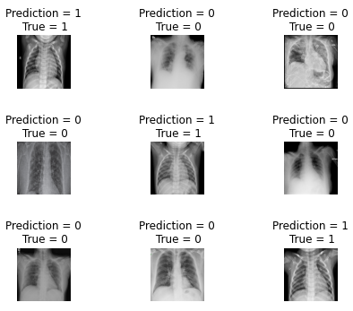

Statistics are also shown in the graphs to clearly understand the training behavior of model:

**Loss Function Graph:**

**Accuracy Graph:**

**Conclusion:**

We can conclude that transfer learning enables us to train models more efficiently and in less computational manner. The model we have trained, now can be saved and used as corona virus detector in future.