Predicting Life Expectancy

Introduction / Project Description :
This project aims to classify countries into two categories based on their life expectancy levels.
We create a binary classification goal using a dataset that includes demographic, economic, and health indicators from several nations:
1 → High Life Expectancy (above median)
0 → Low Life Expectancy (below or equal to median)
The primary objective is to develop and evaluate machine learning models that can use noisy, real-world data to predict life expectancy categories.
Additionally, the research shows how model selection and preprocessing impact performance.

Dataset Construction :

a-Raw Data :
The original dataset contains a wide range of health, demographic, and economic indicators for multiple countries. Key features include: country, status, adult mortality, infant deaths, income composition of resources, schooling, GDP, Alcohol consumption, BMI, vaccination statistics, and other related health metrics
The dataset is noisy by nature, with missing entries and inconsistent values. Because of this, it is suitable for testing classification algorithms with real-world, flawed data.

b. Data Preprocessing :
To prepare the dataset for machine learning models, the following preprocessing steps were performed:
Imported the dataset from the CSV file into a Pandas DataFrame.
Handling Missing Values :
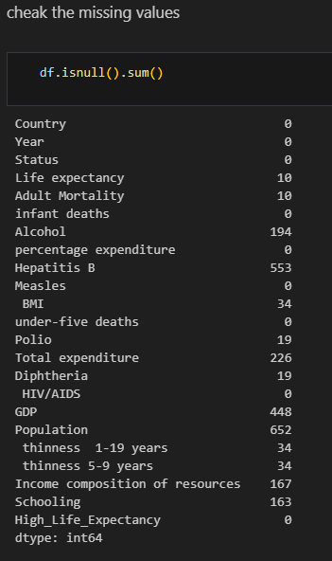
As we can see here, that code show us the amount of missing values ​​in the dataset.

Check the duplicated values :
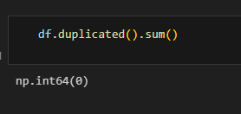
This code here shows us that there is no duplicated data in the dataset
Check the values quality:
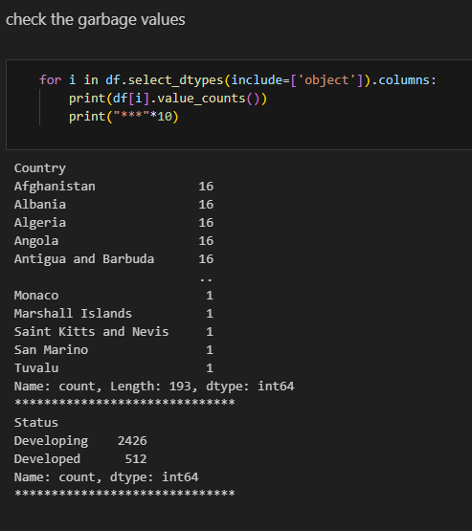
The overall purpose is to perform a quick data quality check or exploratory data analysis (EDA) on categorical features.
The output show:
- For the Country column: It lists many unique countries and their counts. It shows that many countries (like Afghanistan, Albania, etc.) appear 16 times, while many others (like Monaco, Tuvalu, etc.) appear only 1 time. The footer shows a total of 193 unique values (Length: 193).
- For the Status column: It lists two unique values: Developing (2426 counts) and Developed (512 counts).
The initial comment, "check the garbage values", suggests the user is looking for:
- Misspellings or inconsistent casing (e.g., "USA" vs "U.S.A.")—these would appear as separate, low-count unique values (potential "garbage").
- Unexpected categories (e.g., a country column suddenly having the value "N/A" with a high count).

Exploratory data analysis :
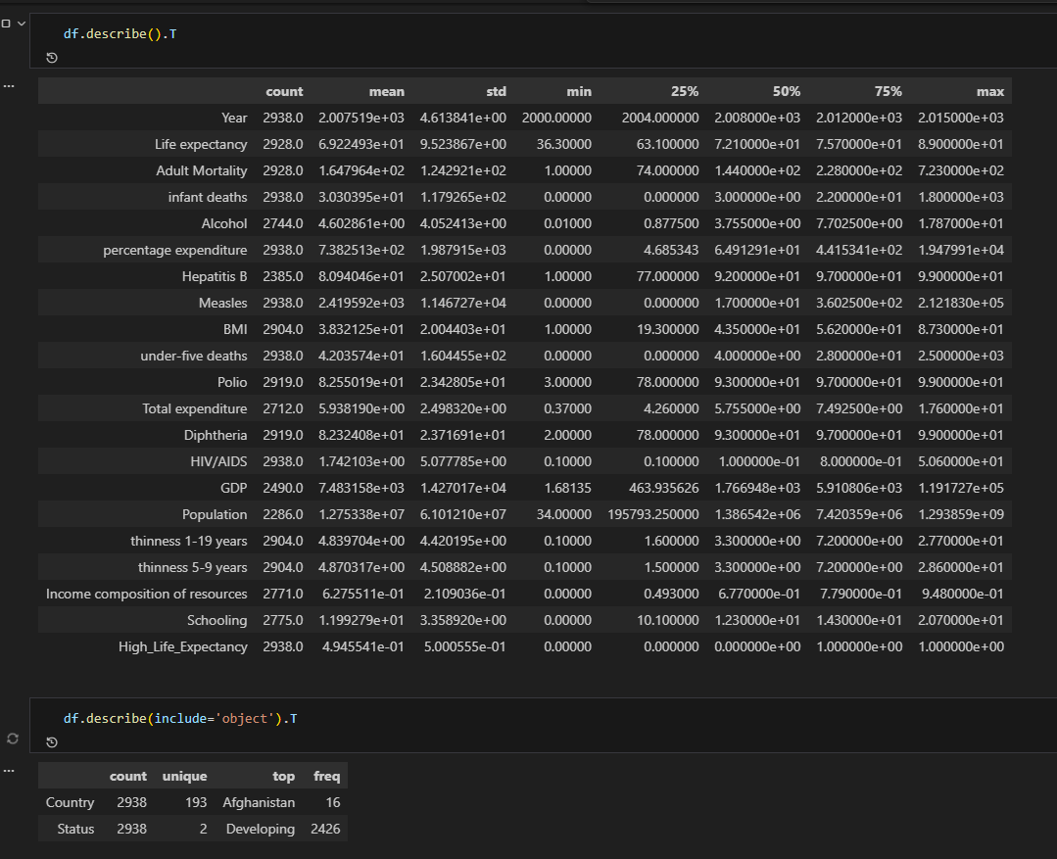
This command generates a descriptive statistical summary of all the numeric columns in the DataFrame df.
- df.describe(): Calculates summary statistics like count, mean, standard deviation (std), minimum (min), maximum (max), and the quartiles (25%, 50% - median, and 75%) for every numeric column.

Key Insights from the Output:
Statistic | Description
count | The number of non-missing values. Used to check for missing data (e.g., GDP has 2490.0 counts, which is less than others like Year with 2938.0, indicating missing values in GDP).
mean | The average value.
std | The standard deviation, measuring how spread out the values are. A high value suggests high variability.
min / max | The smallest and largest values, used to check for outliers or data entry errors.
25%, 50%, 75% | The percentiles, used to understand the distribution of the data. For example, the 50% (median) is less sensitive to outliers than the mean.

df.describe(include='object').T
This command generates a different set of summary statistics specifically for the non-numeric (categorical) columns in the DataFrame df.
- df.describe(include='object'): Tells pandas to only look at columns with the object data type (typically strings or categories).
Statistic | Description
count | The number of non-missing values in the categorical column.
unique | The total number of distinct categories or unique values in the column. The Country column has 193 unique values.
top | The most frequent category in the column. For Status, the top value is Developing.
freq | The count of the top category. The Developing status appears 2426 times.

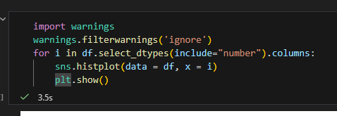
The purpose of this code is for Exploratory Data Analysis (EDA). By viewing the distribution of each numeric variable as a histogram, a data analyst can quickly understand:
• Central Tendency: Where the majority of the values (mean/median) are grouped together.
• Shape: Whether the data is bimodal, skewed (leaning left or right), or regularly distributed.
• Outliers: Values that fall well outside the main distribution.
• Scale: The variable's range of values.
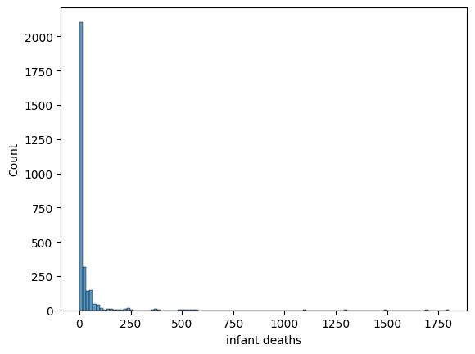
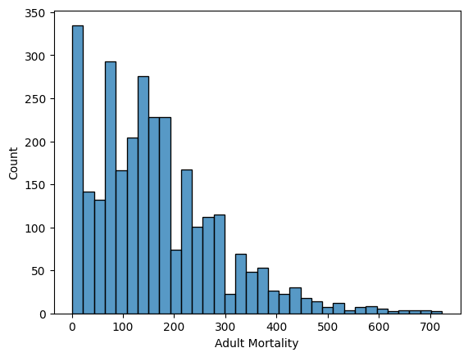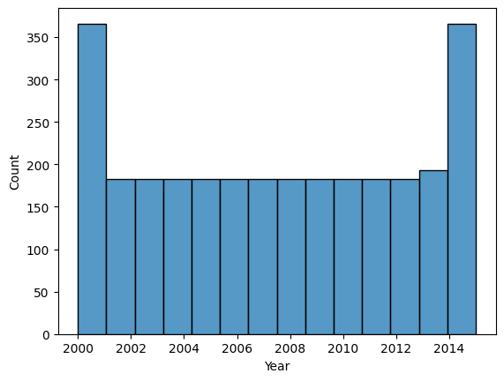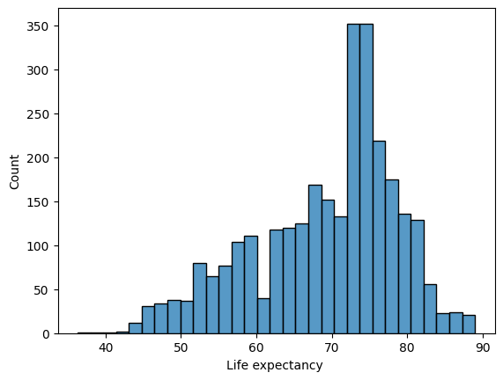

identify the outliers :
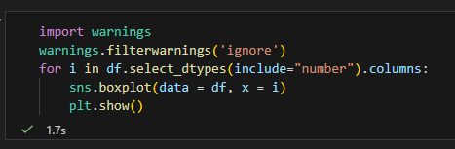
similar to the previous one asked about, but instead of generating histograms, it is used to generate and display a box plot for every numeric column in the DataFrame
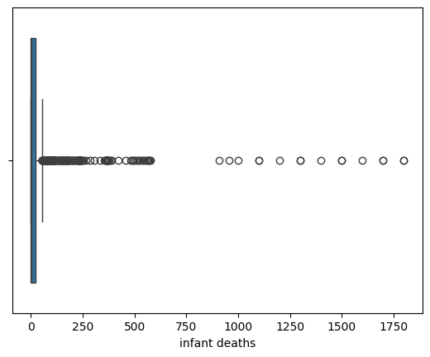
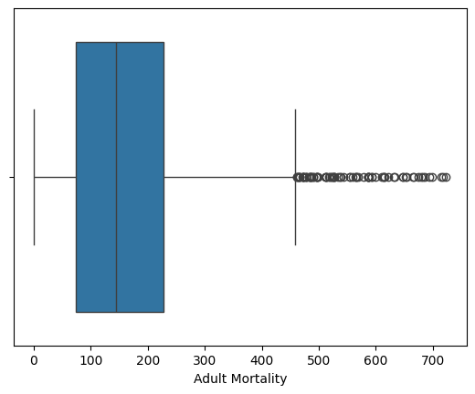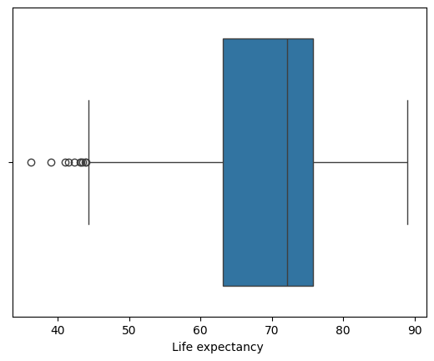
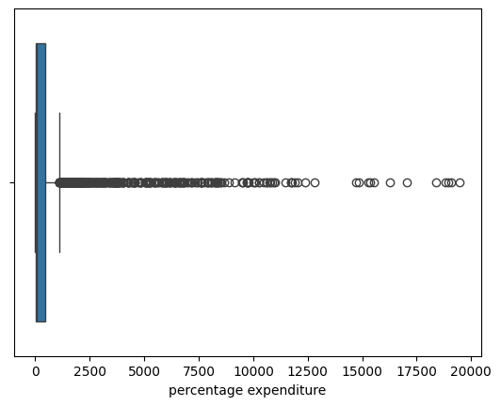

Understand the relationship between the features:
That Python code is performing a visualization process to explore the relationship between various health and economic factors and 'Life expectancy'.
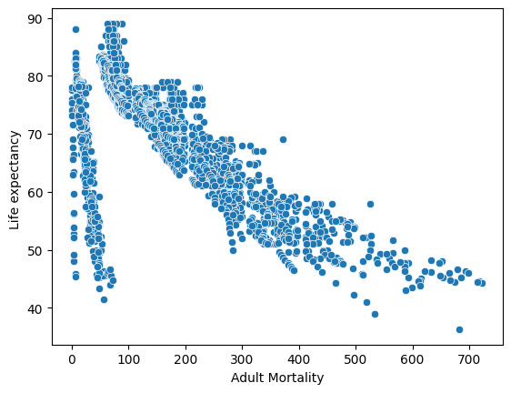
It generates and displays a series of scatter plots by iterating through a predefined list of column names in the DataFrame df.

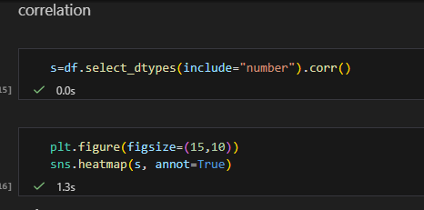
That code is performing a correlation analysis on all the numeric columns in the DataFrame df and then visualizing the results using a heatmap.
The overall purpose is to visually identify strong relationships between the numeric variables in the dataset
• Positive Correlation (closer to +1): Indicated by warmer colors suggesting that as one variable increases, the other also tends to increase (e.g., GDP and Life Expectancy).
• Negative Correlation (closer to -1): Indicated by cooler colors suggesting that as one variable increases, the other tends to decrease (e.g., Adult Mortality and Life Expectancy).
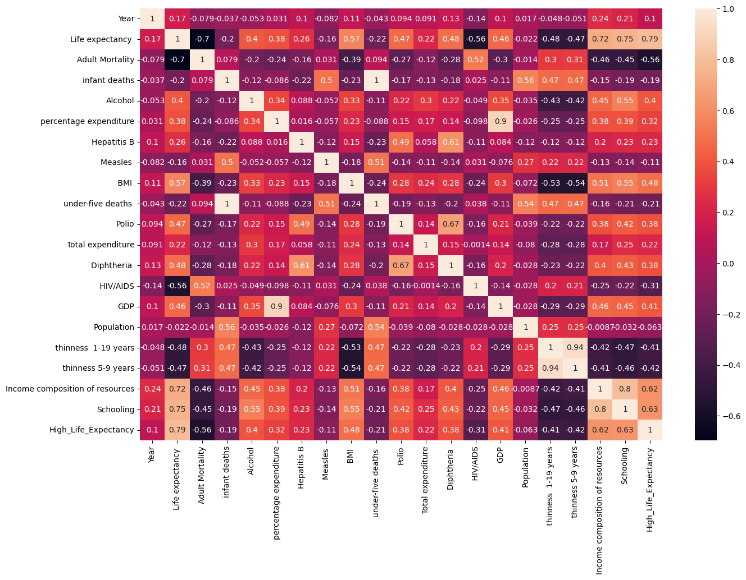
• No Correlation (closer to 0): Indicated by a neutral color (e.g., white or yellow), suggesting no linear relationship.

Missing values treatment:
To simplify the modeling stage, all rows with missing data were removed
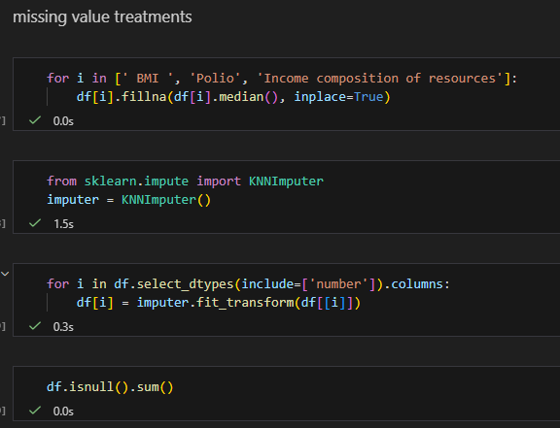

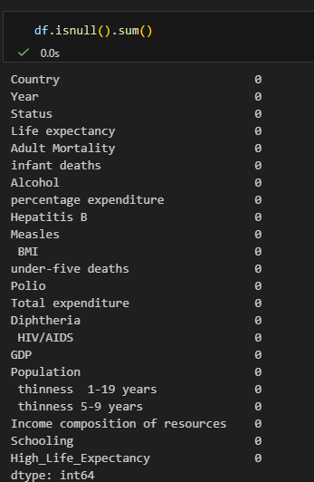
This code block uses a combination of two popular methods to perform missing value imputation on a DataFrame df: K-Nearest Neighbors (KNN) imputation for the remaining numeric columns and median imputation for particular columns.
As we can see here, there are no missing values remaining in any
of the columns of the DataFrame

outliers treatments:
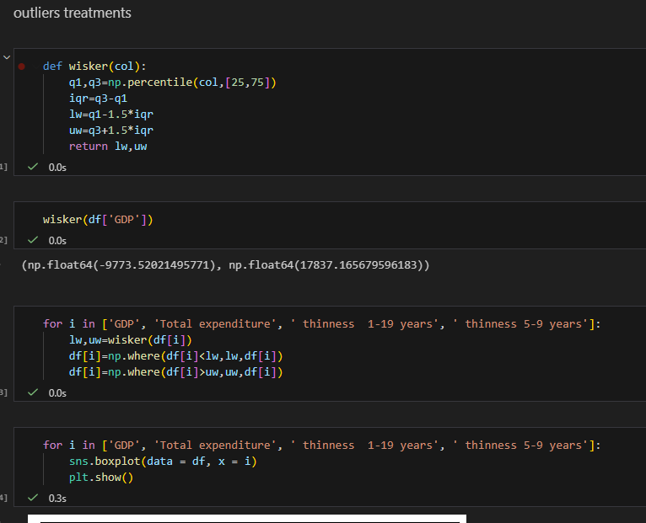
The first part of the code defines a function to calculate the boundaries for non-outlier data.
The next block applies logic to four specific columns: 'GDP', 'Total expenditure', 'thiness 1-19 years', and 'thiness 5-9 years'.
The final block verifies the treatment by regenerating the visualizations.

Model Selection and Rationale :
The main purpose of this document is to present a complete machine-learning workflow for classifying life expectancy levels based on global health indicators.
Because it works so well with the features of this dataset, the Decision Tree Classifier was chosen. The data contains noisy, missing, and correlated health metrics, which makes simpler models such as Naive Bayes less suitable.
Decision Trees do not assume independence between features, can naturally handle non-linear patterns, and offer strong interpretability through visual trees and feature importance rankings. During testing, the Decision Tree also achieved better accuracy and recall compared to other models, making it the most reliable and effective choice for predicting life expectancy categories.
In the other hand Naive Bayes, struggles when correlations are present and demands feature independence.
Additionally, the model conducts an intrinsic kind of feature selection during training and is excellent at capturing non-linear interactions. In the end, the Decision Tree proved to be the most efficient and dependable option for this dataset since it was able to categorize life expectancy levels with greater recall and overall accuracy.

The implementation:
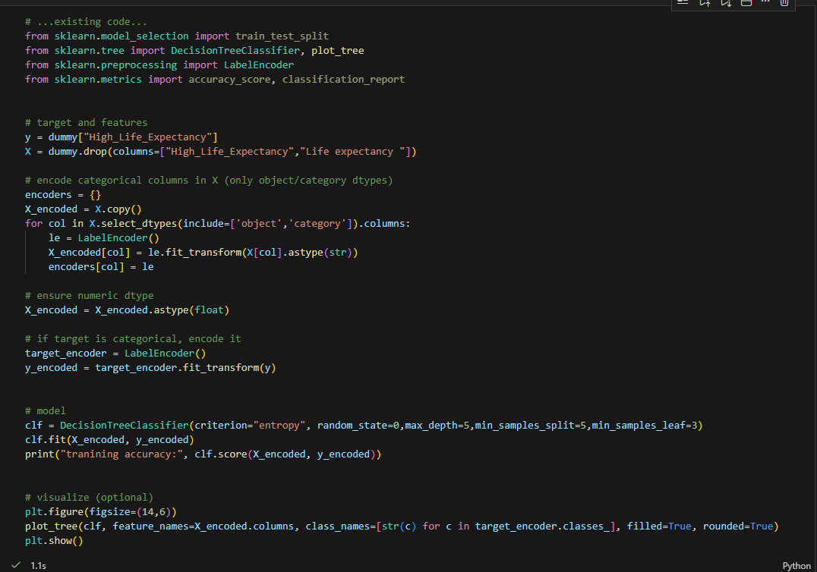
The output:
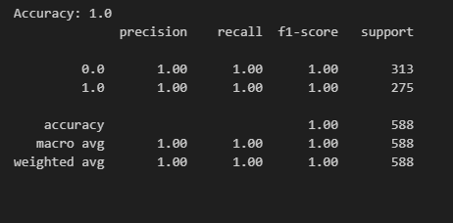

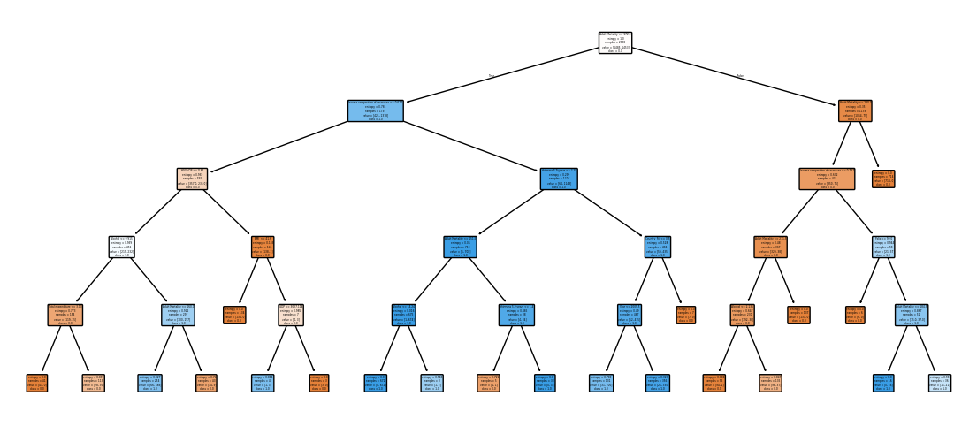

Conclusion:
This project demonstrates how machine learning can be used to classify countries based on life expectancy using noisy health-related data.
In conclusion, the Decision Tree Classifier proved to be an effective and reliable model for classifying life expectancy levels based on global health indicators. Its ability to handle noisy, non-linear, and correlated features made it especially well-suited for this dataset, which contains a diverse mix of health and demographic variables.

