In the name of Allah
SUPARCO Institute of Technical Training

CanSat 2024
Remote Sensing-Communication Class

Critical Design Review (CDR)

The 10th International Iran CanSat Competition
ICC-2024
By
CanSat Team: SITTIANs

DOCUMENTATION PAGE
TITLE: CanSat 2024  Remote Sensing Communication Class | DOCUMENT DATE and EDITION: Mar. 2024, 1st Ed.
AUTHORS:  Qaisar Khan  Muhammad Hamza  Abdul Jabbar  Muhammad Usman  Dilawar Khan | Supervisor: Junaid Sultan
KEYWORDS: CDR, Cansat,
ABSTRACT:
This document outlines preliminary designs, requirements and parts selection for building a Remote Sensing Communication Class Satellite, termed as CanSat, which is able to acquire data such as Temperature, Pressure, humidity as well as able to capture images and send them to ground station. The Satellite is developed under the rules of 10th Iran CanSat Competition 2024, the mission aims at data acquisition and image processing by artificial intelligence in the field of agriculture, environment and crisis management. The CanSat is designed around dimensions, mass requirements and mission requirements as set in competition guidelines.

Table of Contents
1) Introduction 2
Team introduction 3
Team Organization 3
History of participation 3
2) Mission Definition and Objectives 4
2-1) Mission Statement 4
Main Objectives: 4
Bonus Objective: 4
2-2) Concept of Operations (CONOPS) 5
2-3) Requirements and their implementation 7
System requirements 7
Subsystem requirements 9
Sensor Sub System Requirements 9
Communication & Data Handling (CDH) Sub System Requirements 11
Electrical Power System (EPS) Requirements 13
Mechanical Structure Requirements 13
Descent Control / Recovery System Requirements 14
Ground Control System Requirements 15
3) System designs Overview 16
Overall schematic and Cansat layout 16
3-1) System and subsystem architecture and interactions 16
System architecture 16
Recovery Sub System Design 16
Sensor Sub System Design 17
Descent Control Design 18
Mechanical Sub System Design 19
Communication & Data Handling (CDH) Sub System Design 20
Electrical Power System (EPS) Design 21
Ground Control System (GCS) Design 22
Interactions between the subsystems and components 23
3-2) Theoretical and scientific Foundation of the design 24
3-3) Test 24
3-4) Budgeting 25
3-5) Scheduling 25
3-6) Conclusion 26
3-7) References 26
3-8) Annex 26

List of Figures
Page Title

Figure ‎2-1: An Example of CanSat Mission Profile 5
Figure ‎2-2: An example of system architecture 9
Figure ‎2-3: Example of architecture and configuration of Cansat recovery subsystem 10
Figure ‎2-4: Interfaces of electronic and communication subsystems in a Cansat 11
Figure ‎3-1: competition logo 14

List of Tables
Page Title

Table ‎1-1: Example of mission profile 4
Table ‎2-2: Example of Table of Requirements 8
Table ‎2-3: Example of a trade-off table 10
Table ‎2-4: An example of a budgeting table 12
Table ‎3-1: An example of table 14

Abbreviations
CanSat | Can Satellite

Introduction

A CanSat is a miniature representation of a real satellite, cleverly integrated within the volume and shape of a soft drink can (typically a 330 ml can). The challenge for students is to fit all the major subsystems found in a satellite—such as power, sensors, and a communication system—into this compact space. The CanSat is then launched to an altitude of a few hundred meters by a rocket or dropped from a Quadcopter or captive balloon and its mission begins: to carry out a scientific experiment and achieve a safe landing.

CanSat offer a unique opportunity for students to have a first practical experience of a real space project. They are responsible for all aspects: designing the CanSat, selecting its mission, integrating the components, testing, preparing for launch and then analyzing the data.

This report has been prepared for the 10th International Iran CanSat Competition, which provides an opportunity to design, build, and complete the flight mission of CanSat for teams from all over the world.

The competition contains two classes:
1. Remote Sensing-Communication
2. Scientific-Exploration

Our team will be competing in Remote Sensing -Communication Class, mainly due to following reasons:

            - CanSat of similar class has previously been developed at our institute as Final Year Project
            - Scientific Exploration Class needed much more time-consuming effort on designing, implementation and testing, difficult to meet the deadlines of the competition.

Team introduction
Table 1-1:Team Introduction
S. No | Member Name | Institute Name | Major | Degree & Year | Title
1 | Junaid Sultan | Indus University | Electronics | B-Tech (Hons)  2010 | Supervisor
2 | Qaisar Khan | SUPARCO Institute of Technical Training (SITT) | Electronics | Intermediate  2024 | Teammate-1
3 | Hamza Ahmed | SITT | Electronics | Intermediate  2024 | Teammate-2
4 | Abdul Jabbar | SITT | Electronics | Intermediate  2024 | Teammate-3
5 | M. Usman | SITT | Mechanical | Intermediate  2024 | Teammate-4
6 | Dilawar Khan | SITT | Mechanical | Intermediate  2024 | Teammate-5

Team Organization
Figure 1-1 Team Organization

History of participation
We did not participate earlier before this competition.

Mission Definition and Objectives

Mission Statement
The mission of the Remote Sensing-Communication CanSat is to measure environmental data such as temperature, humidity, and pressure, as well as to take images and send them to the ground station. The mission defined in this competition is data acquisition and image processing by artificial intelligence in the field of agriculture, environment and crisis management. In this mission, CanSat is released over ground targets and it must measure the area of target and detecting their colors by using image processing algorithms. In this regard, detecting targets and their colors must be applied in a semi-automatic or automatic manner

Main Objectives:
- Design and Build a CanSat to be launched and deployed from a drone at an altitude of about 300 meters. The CanSat is to descend at 5 m/s or less. It is to meet all the requirements and constraints as laid down in table of requirement at Table 2-2
- CanSat is to measure environmental data such as temperature, humidity, and pressure.
- CanSat must transmit GPS data, sensors data, and CanSat health status information to the ground in real time
- CanSat is released over ground targets and it must measure the area of target and detecting their colors by using image processing algorithms. In this regard, detecting targets and their colors must be applied in a semi-automatic or automatic manner.
- The structure must fulfill dimensions and mass requirements of competitions as specified in table of requirement at Table: 2-2.
- The CanSat landing mechanism must be designed in such a way that it lands the payload at the closest point to the ground target area.

Bonus Objective:
Using the Internet platform to exchange data between the CanSat and the ground station in each stage of the mission (optional) will have extra scores depending on the quality of the work.

Concept of Operations (CONOPS)
The CanSat competition scenario as follows:
    - CanSat is turned on and placed in releaser. Releaser is used for ascending and releasing CanSat and it is provided by competition organizers
    - The ascending CanSat collects mission data such as temperature, pressure, and so on and transmits them to the Ground Station in real-time.
Note 1: Our team should develop and have our own Ground Station.
    - CanSat is released after reaching the specified altitude of the competition. CanSat must also collect and transmit data during the release phase.
    - The descending CanSat must capture images from desired area on the ground using its camera.
These targets must be identified using the images and reported to the ground station during or after the flight.
The area of targets and their colors should be automatically reported by the CanSat.
    - CanSat should have a safe landing using the recovery mechanism after release.
    - A safe landing area the nearest distance within the target should be considered, considering cross-wind or external chaos.
    - After reaching the target position, CanSat stops and declares its presence so that it can be tracked.
    - After finding CanSat, it is turned off and the mission is over.
    - Assessment of the results is carried out using observations by the referees choose by the Competition Organizers.
Table 2-1: Mission profile
Step | duration(s) | start time(s) | Description
CanSat Turned on and placed in releaser |  | 0 | Start of mission
Launch take-off | - | 100 | Start of flight
CanSat collects mission data and transmits to GCS |  | 100 | Real Time data transmission
Release from drone | - | 130
Parachute deployment for recovery | - | 135-205 | Landing phase using parachute
Capture and transmit images during descent | - | 140-190 | Take photos and data gathering
landing on earth | - | 210 | Beacon and GPS to find
Finding and turning off the system |  | 270 | End of Mission

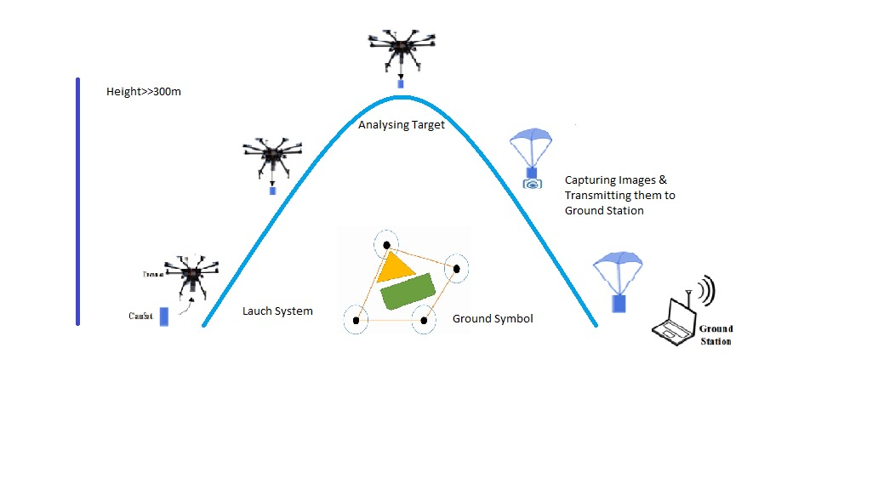
Figure 2-1: CanSat Mission Profile

Requirements and their implementation

System requirements
Technical requirements of the system for competition are listed in table below:
Table 2-2: Table of Requirements for the System
Code | Requirement | Source | Physical specification | Priority | Approval method
 |  |  |  |  | Design review | Test | Analysis | Control
 | The mass of CanSat must be less than 350 gr | competition | structure | high |  |  |  | 
 | In classical class, CanSat must fit inside a standard soda can (115 mm height and 66 mm diameter) | competition | structure | high |  |  |  | 
 | CanSat must be compatible with the ascending system (during ascending, acceleration changes in the design must be considered) | competition | Structure, recovery | high |  |  |  | 
 | CanSat must land safely to the ground (conditions of descending, acceleration changes, and landing must be considered in design) | mission | recovery | medium |  | 
 | The use of toxic and flammable materials is not allowed in the design of CanSat | competition | structure | medium |  | 
 | CanSat must obey the RF regulation | competition | Telecommun  ication | high |  |  | 
 | CanSat must measure atmospheric parameters | mission | payload | high |  | 
 | CanSat must collect data related to atmospheric sensor or data in payload such as temperature | mission | Data management and command | high | 
 | CanSat must transmit GPS data, sensors data, and CanSat health status information | mission | Transmissio n/telecommunication | medium |  | 
 | CanSat must be in operational status for 90 minutes | Operation concept | power | low |  |  | 
 | CanSat must be resistant to operation load (launching phase, phase of releasing before  parachute, releasing with a parachute, and landing) | Operation concept | structure | medium |  |  | 
 | Each CanSat must be equipped with a beacon system to declare its presence at the location | mission | payload | high |  |  | 

Subsystem requirements

Sensor Sub System Requirements
Table 2-3
Code | Requirement | Source | Physical specification | Priority | Approval method
 |  |  |  |  | Design review | Test | Analysis | Control
SCDH.1 | CanSat must measure atmospheric parameters like Air Pressure. | Mission | Data management and command. | High |  |  | 
SCDH.2 | CanSat must collect data related to atmospheric sensor or data in payload such as temperature. | Mission | Data management and command. | High |  |  | 
SCDH.3 | CanSat must measure atmospheric pressure to measure Altitude of CanSat. | Mission | Data management and command. | High |  |  | 
SCDH.4 | CanSat should transmit GPS data. | Cansat bonus Requirement | Data management and command | Low |  |  |  | 
SCDH.5 | Each CanSat must be equipped with a beacon system to declare its presence at the location | Mission | Payload | High |  |  |  | 
SCDH.6 | Cansat must detect Enclosed area of targets and their colors (presenting the area of targets by inserting the area and color on the image). | Competition | Payload | High |  |  |  | 
SCDH.7 | CanSat must measure atmospheric parameters like humidity. | Cansat bonus Requirement | Data management and command | Low |  |  | 
SCDH.8 | CanSat should give Air Condition as an atmospheric Parameter. | Cansat bonus Requirement | Data management and command | Low |  |  | 
SCDH.9 | Cansat should give its Direction and its orientation. | Cansat bonus Requirement | Payload | Low |  |  | 

Communication & Data Handling (CDH) Sub System Requirements
Table 2-4
Code | Requirement | Source | Physical specification | Priority | Approval method
 |  |  |  |  | Design review | Test | Analysis | Control
 | CanSat must obey the RF regulation | Mission | Transmission/ | High |  |  | 
 | CanSat must transmit GPS data, sensors data, and CanSat health status information to the ground in real time | Mission | tele-communication | High |  |  | 
 | Sending measured parameters in the requested data format immediately after the measurement | Mission | Transmission/ | High |  |  | 
 | The communication frequency of the CanSat with the ground station should be in the range of amateur radio frequencies of: 430-440 MHz or 2400 to 2450 MHz | Mission | tele-communication | Low |  |  |  | 
 | Transmitted power shall be less than 20 dBm (or 100 mW). | Mission | Transmission/ | High |  |  |  | 
 | Telecommunications of CanSat must cover a range of more than 500 meters (Intersection requirement) | Mission | tele-communication | High |  |  |  | 
 | CanSat must be able to have a one-way telecommunication with the ground station continuously (from CanSat to the ground station). | Mission | Transmission/ | Low |  |  | 
 | Updating data rate at least every second | Mission | tele-communication | Low |  |  | 
 | At least three images should be transmitted at the time of descent  Images should be completely transmitted in digital format  - The images must be compressed using compression methods | Mission | P Transmission/  tele-communication | Low |  |  | 
 | if using any network-supported communications module, each team should choose a unique random NETID/PANID code. The network settings including NETID/PANID code must be reported in CDR | Mission | Transmission/  tele-communication |  |  |  | 
 | Using the Internet platform to exchange data between the CanSat and the ground station in each stage of the mission (optional) will have extra scores depending on the quality of the work | Competition Bonus requirement | Transmission/  tele-communication |  |  |  | 
 | Valid and reliable telecommunication between Ground Station and CanSat without interference | Operational | Transmission/  tele-communication |  |  |  | 
 | CanSat must store collected data and captured images onboard memory card and on GCS | Operational | Data Handling |  | 
 | Order of data storage should be in alpha recovery (read from left to right) | Competition requirement | Data Handling
 | File extensions should be .CSV or .TXT | Competition requirement | Data Handling |  |  |  | 

Electrical Power System (EPS) Requirements
Table 2-5
code | requirement | source | Physical specification | priority | Approval method
 |  |  |  |  | Design review | test | analysis | control
 | The electrical power supply subsystem of the Cansat must provide the required power for the entire operation time, including the time needed to recover after landing and at least 60 minutes before the operation. | Competition | Power System | High |  |  | 
 | CanSat must be in operational status for 90 minutes | Operation | Power System | High |  |  | 
 | CanSat shall measure its battery Voltage | Operation | Power System | Low | 
 | Battery type and size must comply requirement constrains | Operation | Power System | High | 

Mechanical Structure Requirements
Table 2-6
code | requirement | source | Physical specification | priority | Approval method
 |  |  |  |  | Design review | test | analysis | control
 | The mass of CanSat must be less than 350 gr | competition | structure | high |  |  |  | 
 | In classical class, CanSat must fit inside a standard soda can (115 mm height and 66 mm diameter) | competition | structure | high |  |  |  | 
 | CanSat must be compatible with the ascending system (during ascending, acceleration changes in the design must be considered) | competition | Structure, recovery | high |  |  |  | 
 | CanSat must land safely to the ground (conditions of descending, acceleration changes, and landing must be considered in design) | mission | recovery | medium |  | 
 | The use of toxic and flammable materials is not allowed in the design of CanSat | competition | structure | medium |  | 
 | The team’s name shall be printed on the CanSat to help with the identification of the CanSats. Also, a colored ribbon, which is visible from far away, must be applied axially to the surface of CanSat. | competition | structure | High |  |  |  | 

Descent Control / Recovery System Requirements
Table 2-7:Recovery System Requirements
Tcode | requirement | source | Physical specification | priority | Approval method
 |  |  |  |  | Design review | test | analysis | control
 | The recovery subsystem must be designed with a descent rate equal to or less than 5m/s. | competition | recovery | high |  |  |  | 
 | CanSat should have a safe landing using the recovery mechanism after release. | competition | recovery | high |  |  |  | 
 | A safe landing at the nearest distance within the area of targets should be considered, should be given to Considering cross-wind or external chaos. | competition | recovery | high |  |  |  | 
 | Each CanSat must be equipped with a beacon system to declare its presence at the location | mission | Payload, recovery | high |  |  | 

Ground Control System Requirements
Table 2-8:GCS Requirements
code | requirement | source | Physical specification | priority | Approval method
 |  |  |  |  | Design review | test | analysis | control
 | Each Team should design its own GCS | Competition Rules | Ground Control System | HIGH | ✓ | ✓ | ✓ | ✓
 | The Ground Station must receive data in real time. | Mission Scenario | Ground Control System | HIGH | ✓ | ✓ | ✓ | ✓
 | Directional Antenna should be used for GCS | Operational | Ground Control System | Medium | ✓ | ✓ | ✓ | ✓
 | CanSat shall operate autonomously and no command from Ground Station is allowed to be sent during the operation scenario (telecommand is not allowed). | Competition Rules | Ground Control System | HIGH | ✓ | ✓ | ✓ | ✓
 | Appropriate graphical display of received and analyzed data immediately in Ground Station | Competition Rules | Ground Control System | HIGH | ✓ | ✓ | ✓ | ✓
 | Image Processing of received images for target area and specifications | Competition Rules | Ground Control System | HIGH | ✓ | ✓ | ✓ | ✓

System designs Overview
Two designs were reviewed for the system

System Design 1:
The first design aim at creating space for payload, it provides ease for assembling and testing the system.

Main Features:
- Flat Hexagonal Parachute used which will be deployed after release at 300 meters, by using a miniature Servo
- Flexible antenna used for omni directional transmission
- Electronics System Consists of Separate PCBs for Sub Systems, which will be mounted separately and connected bus connectors, which creates space for components and ease in assembly
Figure:3-1
Parachute Mount
XBEE Module
Omni Tx Antenna
Sensor System
SD Card
Raspberry PI Zero W
Battery
EPS
PI Camera
- Raspberry Pi is mounted vertically with a rods
- Pay Load Camera is place at center of bottom Lid
- Battery and EPS section is placed at bottom section
- Threaded rods are used for support
- Outer Cover will be 3D printed and of thin width. Which will be reduce weight of the system.
Figure 3-2

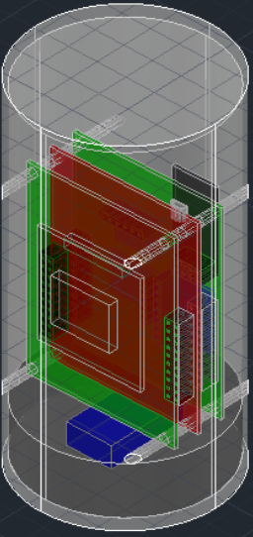
System Design 2:
Figure 3-3
The first design aim at reducing weight

Main Features:
- Flexible antenna used for omni directional transmission
- Electronics System will be in one bay and mounted vertically through Plastic mounting sticks
- Pay Load Camera will be mounted through a servo at bottom Lid for target alignment and stability
- Battery and EPS section is placed at bottom section
- Threaded rods are used for support
- The Structure will be 3D printed
- Flat Hexagonal Parachute used which will be deployed after release at 300 meters, by using a miniature Servo
- No Steel rods in the system which will reduce weight
- The Top Cover and the container are threaded assembling it easily and Parachute attachment
- Flat Hexagonal Parachute used which will be deployed after release at 300 meters, by using a release switch.

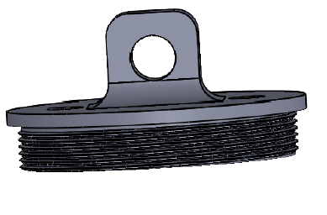
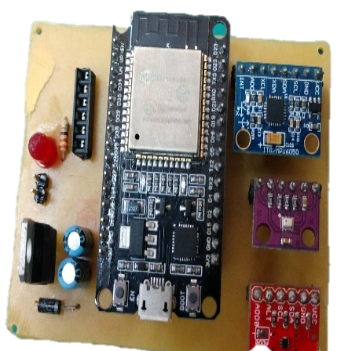
Figure 3-5
Figure 3-4

Conclusion:
Considering all the features, it was decided to select Design 1 , which will be provide , easy accessibility , less power consumption , more space , ease assembling and testing.

System and subsystem architecture and interactions

System architecture
The Whole System comprises of two units: 1. CanSat Container 2. Ground Control System

Figure 3-6: CanSat system architecture

The CanSat Container Contains following subsystems
- Recovery Subsystem
- Sensor Subsystem
- Communication and Data Handling System
- Mechanical Structure
- Electrical Power System

Ground Control System contains
Antenna Reception System with Laptop for GUI, analysis and storage.

Recovery Sub System Design
This section should be devoted to the architecture of the subsystems. Specifications of each subsection should be clearly presented with sufficient details. For example, in accordance with Fig. 2-3, the recovery subsystem consists of the parachute subsystem, mechanical actuators, and electronic circuits to receive command signals, etc.

Figure 3-7: Example of architecture and configuration of Cansat recovery subsystem

Sensor Sub System Design

Table 3-1: Sensor Subsystem Overview and Selection
S.Code | Sensor Type | Selected Sensor Model | Purpose | Section
SSO.1 | Air Pressure | BMP-280 | Measuring Air Pressure as its mission requirement | Structure
SSO.2 | Temperature | TMP-102 | Measuring Air Temperature as its mission requirement | Structure
SSO.3 | Altitude/Height | BMP-280 | Measuring Air Pressure to determine CANSAT height/altitude | Structure
SSO.4 | GPS | NEO-6M | Finding Local or global position of the ground targets and Specially Ground Systems (optional) | Structure/  Tethered Payload
SSO.5 | Location Indicator | Buzzer | To declare the presence of CANSAT at the location | Structure
SSO.6 | Image(Area+Colour) | Raspberry Pi Camera v1.3 | To Detect images of Ground Station. | Tethered Payload
SSO.7 | Humidity | HTU-21D | Measuring Humidity as its mission (bonus points/OPT) requirement | Structure
SSO.8 | Air Condition | MQ-5 GAS SENSOR | Measuring Air Conditions as its mission (bonus points/OPT) requirement | Structure
SSO.9 | Compass (Direction orientation) | MPU-6050 | For the smooth Control of CANSAT Directivity and its orientation | Structure

Table 3-2: Specifications of Selected Sensors

Sensor Subsystem Specifications

SensorModel | Interface | Range  (Min-Max) | Current  (µA) | Volts  (V) | Dimenions  (HxWxL(mm)) | Mass (grams) | Price  ($)
BMP-280  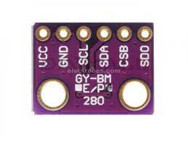 | I2C/SPI | 300 hPa-1100hPa | 0.5 µA at  1 Hz | 3.3v | 2 X 6 X 13.5 | 3 | 3
TMP-102  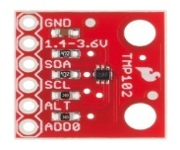 | I2C | -40C to 125C | 1  µA to 10 µA | 1.4 to 3.6 | 1.6 X6X 15.5 | 3 | 2.5
NEO-6M  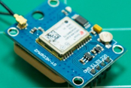 | UART/ I2C/SPI | >50 Km altitude | 20 to 80 mA | 2.7 to 3.6 | 2.4 X 12.2 X 16 | <10 | 6.11
Buzzer   | Digital | <15m | <30 mA | 4 to 8 | 2.6 mm Diameter | 2 | 0.49
HTU-21D  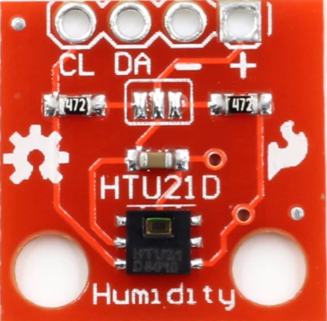 | I2C | 0 to 100 %RH | 0.02 to 0.14 | 1.5 to 3.6 | 0.9 x 3 x 3 | 3 | 1.5
MQ-5  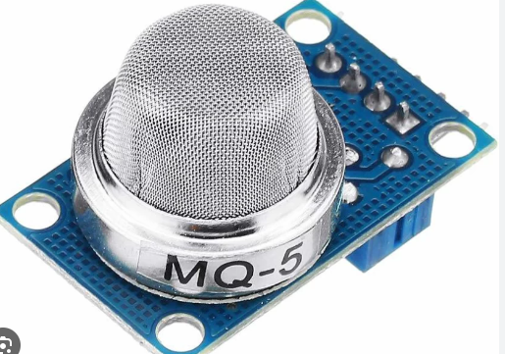 | D/A | 300 to 1000ppm | <100mA | <5 | 0.9 x 3 x 4 | 7 | 0.8
MPU-6050  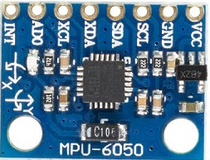 | I2C | X=±250  Y=±500  Z=±1000 | 3mA | 1.5 to 3.6 | 0.9 x 4 x 4 | 5 | 1.5
Raspberry Pi Camera v1.3  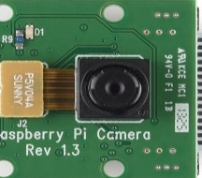 | GPIO | Res:1080 x  640 x 480  Fps:60,30  View:120° | <110 mA | 3.3 to 5 | .9 x 24 x 24.5 | ~3 | 5

Mechanical Sub System Design
This section should be devoted to the architecture of the subsystems. Specifications of each subsection should be clearly presented with sufficient details. For example, in accordance with Fig. 2-3, the recovery subsystem consists of the parachute subsystem, mechanical actuators, and electronic circuits to receive command signals, etc.

Figure 3-5: Mechanical Sub System Design
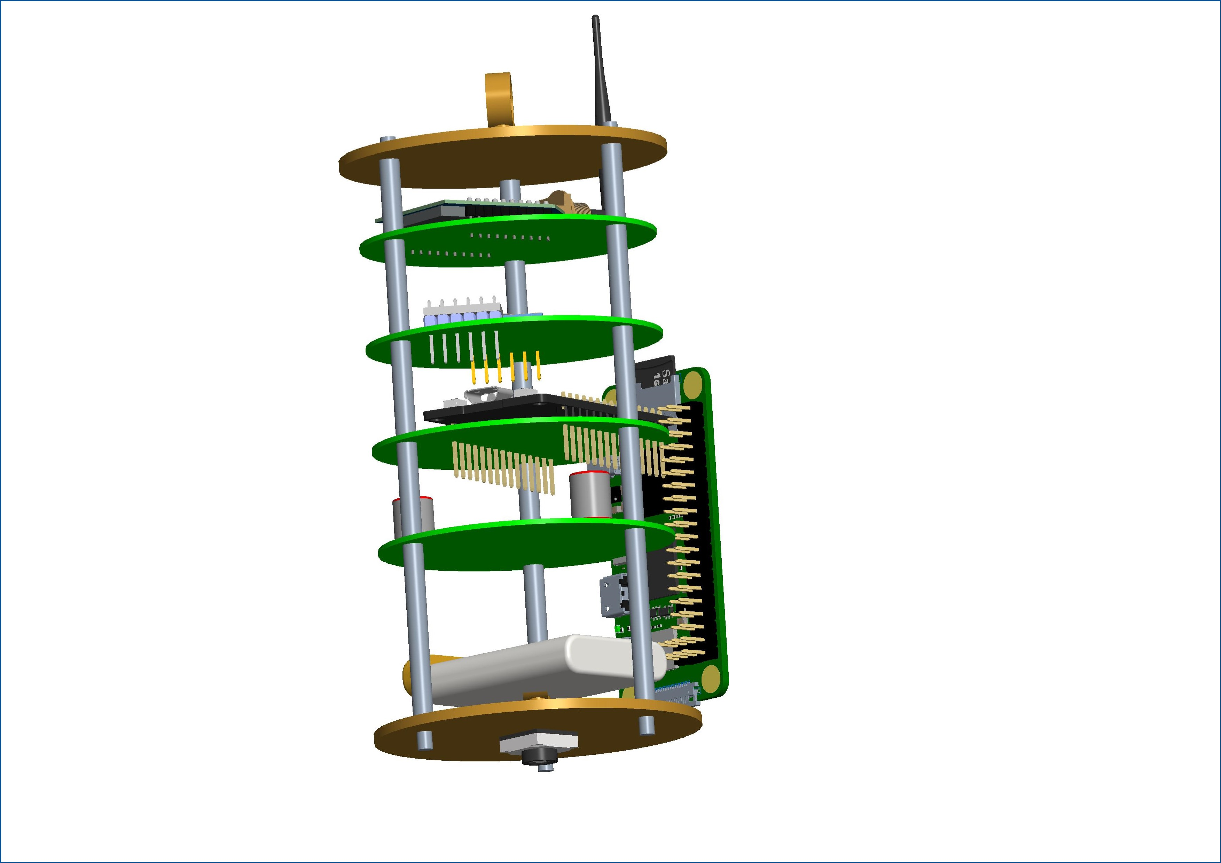
Table 3-3 Example of a trade-off table
Weight factor | Aluminium | Epoxy carbon | Polyester glass | Epoxy glass | Factor
3 | 1 | 3 | 1 | 2 | Strength/mass
1 | 2 | 1 | 3 | 3 | Accessibility in the Market
2 | 2 | 1 | 3 | 2 | Cost
 | 9 | 12 | 12 | 13 | Score
.

Communication & Data Handling (CDH) Sub System Design

Data Handling and Control
Microcontrollers (ESP-32+Pi Zero)
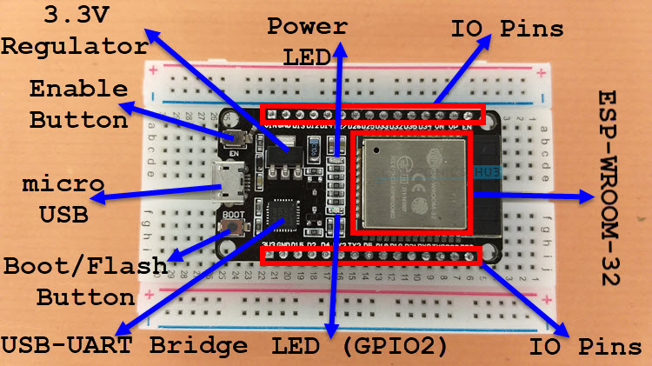

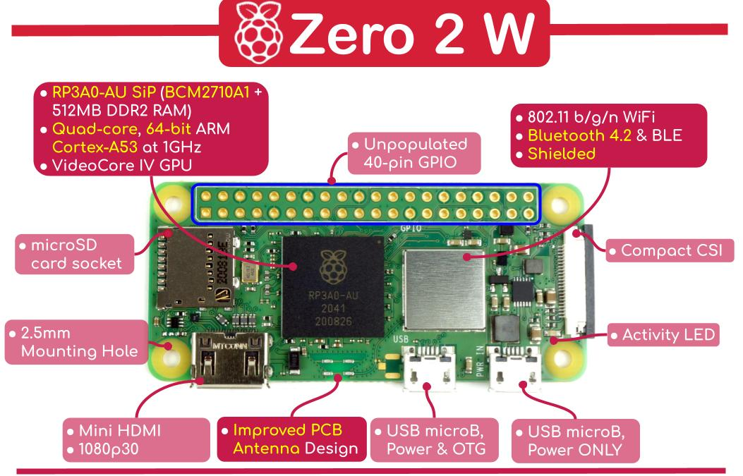

Communication Sub System Design
CanSat Radio Configuration
CanSat to Ground Link

- Communication with ground station using XBEE Pro
- CanSat Transmitting Data to Ground Station

Table ‎2-1: Trade off Communication System
Range | Transmit Power | Sensitivity | Frequency | Baud Rate | Operating current | Operating Voltage | Description
2 miles (3200 m) | 63 mW (+18 dBm) | -101 dBm | ISM 2.4 GHz | RF 250 Kbps | Transmit Current  120 mA @ 3.3 VDC  Receive Current  31 mA @ 3.3 VDC | 2.7 to 3.6V | XBee Pro Module  XBP24-CAWIT-001

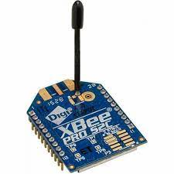
Selection Reason:
Better outdoor Range
High Transmit Power
Flexible Wire Antenna
Figure 3-6: Interfaces of electronic and communication subsystems in a Cansat

Ground Control System Radio Configuration
Table ‎2-1: Requirements of Communication Sub System
Range  Outdoor | Transmit Power | Sensitivity | Frequency | Baud Rate | Operating current | Operating Voltage | Name
4000 ft (1200 m) | 3.1 mW (+5 dBm) / 6.3 mW (+8 dBm) boost mode | -100 dBm / -102 dBm boost mode | ISM 2.4 GHz | RF 250 Kbps | Transmit Current  33 mA @ 3.3 VDC /  45 mA boost mode  Receive Current  28 mA @ 3.3 VDC /  31 mA boost mode | 2.1 to 3.6V | XBee Pro Module  XBP24-CAWIT-001

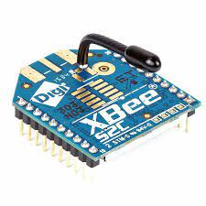
Selection Reason:
Better outdoor Range
Good Sensitivity
Flexible Wire Antenna
Comparatively lower Cost
CanSat to Ground Link Antenna Trade and Selection
Design not yet finalized
Figure 3-7: Interfaces of electronic and communication subsystems in a Cansat

.

Electrical Power System (EPS) Design

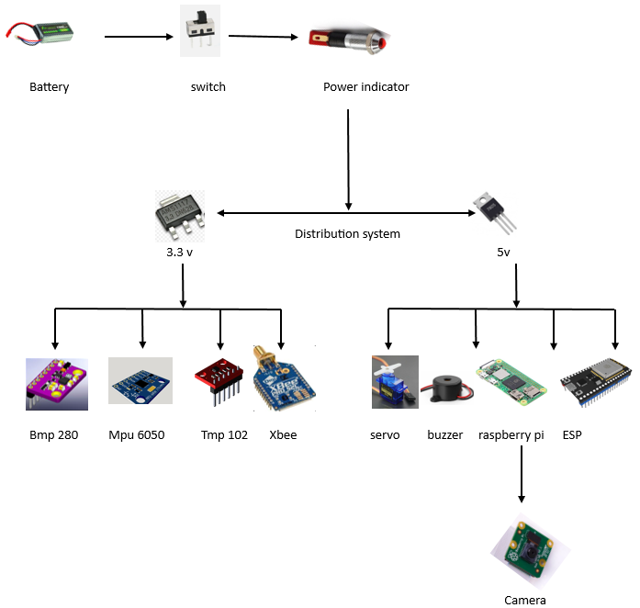
Battery:
It was used as power source of the components for at least two hours.

Power switch:
Diverts and interrupts the current flow from batter to the electrical system.

Power indicator:
Indicates if the system obtains energy.

Batter voltage sense:
battery voltage sense is to monitor the electrical potential of a battery to ensure optimal performance and prevent overcharging or discharging.

Distribution system:
Guarantee that the other electronics will receive the correct voltage and current levels
for the entire time of mission.

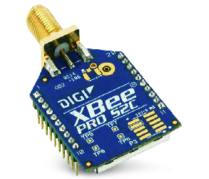

Ground Control System (GCS) Design
- The transmitted data from the Payload will be received by XBee Pro or with WIFI using a custom-made antenna.

- The telemetry data will be transferred to the pc by means of USB connector or WIFI, and will be processed using node-red to display the telemetry data in real time. The data will be saved in a CSV format by the ground station.

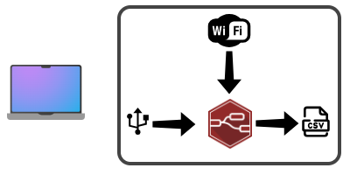

GCS Software
GCS software will be built using Node-red or LabVIEW as a real time plotting application. It will process the data received on the XBEE radio. It will also be responsible for either https requests or MQTT packet submission. We are not using any licensed software.

Telemetry
The Telemetry will be saved in a CSV file format. The image files will be extracted through https requests.

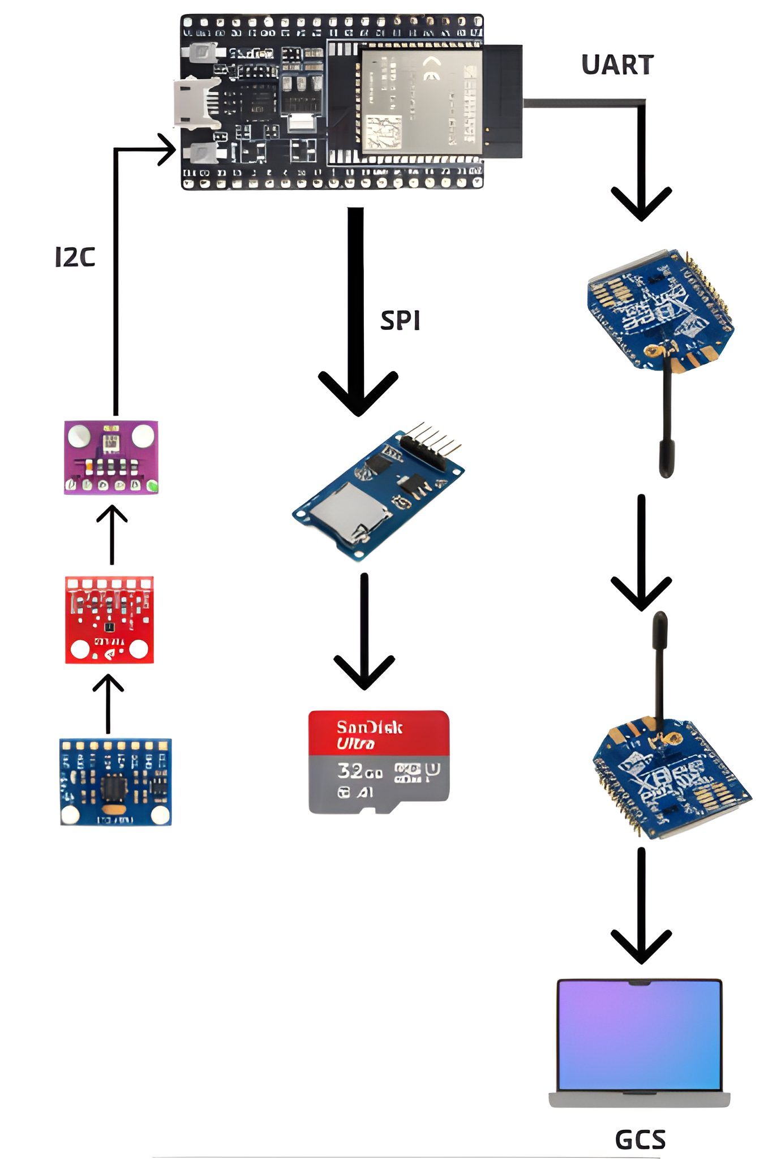
Interactions between the subsystems and components

Main Microcontroller ESP32 acquires data immediately after turning on power, stores data in onboard and memory and transmits data each second to ground station

Figure 3-8: Interfaces of electronic and communication subsystems in a Cansat

Theoretical and scientific Foundation of the design
This subsection presents the scientific aspect of the proposed design from an engineering perspective. For example, the reason for using a delayed parachute, calculating the required time for delay, and supplying landing speed according to the requirement must be presented. In this section, satisfaction of requirements must be defined.

Test
To confirm satisfaction of requirements, the system needs to be thoroughly tested. The space industry uses a bottom-up process for performing the test, which means that first, components are tested to fix problems, if any. After assurance of proper functioning, components are integrated to form a subsystem. In this step, each subsystem has to be tested individually to check its function. A subsystem may not be able to perform its predefined functions. This fault might be due to an Intersection of parts that can be repaired and fixed. However, in some cases, the fault may be due to design errors. In this case, the design must be modified and improved, or the subsystem must be reconstructed. The testing process is a repeatable process that can be repeated several times for a subsystem or a part to eventually achieve the desired result. System integration is carried out after approving the proper functioning of subsystems, and tests are performed on the entire system to ensure its functioning. In this section, teams must provide a specific program for the CanSat testing in their report. This means which parts have to be tested to approve the function and performance of CanSat.
Prerequisites, type of test, method of test, and how to apply results must be mentioned too.
It should be noted that the defined items of this section must be compatible with the column of "approval method" in the requirements table 2-2.

Budgeting
System budgeting involves mass, power, data, costs, and human resource budgeting.
In preliminary design, it is necessary to determine the mass, power and data volume required for processing, transmitting, or storing and also allocate the cost of the system to each subsystem (top to bottom).
Budgeting at the critical design phase must be done for parts and components, and it should also be approved from bottom to top.
Teams should provide a table for each item of system budgeting, such as Table 2-4. In system design, a margin is usually proposed for each item of budgeting to avoid a lack of funds in case of design modification in subsequent phases or when construction and implementation errors occur.
In the preliminary design, the system is broken into subsystems (as in Table 2-4); however, in the critical design phase, the system is divided into parts, and the power consumption, mass, data volume, and cost of each one will be mentioned in budgeting.
Table 3-8: An example of a budgeting table
cost | Human resource | Data volume | mass | Maximum power | Mean power
Rls/$ | Man hour | (Byte) | (kg) | P_{max} (W) | P_{avg} (W)
 |  |  |  |  |  | Structure subsystem
 |  |  |  |  |  | Power subsystem
 |  |  |  |  |  | ...
 |  |  |  |  |  | margin
 |  |  |  |  |  | total

Scheduling
Usually, each project has several phases, such as conceptual design (feasibility), preliminary design, critical design, construction, testing, approval, operation, etc., which should be done according to the schedule at the specified time. Teams should prepare their scheduling for different phases according to the provided overall program. It can be provided in the form of a Gantt chart using software such as Microsoft Project.

Conclusion
In all technical reports, it is necessary to summarize the report in general.

References
If any document, website, or book is used as a reference in the report, it must be referred to. Referring to sources is mandatory while using figures and tables. Text reference can be carried out by using numbers in brackets such as [1], [1,2], [1-4]. There is no difference between English and Persian references. Writing references are as follows, which is the same for an article, book, or pamphlet.
[1]. Writer(s) Surname, "Title", Publication, Year.

Annex
All details that are not required to be mentioned in the original text of the report are included in the annex, such as datasheets of purchased components, technical maps, etc.
In addition, the CVs of all members of the team must be included in the annex.

