PRELIMINARY DESIGN REVIEW (PDR)



Preliminary Design Review (PDR)
SITTians
CANSAT 2024
The 10th International Iran CanSat Competition

PDR CONTENTS:

S.No | Section | Presenter | Pages
1 | The content of the preliminary design report
2 | Introduction
2.1 | Team introduction
2.2 | History of participation
3 | Mission Definition and Objectives
4 | Concept of Operations (CONOPS)
5 | Requirements and their implementation
5.1 | System requirements
5.2 | Subsystem requirements
6 | Reviewing different system-level designs and presenting the chosen one
6.1 | Overall schematic and Cansat layout
7 | Theoretical and scientific Foundation of the design
7.1 | System architecture
7.2 | Architecture and specifications of subsystems
7.3 | Interactions between the subsystems and components
8 | Test
9 | Budgeting
10 | Scheduling
11 | References
12 | Annexes

1.INTRODUCTION:
CANSAT:
A satellite enclosed in a CAN is a CANSAT
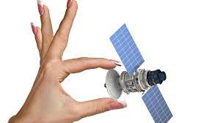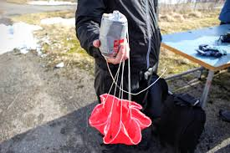

TEAM ORGANISATION
S.No | Member Name | Institute Name | Major | Degree & Year | Title
1 | Junaid Sultan | Indus University | Electronics | B-Tech(Hons)  2010 | Team Leader
2 | Qaisar Khan | SUPARCO Institute of Technical Training(SITT) | Electronics | Intermediate  2024 | Teammate-1
3 | Hamza Ahmed | SUPARCO Institute of Technical Training(SITT) | Electronics | Intermediate  2024 | Teammate-2
4 | Abdul Jabbar | SUPARCO Institute of Technical Training(SITT) | Electronics | Intermediate  2024 | Teammate-3
5 | M.Usmaan | SUPARCO Institute of Technical Training(SITT) | Mechanical | Intermediate  2024 | Teammate-4
6 | Dilawar Khan | SUPARCO Institute of Technical Training(SITT) | Mechanical | Intermediate  2024 | Teammate-5

Team Leader
Mr Junaid Sultan
Mechanics
Descent Control Design,
[
Mechanical Subsystem]
Programming
Communication & Data,
[
Flight Software Design,
Ground Control Subsystem]
Electronics
Sensor
[
Subsystem
,
Electrical Power System]
Muhammad Usman
Hamza Ahmed
Qaisar Khan
Dilawar Khan
Team Leader
Team Leader Team Leader

Faculty advisor
Ms Mehak Fatima

Leader
Mr Musab Dilshad
Leader
Mr Abdul Haseeb
Leader
Mr Umair Siddiqui

Abdul Jabbar
Qaisar Khan
Mechanical Mechanical
z Leader

Acronyms/Abbreviations
Acronyms | Abbreviations | Acronyms | Abbreviations

Mission Description
The 10nd International Iran CanSat Competition contains two classes:
    - Remote Sensing-Communication
    - Scientific-Exploration
Iran CanSat competition provides an opportunity to design, build, and complete the flight mission of CanSat for teams from all over the world. CanSat is a small satellite integrated within the scale of a drink can. Teams can participate in one or both classes. Guidelines for the first class are presented in this document, as our team has decided to participate only in the class.
  - Mission Description
The mission of the Remote Sensing-Communication CanSat is to measure environmental data such as temperature, humidity, and pressure, as well as to take images and send them to the ground station. The mission defined in this competition is data acquisition and image processing by artificial intelligence in the field of agriculture, environment and crisis management. In this mission, CanSat is released over ground targets and it must measure the area of target and detecting their colors by using image processing algorithms. In this regard, detecting targets and their colors must be applied in a semi-automatic or automatic manner.
Note: The CanSat landing mechanism must be designed in such a way that it lands the payload at the closest point to the ground target area.
Our team should measure the distance between the target symbols and their surrounded area (the area within the sides formed by connecting the adjacent vertices) using image processing algorithms performed on the captured images. image processing algorithms can be done on the CanSat or on the ground station.
  - Mission Scenario
The CanSat competition scenario as follows:
    - CanSat is turned on and placed in releaser. Releaser is used for ascending and releasing CanSats and it is provided by competition organizers
    - The ascending CanSat collects mission data such as temperature, pressure, and so on and transmits them to the Ground Station in real-time.
Note 1: Our team should develop and have our own Ground Station.
    - CanSat is released after reaching the specified altitude of the competition. CanSat must also collect and transmit data during the release phase.
    - The descending CanSat must capture images from desired area on the ground using its camera.
These targets must be identified using the images and reported to the ground station during or after the flight.
The area of targets and their colors should be automatically reported by the CanSat.
    - CanSat should have a safe landing using the recovery mechanism after release.
A safe landing at the nearest distance within the area of targets should be considered, should be given to Considering cross-wind or external chaos.
.
    - After reaching the target position, CanSat stops and declares its presence so that it can be tracked.
    - After finding CanSat, it is turned off and the mission is over.
    - Assessment of the results is carried out using observations by the referees choosed by the Compitation Organizers.
Note 2: Using the Internet platform to exchange data between the CanSat and the ground station in each stage of the mission (optional) will have extra scores depending on the quality of the work.
  - OPERATIONAL AND FUNCTIONAL REQUIREMENTS
Capturing at least three images during the CanSat descent and measuring the area of targets and detecting their color.

- Measuring parameters include:
Mandatory:
    - Enclosed area of targets
    - Detecting their colors (presenting the area of targets by inserting the area and color on the image)
    - Air pressure
    - Temperature
    - Height
Optional (with extra scores):
    - Humidity
    - Local or global position of the ground targets
    - Air condition
    - Heading
    - Or any other parameters approved by the referees’ committee
- Sending the image to the ground station and processing it
- Accurate and on-time measurement of parameters
- Sending measured parameters in the requested data format immediately after the measurement
- Valid and reliable telecommunication between Ground Station and CanSat without interference
- Updating data rate at least every second
- Recovering/Retrieving recorded data from memory after the operation
- Appropriate graphical display of received and analyzed data immediately in Ground Station
- Quality and resolution of transmitted and stored images:
    - Images should be completely transmitted in digital format
    - At least three images should be transmitted at the time of descent
    - The images must be compressed using compression methods

1-4 Dimension and Mass Requirements
- The maximum diameter of CanSat should be 66 mm
- The maximum height of CanSat should be 115 mm
- The maximum mass of CanSat should be 350 gr

1-5Radio Frequency Regulation
The communication frequency of the CanSat with the ground station should be in the range of amateur radio frequencies of: 430-440 MHz or 2400 to 2450 MHz. Transmitted power shall be less than 20 dBm (or 100 mW). Also, if using any network-supported communications module, our team should choose a unique random NETID/PANID code.

2-2 Table of Technical Requirements
Technical requirements and their approval methods in the conceptual and preliminary design phase of CanSat are categorized in the following table as an example:
Code | Requirement | Source | Physical specification | Priority | Approval method
 |  |  |  |  | Design review | Test | Analysis | Control
1 | The mass of CanSat must be less than 350 gr | competition | structure | high |  |  |  | 
2 | In classical class, CanSat must fit inside a standard soda can (115 mm height and 66 mm diameter) | competition | structure | high |  |  |  | 
3 | CanSat must be compatible with the ascending system (during ascending, acceleration changes in the design must be considered) | competition | Structure, recovery | high |  |  |  | 
4 | CanSat must land safely to the ground(conditions of descending, acceleration changes, and landing must be considered in design) | mission | recovery | medium |  | 
5 | The use of toxic and flammable materials is not allowed in the design of CanSat | competition | structure | medium |  | 
6 | CanSat must obey the RF regulation | competition | Telecommun  ication | high |  |  | 
7 | CanSat must measure atmospheric parameters | mission | payload | high |  | 
8 | CanSat must collect data related to atmospheric sensor or data in payload such as temperature | mission | Data management and command | high | 
9 | CanSat must transmit GPS data, sensors data, and CanSat health status information | mission | Transmissio n/telecommunication | medium |  | 
10 | CanSat must be in operational status for 90 minutes | Operation concept | power | low |  |  | 
11 | CanSat must be resistant to operation load (launching phase, phase of releasing before  parachute, releasing with a parachute, and landing) | Operation concept | structure | medium |  |  | 
12 | Each CanSat must be equipped with a beacon system to declare its presence at the location | mission | payload | high |  |  | 

SYSTEMS OVERVIEW

Primary Mission CanSat

Power System
Battery 7.4V Li-Ion

Secondary Mission CanSat
Power System
Battery 7.4V Li-Ion

Sensor Subsystem Design
Sensor Subsystem Overview
S.No | Sensor | Model | Function/Purpose | Location
01 | Temperature | BMP-280
02 | Pressure | BMP-280
03 | Altitude | BMP-280
04 | Camera | ESP-32 Cam
05 | Humidity | DHT-11
06 | Positioning & Gyro | MPU-6050  MPU-9250
09 | GPS | NEO-6M
10 | Communication | 3DR Radio V1.3  XBEE

Sensor Subsystem Description
Microcontrollers(ESP-32+Pi Zero)

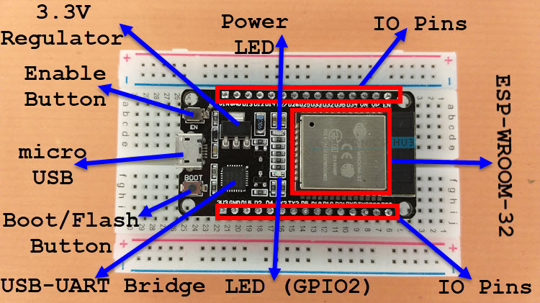
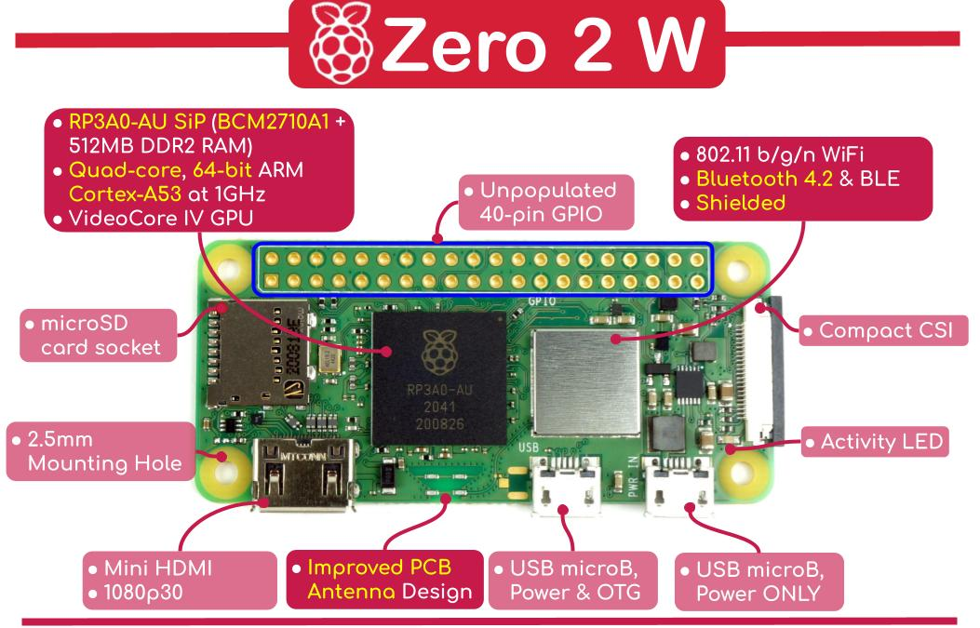
Specifications
ESP-32 Specifications

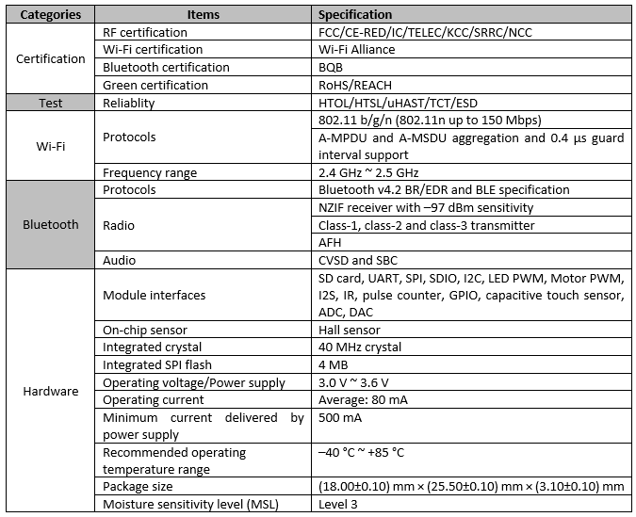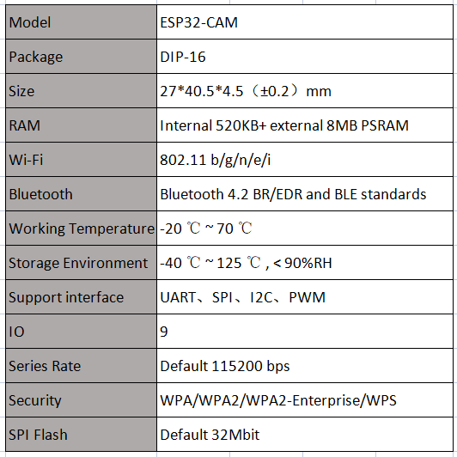

PI-ZER0 2W Specifications
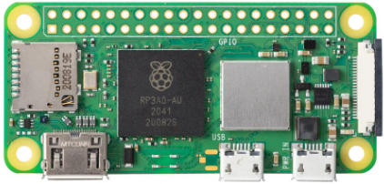
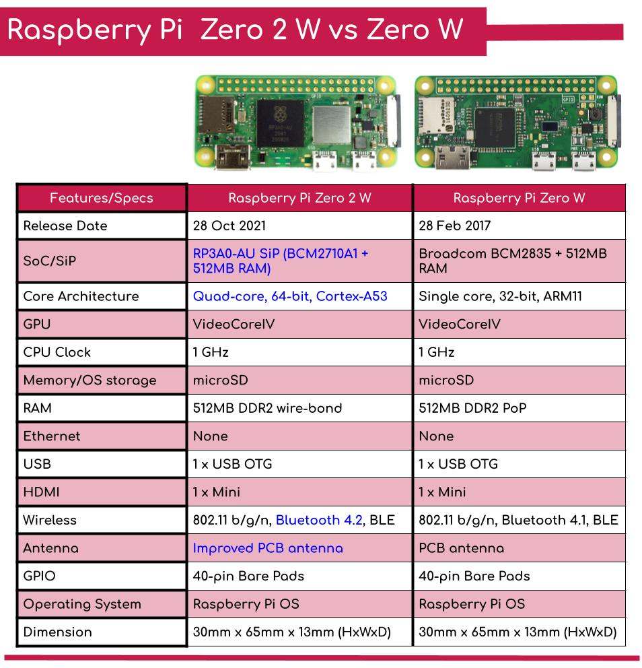
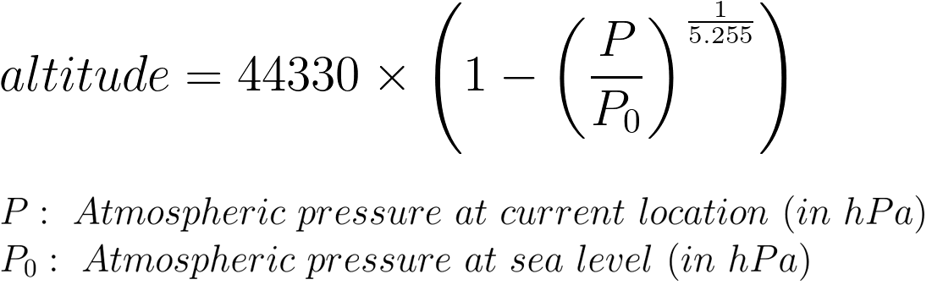
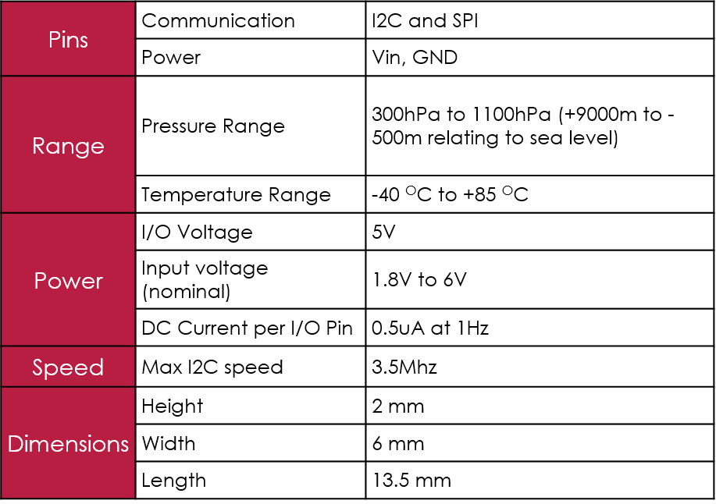
P: measured atmospheric pressure at current location in hPa
P_{O} : absolute pressure above sea level in hPa
Altitude: height of current location of sensor in meters
Altitude can be calculated by putting the value of measured pressure in following formula:
BMP-280 (Temperature + Air pressure Sensor)

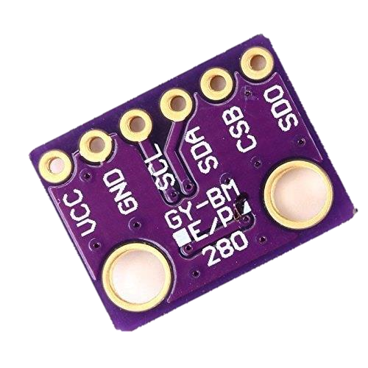

Humidity Sensor (DHT-11)
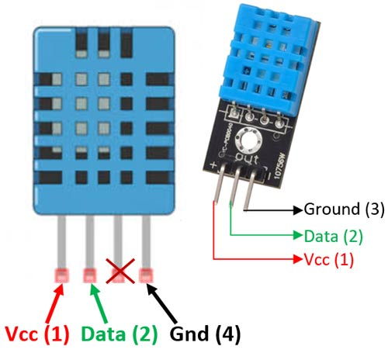
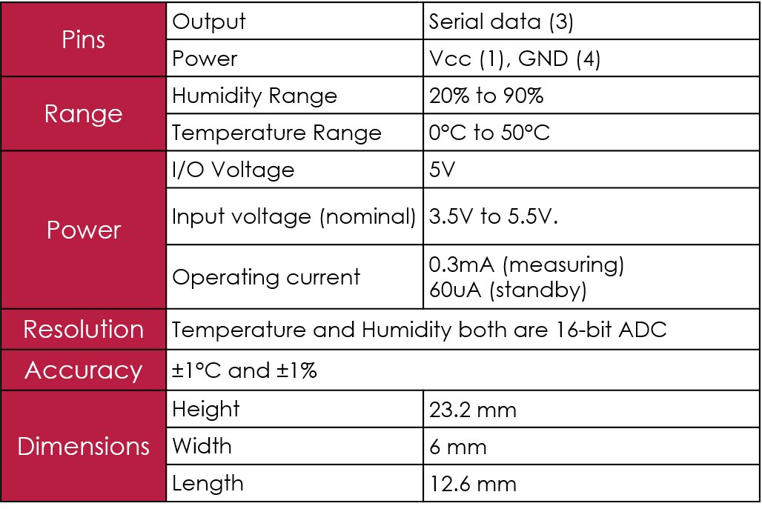

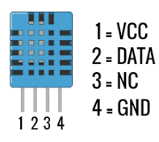

Gyro+Accelerometer Sensor(MPU-6050)
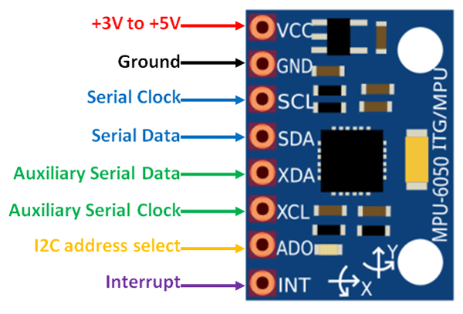
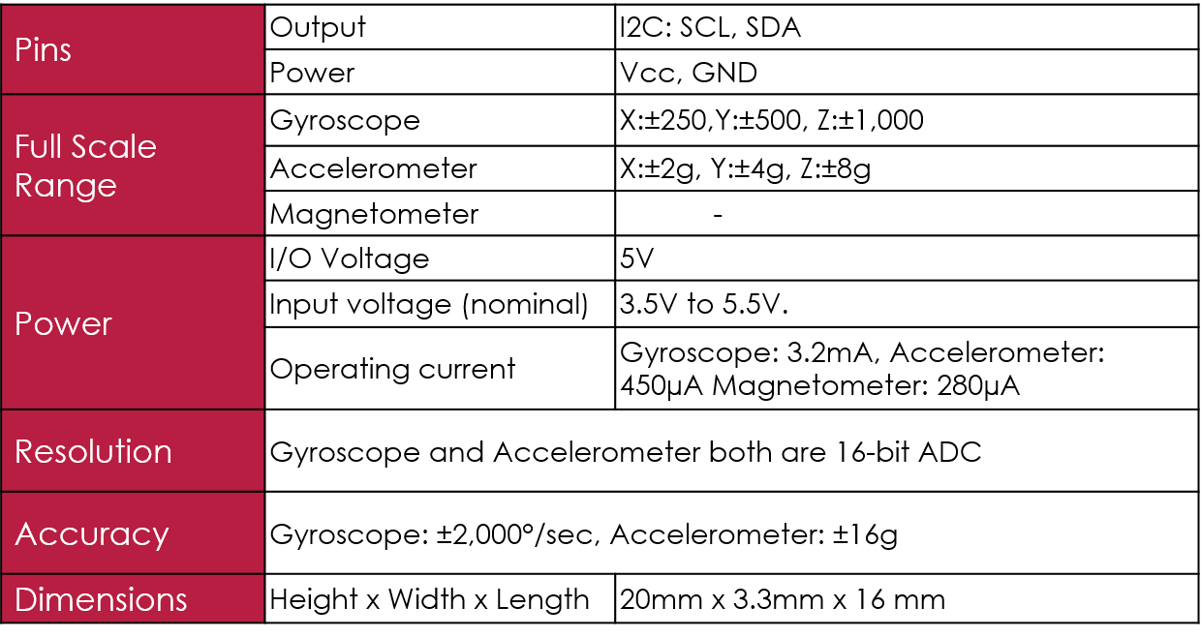

GPS NEO 6-M
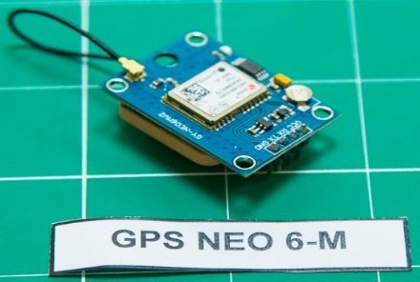
Receiver type: | 50 channels, GPS L1(1575.42Mhz) C/A code, SBAS:WAAS/EGNOS/MSAS
Horizontal position accuracy: | 2.5mCEP (SBAS:2.0mCEP)
cNavigation update rate: | 5Hz maximum (1HZ default)
Capture time: | Cool start: 27s (fastest)；Hot start: 1s
Tracking & Navigation sensitivity: | -161dBm
Communication protocol: | NMEA(default)/UBX Binary
Serial baud rate: | 4800, 9600(default), 19200, 38400, 57600, 115200, 230400
Operating temperature: | -40℃ ~ 85℃
Operating voltage: | 2.7V~5.0V(power supply input via VCC)
Operating current: | 45mA
TXD/RXD impedance: | 510Ohms

COMMUNICATION SENSOR(3DR Radio v1/v1.3)

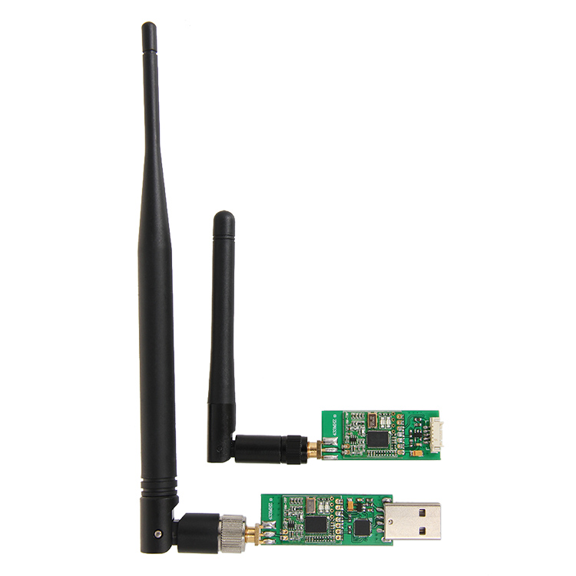

Connecting the radio¶
3DR Radio v1 has different radio modules for air and ground:
- The “ground” module has a USB connector making it easy to connect directly to your ground station. On a windows 7 or higher machine, the require drivers should be automatically installed the first time you plug in the ground module but if it does not install for some reason or the ground computer is running Windows XP (or earlier) you can get the D2XX FTDI driver here.

SPECIFICATIONS

Processing | 100 mW maximum output power (adjustable)
Processing | -117 dBm receive sensitivity
Processing | Based on HopeRF’s HM-TRP module
Processing | RP-SMA connector
Processing | 2-way full-duplex communication through adaptive TDM UART interface
Processing | Transparent serial link
Processing | MAVLink protocol framing
Processing | Frequency Hopping Spread Spectrum (FHSS)
Processing | Configurable duty cycle
Processing | Error correction corrects up to 25% of bit errors
Processing | Open-source SIK firmware
Processing | Configurable through Mission Planner & APM Planner
Features | Interchangeable air and ground modules
Features | Frequency of 915 mHz
Features | Micro-USB port
Features | 6-position DF13 connector
Power | Supply voltage: 3.7-6 VDC (from USB or DF13)
Power | Transmit current: 100 mA at 30 dBm
Power | Receive current: 25 mA
Power | Serial interface: 3.3 V UART
Dimensions | 26.7 cm x 55.5 cm x 13.3 cm (without antenna)
Mass | ~ 50 Grams
Range | ~ 1Km-5Km

Camera Options & Selection
Name | Size  [mm] | Mass  [g] | Operating voltage  [V] | Operating current  [mA] | SD card | Resolution [pixels] | Field of view [°] | Frames per second | Interface | Price [$]
Raspberry Pi Camera | 24  24.5  9 | 3 | 3.3-5.0 | 110 | Yes | 1080  640x480 | 120 | 30  60 | GPIO | 5
ESP-32 Cam(OV5640) | 21  12.5  8.5 | 5 | 3.3-5.0 | 200-300 | Yes | 2592x1944 | 120 | 30  60 | GPIO | 20
Camera  SQ-11 | 45  18  18 | 5 | 3.3-5 | 300 | Yes | 1920x1080 | 140 | 30 | GPIO | 31

Selected Camera | Rationale
Raspberry Pi Camera v.1.3 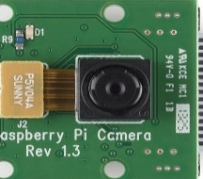 | - Video resolution meets mission requirement  - Able to record the video according to specification in Mission Guide  - Less weight & cheapest  - Smaller size

