Machinelearning

library(dplyr)

##   
## Attaching package: 'dplyr'

## The following objects are masked from 'package:stats':  
##   
## filter, lag

## The following objects are masked from 'package:base':  
##   
## intersect, setdiff, setequal, union

library(ggplot2)  
library(lubridate)

##   
## Attaching package: 'lubridate'

## The following object is masked from 'package:base':  
##   
## date

library(caret)

## Loading required package: lattice

library(randomForest)

## randomForest 4.6-14

## Type rfNews() to see new features/changes/bug fixes.

##   
## Attaching package: 'randomForest'

## The following object is masked from 'package:ggplot2':  
##   
## margin

## The following object is masked from 'package:dplyr':  
##   
## combine

library(rpart)  
library(rpart.plot)  
library(corrplot)

## corrplot 0.84 loaded

data.train<- read.csv("C:\\Users\\CT\\Desktop\\Machine Learning\\pml-training.csv", na.strings = c("NA", "#DIV/0!", ""))  
  
data.test<- read.csv("C:\\Users\\CT\\Desktop\\Machine Learning\\pml-testing.csv", na.strings = c("NA", "#DIV/0!", ""))

Data Understandaing:

dim(data.train)

## [1] 19622 160

Data Transformation : Convert date and add new variable (Day)

data.train$cvtd_timestamp<- as.Date(data.train$cvtd_timestamp, format = "%m/%d/%Y %H:%M")  
data.train$Day<-factor(weekdays(data.train$cvtd_timestamp)) #Add day variable

Exploratory Data Analysis

table(data.train$classe)

##   
## A B C D E   
## 5580 3797 3422 3216 3607

prop.table(table(data.train$classe))

##   
## A B C D E   
## 0.2843747 0.1935073 0.1743961 0.1638977 0.1838243

prop.table(table(data.train$user_name))

##   
## adelmo carlitos charles eurico jeremy pedro   
## 0.1983488 0.1585975 0.1802059 0.1564570 0.1733768 0.1330140

prop.table(table(data.train$user_name,data.train$classe),1)

##   
## A B C D E  
## adelmo 0.2993320 0.1993834 0.1927030 0.1323227 0.1762590  
## carlitos 0.2679949 0.2217224 0.1584190 0.1561697 0.1956941  
## charles 0.2542421 0.2106900 0.1524321 0.1815611 0.2010747  
## eurico 0.2817590 0.1928339 0.1592834 0.1895765 0.1765472  
## jeremy 0.3459730 0.1437390 0.1916520 0.1534392 0.1651969  
## pedro 0.2452107 0.1934866 0.1911877 0.1796935 0.1904215

prop.table(table(data.train$user_name,data.train$classe),2)

##   
## A B C D E  
## adelmo 0.2087814 0.2043719 0.2191701 0.1601368 0.1901857  
## carlitos 0.1494624 0.1817224 0.1440678 0.1511194 0.1688384  
## charles 0.1611111 0.1962075 0.1575102 0.1996269 0.1971167  
## eurico 0.1550179 0.1559126 0.1428989 0.1809701 0.1502634  
## jeremy 0.2109319 0.1287859 0.1905319 0.1623134 0.1558082  
## pedro 0.1146953 0.1329997 0.1458212 0.1458333 0.1377876

prop.table(table(data.train$classe, data.train$Day),1)

##   
## Saturday Thursday  
## A 0.5833804 0.4166196  
## B 0.5600147 0.4399853  
## C 0.5651030 0.4348970  
## D 0.5478220 0.4521780  
## E 0.5581302 0.4418698

qplot(x=Day, fill=classe, data = data.train)

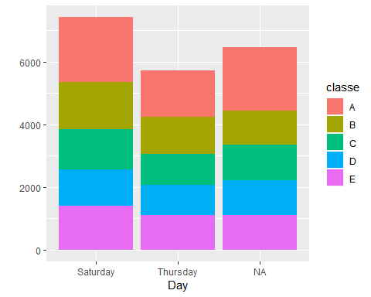

Data Cleaning:

#### Remove columns with NA missing values  
data.train <- data.train[, colSums(is.na(data.train)) == 0]  
data.test <- data.test[, colSums(is.na(data.test)) == 0]   
  
#### Remove columns that are not relevant to accelerometer measurements.  
classe<- data.train$classe  
trainRemove<- grepl("^X|timestamp|window", names(data.train))  
data.train<- data.train[, !trainRemove]  
trainCleaned<- data.train[, sapply(data.train, is.numeric)]  
trainCleaned$classe<- classe  
testRemove<- grepl("^X|timestamp|window", names(data.test))  
data.test<- data.test[, !testRemove]  
testCleaned<- data.test[, sapply(data.test, is.numeric)]

Now, the cleaned data contains 19622 observations and 53 variables for both train and test datasets

Create Train and Test data sets:

set.seed(22519)  
inTrain <- createDataPartition(trainCleaned$classe, p=0.70, list=F)  
trainData <- trainCleaned[inTrain, ]  
testData <- trainCleaned[-inTrain, ]

Data Modelling:

controlRf <- trainControl(method="cv", 5)  
rfmod<- train(classe ~., data=trainData, method="rf", trControl=controlRf, importance=TRUE, ntree=100)  
rfmod

## Random Forest   
##   
## 13737 samples  
## 52 predictor  
## 5 classes: 'A', 'B', 'C', 'D', 'E'   
##   
## No pre-processing  
## Resampling: Cross-Validated (5 fold)   
## Summary of sample sizes: 10989, 10991, 10988, 10989, 10991   
## Resampling results across tuning parameters:  
##   
## mtry Accuracy Kappa   
## 2 0.9902446 0.9876590  
## 27 0.9911181 0.9887647  
## 52 0.9852942 0.9813962  
##   
## Accuracy was used to select the optimal model using the largest value.  
## The final value used for the model was mtry = 27.

Accuacy of the model on Validation data set:

predictRfmod<- predict(rfmod, testData)  
confusionMatrix(testData$classe, predictRfmod)

## Confusion Matrix and Statistics  
##   
## Reference  
## Prediction A B C D E  
## A 1673 0 0 0 1  
## B 7 1128 4 0 0  
## C 0 0 1021 5 0  
## D 0 0 13 950 1  
## E 0 0 1 7 1074  
##   
## Overall Statistics  
##   
## Accuracy : 0.9934   
## 95% CI : (0.991, 0.9953)  
## No Information Rate : 0.2855   
## P-Value [Acc > NIR] : < 2.2e-16   
##   
## Kappa : 0.9916   
## Mcnemar's Test P-Value : NA   
##   
## Statistics by Class:  
##   
## Class: A Class: B Class: C Class: D Class: E  
## Sensitivity 0.9958 1.0000 0.9827 0.9875 0.9981  
## Specificity 0.9998 0.9977 0.9990 0.9972 0.9983  
## Pos Pred Value 0.9994 0.9903 0.9951 0.9855 0.9926  
## Neg Pred Value 0.9983 1.0000 0.9963 0.9976 0.9996  
## Prevalence 0.2855 0.1917 0.1766 0.1635 0.1828  
## Detection Rate 0.2843 0.1917 0.1735 0.1614 0.1825  
## Detection Prevalence 0.2845 0.1935 0.1743 0.1638 0.1839  
## Balanced Accuracy 0.9978 0.9988 0.9908 0.9923 0.9982

accuracy <- postResample(predictRfmod, testData$classe)  
accuracy

## Accuracy Kappa   
## 0.993373 0.991617

Error <- 1 - as.numeric(confusionMatrix(testData$classe, predictRfmod)$overall[1])  
Error

## [1] 0.006627018

So, the estimated accuracy of the model is 99.32% and the estimated out-of-sample error is 0.68%.

Predicting on Test Data Set

result <- predict(rfmod, testCleaned[, -length(names(testCleaned))])  
result

## [1] B A B A A E D B A A B C B A E E A B B B  
## Levels: A B C D E

Correlation Matrix

corrPlot <- cor(trainData[, -length(names(trainData))])  
corrplot(corrPlot, method="circle")

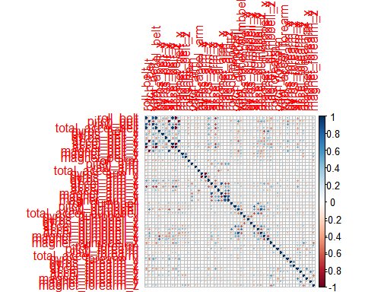 Tree Visualization

rtree<- rpart(classe ~ ., data=trainData, method="class")  
prp(rtree)

