Yarmouk University
Room Reservation System

Phase 1 — Planning Documentation

Version 1.0 | March 2026

Table of Contents
1. Project Overview
2. Objectives
3. Stakeholders
4. Target Users
5. Functional Requirements
6. Non-Functional Requirements
7. Scope Definition
8. Key Features
9. Technical Overview
10. System Architecture Diagram
11. Entity Relationship Diagram
12. Use Case Diagram
13. Reservation Workflow
14. Constraints & Assumptions
15. Risks
16. Timeline
17. Phase 1 Deliverables

1. Project Overview

Project Name
Yarmouk University Room Reservation System (YU-RRS)

Description
YU-RRS is a full-stack web application designed to digitize and streamline the classroom and hall reservation process at Yarmouk University. The system provides an Admin Panel for facility managers and a Doctor Portal for faculty members, enabling end-to-end management of room bookings from request to approval.

Problem Statement
Currently, faculty members at Yarmouk University rely on manual or informal methods (phone calls, paper forms, or email) to reserve lecture halls, labs, and meeting rooms. This results in double-bookings, lack of visibility into room availability, slow approval cycles, and difficulty generating utilization reports for management.

Business Value
- Eliminates scheduling conflicts through real-time availability checking.
- Reduces administrative overhead by automating reservation approval workflows.
- Provides management with actionable analytics on room utilization.
- Improves faculty experience with a self-service portal accessible from any browser.
- Enables data-driven decisions on resource allocation and building planning.

2. Objectives
The following measurable goals define the success criteria for Phase 1:
- Provide a role-based web application accessible to Admin and Doctor user roles.
- Enable real-time room availability search with filtering by date, time, capacity, building, and type.
- Implement a complete reservation lifecycle: Submit → Pending → Approve/Reject → Cancel.
- Give administrators a centralized dashboard to manage buildings, rooms, users, and reservations.
- Provide faculty members with a personal portal including reservations history, calendar view, and smart chatbot.
- Deliver an AI-powered exam seat distribution feature to allocate students across available rooms.
- Generate analytics reports covering room utilization, approval rates, and departmental usage.
- Export reservation data as CSV for offline reporting and record-keeping.

3. Stakeholders
Stakeholder | Role | Primary Interest
University Administration | Sponsor / Decision Maker | Efficient resource management and utilization reports
IT Department (Admin) | System Administrator | Managing buildings, rooms, users, and approvals
Faculty Members (Doctors) | Primary End Users | Quick room booking, availability, personal schedule
Development Team | Builder / Maintainer | Clean architecture, maintainable codebase
Department Coordinators | Indirect Users | Awareness of room availability per department

4. Target Users

Persona 1 — System Administrator (Admin)
- Role: IT staff or facility manager assigned by the university.
- Technical Level: Intermediate — comfortable with web dashboards.
- Goals: Approve/reject reservations quickly, manage room inventory, extract CSV reports, and view analytics.
- Pain Points: Volume of manual requests, double-booking incidents, no visibility into usage patterns.

Persona 2 — Faculty Member (Doctor)
- Role: University professor or lecturer needing a room for classes, exams, or meetings.
- Technical Level: Basic to intermediate — comfortable with email and university portals.
- Goals: Find an available room quickly, submit a booking, track approval status, cancel if needed.
- Pain Points: Not knowing which rooms are free, waiting for manual confirmation, no self-service tool.

5. Functional Requirements

5.1 Authentication & Authorization
- FR-01: Users can register a Doctor account with name, email, password, and department.
- FR-02: Users can log in and receive a JWT token valid for a session.
- FR-03: All API routes are protected; role-based access enforced (Admin vs. Doctor).
- FR-04: Inactive users are blocked from logging in.

5.2 Building Management (Admin)
- FR-05: Admin can create, view, update, and delete buildings.
- FR-06: Each building has a unique code, name, and optional description.

5.3 Room Management (Admin)
- FR-07: Admin can create, view, update, and delete rooms.
- FR-08: Rooms are linked to a building, have a capacity, type, and status.
- FR-09: Room types: lecture_hall, lab, meeting_room, auditorium.
- FR-10: Room status: available, maintenance, occupied.

5.4 Reservation Management
- FR-11: Doctor can search for available rooms filtered by date, time, capacity, building, and type.
- FR-12: Doctor can submit a reservation request (status: pending).
- FR-13: System performs a conflict check — rejects if room is already booked (pending/approved) for overlapping times.
- FR-14: Doctor can view all personal reservations with status indicators and admin notes.
- FR-15: Doctor can cancel future reservations (pending or approved) before the start time.
- FR-16: Admin can view all reservations with filters (status, date range).
- FR-17: Admin can approve or reject a reservation and add notes.
- FR-18: Cancelled reservations show status "cancelled" in the portal.

5.5 Analytics (Admin)
- FR-19: Admin dashboard shows totals: rooms, users, reservations, pending approvals.
- FR-20: Charts display room type distribution, building usage, and departmental breakdown.
- FR-21: Admin can export reservation data as CSV.

5.6 AI Exam Distribution (Admin)
- FR-22: Admin provides total student count and optional building preference.
- FR-23: System uses a greedy algorithm to allocate students across available rooms (largest first).
- FR-24: Result shows each room, allocated count, capacity, utilization percentage, and remaining unallocated students.

5.7 Doctor Portal
- FR-25: Doctor dashboard shows personal reservation stats (total, approved, pending, rejected).
- FR-26: Calendar view shows personal reservations by month.
- FR-27: Chatbot supports natural language queries for availability, reservation history, and general guidance.
- FR-28: Chatbot command /my returns the doctor's latest reservations.
- FR-29: Chatbot command /available <date> <start> <end> <capacity> searches real room availability.

6. Non-Functional Requirements

Performance
- API response time for room availability search: < 500ms under normal load.
- Frontend initial load (Vite production build): < 3 seconds on standard broadband.

Security
- JWT tokens must be validated on every protected API call.
- Passwords stored as bcrypt hashes (cost factor ≥ 10).
- Role authorization enforced server-side; client-side role checks are UI-only.
- No sensitive data (passwords, tokens) logged to console in production.

Scalability
- Database indexed on reservation date, room_id, user_id, and status for query performance.
- Stateless API design allows horizontal scaling behind a load balancer.

Usability
- All user-facing text in the Doctor Portal is in Arabic (RTL support via TailwindCSS).
- Responsive layout — usable on desktop browsers (primary) and tablets.
- Inline error messages and loading states on all forms and data fetches.

Reliability
- Conflict detection prevents double-booking at the database query level.
- API returns structured error JSON with appropriate HTTP status codes (400/401/403/404/409/500).
- Frontend gracefully handles API errors and displays user-friendly messages.

7. Scope Definition

In-Scope (Phase 1)
- User authentication and role-based access control.
- Full CRUD for buildings and rooms (Admin).
- Reservation submission, approval/rejection, and cancellation workflow.
- Room availability search with conflict detection.
- Admin analytics dashboard (summary stats + charts).
- AI-powered exam student distribution.
- Doctor portal: dashboard, find room, my reservations, calendar, chatbot.
- CSV export for reservations.
- Arabic-language UI for Doctor Portal.

Out-of-Scope (Phase 1)
- Real-time push notifications (WebSocket / Server-Sent Events).
- Email or SMS notification system.
- Mobile application (iOS / Android).
- Integration with university LDAP / SSO directory.
- Production deployment, CDN, and monitoring setup.
- Recurring / periodic reservations (weekly schedule blocks).
- QR code check-in system.
- Multi-language support beyond Arabic and English.

8. Key Features
# | Feature | User | Description
1 | Room Availability Search | Doctor | Filter by date, time, capacity, building, room type
2 | Reservation Submission | Doctor | Submit pending request with conflict detection
3 | Reservation Approval | Admin | Approve or reject with optional admin notes
4 | Cancellation | Doctor | Cancel pending or approved future reservations
5 | Analytics Dashboard | Admin | Stats, charts, utilization, export CSV
6 | AI Exam Distribution | Admin | Greedy allocation of students across available rooms
7 | Personal Calendar | Doctor | Monthly calendar view of own reservations
8 | Smart Chatbot | Doctor | NL queries: /my, /available, schedule, availability
9 | User Management | Admin | View users, activate/deactivate accounts
10 | CSV Export | Admin | Download reservations and dashboard data as CSV

9. Technical Overview

Tech Stack
Layer | Technology | Version / Notes
Frontend Framework | React | 19 — with Vite build tool
Styling | TailwindCSS | 3 — utility-first CSS
Calendar Component | FullCalendar | React adapter
Charts | Chart.js + react-chartjs-2 | Bar, Doughnut, Line
Icons | Lucide React + Material Symbols | Outline icons
HTTP Client | Axios | Centralized API service layer
Backend Framework | Express.js | Node.js 18+
ORM | Prisma | MySQL adapter
Database | MySQL | 8.0 — InnoDB engine, utf8mb4
Authentication | JWT + bcryptjs | Stateless token auth
Dev Server | Vite | Proxy /api/* → :5000

Architecture Style
The system follows a classic 3-Tier Architecture: a React SPA (Client), an Express.js REST API (Server), and a MySQL relational database. Communication between layers uses JSON over HTTP. The Vite development server proxies /api/* requests to the backend, and Axios manages all HTTP calls from the frontend through a centralized api.js service file.

Port Configuration
Service | Port | Protocol
React Frontend (Vite Dev) | 3000 | HTTP
Express Backend API | 5000 | HTTP
MySQL Database | 3306 | TCP

10. System Architecture Diagram
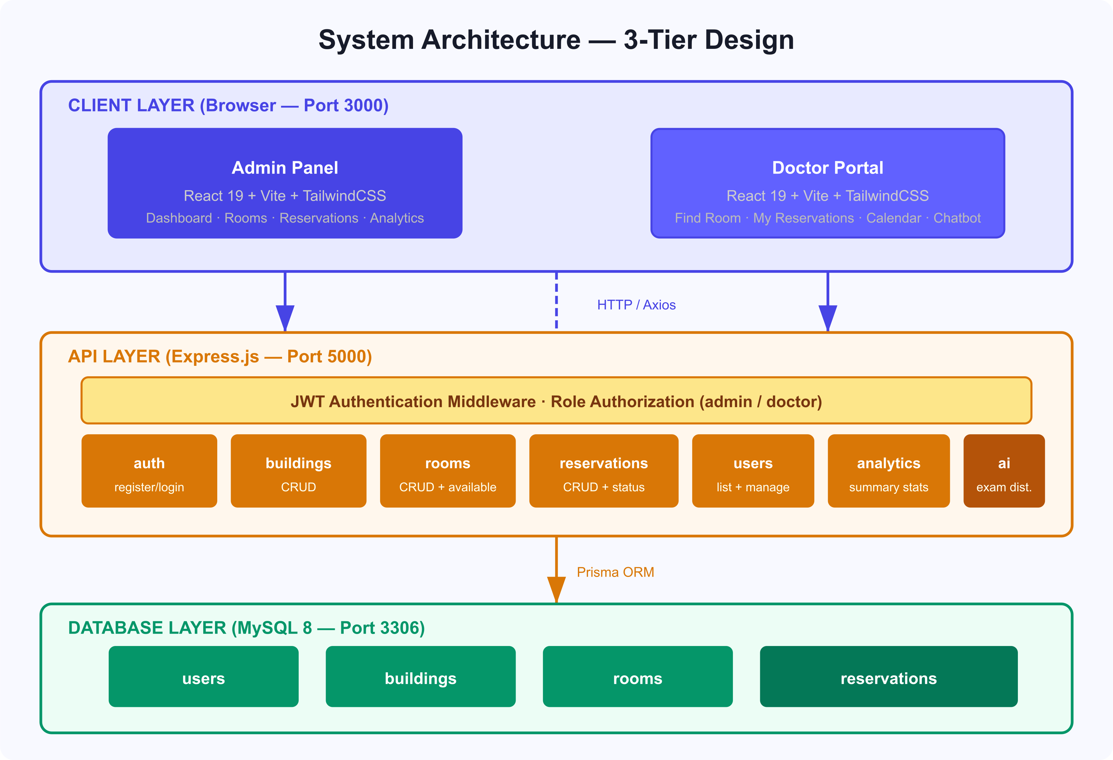
Figure 1 — 3-Tier Architecture: Client Layer (React), API Layer (Express + JWT), Database Layer (MySQL)

11. Entity Relationship Diagram
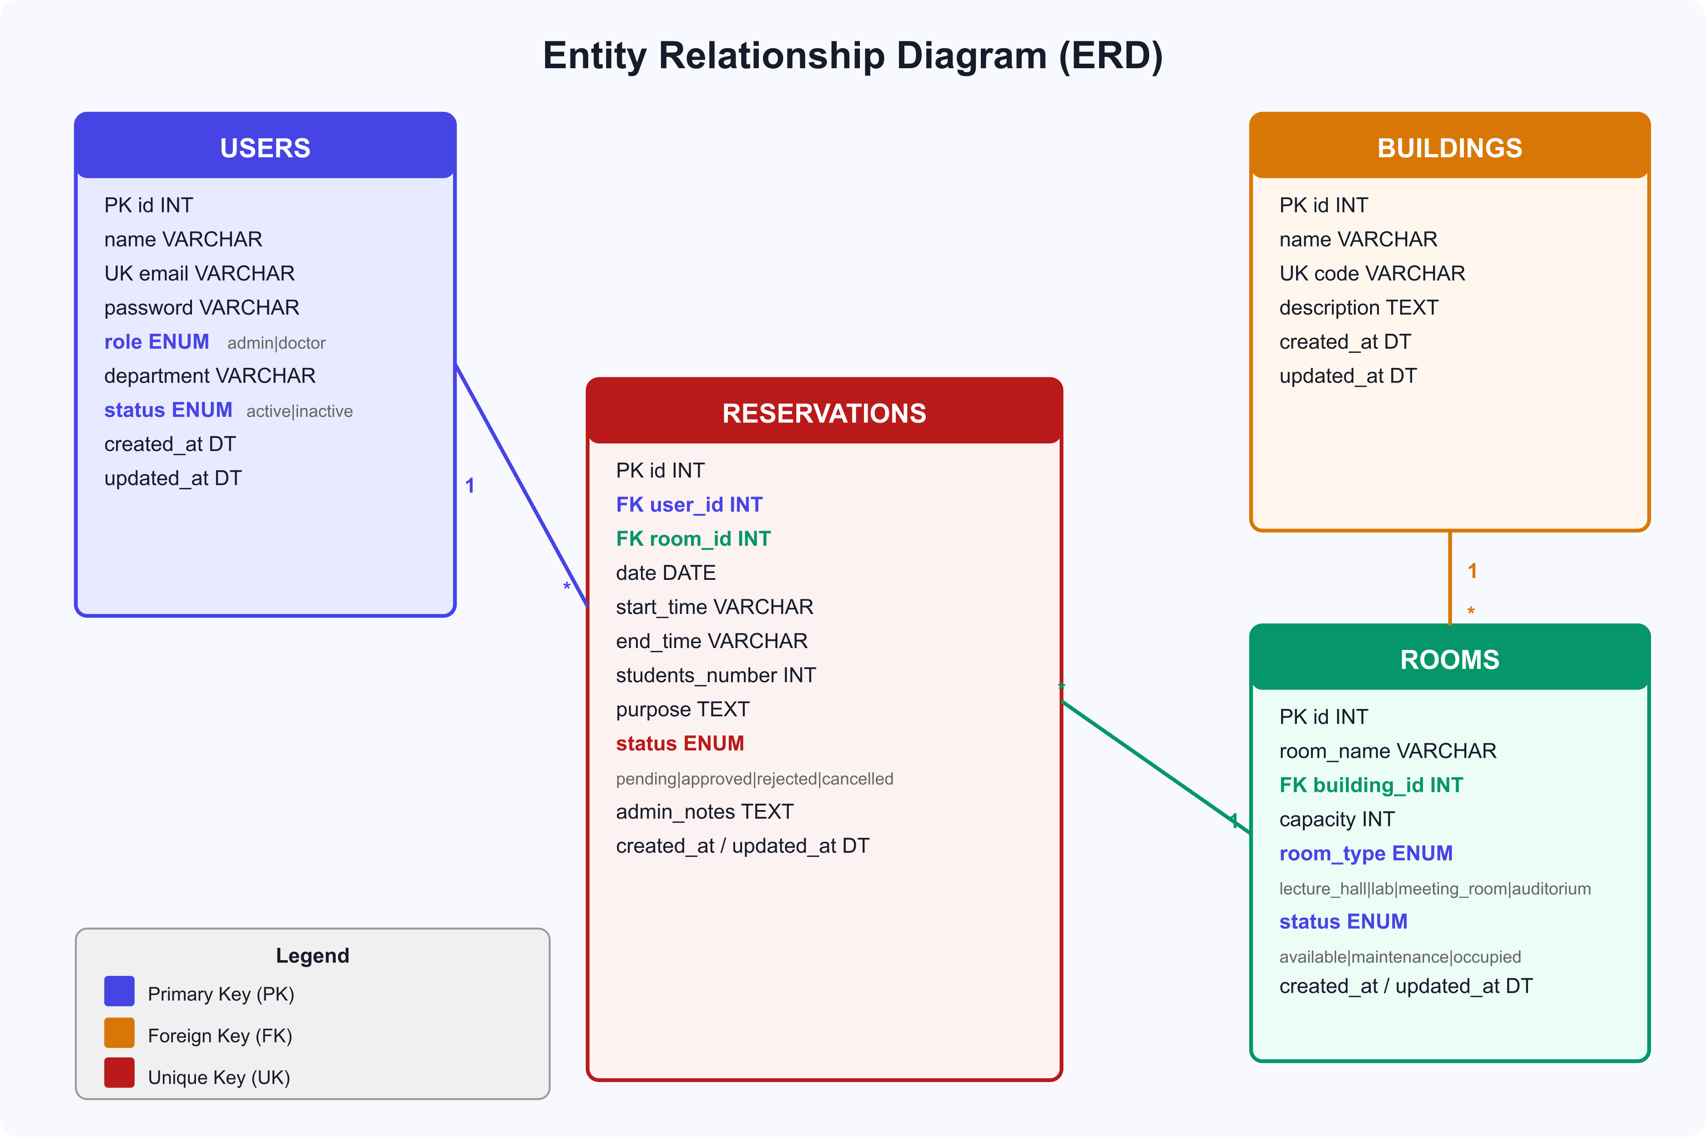
Figure 2 — ERD: 4 entities (users, buildings, rooms, reservations) with FK relationships and enum fields
Key Relationships:
- Users (1) → Reservations (*) — a doctor can have many reservations
- Buildings (1) → Rooms (*) — a building contains many rooms
- Rooms (1) → Reservations (*) — a room can be reserved many times

Reservation Conflict Rule:
- When submitting a reservation, the backend queries for existing reservations on the same room, same date, with overlapping times and status IN (pending, approved). If any match is found, a 409 Conflict is returned.

12. Use Case Diagram
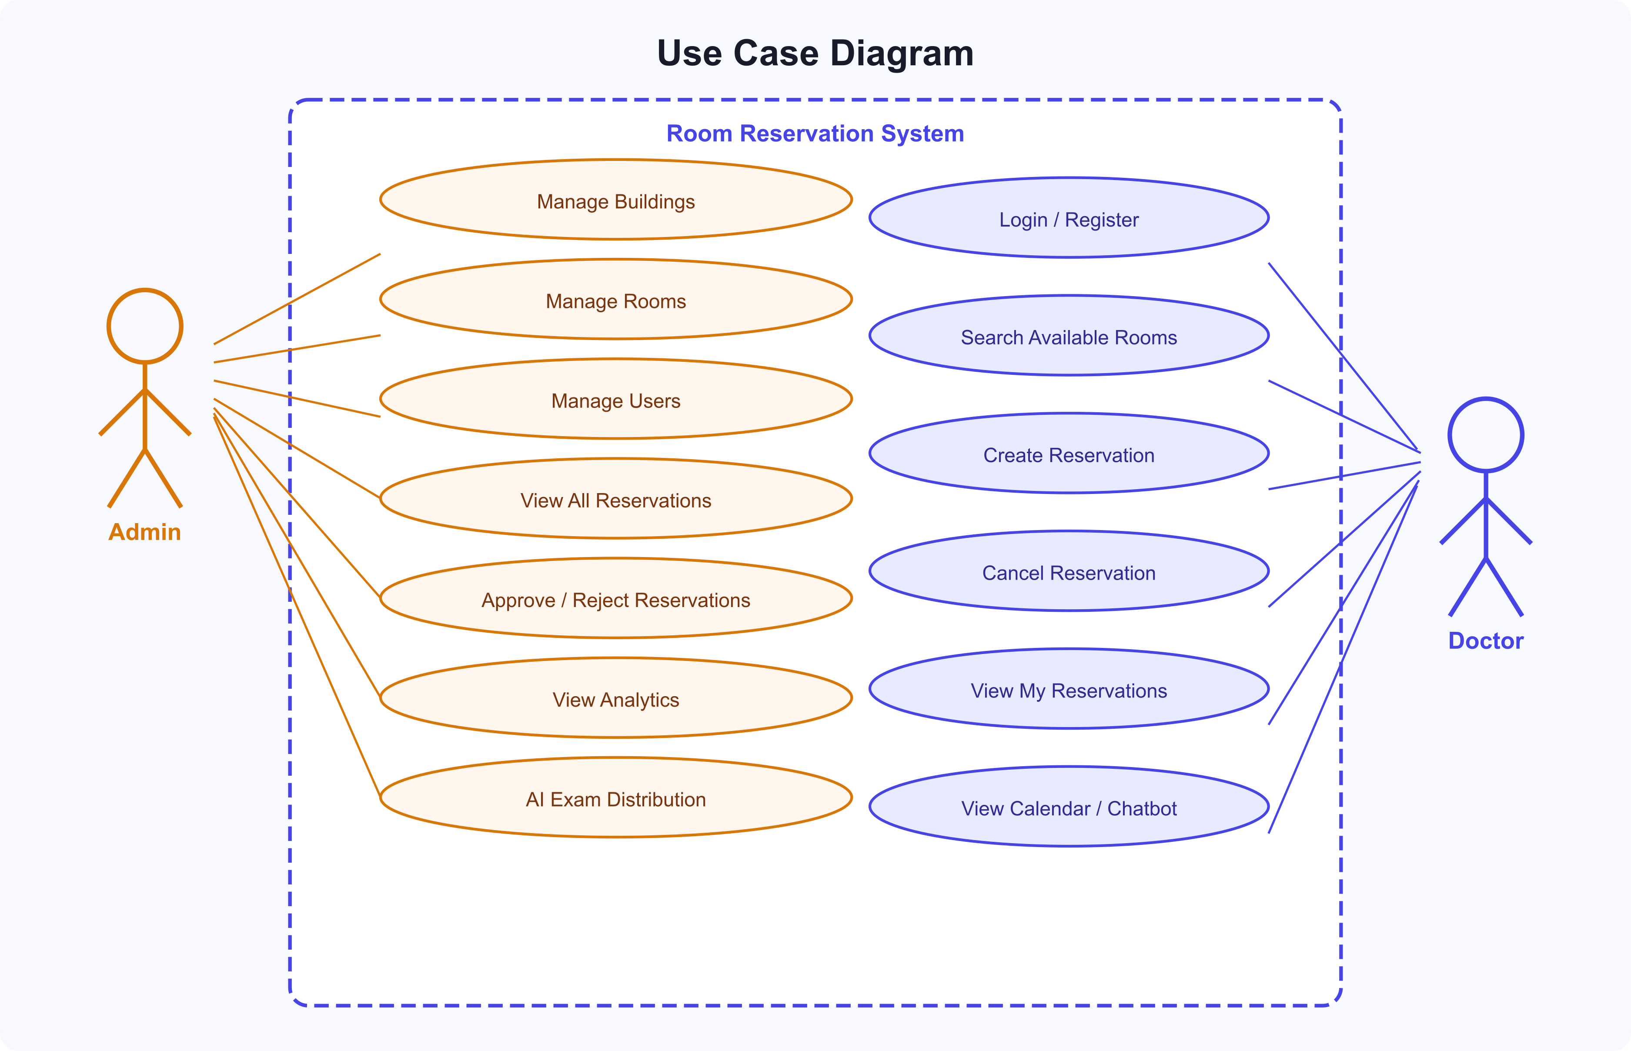
Figure 3 — Use Cases: Admin (left) manages system resources; Doctor (right) manages own reservations

13. Reservation Workflow
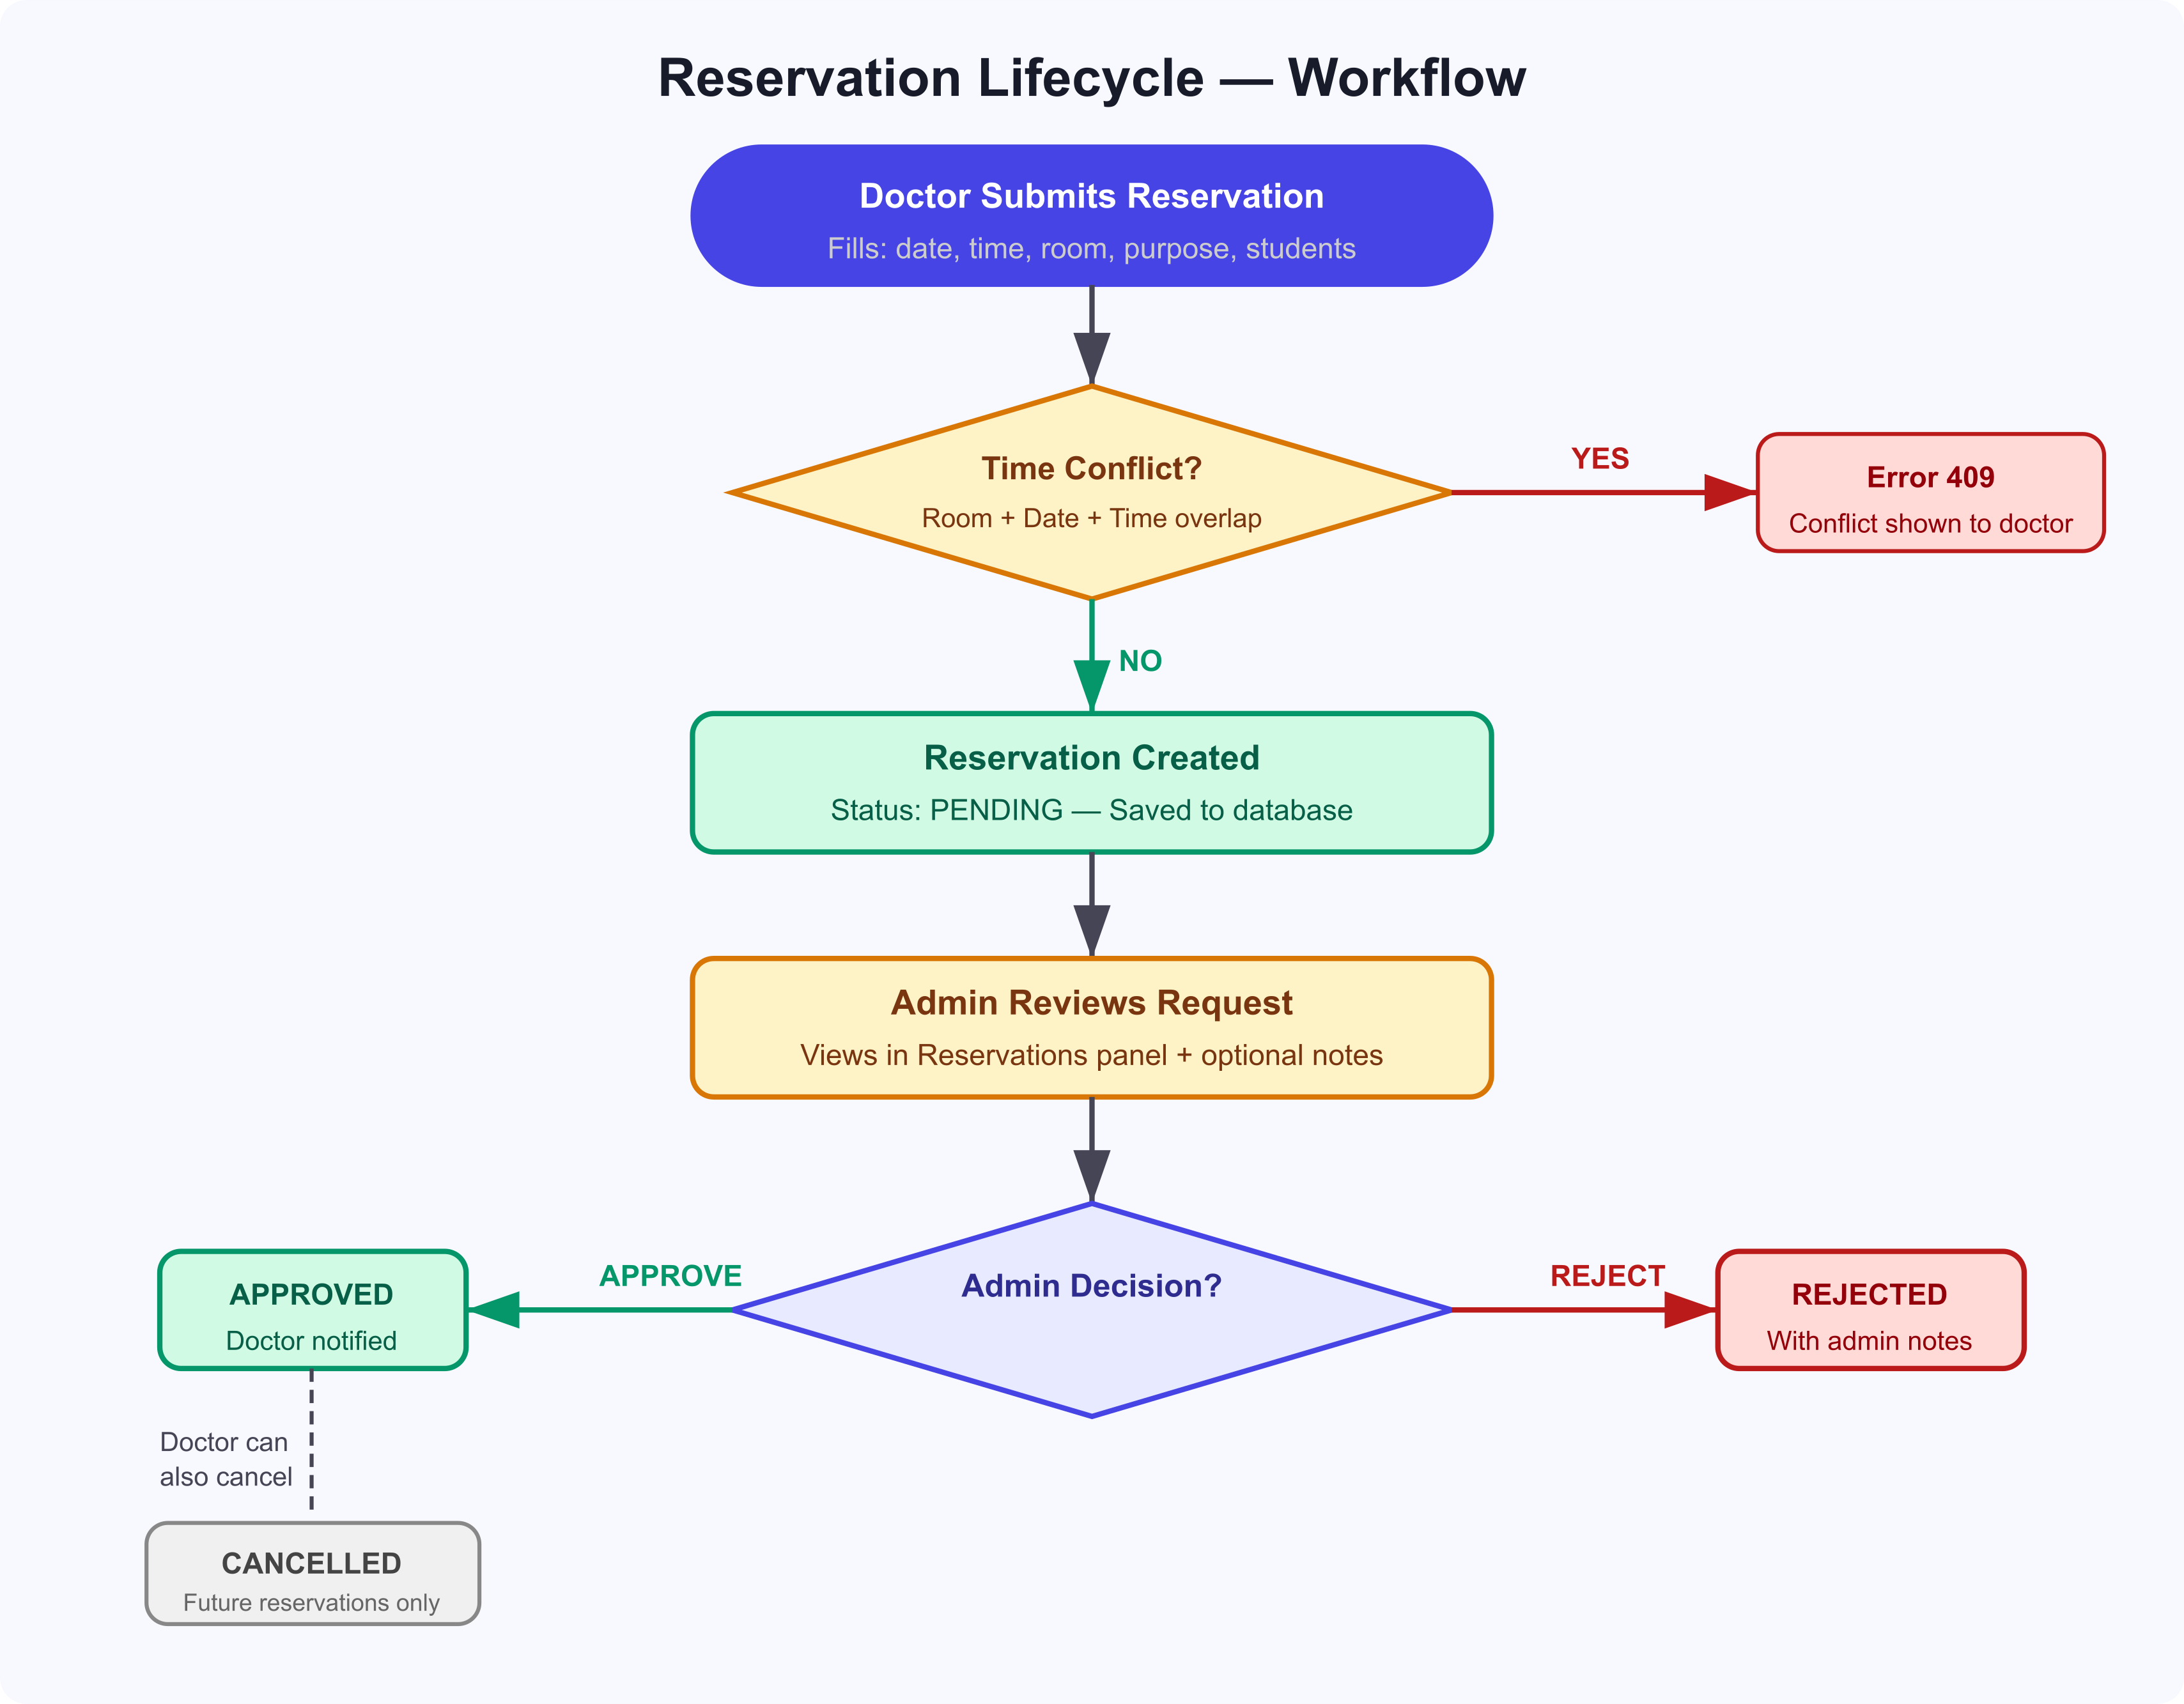
Figure 4 — Reservation Lifecycle: Submit → Conflict Check → Pending → Admin Decision → Approved/Rejected/Cancelled
Step-by-step:
- Step 1: Doctor fills the reservation form (room, date, start/end time, students, purpose).
- Step 2: Backend checks for time conflicts on the selected room. Returns 409 if conflict found.
- Step 3: No conflict → reservation created with status PENDING.
- Step 4: Admin reviews the pending request in the Reservations panel.
- Step 5: Admin approves → status APPROVED; Admin rejects → status REJECTED (with optional notes).
- Step 6: Doctor can cancel any future (upcoming) reservation with status PENDING or APPROVED → status CANCELLED.

14. Constraints & Assumptions

Constraints
- The system is designed for local/university LAN deployment in Phase 1 — no external hosting.
- MySQL 8 and Node.js 18+ must be installed on the host machine.
- XAMPP or equivalent is the assumed local database server on Windows.
- The chatbot uses deterministic rule-based logic — no external AI API is integrated in Phase 1.
- No file upload capability (e.g., room images) is included in Phase 1.

Assumptions
- Each doctor self-registers; the admin can deactivate accounts if needed.
- A single admin account exists by default (seeded). Admin role assignment is done directly in the database.
- The university operates in Arabic (Jordan timezone UTC+3); all dates/times are local.
- Room availability conflicts are checked at the application layer (no database-level time-range locking).
- The Prisma ORM seed script populates representative demo data for testing.

15. Risks
Risk | Likelihood | Impact | Mitigation
Double booking due to race conditions | Low | High | Add database-level unique constraint or pessimistic lock on reservation creation
JWT token theft / XSS attack | Medium | High | Store token in memory (not localStorage) in Phase 2; add Content-Security-Policy headers
Database grows large with no archiving | Low | Medium | Add a soft-delete / archive mechanism for old reservations in Phase 2
User password brute-force | Medium | Medium | Add rate limiting middleware (e.g., express-rate-limit) to /auth/login
Chatbot misinterprets natural language | High | Low | Fallback to generic helpful message; add slash commands (/available, /my) as reliable alternatives
Scope creep from stakeholders | Medium | Medium | Strictly follow Phase 1 scope; log new requests for Phase 2 backlog

16. Timeline — Rough Estimation
Phase | Activities | Duration
Planning (Phase 1) | Requirements gathering, stakeholder interviews, scope definition, this document | 1 week
Design | UI/UX wireframes, DB schema design, API contract definition, architecture decision | 1 week
Development — Backend | Express server, Prisma schema, routes: auth/buildings/rooms/reservations/users/analytics/ai, seed | 2 weeks
Development — Frontend | React app, Admin panel pages, Doctor portal pages, service layer, chatbot | 3 weeks
Integration & Testing | End-to-end flow testing, conflict detection testing, role authorization, CSV export | 1 week
Bug Fixes & Polish | UI polish, Arabic localization, error handling, performance review | 1 week
Delivery / Demo | Final demo, documentation delivery (README, API docs, Phase 1 doc) | 2–3 days

Total estimated duration: ~9 weeks (1 developer). Can be reduced to ~5 weeks with a team of 2–3.

17. Phase 1 Deliverables
- Working full-stack web application (Frontend + Backend + Database) running locally.
- MySQL database with complete schema and representative seed data.
- Admin Panel — fully functional with all CRUD pages, analytics, and exam distribution.
- Doctor Portal — fully functional with room search, reservations, calendar, and chatbot.
- JWT-based authentication with Admin and Doctor roles.
- REST API with all documented endpoints.
- AI Exam Distribution feature (greedy algorithm).
- Smart Chatbot with real-data commands (/my, /available, schedule queries).
- CSV export for reservation data.
- Project documentation:
  - README.md — quick start guide
  - design/API.md — full API reference
  - design/ARCHITECTURE.md — system architecture
  - database/ERD.md — entity relationship documentation
  - database/schema.sql — raw SQL schema
  - design/PHASE1_PLANNING.docx — this document

— End of Phase 1 Planning Documentation —
Yarmouk University Room Reservation System | 2026

