|  |  |
| --- | --- |
|  | Operating System  Assignment # 03 |



|  |  |
| --- | --- |
|  | Merge Sort Using Multi-Threading on 6 cores |
|  | Made by: Instructor: Ma’am Asia Aman |
|  | MUHAMMAD QALB E ALI  200901105 CS-01 B  12/28/22 |

Table of Contents

Code Output: 2

Cores: 3

MAC Address: 4

References: 4

# Code Output:

# Cores:

# MAC Address:

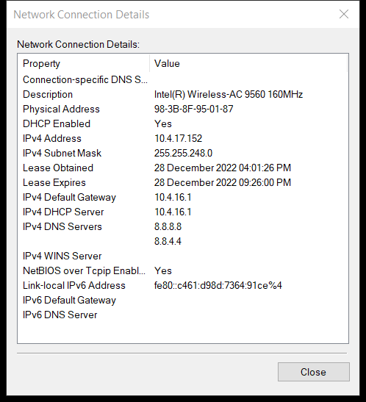

# References:

Code Reference: <https://github.com/kartiksrinivas007/Multithreaded-Merge-Sort>

My GitHub: <https://github.com/Qalb-E-Ali>