INCIDENT RESPONSE & SOC INVESTIGATION CASE STUDY
Suspected Account Compromise and Malware Infection
Incident ID: TN-INC-2026-001
Organization:
TechNova Solutions Ltd.
Prepared by:
Qalbe Raj
Role:
SOC Analyst — Simulated Case Study
Date:
10 September 2026
Classification:
SIMULATED ACADEMIC CASE STUDY

- Project Overview

- This project simulates the role of a Security Operations Center (SOC) Analyst responding to a cybersecurity incident within a fictional organization, TechNova Solutions Ltd.
- The simulated incident involves multiple failed authentication attempts, a successful login, malware alerts on an employee endpoint, suspicious PowerShell activity, and repeated outbound network connections to an external destination.
- The purpose of the investigation is to demonstrate the major activities performed during incident response, including incident identification, classification, evidence analysis, containment, eradication, recovery, documentation, and lessons learned.
- Because the training program did not provide real security logs or incident evidence, all logs, alerts, timestamps, IP addresses, usernames, and other technical indicators used in this project are simulated for educational purposes.
- The investigation follows established incident-response principles, including detection and analysis, response and containment, recovery, and continuous improvement.

- Organization and Security Environment

- TechNova Solutions Ltd. is a fictional technology services organization used for this simulated cybersecurity investigation. The organization has approximately 150 employees and operates a Windows-based corporate environment.
- The environment contains employee workstations, Windows servers, Active Directory, corporate email services, VPN access, a network firewall, endpoint security controls, and centralized security monitoring.
- The SOC is responsible for monitoring authentication activity, endpoint alerts, network traffic, firewall events, malware detections, and suspicious user behaviour.

Component | Description
Active Directory | Centralized user authentication and account management
Windows endpoints | Employee workstations
Firewall | Controls and monitors network traffic
EDR
  Detects suspicious endpoint activity
SIEM | Centralizes and correlates security logs
VPN
  Provides secure remote access
SOC
  Monitors and responds to security events

- Incident Overview
Field | Details
Incident ID | TN-INC-2026-001
Incident Date | 10 September 2026
Severity
  High
Affected User | john.mwangi
Department | Human Resources
Hostname | TN-HR-023
Operating System | Windows 11
Internal IP | 10.10.20.23
Incident Type | Suspected account and endpoint compromise
Status
  Under Investigation
Evidence | Simulated logs and alerts

The incident began with repeated authentication failures against the account john.mwangi. A successful authentication subsequently occurred from the same source address. Several minutes later, the associated endpoint generated alerts involving a suspicious document, malicious macro behaviour, PowerShell execution, and malware. Repeated outbound network connections from the endpoint were subsequently observed.

- Incident Identification

Authentication Activity
The authentication logs show five consecutive failed login attempts against the john.mwangi account between 09:12:14 and 09:13:22. All attempts originated from the same simulated external IP address, 185.220.101.45. At 09:14:03, a successful authentication was recorded from the same source.
Then:
The pattern is suspicious because multiple failed attempts were followed by a successful authentication. This could indicate password guessing, credential stuffing, or use of previously compromised credentials. Additional authentication context would be required to determine the exact technique.

4.2 Endpoint Activity
Explain the document → macro → PowerShell → malware sequence.

  - Network Activity
Explain the repeated outbound connections.

4.4 Correlation
Individually, each alert could have a benign explanation. However, when the authentication, endpoint, and network events are correlated chronologically, they form a consistent pattern indicating a likely compromise of the user account and endpoint.

- Incident Classification
Category | Assessment | Reason
Brute Force | Suspected | Multiple failed authentication attempts followed by success
Malware | Likely | EDR reported malware detection
Insider Threat | Not indicated | No evidence of intentional employee activity
Data Breach | Not confirmed
  No direct evidence of data exfiltration
- High-Severity Suspected Endpoint Compromise Involving Credential Attack Activity and Malware

- Attack Chain
Phishing Email

User Interaction

Credential Compromise

Authentication Attempts

Successful Login

Malicious Document

PowerShell Execution

Malware Detection

Suspicious Traffic

SOC Detection

- Investigation Methodology

- Review authentication logs.
- Identify unusual login patterns.
- Correlate successful authentication.
- Review EDR alerts.
- Identify suspicious processes/files.
- Review firewall traffic.
- Identify IOCs.
- Build timeline.
- Determine scope.
- Recommend containment.

- IOC Analysis

- An Indicator of Compromise (IOC) is a piece of observable information that may indicate malicious activity or compromise, such as an IP address, domain, file hash, filename, account, process, or other artifact.
IOC Type | Indicator | Associated Asset | Significance | Recommend Action
IP Address | 185.220.101.45 | AD-SERVER / john.mwangi | Source of repeated authentication attempts | Investigate and block if confirmed malicious
IP Address | 91.214.124.77 | TN-HR-023 | Suspicious outbound destination | Investigate and block if confirmed malicious
Hostname | TN-HR-023 | HR workstation | Potentially compromised endpoint | Isolate and investigate
Username | john.mwangi | Active Directory | Potentially compromised endpoint | Reset credentials and investigate
File | Invoice_September.docm | TN-HR-023 | Suspicious document | Preserve and analyze
File | update.ps1 | TN-HR-023 | Suspicious PowerShell script | Quarantine and investigate
Process | powershell.exe | TN-HR-023 | Potential malicious execution | Investigate command/process lineage

- Incident Timeline

Time | Event | Evidence Source | Analyst Interpretation | Action
09:12:14 | Failed login | Authentication logs | Possible credential attack | Monitor
09:12:31 | Failed login | Authentication logs | Repeated authentication failure | Correlate
09:12:48 | Failed login | Authentication logs | Suspicious pattern developing | Investigate
09:13:05 | Failed login | Authentication logs | Possible brute-force activity | Investigate
09:13:22 | Failed login | Authentication logs | Five consecutive failures | Escalate
09:14:03 | Successful login | Authentication logs | Potential account compromise | Investigate immediately
09:18:42 | Suspicious document detected | EDR | Possible malicious attachment | Escalate
09:19:07 | Malicious macro behaviour | EDR | Potential execution of malicious code | Contain
09:20:15 | PowerShell activity | EDR | Potential malicious execution | Investigate
09:22:34 | Malware detected | EDR | Endpoint potentially compromised | Isolate
09:23:11 | Outbound connection | Firewall | Suspicious external communication | Investigate
09:24:02 | Outbound connection | Firewall | Repeated external communication | Monitor
09:25:17 | Outbound connection | Firewall | Potential C2 activity | Contain
09:27:45 | Outbound connection | Firewall | Continued communication | Block/isolate
09:29:03 | Outbound connection | Firewall | High-risk repeated communication | Escalate

- MITRE ATT&CK

Technique | ID | Evidence
Brute Force | T1110 | Multiple failed authentication attempts
Valid Accounts | T1078 | Successful authentication using employee account
User Execution | T1204
  Malicious document opened by user in scenario
Power Shell
  T1059.001
  PowerShell activity detected
Application Layer Protocol | T1071 | HTTPS outbound communication, if supported by evidence

- Containment Strategy

- Immediate containment
- Isolate TN-HR-023.
- Disable or temporarily lock john.mwangi.
- Reset the user's password.
- Revoke active sessions where applicable.
- Block suspicious network indicators after validation.
- Preserve logs.
- Search other endpoints for the same indicators.
- Check for lateral movement.

- Eradication

- Quarantine malware.
- Remove malicious files.
- Investigate PowerShell execution.
- Identify persistence.
- Patch vulnerabilities.
- Reset credentials.
- Scan the endpoint.
- Search other endpoints for IOCs.
- Rebuild/reimage if system integrity cannot be trusted.

- Recovery
- Verify the endpoint is clean.
- Restore/reimage if required.
- Apply security updates.
- Restore necessary user data from trusted sources.
- Reconnect the endpoint.
- Monitor the endpoint.
- Monitor the account.
- Confirm no further suspicious network traffic.
- Close the incident only after validation.

14. Root Cause Analysis
Confirmed from simulated evidence:
- Repeated authentication failures
- Successful authentication
- Suspicious document
- PowerShell activity
- Malware detection
- Suspicious outbound traffic

Likely cause:
Phishing-assisted credential compromise followed by malicious document execution.

Still requiring investigation:
- Whether credentials were actually stolen through phishing
- Whether data was exfiltrated
- Whether other endpoints were compromised
- Whether lateral movement occurred

  - Lessons Learned

• MFA should be enabled.
• Authentication monitoring should be improved.
• Email attachments should be inspected/sandboxed.
• EDR is important.
• PowerShell activity should be monitored.
• Network traffic should be correlated with endpoint alerts.
• Employees need phishing awareness training.
• Least privilege should be enforced.
• Security logs should be centralized.

  - Preventive Action Plan

Finding | Risk | Recommendation | Priority
No evidence of MFA | Account Compromise | Implement MFA | Critical
Repeated Login Attempts | Brute-force Risk | Account lockout | High
Malicious Attachement | Malware Risk | Email Filtering | High
PowerShell Execution | Code Execution Risk | PowerShell  Monitoring | High
Endpoint Compromise | Malware Risk | EDR | Critical
Limited Correlation | Delayed Detection | SIEM | High
Potential Lateral Movement | Wider Compromise | Network  Segmentation | High
Credential Compromise | Unauthorized Access | Pssword Reset | Critical
User Interaction with Malicious Content | Phishing Risk | Security Awareness Training | Medium

  - Incident Response Lifecycle

Preparation

Detection & Analysis

Containment

Eradication

Recovery

Lessons Learned

Improvement

  - Conclusion
• The account was targeted.
• Successful authentication occurred.
• Malware was detected.
• The endpoint showed suspicious outbound communication.
• The events were correlated.
• The endpoint/account should be contained.
• Data breach wasn't confirmed.
• Preventive controls should be implemented.

  - References
- NIST SP 800-61 Rev. 3 — Incident Response Recommendations and Considerations for Cybersecurity Risk Management
- NIST SP 800-61 Rev. 3
- Also add:
- MITRE ATT&CK
- MITRE ATT&CK

20. Evidence
Evidence 1: Authentication Logs

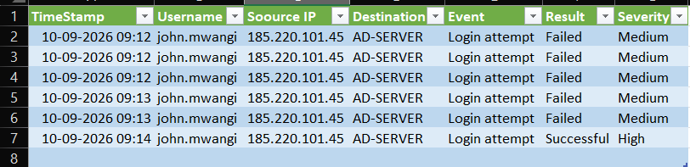

Evidence 2: Endpoint Alerts
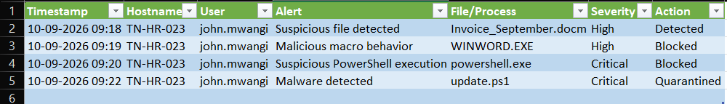

Evidence 3: Firewall Logs
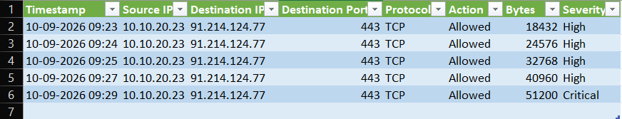

Evidence 4: IOC Register
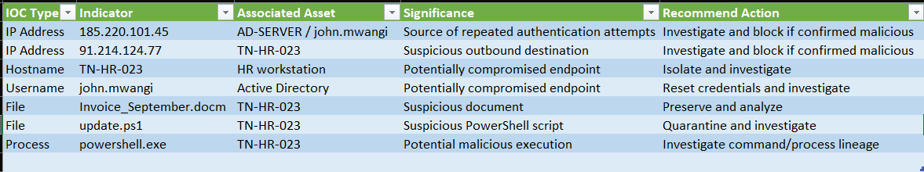

Evidence 5: Incident Timeline
