BAHRIA UNIVERSITY KARACHI CAMPUS
DEPARTMENT OF COMPUTER SCIENCE


Artificial Intelligence Lab (CSL-411)
BSIT-6A Fall 2025
AI-Based Financial Fraud Detection System

Submitted by:
Syed Qambar Ali Shah (02-235231-006)
Muhammad Usman Shamsi (02-235231-047)
Laiba Bashir Abbasi (02-235231-016)
Submitted To:
Ms Madiha Aslam
Submitted On:
December 22, 2025

Acknowledgement
We would like to express our sincere gratitude to Ms. Madiha Aslam, Lab Engineer of the Artificial Intelligence Lab (CSL-411), for her continuous guidance, support, and valuable suggestions throughout the completion of this semester project.
We would like to express our sincere gratitude to our course instructor for providing continuous guidance, valuable suggestions, and constructive feedback throughout the development of this project. We are also thankful to the department for providing the academic resources and laboratory facilities necessary for successful project completion. We would like to acknowledge the support of my classmates for their cooperation and discussions.

Abstract
The rapid expansion of online banking and digital payment platforms has led to a significant rise in financial fraud incidents. Traditional fraud detection systems, which rely on static rules and manual verification, are increasingly ineffective against evolving fraud techniques. This project presents an AI-based Financial Fraud Detection System that employs supervised machine learning algorithms, namely Artificial Neural Network (ANN) and Decision Tree (DT), to identify fraudulent transactions. The system performs data preprocessing, class balancing, model training, and evaluation using metrics such as accuracy, precision, recall, F1-score, ROC curve, and AUC. A Tkinter-based graphical user interface allows real-time fraud prediction. The comparative analysis demonstrates that machine learning-based approaches significantly enhance fraud detection accuracy and reliability

Table of Contents

Acknowledgement 2
Abstract 3
1. Introduction 5
2. Problem Statement 5
3. Existing Systems 5
Comparison with Proposed System 6
4. Objectives and Goals 6
5. Project Scope 6
6. Workflow (UML Representation) 7
7. Overview of Project 9
8. Tools and Technologies 10
9. Project Features 10
Functional Requirements 10
Non-Functional Requirements 11
10. Course Implemented Concepts 11
11. Output 14
12. Future Work 18
13. Conclusion 19
14. References 19

1. Introduction
Financial fraud has become a major concern for modern financial institutions due to the increasing use of electronic transactions, online banking, and digital wallets. Fraudsters continuously adopt sophisticated techniques to exploit system vulnerabilities, making fraud detection a complex task. Manual monitoring and traditional detection techniques are inefficient when dealing with large volumes of transaction data. Machine learning provides intelligent and automated solutions by learning hidden patterns from historical data. This project focuses on designing a machine learning-based fraud detection system and comparing the performance of Artificial Neural Networks and Decision Tree algorithms.

2. Problem Statement
Existing fraud detection systems rely heavily on predefined rules, static thresholds, and manual inspection. Such approaches are unable to adapt to new fraud patterns, resulting in delayed detection and high false-positive rates. Moreover, these systems lack scalability and real-time decision-making capabilities. Therefore, there is a need for an intelligent, automated, and scalable fraud detection system that can accurately identify fraudulent financial transactions with minimal human intervention.

3. Existing Systems
Current fraud detection mechanisms include rule-based systems, statistical analysis methods, and manual audits. Rule-based systems require constant updates and fail to detect unknown fraud patterns. Statistical techniques are limited in capturing complex relationships among transaction attributes. Manual audits are time-consuming and prone to human error. In contrast, machine learning-based systems learn from historical data, adapt to changing patterns, and provide improved detection accuracy with reduced false alarms.

Comparison with Proposed System

Feature | Existing System | Proposed System
Detection Method | Rule-based | Machine Learning
Adaptability | Low | High
Real-time Detection | No | Yes
Accuracy | Moderate | High
Model Comparison | Not Available | ANN vs DT

4. Objectives and Goals
The main objectives of this project are:
- To develop an AI-based financial fraud detection system
- To preprocess and balance transaction data effectively
- To implement and compare ANN and Decision Tree models
- To evaluate model performance using standard metrics
- To provide real-time fraud prediction through a GUI
- To visualize results for better interpretability

5. Project Scope
The scope of this project includes the analysis of historical transaction data to detect fraudulent activities using supervised machine learning techniques. The system is designed for academic and experimental purposes. While it is not directly integrated with live banking systems, it provides a strong foundation that can be extended to real-world financial environments with larger datasets, real-time data streams, and advanced machine learning models

6. Workflow (UML Representation)
The following activity diagram illustrates the overall workflow of the proposed AI-based financial fraud detection system. It represents the sequential flow of operations starting from loading the transaction dataset to performing real-time fraud prediction. The diagram highlights key stages such as data preprocessing, class balancing, model training, evaluation, and user interaction through the graphical interface.
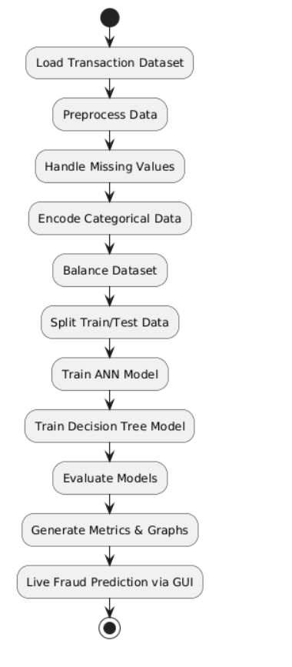
Figure 1: Activity Diagram of Financial Fraud Detection System Workflow

The sequence diagram below demonstrates the interaction between the user, graphical user interface, preprocessing module, and machine learning models during the fraud prediction process. It clearly shows how transaction details provided by the user are processed and passed to the ANN and Decision Tree models, and how the final prediction result is returned and displayed.
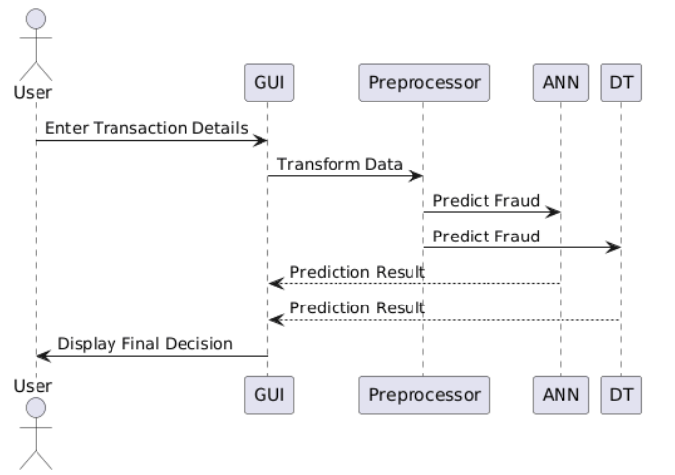
Figure 2: Sequence Diagram for Fraud Prediction Process
The following component diagram presents the high-level architecture of the proposed financial fraud detection system. It illustrates the major system components, including the user interface, data preprocessing module, machine learning models, and data layer, along with their interconnections. This diagram helps in understanding the structural organization of the system.
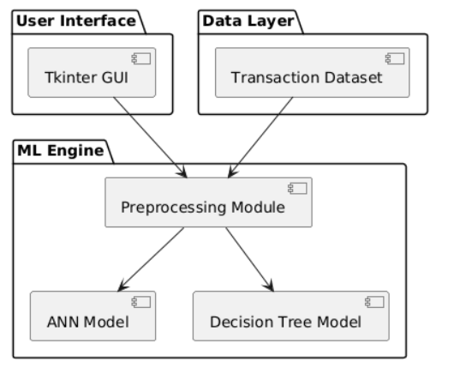
Figure 3: Component Diagram of AI-Based Fraud Detection System

The activity diagram below explains the model training and evaluation workflow implemented in this project. It highlights how machine learning concepts such as dataset handling, class balancing, model training, and performance evaluation are practically applied using Artificial Neural Network and Decision Tree algorithms.
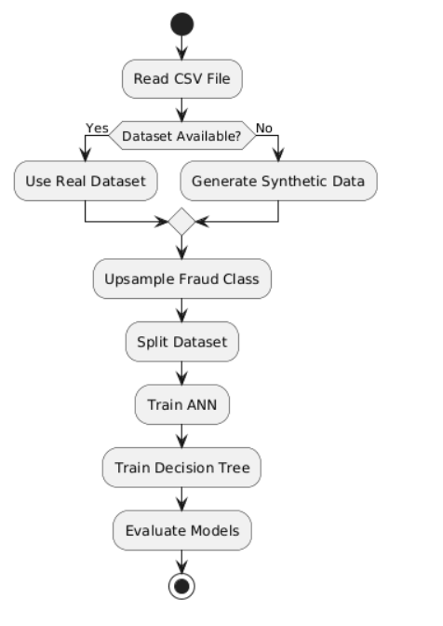
Figure 4: Activity Diagram of Model Training and Evaluation Process

7. Overview of Project
The proposed system consists of multiple components, including data preprocessing modules, machine learning models, evaluation mechanisms, and a user interface. Numerical transaction attributes are normalized, while categorical attributes are encoded using one-hot encoding. The system trains ANN and Decision Tree models and compares their performance. A Tkinter-based GUI allows users to input transaction details and receive instant fraud predictions along with model outputs.

8. Tools and Technologies
Category | Tools / Libraries Used | Purpose
 |  | Core language for system development
  Programming Language
  Python
Data Handling | Pandas, NumPy | Data loading, preprocessing, numerical operations
Machine Learning | Scikit-learn | ANN (MLPClassifier), Decision Tree, Logistic Regression
Model Utilities | Joblib, Cloudpickle, Threadpoolctl | Model saving, loading, and training optimization
Explainable AI | SHAP, Slicer | Feature-level explanation of predictions
Visualization | Matplotlib, Seaborn | ROC curves, confusion matrices, performance graphs
GUI Framework | Tkinter, CustomTkinter | Desktop-based user interface
UI & Graphics Support | Pillow, DarkDetect | Image handling and dark mode support
Scientific Computing | SciPy, Numba | Mathematical and performance optimization tasks
Utility Libraries | TQDM, Typing-Extensions, Six | Progress tracking and code compatibility

9. Project Features

Functional Requirements
- Load and preprocess transaction data
- Handle missing values and class imbalance
- Train ANN and Decision Tree models
- Evaluate models using performance metrics
- Perform real-time fraud prediction
- Display graphical results

Non-Functional Requirements
- Accuracy and reliability
- Scalability
- User-friendly interface
- Efficient processing

10. Course Implemented Concepts
This project implements several core concepts of Machine Learning and Artificial Intelligence, including supervised learning, feature scaling, one-hot encoding, data imputation, class imbalance handling, model evaluation metrics, ROC analysis, and GUI-based system development. The practical implementation of these concepts strengthens theoretical knowledge gained during the course
Algorithms (ANN, DT, LR)
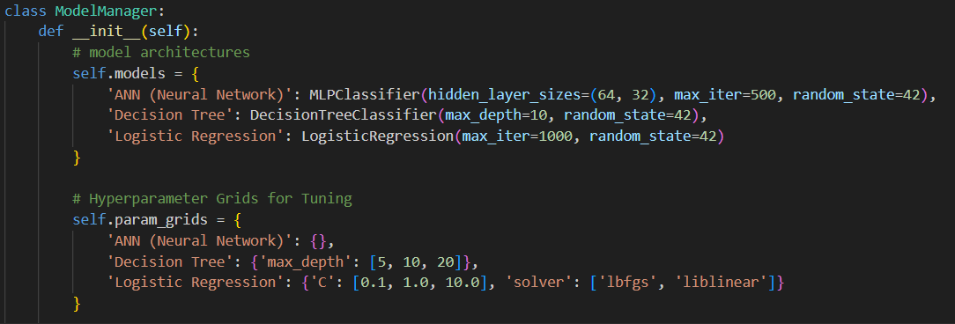

Models Training
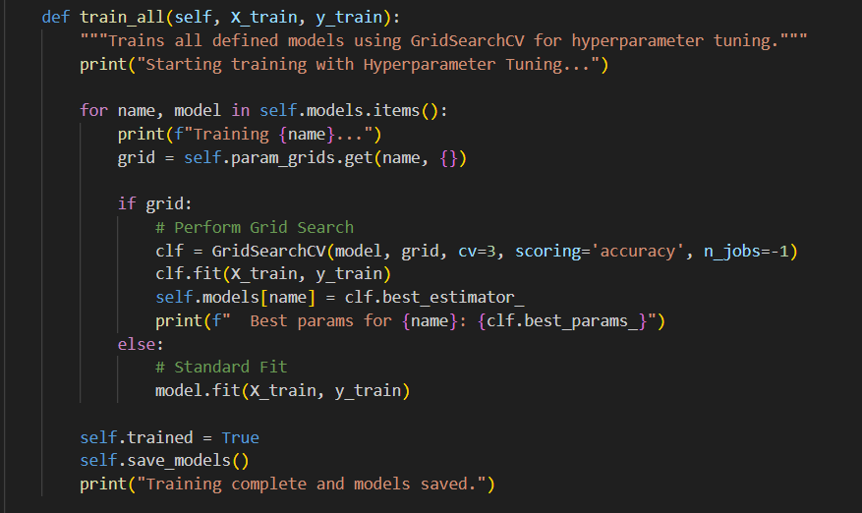
Data Preprocessing and Feature Engineering
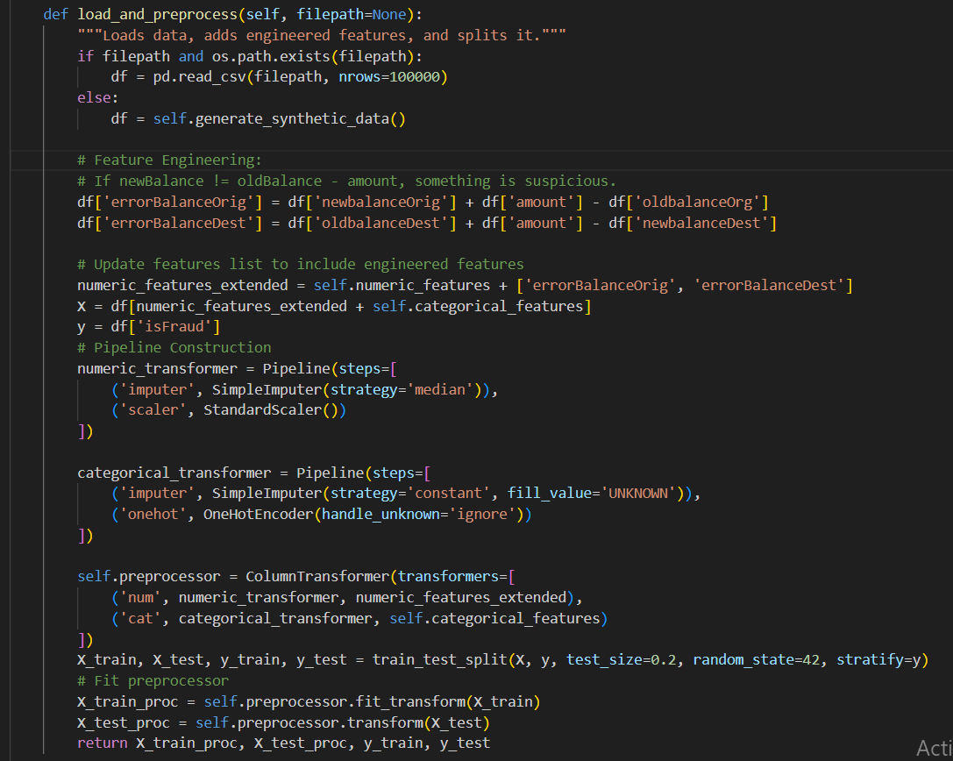
Bar Chart Analysis
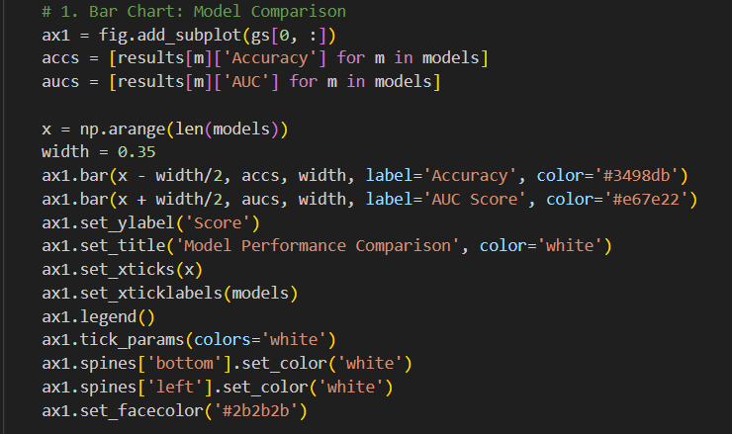
ROC Curve
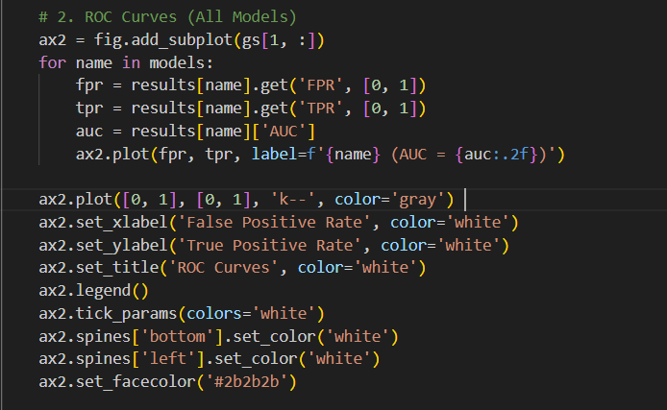
Confusion Matrix
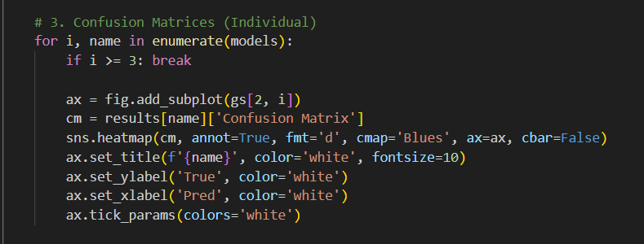

11. Output
The system produces multiple outputs, including accuracy scores, precision, recall, F1-score, confusion matrices for both models, ROC curve comparison, and feature importance visualization. The graphical user interface displays live fraud prediction results. Screenshots of the GUI and graphs are included in this section
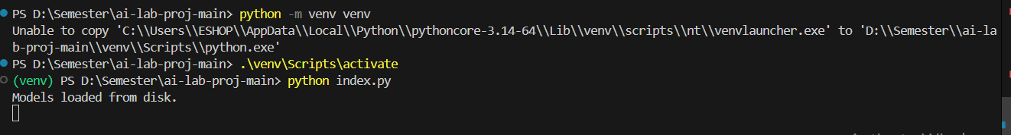
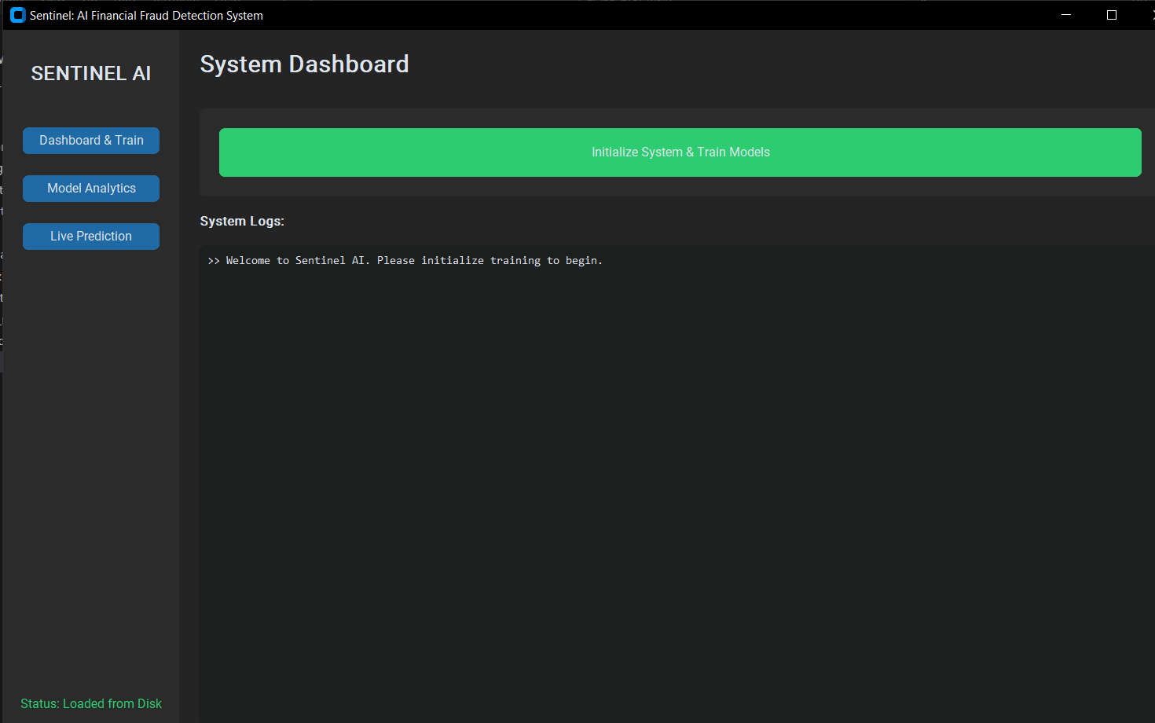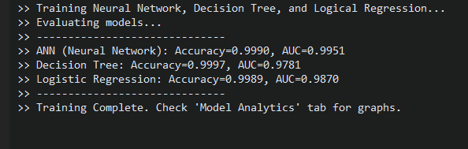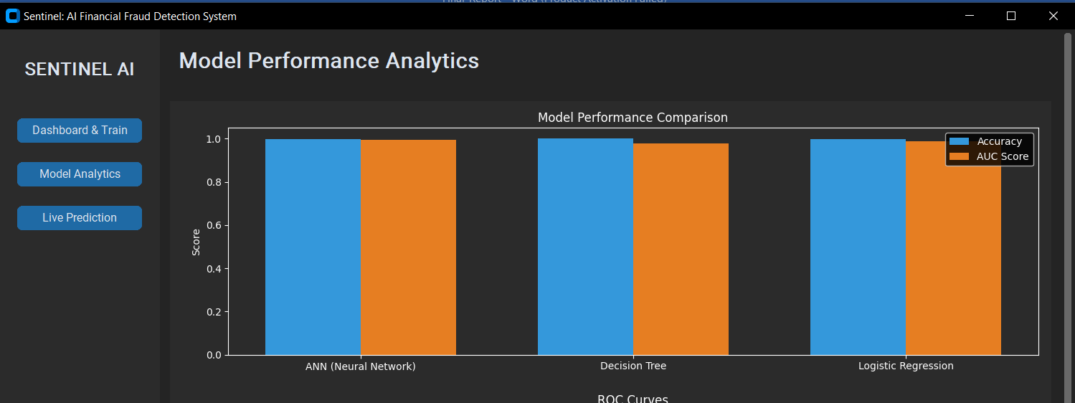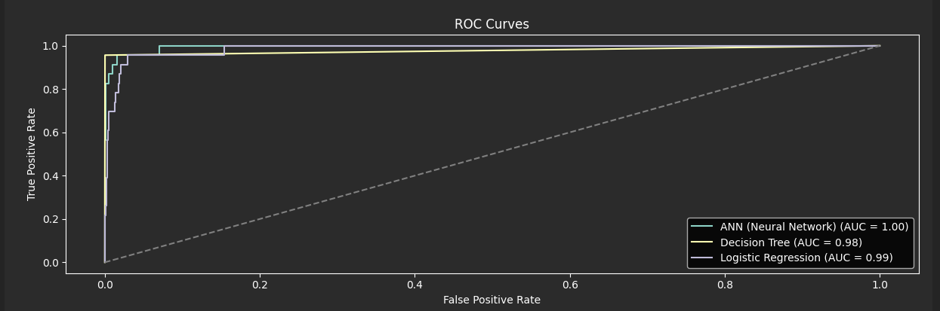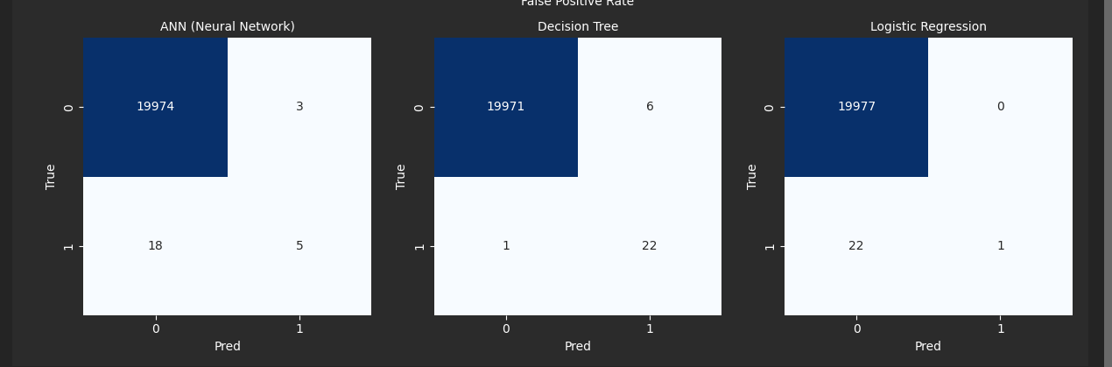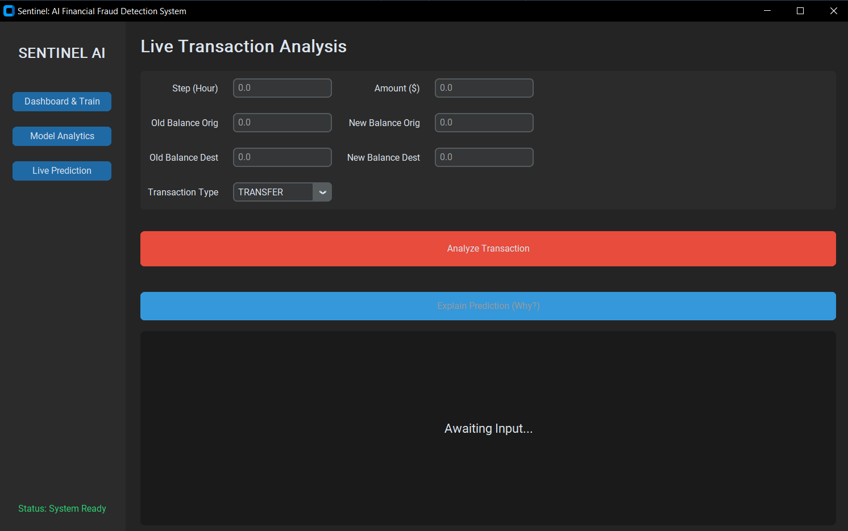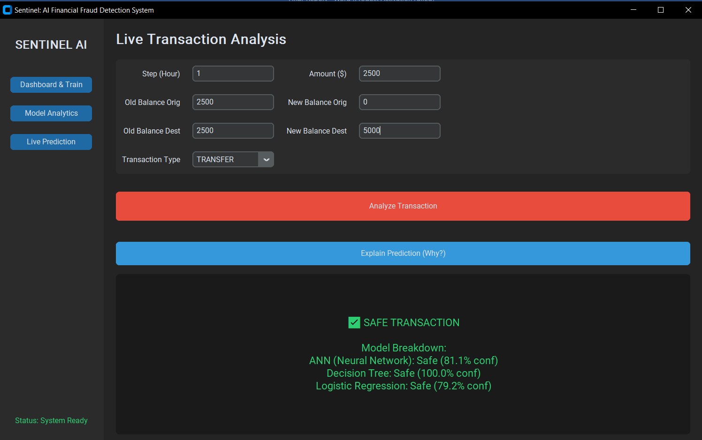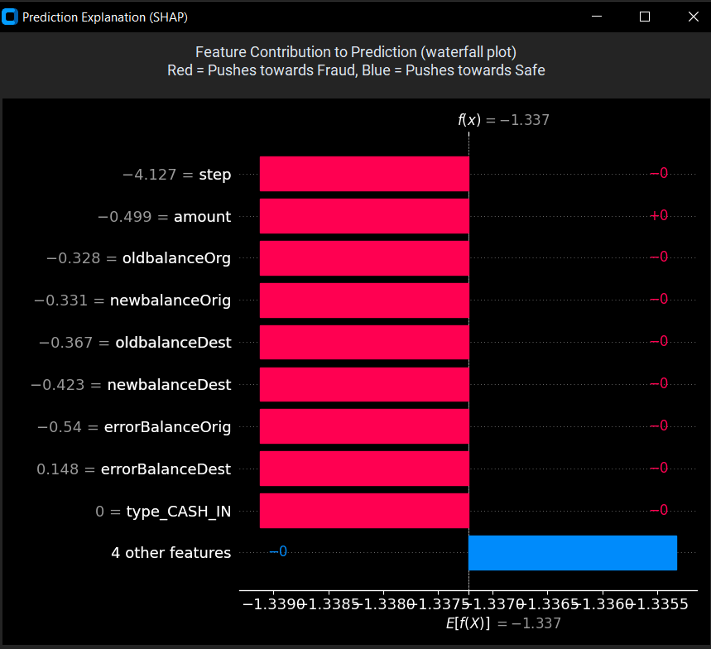
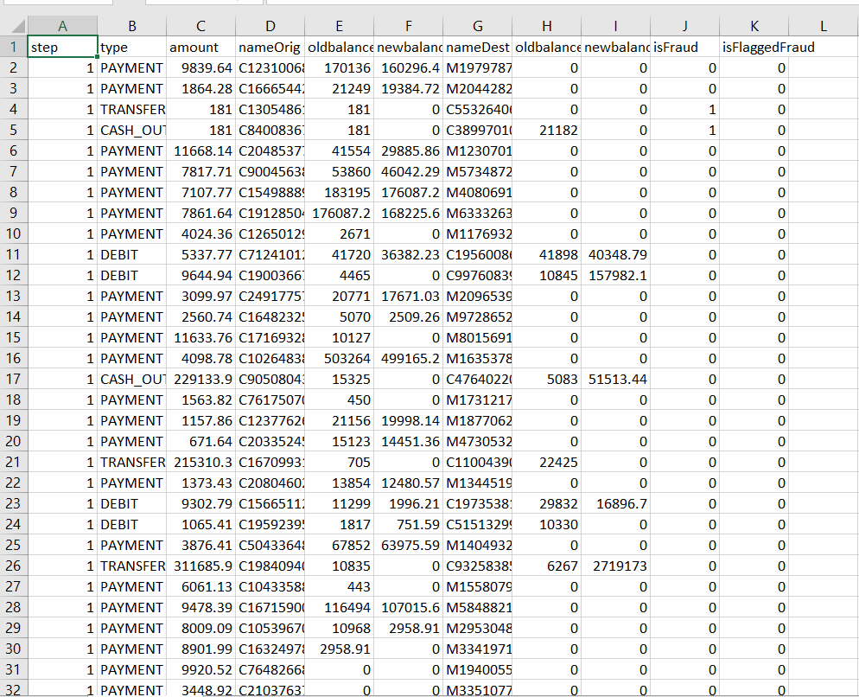

12. Future Work
Future enhancements may include integration with real-time transaction processing systems, deployment on cloud platforms, implementation of advanced models such as Random Forest, XGBoost, and LSTM, and incorporation of explainable AI techniques to improve transparency and trust in fraud detection decisions
No AI model is 100% perfect. In financial systems, we must balance security with user convenience. This section outlines the technical and practical limitations of our current system.

13. Conclusion
This project successfully demonstrates the effectiveness of machine learning techniques in detecting financial fraud. The comparative analysis of Artificial Neural Network and Decision Tree models shows that both approaches provide reliable predictions, with each having its own strengths. The developed system offers accurate detection, meaningful visualizations, and an interactive user interface, making it suitable for academic study and potential real-world applications

14. References (IEEE Style)
[1] “Tkinter — Python interface to Tcl/Tk,” Python Documentation, Python Software Foundation, 2025.
[2] F. Pedregosa et al., “Scikit-learn: Machine learning in Python,” J. Mach. Learn. Res., vol. 12, pp. 2825–2830, 2011.
[3] Kaggle, "Financial Fraud Detection Dataset (2016)."

