**SCHOOL OF COMPUTER SCIENCE AND ENGINEERING**

**DEPARTMENT OF INTELLIGENT SYSTEM**

**LOVELY PROFESSIONAL UNIVERSITY, JALANDHAR**

**FORMAT FOR PREPARING END TERM PROJECT REPORT**

The purpose of the report is to explain overall working of the project. The report should contain an account of the activity for whole of project and as well as implementation of its working.

1. First Page (Appendix 1)

1. Declaration Page (Appendix 2)

1. Table of Contents (Appendix 3)

1. Bonafide Certificate for Supervisor Signature and Details (Appendix 4)

1. Background and objectives of the project assigned.

An introductory description (2-3 pages) of the project with respect to: Background, motivation and outcome of project and concrete goals and objectives.

1. Description of Project

The students are required to provide description in terms of modules and prepare pictorial flow of project. 7. Description of Work Division in terms of Roles among Students.

Here students are required to explain the work done by each student for roles allotted in MTE report.

8. Implementation of scheduled work of Project

The students are required to provide implementation of project in terms of its working and provide screenshots of designed web pages with proper explanation.

1. Technologies and Framework to be used.

The students are required to mention the technology and platform to be used in project.

1. SWOT Analysis achieved in project.

Include an analysis of project in terms of Strengths, Weaknesses, Opportunities and Threats. Strengths and weaknesses refer to the internal capabilities of the project, i e are under its control, and should be regarded relative to competitors, whereas opportunities and threats are found in the external environment, usually outside the control of the project.

Typing Instructions:

The impression on the typed copies should be black in color. One and a half spacing should be used for typing the text, and shall be typed in the Font style ‘Times New Roman’ and Font size 12, unless otherwise stated explicitly.

**APPENDIX 1**

# TITLE OF PROJECT

Helping Hands

PROJECT- 21

END TERM REPORT

***by***

*Nikita Kaushik*

## NAME OF THE CANDIDATE(S)

(Section: ____K19BY__)

(Roll Number(s): _63, 62, 61__)



### **Department of Intelligent Systems**

**School of Computer Science Engineering**

**Lovely Professional University, Jalandhar**

Month- April Year - 2020

**APPENDIX 2**

## Student Declaration

This is to declare that this report has been written by me/us. No part of the report is copied from other sources. All information included from other sources have been duly acknowledged. I/We aver that if any part of the report is found to be copied, I/we are shall take full responsibility for it.

Name: S.Vineel

Roll number: _63_

Name: Qamber hasnain

Roll number: _62_

Name: Vibhor

Roll number: _61_

### PlaceDate

#### APPENDIX 3

#### TABLE OF CONTENTS

**TITLE**

* 1. ........**Introductory description of the project**....................
     1. **...........................Description.............................................**
     2. **....................Contents of project........................................**
  2. **...........................Actual Webpage…...................................**
     1. **...................................some screen shots**

APPENDIX 4

BONAFIDE CERTIFICATE

Certified that this project report Website “HELPING HANDS” is the bonafide work of S. Vineel, Qamber Hasnain and Vibhor who carried out the project work under my supervision.

Nikita Kaushik

U id: 25821

**Introductory Description of the project:**

No one is useless in this world who lightens the burdens of another

My law of life is to be caring. Whenever I see someone in need of help, I try to do everything to help them. People may not look like they need help, but maybe they do. When I was in fifth grade, my friend, Saashah, looked ok to me. But actually she needed help. She was having problems with her family, so I decided to help her. In the end, she came out alright, and I was relieved. I love to be kind, funny, and caring. But I don’t always stay that way. I can be cruel and mean sometimes, but I try hard to become what I want to become. I pray to God to help me become good. Of course I have to try on my own, but God always gives out a helping hand as well. One thing I can’t stand is people being racist. I think everyone should be treated equally. I would get mad whenever someone would call me Chinese. They would make fun of me, but I tried to ignore it. I also can’t stand it when my friends get pushed around. My law of life is highly involved with God. He gives me faith, and I the things I need to try and fulfill my law of life.

**Description of the Project:**

We made this project as a assignment by our teacher but it was very crucial about the management of account by the government , staff members anywhere, at this Point of time where the population is very high where maintaining record of each and every individual is next to impossible , so by the projects like this we find more about making life of peoples easier and can be said as home service where every individual has an account wherever on whichever gadget he can access all the facilities and this data can be stored on server by this medium important time of peoples is saved and we can store the maximum data of every individual all over the community.

**About the project:**

There is a Register your complaint panel in Home tab in the webpage where any individual can register his/her problems and their problem can be seen by the Authorities of respective departments, the main aim of the project is to register complaints of any type from anywhere in India and to take their complaints to respective Authorities online on a single website, as India is in list the developing countries and as per Digital India.

**Contents on the project :**

The webpage is made with mainly html, css and some basic javascript. The main content the web page it is built with proper use of major attributes for a basic layout which mainly contains the structure like rowspan, colspan, buttons like submit, etc. But we even used css to decorate webpage with some color to make that look beautiful, and proper use means we used inline css in the webpage, and moreover classes .and javascript helped in adding some extra details on login panel of the user.

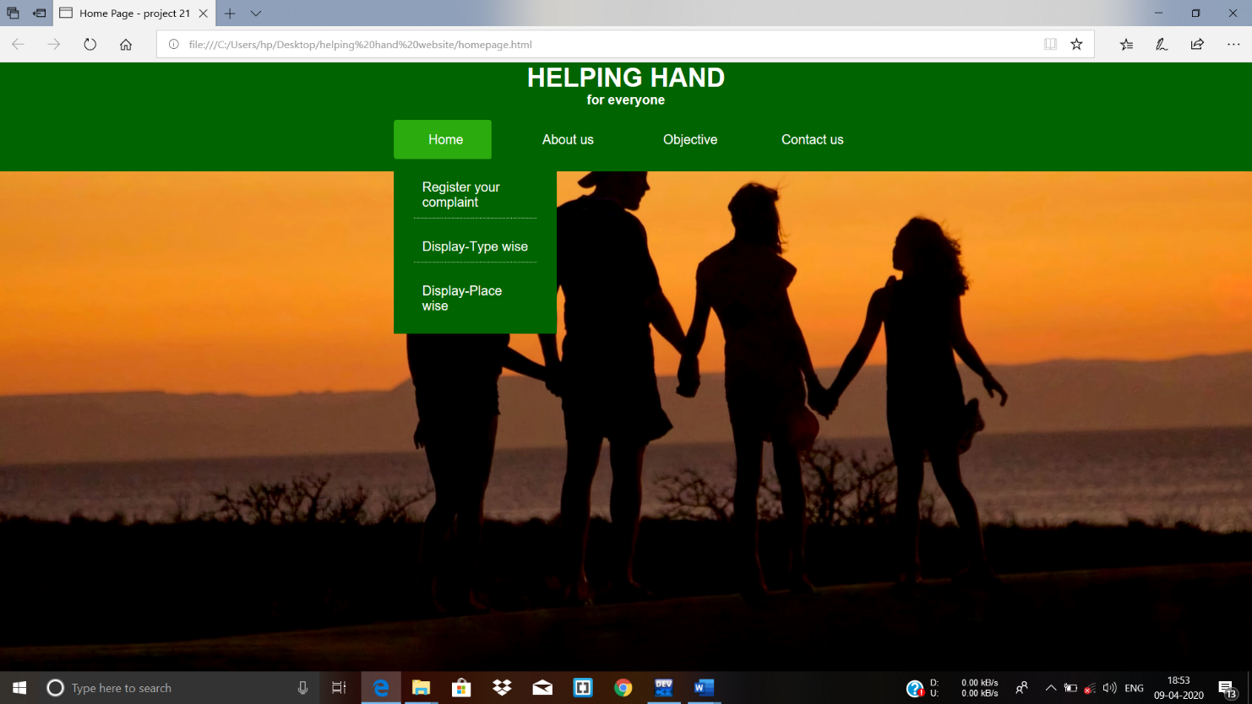

This is the homepage of the website where user can register his/her complaint.

* The Home tab there is first option is Register your complaint, second option is Display-Type wise in which user or authory can see the problems of same type, then comes Display-Place wise option in which those entered details will be shown as per the selected place.
* The next tab About us has our Mission and Names of our team members.
* Then the next tab Objective has our work objective.
* Then next tab Contact us has the mobile phone numbers of the team members.

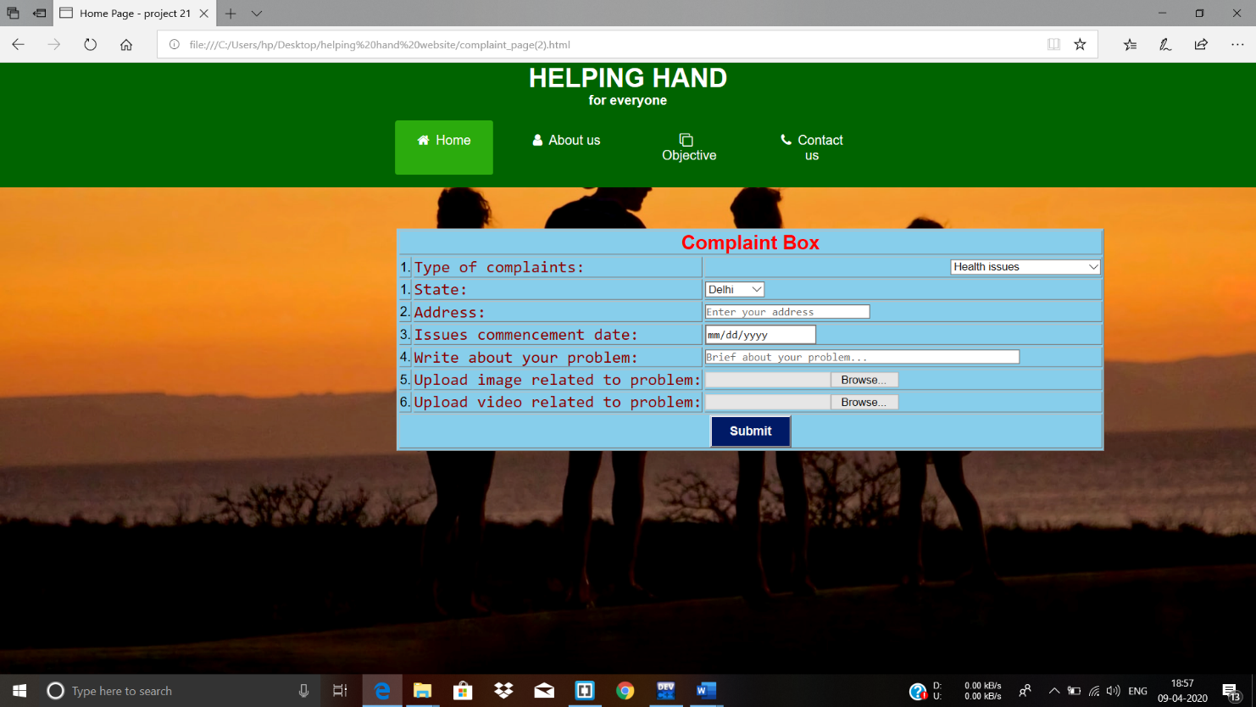

* Now this is complaint page where complaint will be registered.
* There are different type of options in this web page as type of complaints, State, address, date, brief about their problems, image or video uploading option.
* When user click on “submit” button the will be saved.

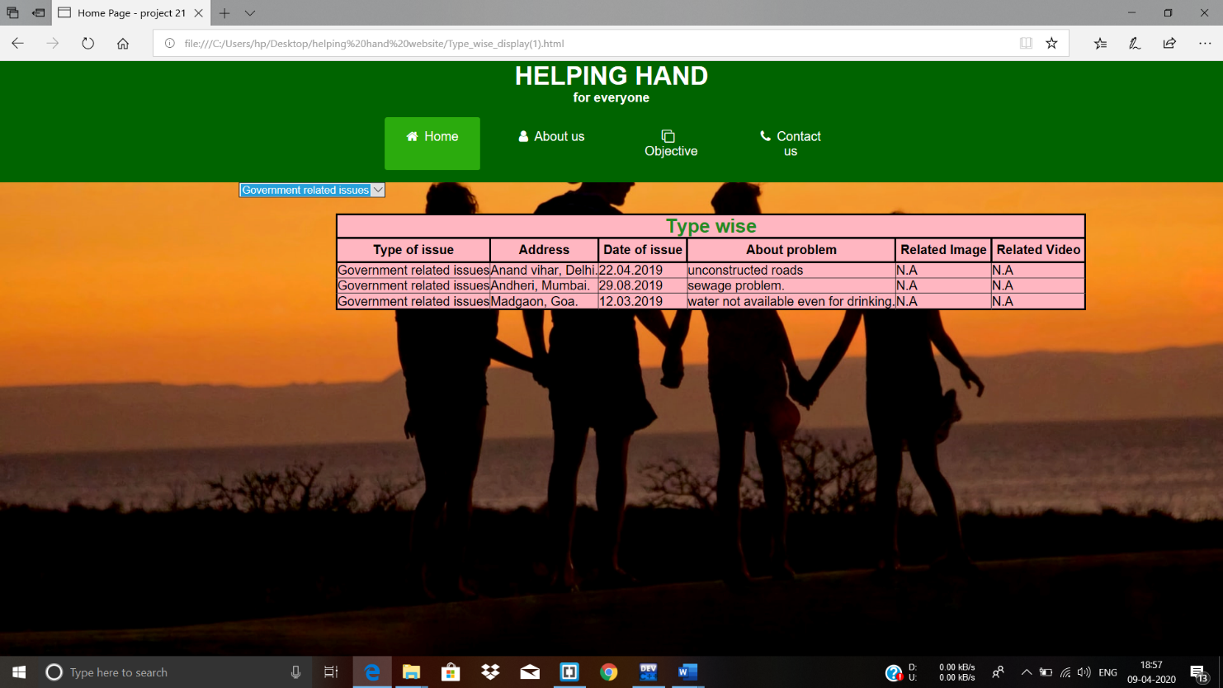

* The second content of the webpage is the quick links for the frequently asked questions which make an ease for the user while any difficulties faced by them. It contains small questions like create your type of issue video related to your problem etc.
* In this page user or Authority can see the complaint as per type of complaints.

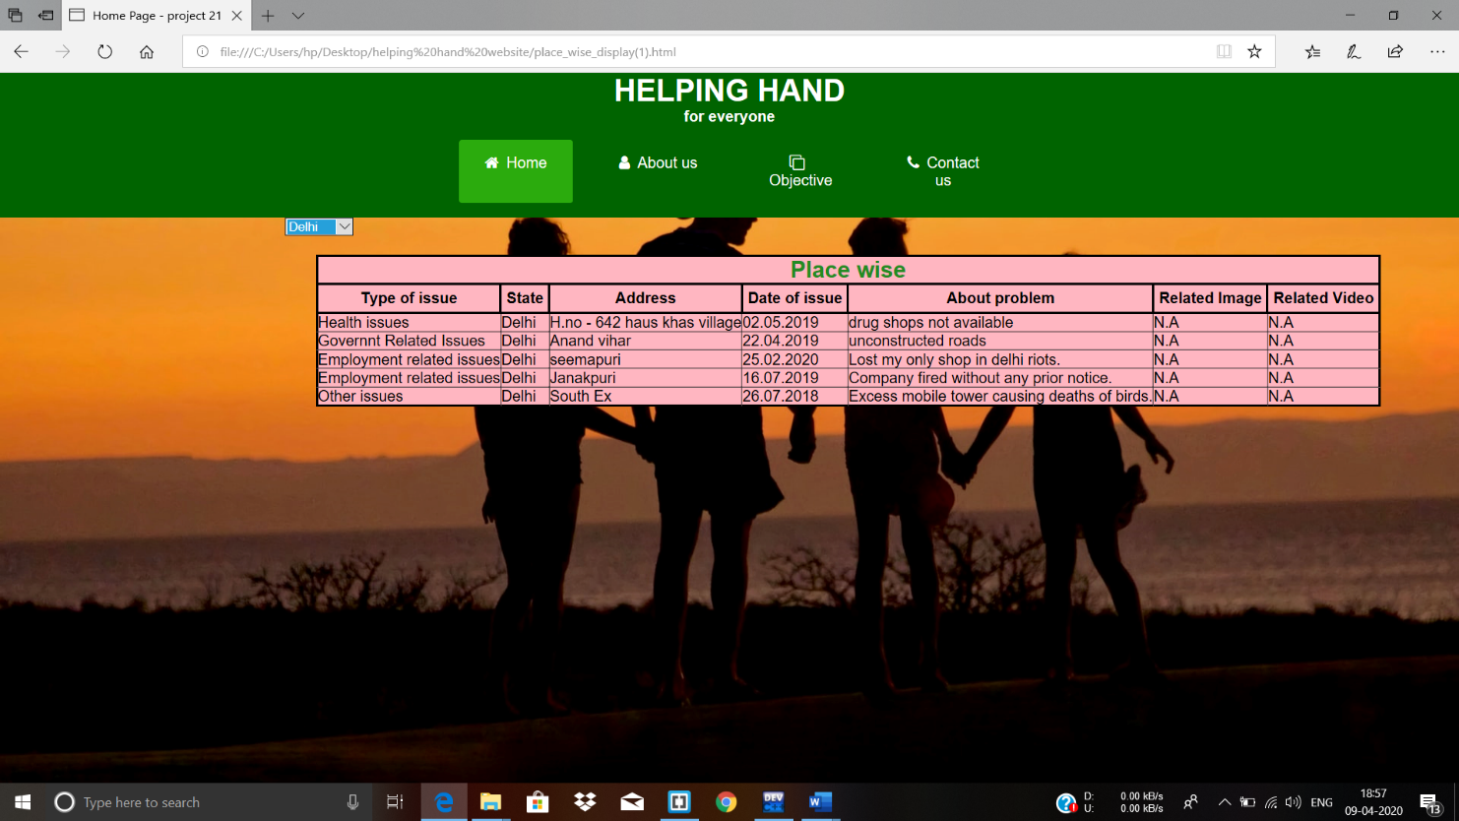

* This is the last page of this website where user or authority can see all the registered problems in their respective states.

**Moto of the Project:**

**“HELPING HUMANS MAKES US HUMAN”**

~~~END OF REPORT.