
Online website — User Manual

Prepared by: Rizviz International Impex
Version 1.0 | June 2026

1. Introduction to Rizviz ERP
Rizviz ERP is a comprehensive Enterprise Resource Planning system developed exclusively for Rizviz International Impex. It is designed to unify and streamline all core business processes across multiple companies and branches into a single, integrated platform.

The system provides a centralized environment where authorized personnel can manage Human Resources, Payroll, Finance, Inventory, and Operations — all accessible through a secure, role-based login.

1.1 Key Features
- Multi-Company / Multi-Branch architecture
- Role-based access control for secure, permission-driven usage
- Centralized employee and HR management
- Real-time payroll and salary processing
- Integrated leave, attendance, and performance tracking
- Audit trails and activity logging for compliance

1.2 System Requirements
To access the Rizviz ERP, you need:
- A modern web browser (Google Chrome recommended, version 90+)
- Active network/internet connection to the ERP server
- Valid company-assigned login credentials (username and password)
- JavaScript enabled in the browser

1.3 Intended Audience
This manual is intended for all users who have been assigned login credentials to the Rizviz ERP platform, including HR administrators, branch managers, finance officers, and system administrators.

2. Login Module
The Login Module is the entry point to the Rizviz ERP system. It ensures that only authorized users can access the platform by verifying their identity through a combination of company selection, branch selection, username, and password.

URL: localhost:3000/login (internal network access)

📌 Important: All four fields on the login screen are mandatory. Leaving any field empty will prevent login.

2.1 Login Screen Overview
When you navigate to the ERP login URL, the following screen is displayed:

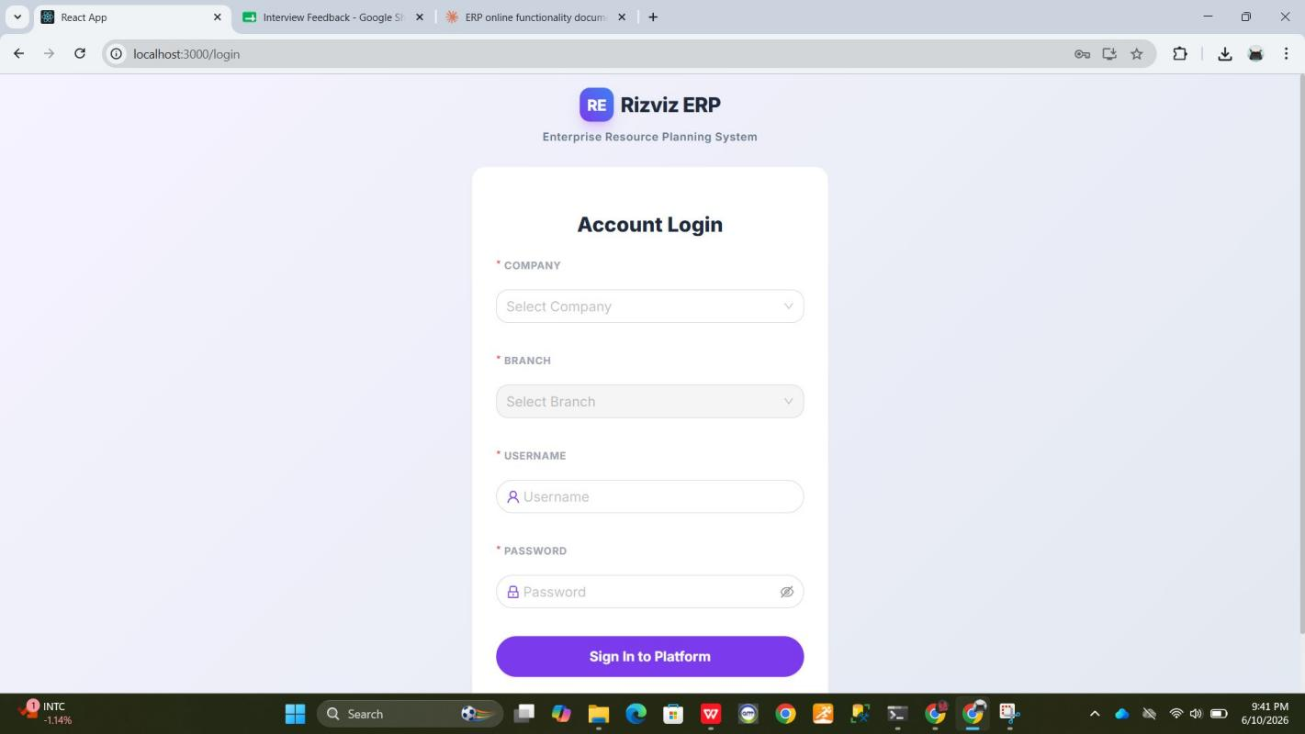
Figure 1 — Rizviz ERP Login Page (Default State)
The login page consists of two main areas:
- Header Section — Displays the Rizviz ERP logo (purple RE badge) and the system name "Enterprise Resource Planning System".
- Login Form — A white card centered on a light gray background, containing all required fields to authenticate the user.
- Footer — A copyright notice at the bottom: "© 2026 Rizviz Int. Impex. All rights reserved."

2.2 Login Form — Field Reference
The login form contains four fields, each described in detail below:

Field Name | Status | Description
Company | Required
Branch | Required
Username | Required
Password | Required

2.3 Step-by-Step Login Instructions
Follow these steps to log in to the Rizviz ERP:

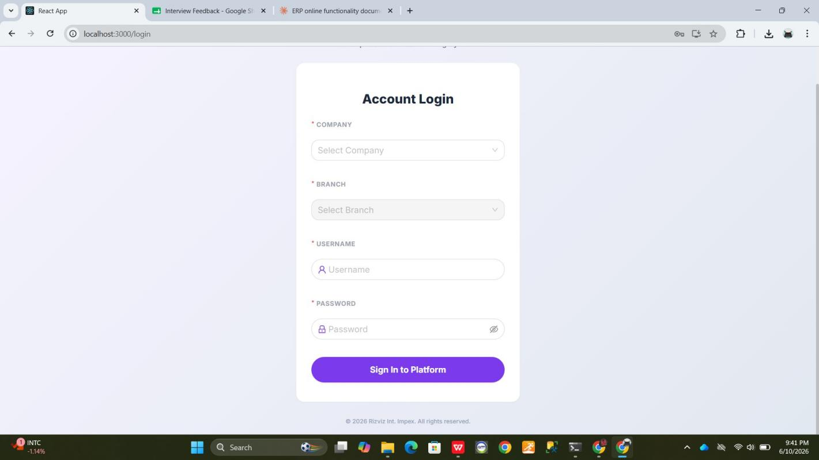
Figure 2 — Login Page (Scrolled View, All Fields Visible)
- Open the ERP in your web browser by navigating to the system URL.
- Click on the Company dropdown and select your company (e.g., Rizviz Int. Impex).
- Click on the Branch dropdown (now enabled) and select your assigned branch.
- Enter your Username in the username field.
- Enter your Password. Use the eye icon to verify the password if needed.
- Click the Sign In to Platform button to authenticate.
- Upon successful authentication, you will be redirected to the ERP Dashboard.

2.4 Company Dropdown — Behavior
The Company dropdown is the first field on the login form. By default, it shows "Select Company" as a placeholder. When clicked, it expands to display a list of all available companies.

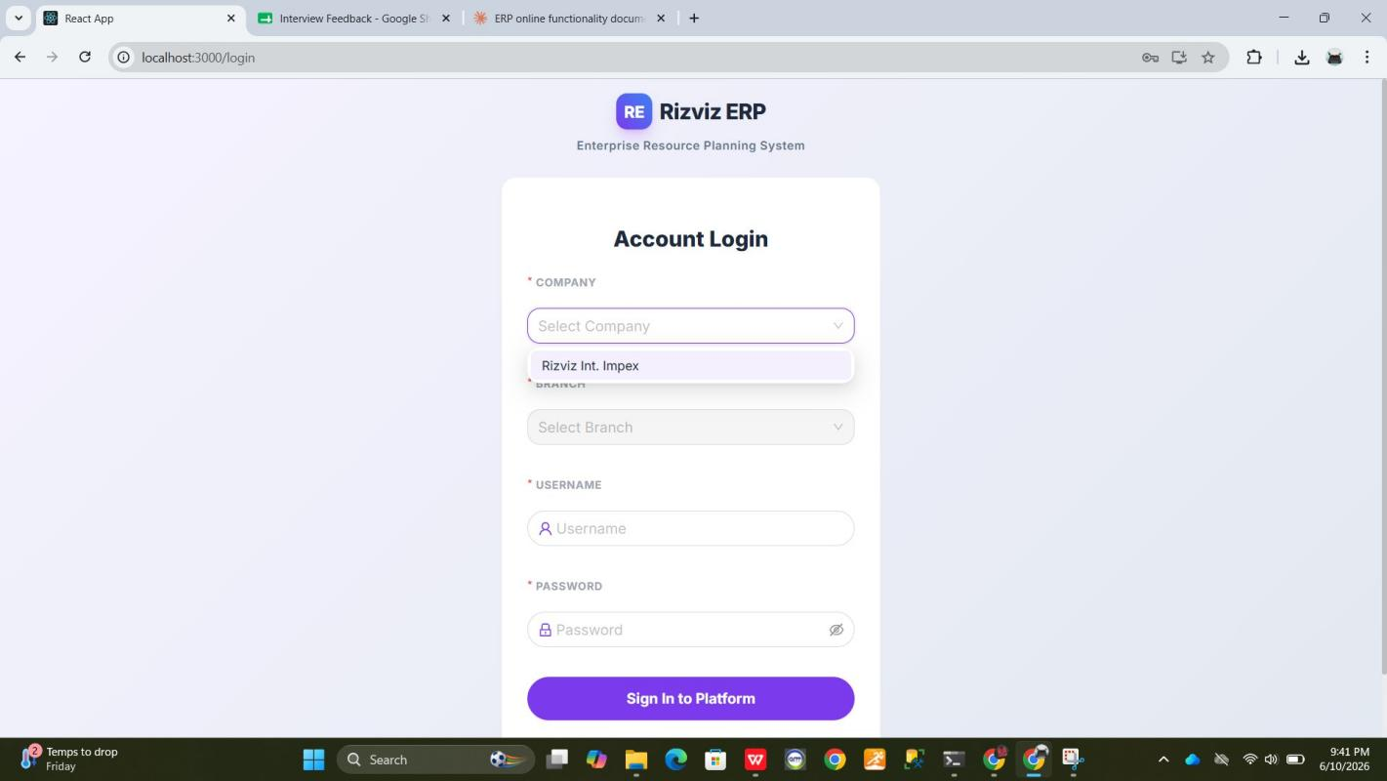
Figure 3 — Company Dropdown Expanded (Rizviz Int. Impex visible)
In the current configuration, the following company is available:
- Rizviz Int. Impex

📌 Note: The company list is managed by the system administrator. Contact your admin if your company does not appear in the list.

2.5 Branch Dropdown — Behavior
The Branch dropdown is dynamically populated based on the company selected. It remains in "Select Branch" placeholder state until a company is chosen. Once a company is selected, the following branches become available:

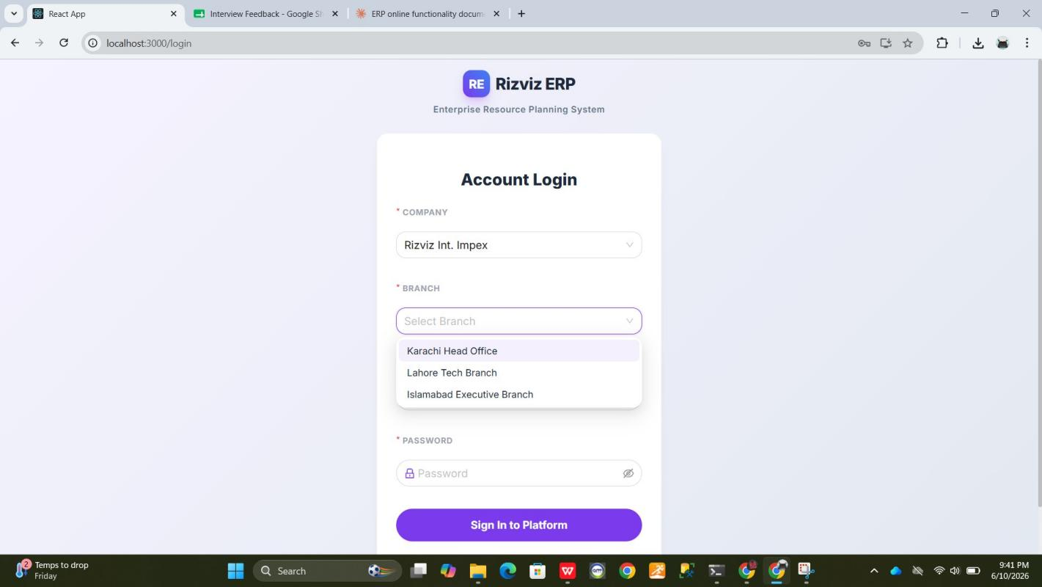
Figure 4 — Branch Dropdown Expanded (Three branches available)
- Karachi Head Office
- Lahore Tech Branch
- Islamabad Executive Branch

📌 Note: Only select the branch to which you are officially assigned. Logging in under a different branch may restrict access to relevant records.

2.6 Completed Login Form — Example
The screenshot below shows the login form fully filled in and ready to submit. All four fields have been populated correctly:

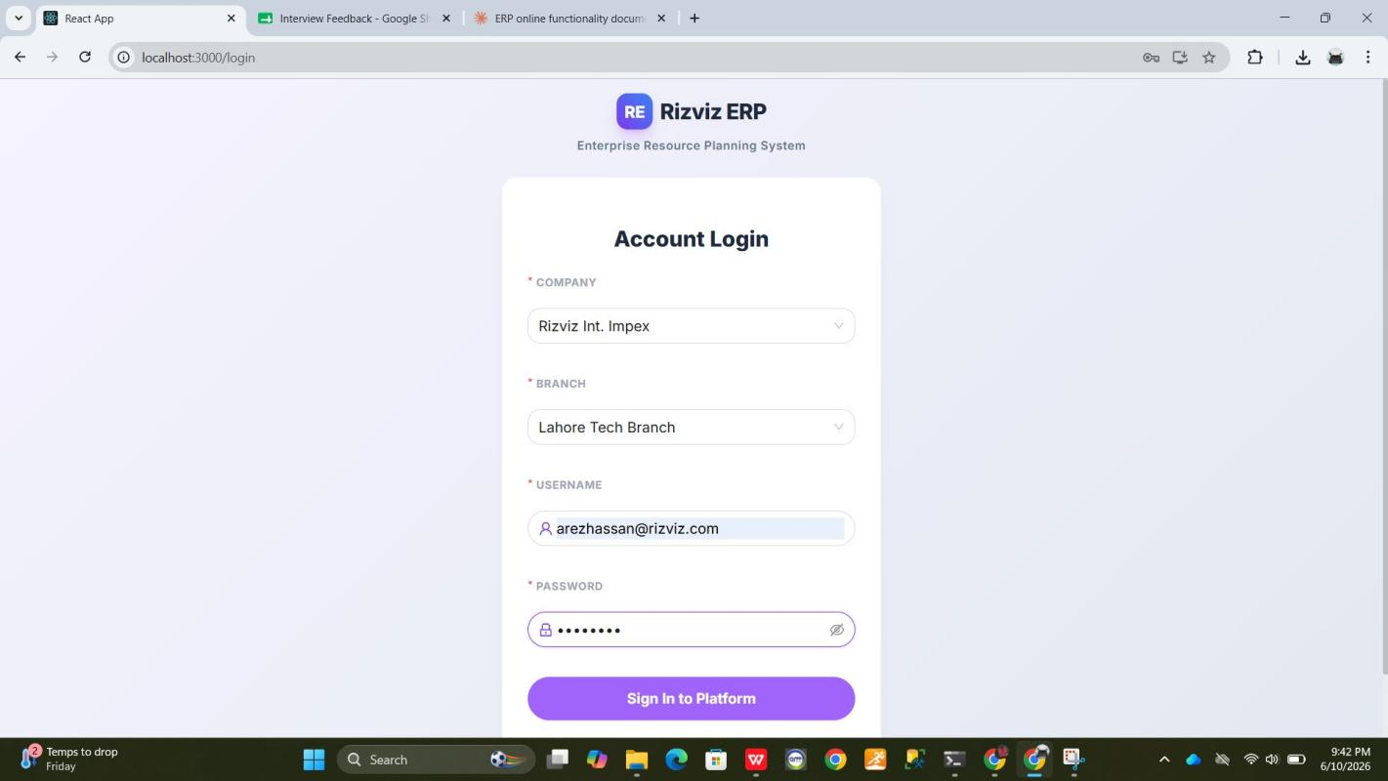
Figure 5 — Login Form Fully Filled (Company, Branch, Username, Password entered)
- Company: Rizviz Int. Impex
- Branch: Lahore Tech Branch
- Username: arezhassan@rizviz.com
- Password: entered and masked with dots (●)

Once all fields are filled, the user clicks "Sign In to Platform" to complete the authentication process.

2.7 Password Field — Behavior
The Password field masks all entered characters by default, displaying dots (●) for each character. It features a lock icon on the left side. A visibility toggle icon (eye icon) is located on the right side of the field:
- Clicking the eye icon will reveal the password in plain text (to verify entry).
- Clicking it again will re-mask the password.

📌 Security Tip: Do not use the show-password feature in public areas or shared screens. Always ensure your password remains confidential.

2.8 Sign In to Platform Button
The "Sign In to Platform" button is a prominent purple button at the bottom of the login form. It submits all four form fields to the authentication server.

Behavior:
- If all fields are filled correctly and credentials match — the user is redirected to the ERP Dashboard.
- If any field is empty — the system highlights the missing field and prompts the user to complete it.
- If credentials are invalid — an authentication error message is displayed.

3. Troubleshooting & Common Issues

Issue | Resolution
Branch dropdown not populating | Ensure you have selected a Company first. The Branch field depends on the Company selection.
Invalid username or password error | Double-check your credentials. Ensure Caps Lock is OFF. Contact your system administrator if the issue persists.
Cannot access the login page | Verify you are connected to the correct network (VPN or office LAN). Check the URL for any typos.
Login page not loading / blank screen | Clear your browser cache and try again. Ensure JavaScript is enabled. Use Google Chrome for best compatibility.
Forgot password | Contact your system administrator to reset your password. There is no self-service password reset feature.
Locked out of account | After multiple failed login attempts, your account may be locked. Contact the system administrator to unlock it.

4. Security & Best Practices
To maintain the security and integrity of your ERP account, follow these best practices:

- Never share your login credentials with anyone, including colleagues or supervisors.
- Always log out of the ERP system when your session is complete, especially on shared computers.
- Do not save your ERP password in the browser on shared or public devices.
- Change your password regularly (at least every 90 days) using a strong combination of uppercase, lowercase, numbers, and special characters.
- If you suspect your account has been compromised, contact the system administrator immediately.
- Avoid logging in from unsecured public Wi-Fi networks without a VPN.

📌 Your ERP account is tied to your employee profile and all actions performed are logged for audit purposes. Unauthorized access is a violation of company policy.

5. Contact & Support
If you encounter any issues not covered in this manual or require assistance with your ERP access, please reach out to:

Support Team | IT Department — Rizviz International Impex
Email | support@rizviz.com
Office Hours | Monday – Friday, 9:00 AM to 6:00 PM (PKT)

1. Dashboard Overview
After a successful login, the user is automatically redirected to the Interview Dashboard — the main landing page of the Rizviz ERP system. This dashboard provides a real-time, at-a-glance summary of all interview activities associated with the currently logged-in user and selected company/branch.
The dashboard is role-aware: the data displayed is filtered based on the user's role (e.g., Interviewee, HR Manager, Admin) and their assigned branch.

1.1 Dashboard URL
After login, the system navigates to:
localhost:3000/dashboard
📌 The Dashboard is the default post-login screen. Users cannot access it without valid authenticated credentials.
1.2 Page Layout
The Dashboard is divided into the following structural areas:
- Top Navigation Bar — Company and Branch selector, notification bell, and logged-in user profile.
- Left Sidebar — Module navigation links: Dashboard, Interviews, Calendar, AI Feedback, Leads.
- Main Content Area — The Interview Dashboard panel with summary statistics.
- Dark Mode / Sidebar Controls — Located at the bottom of the left sidebar.

2. Top Navigation Bar
The top navigation bar is always visible across all ERP modules. It provides context about the current session and quick access to key functions.

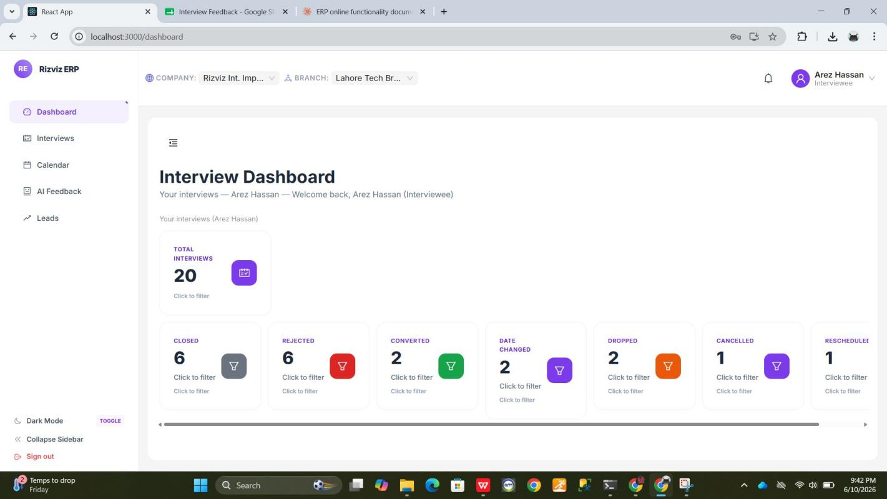
Figure 1 — Rizviz ERP Dashboard (Post-Login State)
2.1 Navigation Bar Elements
Element | Location | Description
RE Logo Badge | Top-left corner | Displays the Rizviz ERP brand logo (purple 'RE' badge) and system name.
Company Selector | Top-center | Shows the currently active company (e.g., Rizviz Int. Imp…). Dropdown allows switching companies.
Branch Selector | Top-center | Shows the active branch (e.g., Lahore Tech Br…). Dropdown allows switching branches.
Notification Bell | Top-right | Displays a bell icon for system notifications and alerts.
User Profile Badge | Top-right corner | Shows the logged-in user's name and role (e.g., Arez Hassan — Interviewee). Click to access profile options.

3. Left Sidebar — Navigation Menu
The left sidebar provides access to all major modules within the Rizviz ERP. It is visible on every page and highlights the currently active module.

3.1 Sidebar Menu Items
Menu Item | Description
Dashboard | The main landing page. Shows interview statistics and summary tiles. Currently active (highlighted in purple).
Interviews | Access and manage all interview records — schedule, view details, update statuses.
Calendar | A calendar view of all scheduled interviews, organized by date.
AI Feedback | View AI-generated feedback and performance analysis for completed interviews.
Leads | Manage leads and potential candidate pipelines (role-specific access may apply).

📌 The active module is highlighted with a purple background in the sidebar. In the current view, 'Dashboard' is the active selection.
3.2 Sidebar Controls (Bottom)
At the bottom of the sidebar, the following controls are available:
- Dark Mode — A toggle switch to switch the interface between light and dark themes.
- Collapse Sidebar — Collapses the sidebar to icon-only view, expanding the main content area.
- Sign Out — Logs the current user out and redirects to the Login page.

4. Interview Dashboard — Main Content Area
The central content area of the Dashboard page displays the Interview Dashboard panel, which provides a statistical overview of all interviews for the currently logged-in user.

4.1 Dashboard Header
The top of the content area displays:
- Title: "Interview Dashboard"
- Subtitle: "Your interviews — [User Name] — Welcome back, [User Name] ([Role])"
- Section label: "Your interviews ([User Name])"

Example for the current session:
Your interviews — Arez Hassan — Welcome back, Arez Hassan (Interviewee)
4.2 Total Interviews Tile
The first and largest statistics tile displays the total count of all interviews linked to the logged-in user. It features:
- Label: "TOTAL INTERVIEWS"
- Count: A large numeric value (e.g., 20)
- Icon: A purple calendar-style icon badge on the right.
- "Click to filter" link — Clicking this tile filters the Interviews list to show all interviews.

📌 The total count of 20 reflects all interviews regardless of their status for the current user (Arez Hassan) in the selected branch.
4.3 Status Summary Tiles
Below the Total Interviews tile, a horizontal row of smaller status tiles provides a breakdown of interviews by their current status. Each tile includes a status label, a count, a colored icon, and a "Click to filter" action.

Status | Count | Icon Color | Description
CLOSED | 6 | Gray | Interviews that have been formally closed without conversion.
REJECTED | 6 | Red | Candidates who were rejected after the interview process.
CONVERTED | 2 | Green | Interviews that resulted in a successful hire or conversion.
DATE CHANGED | 2 | Purple | Interviews where the scheduled date was modified.
DROPPED | 2 | Orange | Candidates who dropped out before or during the interview.
CANCELLED | 1 | Orange | Interviews that were formally cancelled by either party.
RESCHEDULED | 1 | Purple | Interviews that were moved to a new date/time after initial scheduling.

📌 Each status tile is interactive. Clicking 'Click to filter' on any tile filters the Interview list to show only records matching that status.
4.4 Filter Functionality
Every statistics tile on the dashboard includes a 'Click to filter' link. This feature allows users to quickly drill down into interview data without manually applying filters in the Interviews module.
- Clicking any status tile will navigate the user to the Interviews list pre-filtered by that status.
- Clicking the Total Interviews tile will show all interviews without any status filter.
- The filter icon (funnel icon) on each tile provides a visual indicator that the tile is interactive.

5. Dashboard — Quick Reference Summary
Dashboard Element | Purpose
Total Interviews tile | Shows the complete count of all interviews for the user. Click to view all.
Status tiles (7 tiles) | Breakdown by Closed, Rejected, Converted, Date Changed, Dropped, Cancelled, Rescheduled.
Click to filter | Navigates to Interviews module with the selected status pre-applied as a filter.
Company / Branch selector | Allows switching between companies and branches without logging out.
Dark Mode toggle | Switches the UI between light and dark themes.
Collapse Sidebar | Hides sidebar labels to maximize the main content area.
Sign Out | Ends the session and redirects to the Login page.

6. Troubleshooting & Common Issues
Issue | Resolution
Dashboard shows 0 for all counts | Verify that the correct Company and Branch are selected in the top navigation bar. Data is branch-specific.
Dashboard not loading after login | Clear your browser cache and reload. Ensure JavaScript is enabled and you are using Google Chrome.
Status tile counts seem incorrect | Data is filtered by the logged-in user and active branch. Switch branch context if you expect to see other records.
Clicking filter link does nothing | Ensure JavaScript is fully loaded. Try refreshing the page and clicking again.
Dark Mode toggle not working | Try refreshing the page. If the issue persists, clear browser storage/cache.

7. Contact & Support
If you encounter any issues not covered in this manual or require assistance, please reach out to:

Support Team | IT Department — Rizviz International Impex
Email | support@rizviz.com
Office Hours | Monday – Friday, 9:00 AM to 6:00 PM (PKT)

© 2026 Rizviz International Impex. All rights reserved. | Confidential — For Internal Use Only

8. Interviews Module
The Interviews Module is the central data hub of the Rizviz ERP. It aggregates all interview records sourced from Interview Software.xlsx through a live sync mechanism. Users can browse, filter, and analyze interview data across List, Grid, and Calendar views — and filter by date range, candidate name, job hunter, and company. The module also provides a real-time status summary across all interview outcomes.
8.1 Interviews URL
The Interviews page is accessible from the left sidebar. After clicking the Interviews menu item, the system loads:
localhost:3000/interviews
📌 The Interviews page is role-aware. Administrators see all records; Interviewees and Job Hunters see only records associated with their profile.
8.2 Page Layout
The Interviews page is organized into the following areas:
Page Header — Title 'Interviews', subtitle with sync source info, and 'Last synced' timestamp with the last Excel save time.
View Mode Tabs — Five view controls at the top right: List, Grid, Calendar, Recent 90 days, and Refresh.
Statistics Tiles — Clickable summary tiles showing interview counts per outcome status.
Filter Bar — Live search input and Candidates dropdown for narrowing records.
Sync Info Banner — Blue informational bar explaining the Excel sync workflow.
Interviews Table — Sortable, paginated grid of all interview records.
8.3 Statistics Tiles
A row of interactive tiles at the top summarizes interview counts by status. Each tile includes a 'Click to filter' link that filters the table below to that specific status.
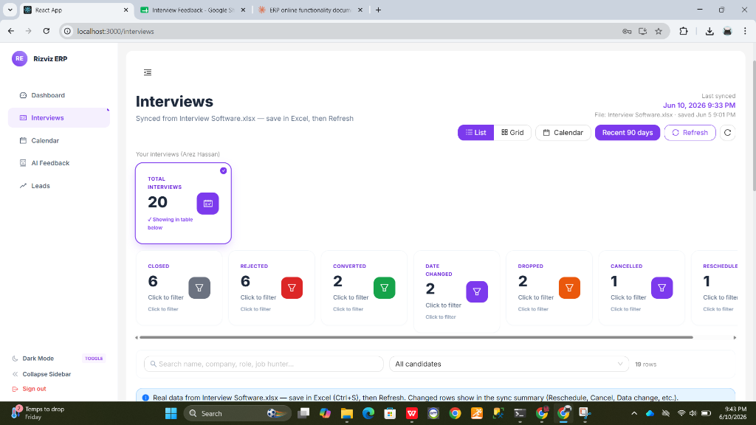
Figure 2 — Interviews Module (Statistics Tiles & View Controls)
Tile | Count (Example) | Description
Total Interviews | 20 | All interview entries regardless of status.
Closed | 6 | Interviews closed with a final recorded outcome.
Rejected | 6 | Candidates rejected during the interview process.
Converted | 2 | Candidates who received an offer or were placed.
Date Changed | 2 | Interviews where the scheduled date was rescheduled.
Dropped | 2 | Interviews dropped by the candidate or company.
Cancelled | 1 | Interviews formally cancelled with no further rounds.
Reschedule | 1 | Interviews pending a rescheduled date confirmation.

8.4 View Modes
Five view toggle buttons at the top-right allow switching between different presentation formats:
List — Default column-based table view with full sortable row detail.
Grid — Card-based layout showing interviews as visual summary cards.
Calendar — Navigates to the Interview Calendar (localhost:3000/interviews/calendar).
Recent 90 days — Applies a quick filter to show only interviews active in the last 90 days.
Refresh — Fetches the latest data from the backend and re-syncs with Interview Software.xlsx.
8.5 Filter Controls
Two filter controls sit below the statistics tiles:
Search Bar — Live-search matching candidate name, company, role, and job hunter simultaneously.
Candidates Dropdown — Scopes the table to a specific interviewee profile. Defaults to 'All candidates'.
📌 The row count indicator (e.g., '19 rows') updates dynamically as filters are applied.
8.6 Interviews Table
The main table lists all matching records. Each row is a single interview entry. Columns support ascending/descending sort by clicking the header arrows.
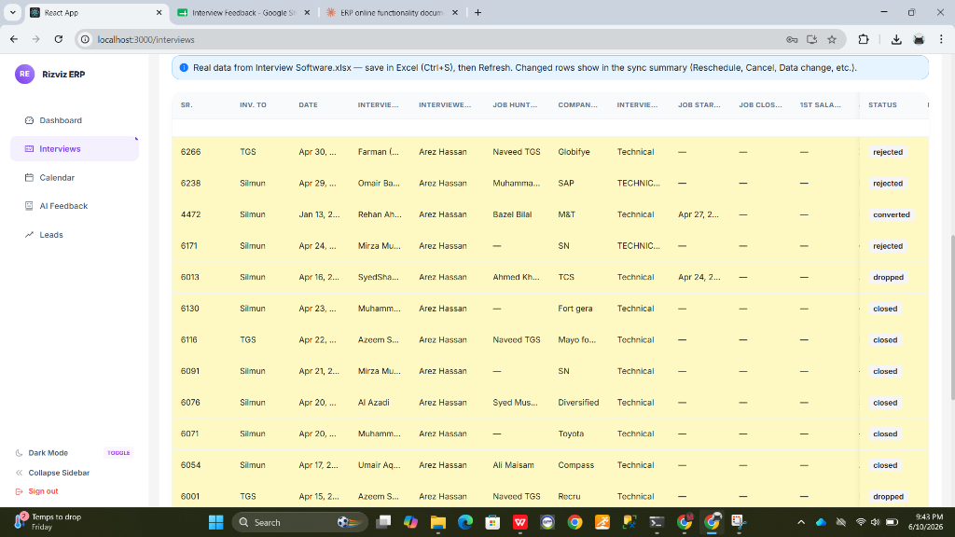
Figure 3 — Interviews Table (List View, Scrolled)
Column | Description
SR | Unique Serial Number of the interview record, sourced from the Excel file.
INV. TO | The company or entity the interview was conducted for.
DATE | The scheduled date of the interview session.
INTERVIEWER | The recruiter or HR representative who conducted the interview.
INTERVIEWEE | The candidate who attended the interview.
JOB HUNTER | The BD or placement agent managing this interview.
COMPANY | The target company for which the interview was held.
INTERVIEW TYPE | Category of the interview (e.g., Technical, HR, Managerial).
JOB START DATE | Proposed or confirmed job start date if the interview resulted in placement.
JOB CLOSE DATE | Date the job position was formally closed or filled.
1ST SALARY | First-month salary or offered package for converted interviews.
STATUS | Current outcome (rejected, converted, dropped, closed, cancelled, etc.).

8.7 Sync Mechanism
The Interviews Module is powered by a live sync with Interview Software.xlsx. The blue banner at the top of the table explains the workflow:
Real data is read directly from Interview Software.xlsx on the server.
To push updates: Save in Excel (Ctrl+S), then click Refresh in the ERP.
Changed rows (Rescheduled, Cancelled, Date changed, etc.) are highlighted in the sync summary after refresh.
📌 The 'Last synced' indicator at the top right shows when the ERP last fetched data from the Excel file.
8.8 Interviews Module — Quick Reference Summary
Feature | Purpose
Statistics Tiles | Clickable count cards per status; filters the table when clicked.
List View | Default sortable, column-based grid with all interview details.
Grid View | Card-based visual layout for interviews.
Calendar View | Month-by-month interview date plotter.
Recent 90 Days | Quick-filters to show only recently active interviews.
Refresh | Re-syncs ERP with the current saved state of Interview Software.xlsx.
Search Bar | Live search across all major interview fields simultaneously.
Candidates Dropdown | Scopes table to a specific interviewee / candidate profile.

9. Calendar Module
The Calendar module provides a visual, month-by-month overview of all scheduled interviews. It aggregates data from the Interviews list and plots each interview event on the corresponding date, allowing recruiters and managers to quickly identify busy periods and track upcoming interview activity.
9.1 Calendar URL
The Calendar is accessible from the left sidebar. After navigating to the module, the system loads:
localhost:3000/interviews/calendar
📌 The Calendar is accessible from the left sidebar by clicking the Calendar menu item. A “Back to Interviews” link at the top allows quick navigation back to the Interviews list.
9.2 Page Layout
The Calendar page is divided into the following areas:
- Header Bar — Displays the page title “Interview calendar” along with a data summary (total rows loaded, events on calendar, and items without a date). Example: “Same data as the Interviews list: 20 rows loaded. 23 on the calendar. 0 without a date.”
- Month Statistics Bar — Shows how many events fall in the current month and across how many days. Example: “This month: 20 events on 16 days (53%). Up to 8 chips per day.”
- Calendar Controls — Previous/Next month arrows, current month label, “Busiest month” shortcut button, “Today” button, and “Sync & refresh” button.
- Monthly Grid — A standard 7-column grid (Sun–Sat) showing each day of the month. Interview events appear as colored chips inside the corresponding day cell.
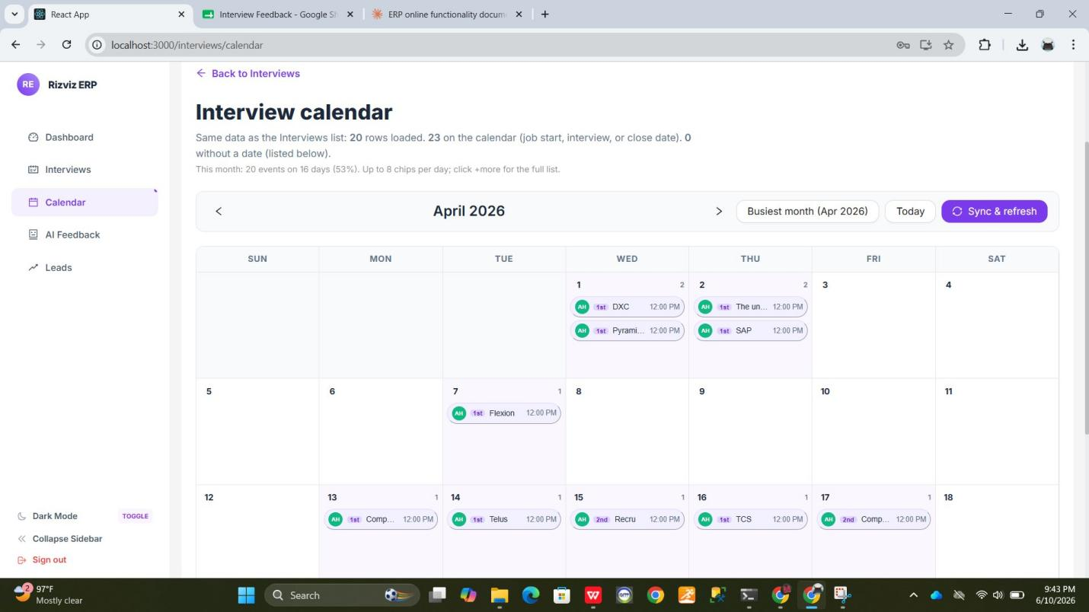
Figure 2 — Interview Calendar (April 2026 Overview)
9.3 Interview Event Chips
Each interview appearing on the calendar is represented as a compact event chip inside its corresponding day cell. Every chip displays the following information at a glance:
Chip Element | Description
Recruiter Avatar | A circular green badge showing the recruiter’s initials (e.g., AH for Arez Hassan).
Interview Round | A small purple badge indicating the round number (e.g., 1st, 2nd).
Company Name | The target company name (truncated if long, e.g., “Comp…”).
Scheduled Time | The interview time in EST (e.g., 12:00 PM).

9.4 Event Tooltip (Hover Detail)
Clicking or hovering over any event chip on the calendar opens a detailed tooltip popup. The tooltip displays the following fields:
Field | Description
Candidate | Full name of the candidate being interviewed (e.g., Omair Bangash EXE).
Company | The company at which the interview is scheduled (e.g., SAP).
Recruiter | The recruiter assigned to this interview (e.g., Arez Hassan).
Status | Current interview status (e.g., Rejected, Converted, Closed).
Type | Interview type (e.g., TECHNICAL / RECRUITER).
Date | The scheduled date and time of the interview in EST (e.g., Apr 29, 2026 12:00 AM).
Job Hunter | Name of the job hunter responsible for sourcing this candidate (e.g., Muhammad Moeed).
EST | Eastern Standard Time for the interview (e.g., 12:00 PM).
PAK (PKT) | Pakistan Standard Time equivalent (e.g., 9:00 PM).

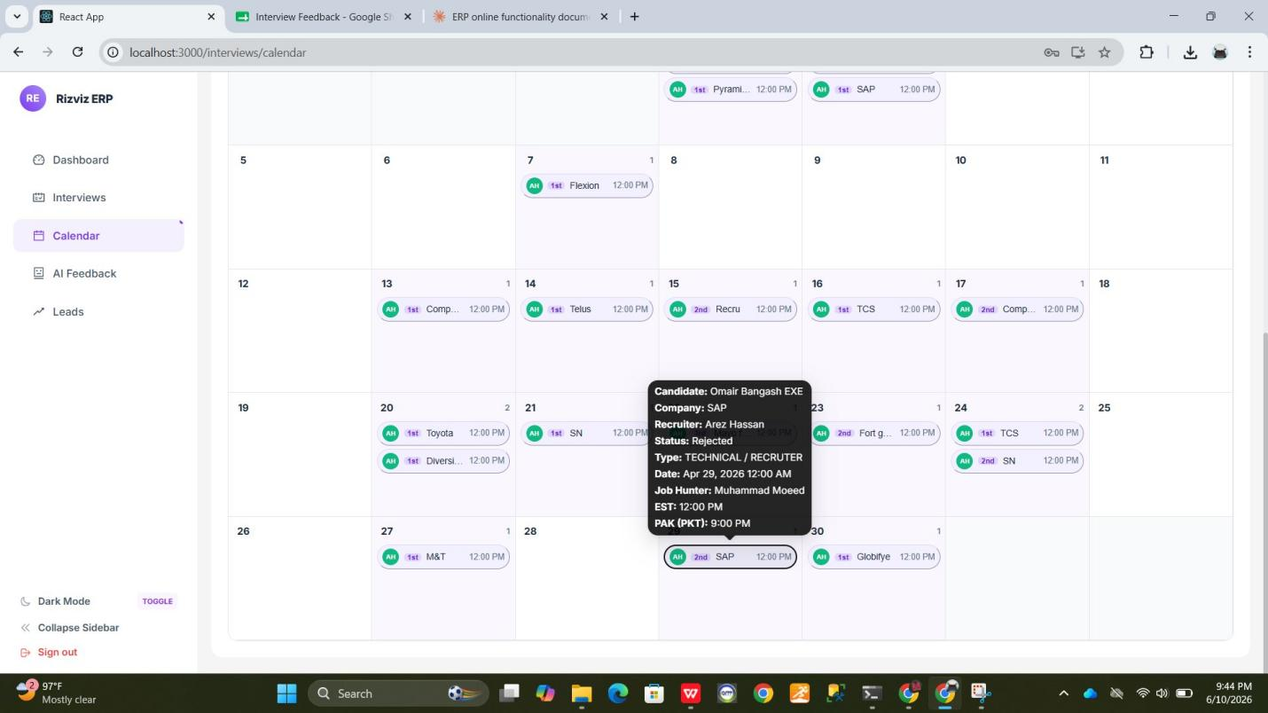
Figure 3 — Interview Event Tooltip (Hover Detail View)
9.5 Calendar Controls
Control | Function
‹ / › Arrows | Navigate to the previous or next calendar month.
Busiest Month | Jumps directly to the month with the most interview events (shown in parentheses, e.g., Busiest month (Apr 2026)).
Today | Returns the calendar to the current month.
Sync & refresh | Re-fetches the latest interview data from the server and refreshes the calendar view.
Back to Interviews | A link at the top of the page that returns the user to the Interviews list.

9.6 Calendar — Quick Reference Summary
Calendar Feature | Purpose
Monthly grid view | Visual overview of all interview dates in the selected month.
Event chips | Show recruiter initials, round, company name, and time per interview.
Tooltip popup | Shows full interview details including EST and PKT times on hover/click.
Busiest Month button | Quick-jump to the month with the highest number of interviews.
Sync & Refresh | Fetches the latest data from the server and updates the calendar in real time.
Back to Interviews link | Returns the user to the Interviews list without losing the current month context.

10. AI Feedback Module
The AI Feedback Module is an advanced, intelligence-driven evaluation collection tool. It is designed to simplify and enhance how interviewers record post-interview evaluations. By allowing recruiters and interviewers to provide feedback using voice or text in Urdu/English, the system bridges linguistic gaps and automates documentation. It integrates Whisper AI to transcribe verbal feedback and Llama-3 AI to translate and refine the text into a professional, structured English summary. All records are backed up locally and synchronized with the master Google Sheet.
10.1 AI Feedback URL
The AI Feedback is accessible from the left sidebar. After navigating to the module, the system loads:
localhost:3000/interviews/feedback
📌 The AI Feedback is accessible from the left sidebar by clicking the AI Feedback menu item. Active authenticated credentials are required to access this module.
10.2 Page Layout
The AI Feedback page is divided into the following areas:
Header Bar — Displays the page title “Interview Feedback” along with a descriptive subtitle and the prominent “+ Add Feedback” button.
Filter Card — Contains a live search input field (searches by candidate, interviewer, or company name) and a recommendation status dropdown filter (All, Recommended, Not Recommended).
Feedbacks Grid — A clean table listing saved feedback entries. Columns displayed are: Sr, Date, Interviewee, Job Hunter, Company, Interview Type, Status, Inv. To, Interview For, Job Start Date, and Actions.
Action Buttons — Includes 'View' (opens a detailed read-only modal with audio playback and full evaluation fields) and 'Delete' (accessible only to system Administrators).
10.3 AI Interview Feedback Modal
Clicking the “+ Add Feedback” button displays the AI Interview Feedback modal. This modal is the primary workspace for entering interview evaluations. It consists of session selectors, candidate detail mappings, input mode tabs, and the AI processing area.
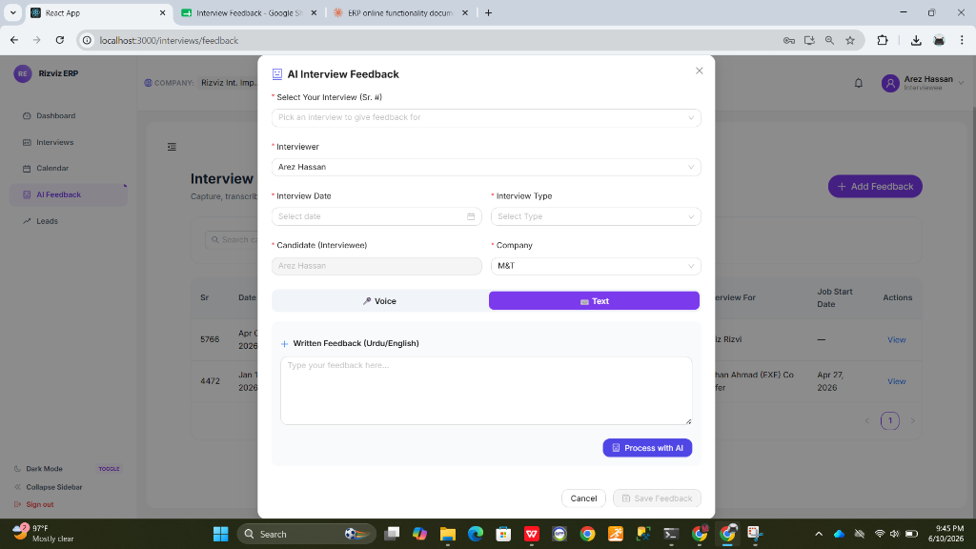
Figure 4 — AI Interview Feedback Modal (Text Input Mode)
10.4 Voice Recording & Whisper Transcription
When using the 'Voice' tab, interviewers can verbally dictate their feedback in Urdu, English, or a mix of both (Roman Urdu):
Clicking the red microphone button starts the recording. A digital clock displays the elapsed recording time in a blinking format.
Clicking the stop button compiles the stream into a local WebM audio block.
A native audio player allows you to replay the recorded feedback for review. Click 'Re-record' if you wish to overwrite the clip.
Click 'Process with AI' to trigger the Whisper AI transcription. The speech is translated to Urdu text and displayed in a right-aligned, RTL-formatted Urdu transcription box.
10.5 Written Text & Llama Enhancement
When using the 'Text' tab, you can manually type rough notes, observations, or draft sentences. After typing your notes (in either Urdu or English), click the 'Process with AI' button. The Llama-3 language model automatically translates the text to English, organizes it structurally, and creates a polished, professional evaluation summary.
10.6 AI Review & Recommendation Selection
Once the AI processing is complete, the modal displays the editable English Translation block. The interviewer can make manual adjustments, correct specific terms, or add context. Below the text area, you must select the 'Recommendation' status ('Recommended' or 'Not Recommended') and fill in optional ratings, strengths, and weaknesses before clicking 'Save Feedback'.
10.7 Database & Google Sheets Synchronization
Saving a feedback entry triggers the following backend processes:
Excel Persistence: The backend opens the local 'interviews.xlsx' workbook, appends the necessary columns ('AI Feedback', 'Rating', 'Strengths', 'Weaknesses', 'Recommendation', 'Feedback By', 'Feedback Date'), and writes the data to the corresponding row matching the selected interview Sr. #.
Database Backup: Saves the record to the SQL/SQLite database under the 'InterviewFeedback' entity as a persistent backup.
Google Sheets Sync: Appends or updates the feedback row in the master Google Spreadsheet ('Interview Feedback' sheet).
📌 Security Guard: The system features a duplicate prevention lock. An error will be displayed if you try to submit multiple feedbacks for the same interview Sr. #. In case of network interruption, local saves succeed immediately, and the Google Sheets sync is queued for automatic background retries.
10.8 Role-Based Access Controls (RBAC)
Data visibility on the AI Feedback page is automatically restricted based on the logged-in user's role:
Admin — Full access: can view all feedback entries, delete records, and perform administrative cleanup of empty rows in the Google Sheet.
Interviewee — Restricted access: can only view feedback records where their user account name matches the Candidate (IntervieweeName) field.
Job Hunter — Restricted access: can only view feedback records where their name matches the Interviewer (InterviewerName) field.
Both — Combined access: can view records matching either their Candidate or Interviewer credentials.
10.9 AI Feedback — Quick Reference Summary
AI Feedback Feature | Description / Action
Voice Input | Record audio feedback directly in the browser using your microphone.
Text Input | Type rough observations or notes in Urdu or English manually.
Whisper Transcription | Transcribes Urdu voice recordings into readable Urdu text.
Llama-3 Enhancement | Translates and refines Urdu transcripts/notes into professional English summaries.
Duplication Guard | Blocks saving if a feedback entry already exists for the selected Sr. #.
Google Sheets Sync | Automatically syncs local evaluations with the remote master Google Sheet.
Role-Based Isolation | Restricts candidate/recruiter visibility to their respective records.
Admin Row Deletion | Allows administrators to purge feedback rows from local and remote logs.

11. Leads Module
The Leads Module is a centralized pipeline management tool that aggregates and tracks all candidate leads derived from interview activity. Leads are automatically generated from Excel sync operations or can be added manually by team members. Each lead entry represents a candidate's journey across one or more companies and tracks their current recruitment outcome status. The module provides statistics tiles, advanced filtering, a searchable grid table, and a detail modal for per-lead inspection.
11.1 Leads Module URL
The Leads page is accessible directly from the left sidebar navigation. After clicking the Leads menu item, the system navigates to:
localhost:3000/leads
📌 The Leads module is role-aware. Leads displayed are automatically scoped to the logged-in user's profile. Administrators can view all leads across all profiles.
11.2 Page Layout
The Leads Management page is organized into the following structural areas:
Page Header — Displays the title 'Leads Management' and a subtitle ('Leads derived automatically from Excel sync or added manually by team members.'), along with a 'Refresh' button to reload the latest data.
Statistics Tiles — A horizontal row of summary cards at the top showing the count of leads by outcome category.
Filter Controls — A search bar and three dropdown filters (Outcome, Profile, Company) to narrow down the leads list.
Leads Grid Table — A sortable, paginated table listing all matching leads with key columns and quick-action buttons.
11.3 Statistics Tiles
At the top of the Leads Management page, a row of summary cards provides an at-a-glance count of leads by their current outcome status:
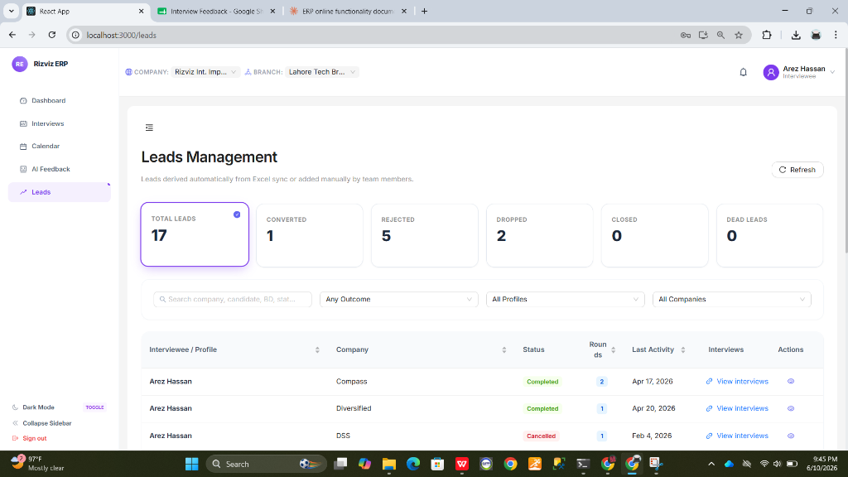
Figure 5 — Leads Management Page (Overview & Statistics Tiles)
Tile | Description
Total Leads | The total number of all lead entries across all statuses. Highlighted with a purple border and a blue info icon.
Converted | Leads where the candidate successfully converted (received an offer or was placed).
Rejected | Leads where the candidate was rejected during the interview process.
Dropped | Leads that were dropped by the candidate or company mid-process.
Closed | Leads that were manually closed or archived by the team.
Dead Leads | Leads with no recent activity or no longer relevant to the pipeline.

11.4 Filter Controls
Below the statistics tiles, three filter controls allow users to narrow down the leads list:
Search Bar — A live-search input field. Searches across company name, candidate name, BD name, and lead status simultaneously.
Outcome Dropdown — Filters leads by their recruitment outcome (e.g., Any Outcome, Converted, Rejected, Dropped, Closed, Dead Leads).
Profile Dropdown — Filters leads by interviewee / candidate profile (e.g., All Profiles, or a specific individual).
Company Dropdown — Filters leads by the associated company name (e.g., All Companies, or a specific company).
📌 All filters work in combination. For example, selecting 'Rejected' from the Outcome dropdown and typing a company name in the search bar will show only Rejected leads for that specific company.
11.5 Leads Grid Table
The main content area displays a sortable, paginated table of all leads matching the active filters. Each row in the table represents a single lead entry.
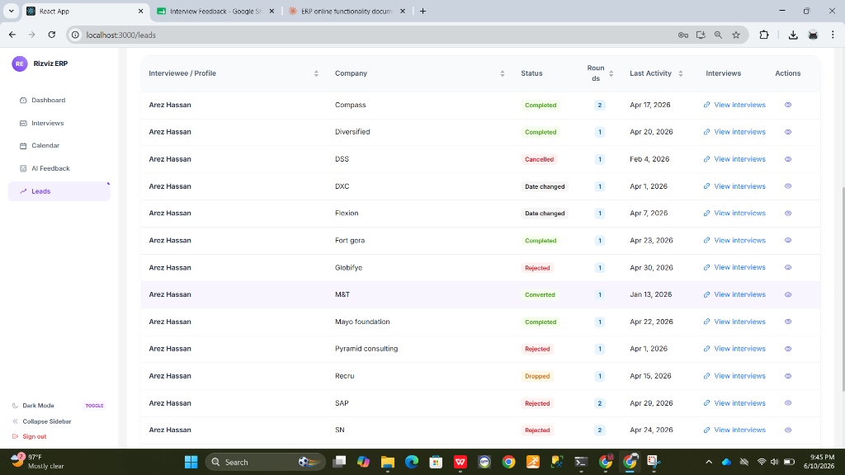
Figure 6 — Leads Management Page (Scrolled View, Full Grid Table)
Column | Description
Interviewee / Profile | The name of the candidate or interviewee associated with the lead.
Company | The target company for which the interview(s) were conducted.
Status | The current recruitment outcome of the lead (Completed, Rejected, Converted, Dropped, Cancelled, Date changed). Each status is color-coded for quick identification.
Rounds | The total number of interview rounds completed for this lead at the given company.
Last Activity | The date of the most recent interview or update associated with this lead.
Interviews | A 'View Interviews' hyperlink that navigates to the filtered Interviews list for this specific lead-company combination.
Actions | An eye icon button that opens the Lead Details modal for a detailed view of the lead record.

11.6 Lead Details Modal
Clicking the eye icon (👁) in the Actions column of any lead row opens the Lead Details modal. This modal provides a structured summary of the selected lead record.
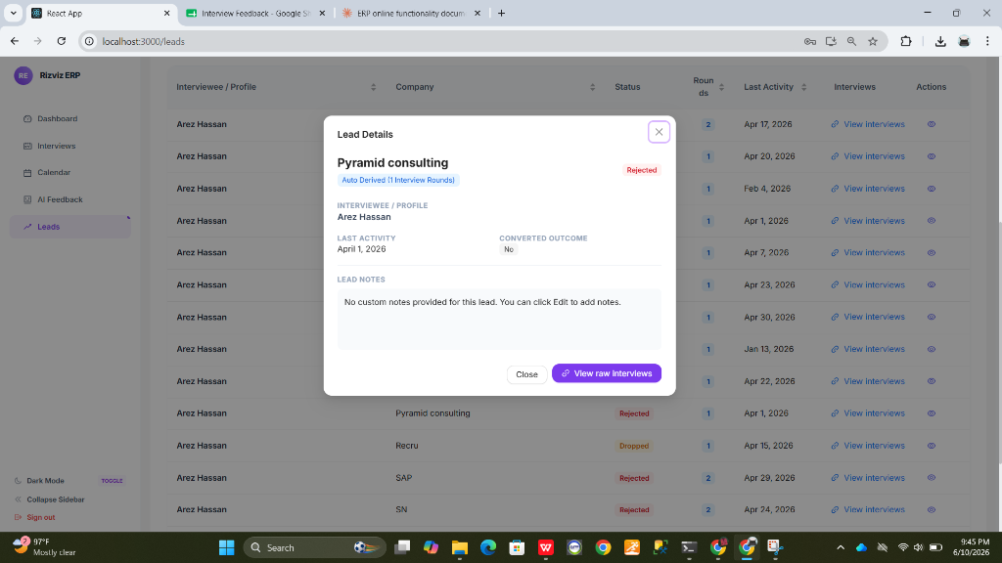
Figure 7 — Lead Details Modal (Summary View and Actions)
The Lead Details modal displays the following information:
Company Name — Displayed prominently as the modal title (e.g., 'Pyramid consulting').
Source Badge — Indicates how the lead was created: 'Auto Derived [X Interview Rounds]' for automatically generated leads, or 'Manually Added' for user-created records.
Status Badge — Shows the current outcome in a color-coded label (e.g., Rejected shown in red, Converted shown in green).
Interviewee / Profile — The candidate name linked to this lead.
Last Activity — The date of the most recent interview event associated with this lead.
Converted Outcome — Whether the lead ultimately resulted in a successful placement (Yes / No).
Lead Notes — Any custom notes added by a team member. Displays 'No custom notes provided for this lead. You can click Edit to add notes.' if no notes exist.
Two action buttons are available at the bottom of the modal:
Close — Dismisses the modal and returns to the leads grid.
View raw Interviews — Navigates to the Interviews list, pre-filtered to show only the interview rounds associated with this specific lead.
11.7 Status Color Reference
Lead statuses in the grid table are color-coded for quick visual identification:
Status | Color | Meaning
Completed | Green | All interview rounds completed successfully.
Converted | Blue / Teal | Candidate received an offer or was successfully placed.
Rejected | Red | Candidate was rejected at one or more stages.
Dropped | Orange | Lead was dropped by the candidate or company.
Cancelled | Gray / Red | Interview was cancelled; no further rounds planned.
Date changed | Yellow / Amber | Interview date was rescheduled; lead is still active.

11.8 Leads Module — Quick Reference Summary
Leads Feature | Purpose
Statistics Tiles | At-a-glance count of leads grouped by outcome status (Converted, Rejected, Dropped, Closed, Dead).
Refresh Button | Fetches the latest lead data from the server and updates all tiles and grid entries in real time.
Search Bar | Live search across candidate name, company, BD, and status fields simultaneously.
Outcome Filter | Filters the grid to show only leads matching the selected recruitment outcome.
Profile Filter | Restricts the grid to leads belonging to a specific interviewee or candidate profile.
Company Filter | Narrows the leads grid to show only records associated with a chosen company.
View Interviews link | Directly navigates to the Interviews list pre-filtered for that lead's company-candidate pair.
Lead Details Modal | Opens a structured summary card with notes, source, outcome, and last activity for the selected lead.
View raw Interviews button | From within the Lead Details modal, jumps to all raw interview rounds for that specific lead.

12. Dark Mode
The Rizviz ERP includes a built-in Dark Mode that switches the entire interface to a dark color scheme. Dark Mode reduces eye strain during extended sessions, particularly in low-light environments. The setting is applied globally — it affects all pages including Dashboard, Interviews, Calendar, AI Feedback, and Leads — and is persisted across page navigation for the duration of the session.
12.1 Toggling Dark Mode
Dark Mode can be toggled from the bottom of the left sidebar navigation panel. The control is always visible regardless of which module is active:
Locate the 'Dark Mode' label at the bottom-left of the sidebar.
Click the TOGGLE button next to it to switch between Light Mode and Dark Mode.
The interface will instantly re-render in the selected mode — no page reload is required.
To return to Light Mode, click the same TOGGLE button again (the label changes to 'Light Mode').
📌 Dark Mode preference is session-scoped. If you close and reopen the browser, the interface will return to Light Mode by default.
12.2 Dark Mode Interface
When Dark Mode is active, the following visual changes are applied across the entire ERP:
Page Background — Changes from white (#FFFFFF) to a deep navy/dark tone for reduced brightness.
Sidebar — Background darkens; menu item text becomes light-colored for contrast.
Tables — Row backgrounds switch to dark variants; text remains legible with high contrast.
Status Badges — Colors are slightly adjusted for dark background readability.
Modals & Dialogs — Background panels and input fields adopt dark-themed fills.
Navigation Bar — Top bar background and text adapt to the dark palette.
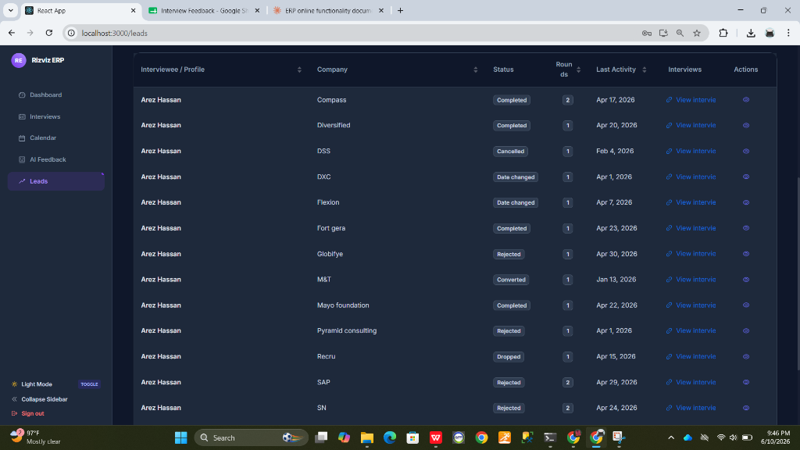
Figure 8 — Leads Module in Dark Mode (Dark Theme Active)
12.3 Dark Mode — Quick Reference Summary
Feature | Description
Toggle Location | Bottom of the left sidebar — 'Dark Mode / TOGGLE' control.
Activation | Click TOGGLE once to enable Dark Mode; click again to return to Light Mode.
Scope | Applied globally across all ERP pages and modules instantly.
Persistence | Session-scoped only; does not persist after browser close/reopen.
Affected Areas | Sidebar, top navigation bar, all page backgrounds, tables, modals, and input fields.

