**CPE223 – Signalsa and Systems**



**Lab # 6**

**To Sketch the Response of Linear Time Invariant Systems by Performing Convolution Using MATLAB**

|  |  |
| --- | --- |
| **Name** | Muhammad Aizaz Arshad |
| **Registration Number** | 088 |
| **Class** | FA18-BCE-A |
| **Instructor’s Name** | Umair Khan |

**OBJECTIVE:**

Construct and display the convolution and deconvolution of Continuous and Discrete time signals using MATLAB.

**REQUIRED EQUIPMENT:**

**Software:**

* **MATLAB**

**METHODOLOGY:**

In order to calculate response of system impulse response h (t) and the input signal x (t) is

required. After using convolution built-in function, the convolution of x(t) and h(t) can

easily be obtained without any obstacle. Several examples on determining the convolution

between the two discrete time signals or continuous time signals were practiced. After finding

the length of convolution which is given by the formula:

Length(y) = length (x) +length (h) -1

The command for convolution is:

Y= conv (x, h)

If we were given the input and output response in the form of convolution, we were able to

calculate the impulse response by using the command of deconvolution given below;

h(t) = deconv (y, x)

Where x is called the input vector and y is the output response of the system.

**CONCLUSION:**

In this lab we practice to convolve the two signals that are input (x(t)) and impulse (h(t)) response of the system and computing the output response (y(t)) as a result of that convolved signal. The built-in command enabled us to analyze direct computation of the output response or we can make general function of convolution to get output. We have also use deconvolution command to find impulse response when output and input response were given. Convolution has a lot of applications in signal processing.

**IN LAB TASKS:**

**Question 1:**

t1=0:0.1:1;

t2=0:0.1:2;

h=1-t1;

x=ones(size(t2));

y1=conv(x,h).*0.1;

plot(y1)

xlabel('Time')

ylabel('Amplitude')

title('y(t)')

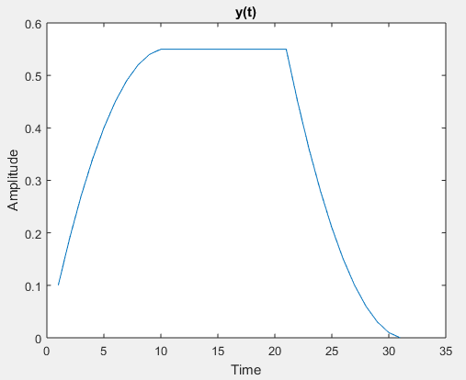

**Question 2:**

t1=0:0.1:1;

t2=0:0.1:2;

h=1-t1;

x=ones(size(t2));

y=conv(x,h).*(0.1);

h=deconv(y,x)./0.1;

plot(h)

xlabel('Time')

ylabel('Amplitude')

title('h(t) With Deconvolution')

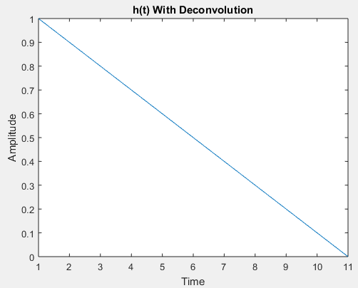

**Question 3:**

t1=-1:0.1:0.5;

t2=0.5:0.1:3;

t=[t1 t2];

x1=0.6.*ones(size(t1));

x2=0.3.*ones(size(t2));

x=[x1 x2];

subplot(2,3,1)

plot(t,x)

xlabel('time')

ylabel('Amplitude')

title('x(t)')

h=(exp(-t).*heaviside(t)).*ones(size(t));

subplot(2,3,2)

plot(t,h)

xlabel('time')

ylabel('Amplitude')

title('h(t)')

subplot(2,3,3)

plot(-t-2,h,t,x,':*r')

xlabel('time')

ylabel('Amplitude')

title('Zero overlap')

subplot(2,3,4)

plot(-t-1,h,t,x,':*r')

xlabel('time')

ylabel('Amplitude')

title('Partial overlap')

subplot(2,3,5)

plot(-t+1,h,t,x,':*r')

xlabel('time')

ylabel('Amplitude')

title('Complete overlap')

subplot(2,3,6)

plot(-t+4,h,t,x,':*r')

xlabel('time')

ylabel('Amplitude')

title('Partial overlap')

%OUTPUT

m=length(x);

n=length(h);

y=n+m-1;

X=[x,zeros(1,m)];

H=[h,zeros(1,n)];

for i=1: y

Y(i)=0;

for j=1:i

if(i-j+1>0)

Y(i)=Y(i)+X(j).*H(i-j+1);

else

end

end

end

figure;

subplot(1,2,1)

plot(Y)

ylabel('Amplitude')

xlabel('Time')

title('Y(t) Without Convolution')

a=conv(x,h);

subplot(1,2,2)

plot(a)

ylabel('Amplitude')

xlabel('Time')

title('Y(t) With Convolution')

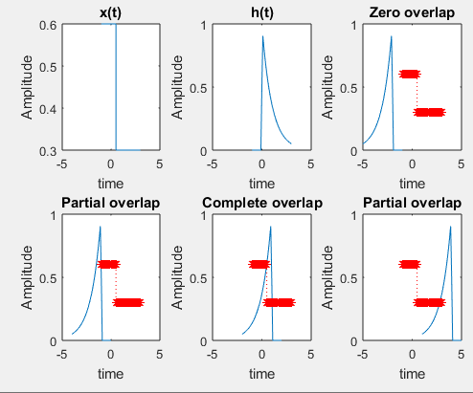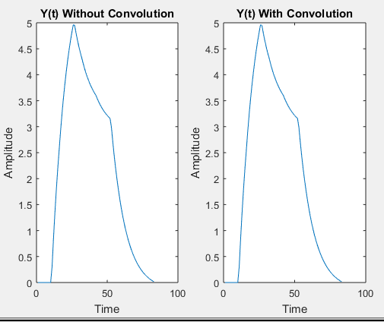

**Question 4:**

n=-5:5;

h=n;

n1=0:4;

x=ones(size(n1));

a=length(x);

b=length(h);

Y=a+b-1;

y=zeros(1,Y);

for i=0:Y

for j=0:Y

if((i-j+1) > 0 && (i-j+1) <= b && (j+1) <= a)

y(i+1) = y(i+1)+x(j+1)*h(i-j+1);

end

end

end

subplot(1,2,1)

stem(y)

xlabel('Time')

ylabel('Amplitude')

title('y[n] Without Convolution')

c=conv(x,h)

subplot(1,2,2)

stem(c)

xlabel('Time')

ylabel('Amplitude')

title('y[n] With Convolution')

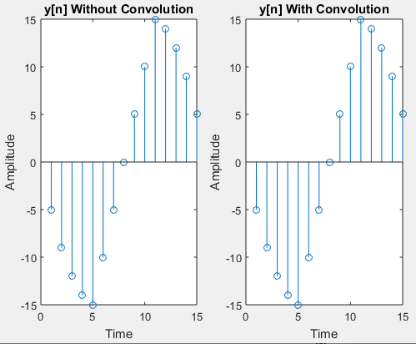

**Question 5:**

n=-2:0.1:2;

n1=-1:0.1:3;

x=n.^2;

h=1./(n1+2);

y=conv(x,h).*0.1;

stem(y)

xlabel('Time')

ylabel('Amplitude')

title('y[n] With Convolution')

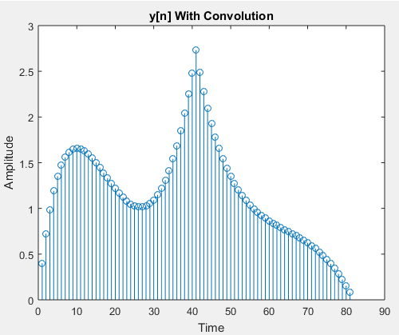

**FIND IMPULSE RESPONSE:**

n=-2:0.1:2;

n1=-1:0.1:3;

x=n.^2;

h=1./(n1+2);

y=conv(x,h)

subplot(1,2,1)

stem(h)

xlabel('Time')

ylabel('Amplitude')

title('h[n]')

H=deconv(y,x)

subplot(1,2,2)

stem(H)

xlabel('Time')

ylabel('Amplitude')

title('h[n] (verified)')

