**CPE223 – Signals and Systems**



**Lab Report # 5**

**TO EXPLAIN THE PROPERTIES OF THE SYSTEM USING I/O**

**RELATIONSHIP IN MATLAB**

|  |  |
| --- | --- |
| Name | Muhammad Aizaz Arshad |
| Registration Number | 088 |
| Class | FA18 BCE-A |
| Instructor’s Name | Umair Khan |

**Objectives: -**

Show the properties (causality, linearity, stability and time invariance) of different systems using MATLAB

**Methodology: -**

Firstly, causality of system was checked. For this purpose, signal x (t) has been plotted in MATLAB. And it was checked that if the corresponding output (𝑡) depends only on the present and past values of (𝑡), as if it starts from zero, then plotted signal is causal otherwise this signal is non-casual.

Second property of Static and dynamic system has been checked. Again, signal x(t) or x[n] has been plotted in MATLAB. If it was checked that corresponding output (𝑡) or [𝑛] depends only on the value of the input signal at the same time then it is static otherwise this non static system is dynamic.

For checking linearity of system, on plotting the input signal x(t) if linear combination of two signals is the linear combination of the responses of the system to each one of these signals then it is linear system. For checking stability condition, we were checking finite or infinite signal if they were finite, we got the result in the form of BIBO stable signal otherwise it was unstable.

The last one was time variance if after shifting the signal remains the same it was time invariant signal other it was time variant.

**Conclusion: -**

In this lab we have learned about different properties of systems in aspect to the course of Signals and Systems. As an outcome of this lab students were then able to implement those properties on different type of systems and analyze the nature of an input signal to that system. Analyzing the nature of signal was an important tool as most of the things are the basic requirement.

**In Lab:**

**Task 1: -**

t=1:0.1:2;

x=heaviside(t)-heaviside(t-1);

y1=3.*(heaviside(t)-heaviside(t-1));

y2=heaviside(t-1)-heaviside(t-1-1);

subplot 121

plot(t,y1)

title('Dynamic')

subplot 122

plot(t,y2)

title('Dynamic')

**Output: -**

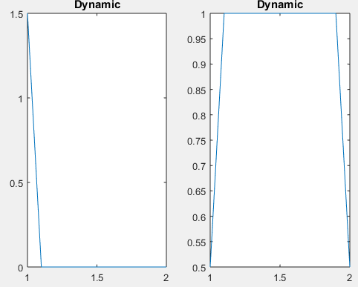

**Task 2: -**

n=-1:3;

x=[0 1 2 3 4];

x1=x./2;

y1=x.^2;

y2=x1;

subplot 211

stem(n,y1)

title('Dynamic')

subplot 212

stem(n,y2)

title('Dynamic')

**Output: -**

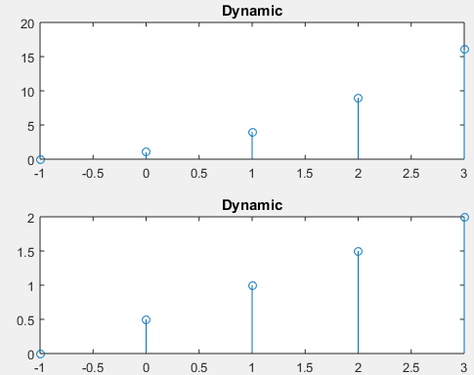

**Task 3: -**

t=-1:1;

x1=heaviside(t)-heaviside(t-2);

y1=2*x1;

y2=x1.^2;

subplot 221

plot(t,y1)

title('LINEAR')

subplot 222

plot(t,y2)

title('NON LINEAR')

**Output: -**

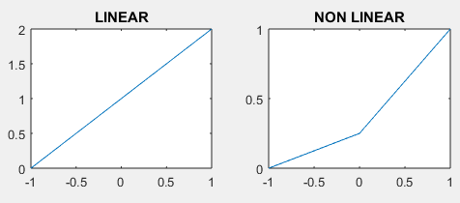

**Task 4:-**

n=0:5;

x1=0.8.^(n);

x2=cos(n);

y1=2.^x1;

y2=n.*x2;

y3=2.^x1;

y4=n.*x2;

subplot(2,2,1)

stem(n,y1)

title('y1')

subplot(2,2,2)

stem(n,y2)

title('y2')

subplot(2,2,3)

stem(n,y3)

title('y3')

subplot(2,2,4)

stem(n,y4)

title('y4')

**Output: -**

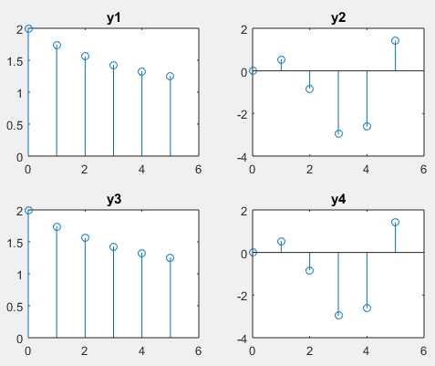

**Task 5: -**

t=0:0.01:5;

x=heaviside(t)-heaviside(t-5);

y=t.*exp(-t).*x;

plot(t,y)

title('TIME INVARIANT')

**Output: -**

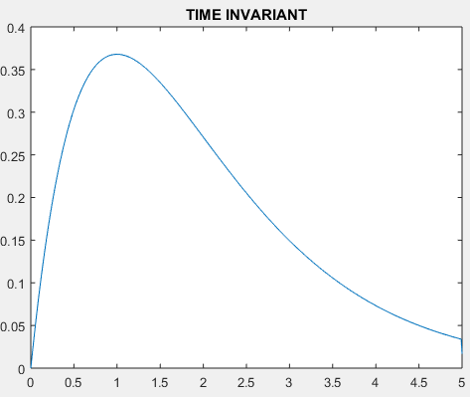

**Task 6: -**

t=0:0.01:8;

x=cos(t).*(heaviside(t)-heaviside(t-10));

y=1-2. *(cos(t-1). *(heaviside(t-1)-heaviside(t-10-1)));

subplot 211

plot (t, y)

title ('TIME INVARIANT')

subplot 212

plot (t, x)

title ('x(t)')

**Output: -**

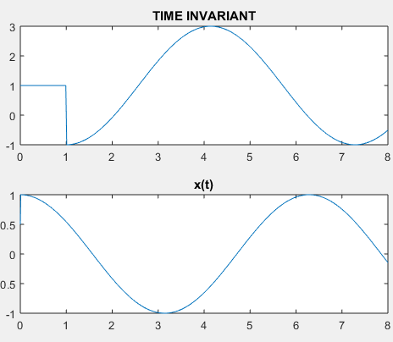

**Task 7: -**

t=0:0.01:5;

x=cos(2*pi*t);

y1=x.^2;

y2=t.*x;

subplot 211

plot (t, y1)

title ('Stable')

subplot 212

plot (t,y2)

title ('Stable')

**Output: -**

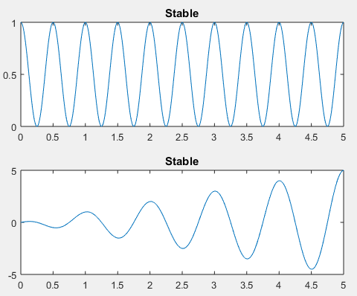

**Task 8: -**

n1=-2:2;

n2=-2:4;

x1=2. *(n1);

x2=n2. /3;

y1= -x1;

y2= -x2;

subplot 221

stem(n1,y1)

title ('Dynamic')

subplot 222

stem(n1,y1)

title ('Non Causal')

subplot 223

stem(n2,y2)

title ('Linear')

subplot 224

stem(n2,y2)

title ('Shift Invariant')

**Output: -**

